Monthly Report of DcBot

**1. 过去一个月每周的成交量密集成交区变化。**

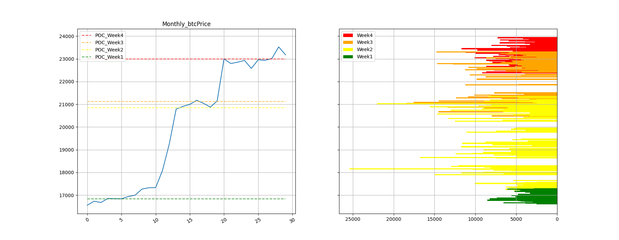

-上图是BTC本月每周的密集成交区分布图

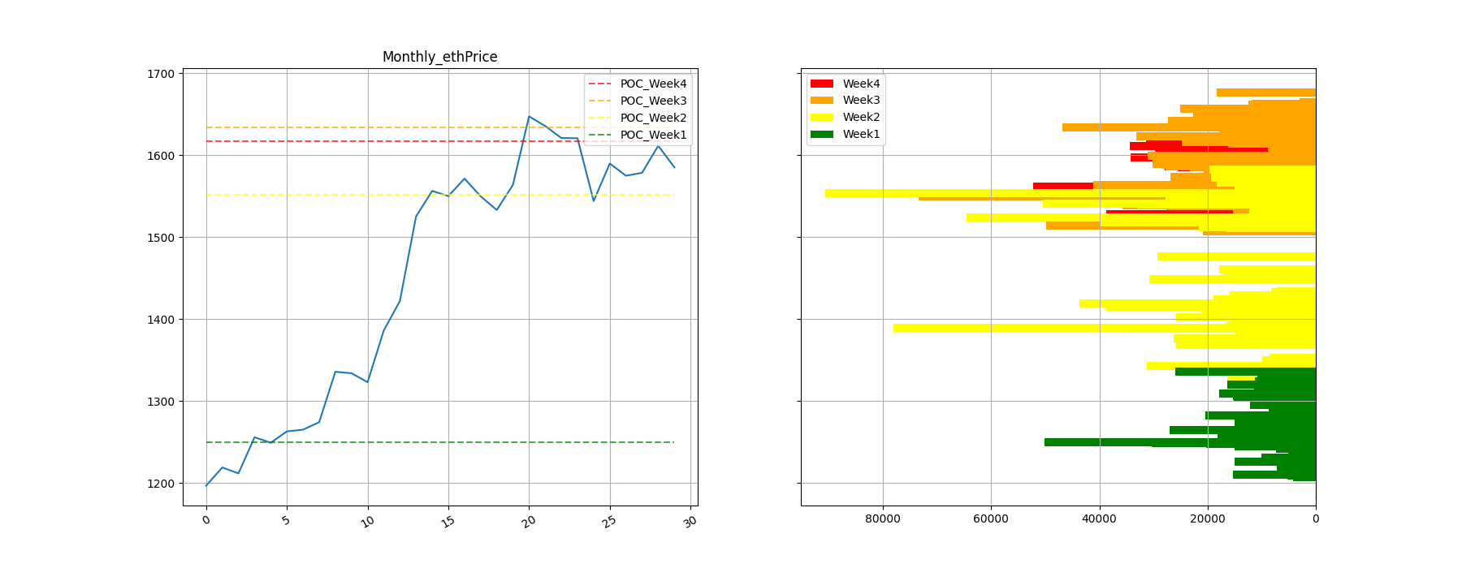

-上图是ETH本月每周的密集成交区分布图

表格显示BTC过去一个月中每周的密集成交区间

|  |  |  |  |
| --- | --- | --- | --- |
| POC_SAR | Point Of Control | Support | Resistance |
| week4_btc | 22993.84 | 22864.14 | 23221.84 |
| week3_btc | 21123.24 | 20682.29 | 21428.32 |
| week2_btc | 20858.37 | 20604.78 | 21096.76 |
| week1_btc | 16833.48 | 16786.34 | 16873.33 |

表格显示ETH过去一个月中每周的密集成交区间

|  |  |  |  |
| --- | --- | --- | --- |
| POC_SAR | Point Of Control | Support | Resistance |
| week4_eth | 1617.15 | 1566.36 | 1622.1 |
| week3_eth | 1634.0 | 1614.58 | 1662.41 |
| week2_eth | 1551.34 | 1515.66 | 1561.97 |
| week1_eth | 1250.12 | 1245.84 | 1256.42 |