**Diploma Game Proposal**

**U.F.O.**

Daniel Cherrin

**The Pitch**

U.F.O. is a physics-based puzzle action game, where the player must deliver various packages, solve puzzles and avoid trouble equipped only with their UFO’s trusty state-of-the-art tractor beam.

**Platform**

For the development of U.F.O, I’m going to try and use Unity 2017.2.0f3 and release for Windows 10. My reasoning for using this build is for consistency between workstations and online support

Windows 10 was selected since it’s the latest OS that is still being supported for Microsoft.

**Game Design**

The core gameplay system is intended to center around curiosity of what is possible to do with the UFO core mechanic; the tractor beam. Using Unity’s inbuilt physics system, the intention is to make all objects manipulable using the beam and have unique effects on each object. I want the feeling similar to the curiosity the player gets from using the gravity gun in HL2. The element missing from that game however was interpreting held objects as a sort of sci-fi mace and the objects could only be fired to do damage.

The tractor beam will be able to cycle through objects in it to freeze the relative position inside it so that it can be carried and manipulated.

The player will also be able to perform an inside loop flight maneuver to swing the object and perform unique actions such as cutting, bashing, pulling or stabbing.

Object collision effects can range from stabbing force, slicing force, blunt force, explosive force.

More unique effects will be pulling objects out of there intentional places and repurposing their use. Eg. Unmounting a laser and changing it’s direction and placement.

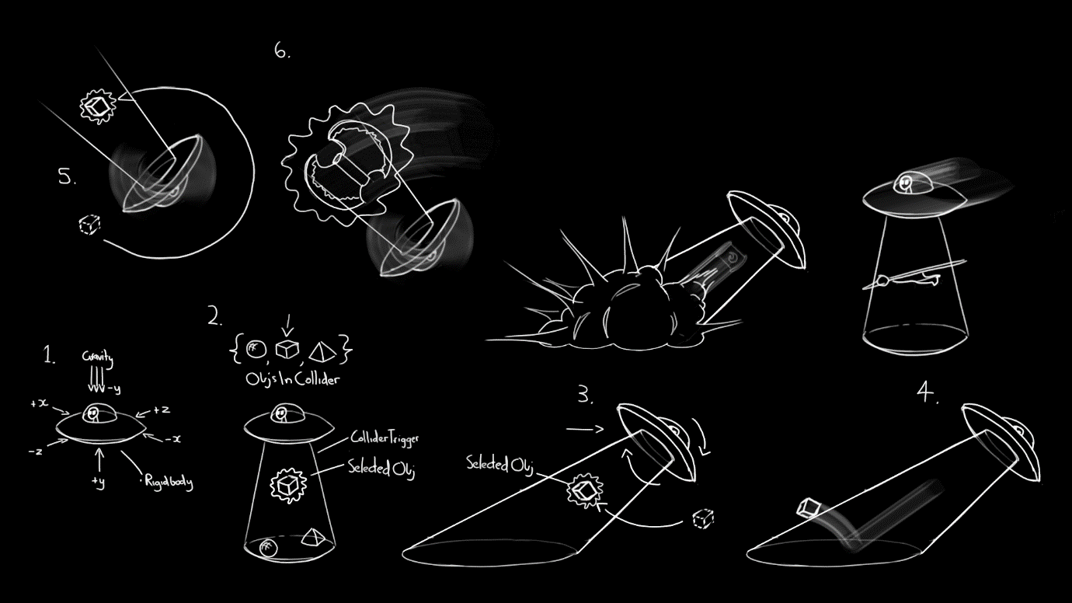

**GUI Design**

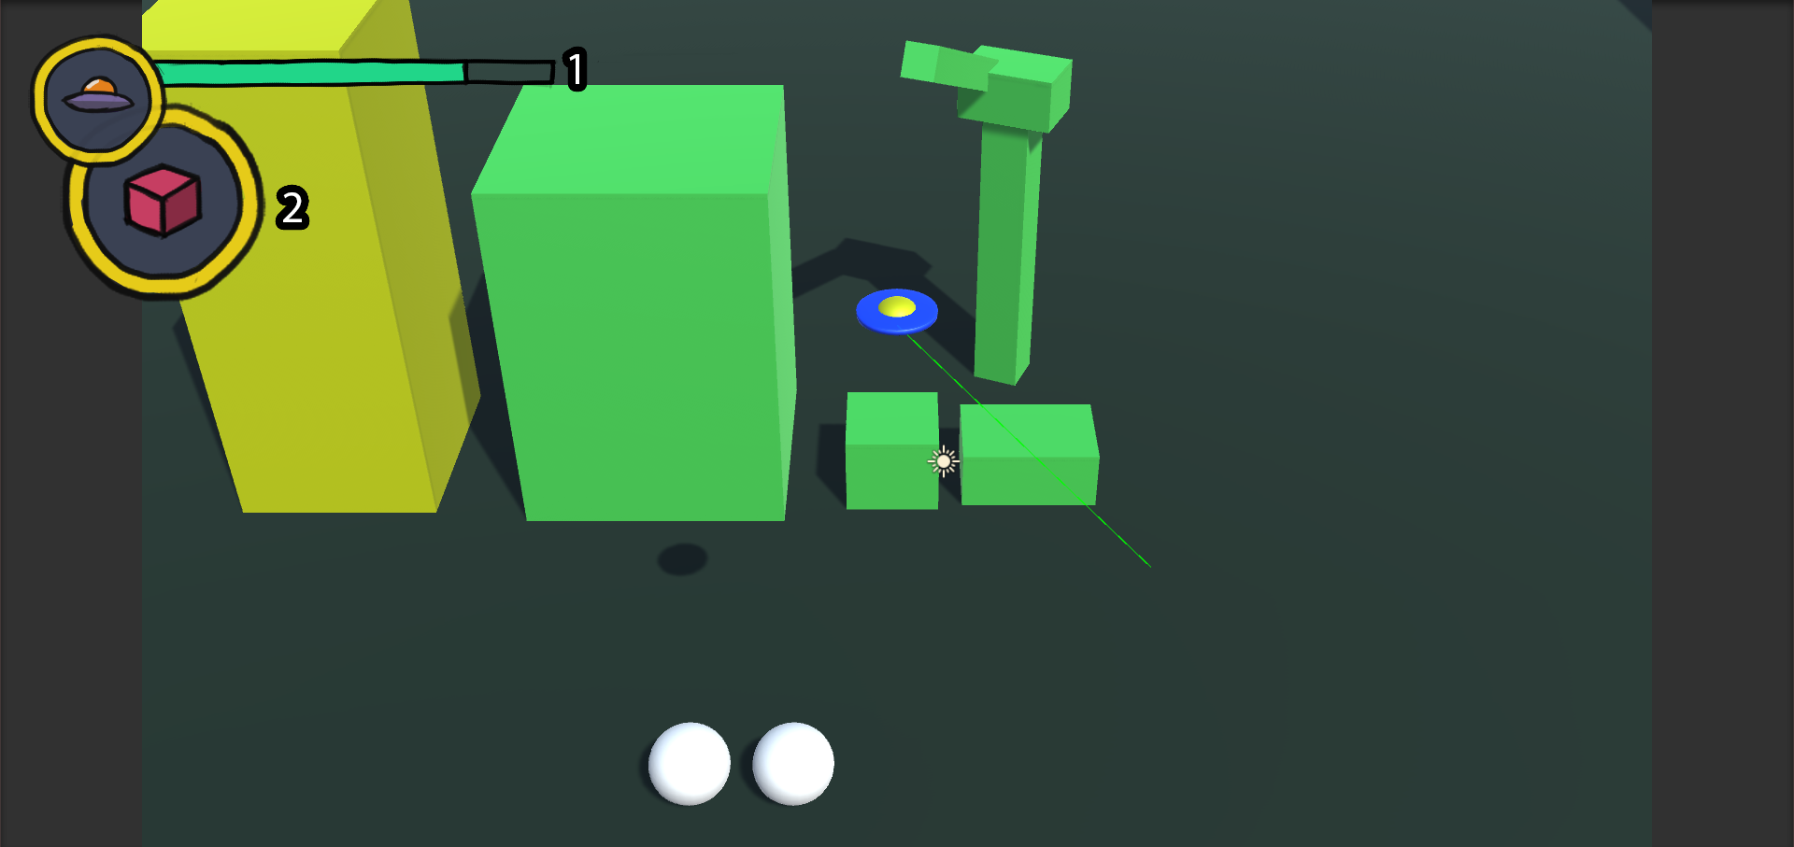

1. This represents the player’s health.
2. This represents the object the player currently has in their tractor beam.

**Development Plan**

**Week 6 Sprint:**

Movement, hovering and tilting towards a direction according to the player’s input.

The UFOhas to be able to unlock it’s rotation it perform loops while moving in order for it to swing the selected object in it’s tractor beam.

**Week 8 Sprint:**

Tractor beam collider and cycling between tractor beam objects. Selected object must follow inside the tractor beam but other objects with a stronger mass can knock it outside of the beam. Selected object must be on the relative underside of the UFO. Selected object must inherit the UFO’s transform (Euler or Quaternion).

**Week 10 Sprint:**

Tractor beam has to be able to launch objects from the tractor beam. Look for or create 3rd party assets that fit the criteria for; blunt, slicing, explosive and stabbing forces. Rework Nudger behavior script to emulate a proximity homing missile enemy that creates explosive force upon destruction. Create a missile launcher enemy that fires prefab projectiles.

**Week 12 Sprint:**

Look for 3rd party environment assets; at least one objects for each specific force. Work out the rules to each force and how they will interact with the environment and other force objects. Create object health, player health and enemy health system that receives that interprets forces as damage.

**Week 14 Sprint:**

Create generic main menu and setting controls. Design tutorial/intro level that introduces all the base gameplay concepts. Create door prefabs and switch prefabs. Door prefabs will accept reference to instances of switch prefabs and opens when all of them are activated.

**Week 16 Sprint:**

Bug fixing sprint and polish. Sprint mainly for any hiccups.

**Week 17 Sprint:**

Bug fixing sprint and polish. Sprint mainly for any hiccups.

