Website runs on jekyll

Installation:

<https://jekyllrb.com/docs/installation/>

once installed go to the folder where you have the website. Then build the local site via the following

<https://jekyllrb.com/docs/>

Steps in Github:

first -> update from origin (Froeling)

then -> push to master (e.g. Siero)

finally do->pull request (Froeling)

To locally build website:

type on cmd line in location 7Twebsite[ : bundle exec jekyll serve

then <http://localhost:4000> in your browser ,viola!

Two types of pages:

1. main page which is accessible by the menu structure
2. project page which is only accessible via a main page

Pages are *.md files which means they are formatted using the markdown language.

<https://www.markdownguide.org/basic-syntax/>

Each page start with a YAML header indicated by “---” (https://yaml.org/)

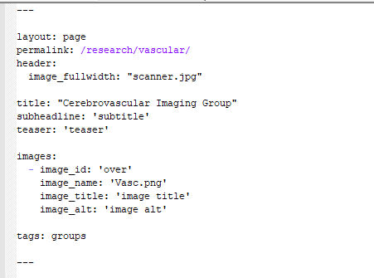

In this header all meta information of the page is defined.

**MAIN PAGE**

For main pages you can change:

* the header image, if you provide a header image it should be ~1100x300px
* the title/subtitle/teaser
* add images, each image starts with – image_id. All image information must be filled out.

**tags and permalink should not be changed!!!!!!**

After the second “---” The page content starts. Here you can use normal markdown layout OR insert html stuff if you want.

Adding the images you defined in the header is done with:

{% include page-image im_id="id_name" %}

**The bottem part of the page after the first <br> should not be touched**

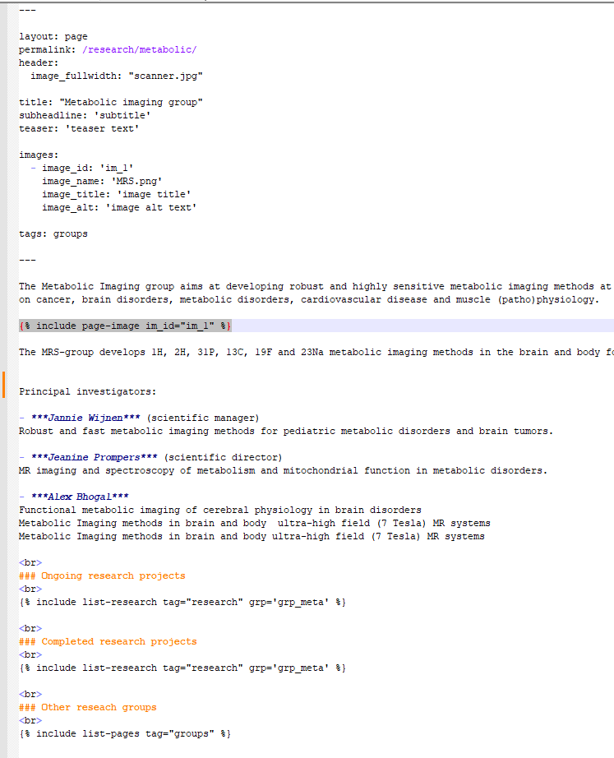

**PROJECT PAGE**

Project pages work the same as main pages with two differences.

1. The permalink whould be changed to projects/xxxx with xxx the name you want.
2. In the tags field the tag “-projects” OR “-projects_old” should be used. A second tag should be added which defines where your project shows up. This can be on or multiple of the follwing:
   1. - grp_meta (metabolic imaging)
   2. - grp_plat (platform and methods)
   3. - grp_pre (preclinical)
   4. - grp_rec (recon)
   5. - grp_rf (RF and safety)
   6. - grp_vasc (vasular brain)
   7. - grp_coil (coil lab)
   8. - grp_soft (software)

