Analysis

Analytical Solution: Modelling, Evaluation and Technical Findings
This section explains how we got from the cleaned data to the final model: how we prepared the data, dealt with class imbalance and validated the results, why we went with a random forest, how well it does, and where you shouldn't trust it. Unless it says otherwise, the numbers come from the held-out test set of 4,136 households (760 food insecure, 18.4%). You can reproduce all of them by knitting our SDHSA_Final_Analysis.Rmd in the folder.

1. Preprocessing, missing values and validation
We split the cleaning into two parts so the model and the Shiny app treat data the same way. The fixed rules, which don't learn anything from the data (survey codes 9 and 99 become missing, nominal codes become factors), live in preprocess.R. Everything that is learned from the data sits in a recipe stored inside the fitted workflow. It drops 34 ID, weight and duplicate columns, adds a missing-value flag for rent, fills gaps with training medians and modes, maps unseen categories to "new", pools levels under 1%, creates dummy variables, and removes constant, near-constant, highly correlated (above 0.95) and linearly dependent columns before scaling. That leaves 82 predictors. The recipe is only ever fitted on training data (and refitted inside each cross-validation fold), so nothing from the validation or test data leaks into the model.
There are two kinds of missing data. Six fields (for example distance to toilet, 97% missing, and rent, 75%) are empty simply because the question doesn't apply to every household, so it's skip-logic rather than lost data. We kept a flag for rent and imputed the rest. That's probably the weakest decision in the pipeline, because the model can't tell that a question didn't apply, and an explicit "not applicable" category is the first thing we'd try next. Unknown answers (code 9 or 99) are rare in the training data (three households or fewer per column), so they matter mostly for new uploads.
While adding range checks to the app we noticed something odd: SalaryEarnersInHousehold and TotalGrantRecipients hold Rand amounts, not head-counts. 64% and 59% of rows are above 20, and in 83% of households the two columns add up exactly to household income. The model isn't affected, but we should describe them as salary income and grant income and rename them in the data dictionary.

2. Class imbalance
Only 18.4% of households are food insecure, so a model that always says "secure" would be 81.6% accurate and completely useless. That's why we didn't use accuracy. Instead we used stratified splits and cross-validation, compared models on ROC AUC, precision-recall AUC and the Brier score, and dealt with the imbalance by lowering the decision threshold from 0.50 to 0.30. To make sure that wasn't hiding a better option, we also tried class weights and down-sampling in 5-fold cross-validation (Table 1).
Model (5-fold CV, training data) | ROC AUC | PR AUC | Brier (lower is better)
Logistic regression | 0.819 | 0.517 | 0.117
Random forest (final) | 0.830 | 0.556 | 0.114
Random forest + class weights | 0.829 | 0.556 | 0.114
Random forest + down-sampling | 0.825 | 0.534 | 0.175
Table 1. Cross-validated comparison, including imbalance handling.
Class weights barely changed anything, since the forest grows deep trees whose leaves are nearly pure. Down-sampling was worse on every measure and badly distorted the probabilities (Brier 0.175), because the model learns from a 50/50 world and then gets used on an 18/82 one. The app shows probabilities as risk scores, so we stuck with the plain forest and a lower threshold.

3. Model selection and tuning
For validation we used the 80/20 stratified hold-out from Milestone 2 (16,548 training and 4,136 test households), plus 5-fold stratified cross-validation on the training set with set.seed(381). We tried 15 random forest settings (mtry 5-20, min_n 2-25, 500 trees). The best was mtry = 11, min_n = 2 (AUC 0.8295), which is exactly what the deployed model uses. Twelve of the 15 settings landed within 0.002 AUC of it, so the surface is pretty flat and tuning matters far less than the choice of predictors. Logistic regression was our simple benchmark. The forest ranked better in cross-validation (0.830 against 0.819) and picks up non-linear income effects and interactions without us adding them by hand, so we went with it. The trade-off is that it's harder to interpret, which we cover with variable importance and the model card in the app.

4. Final evaluation on the test set
The random forest gets a ROC AUC of 0.840 (95% bootstrap interval 0.825 to 0.855). That's comfortably above our Milestone 1 target of 0.75 and above logistic regression at 0.819. Its precision-recall AUC is 0.539 against a base rate of 0.184, and its Brier score is 0.113. When we score the test set through the app's score_households() function, we get the saved predictions back to within 1e-16, so the app gives exactly these results.
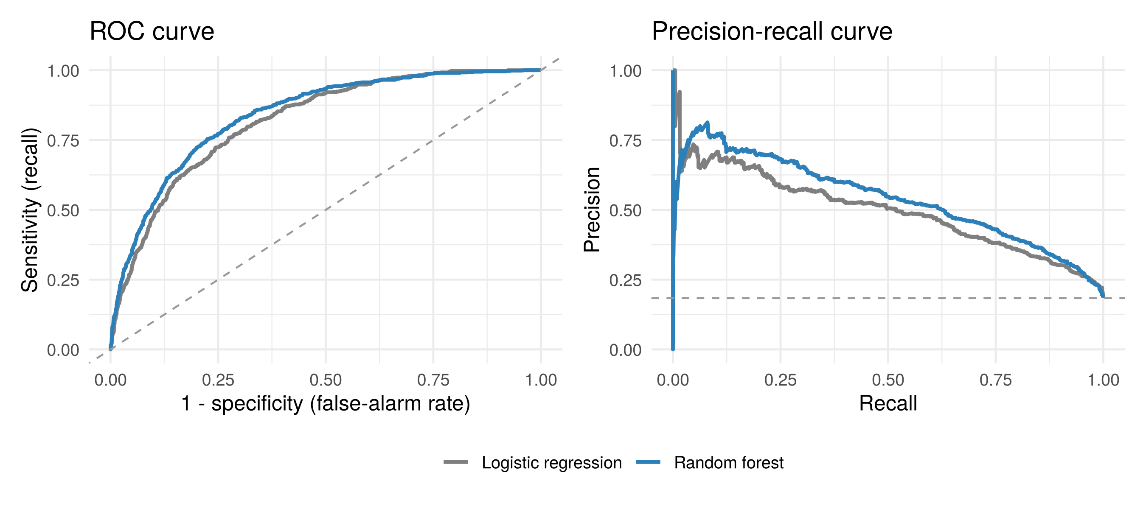
ROC and precision-recall curves, random forest and logistic regression (test set).
Threshold. At the default 0.50 the forest only finds 25% of food-insecure households (187 of 760). At 0.30 it finds 63% (482 of 760) with 49% precision and the best F1 score (0.55). About one flag in two is a false alarm, and 24% of households get flagged against an 18% base rate (Table 2). That's fine for screening with a person reviewing the results, but not for deciding whether an individual household gets help. The threshold really comes down to how costly a missed household is compared with a false alarm, so the programme owner should confirm it.
Threshold | Flagged | TP | FP | FN | Recall | Precision | Specificity
0.20 | 39.5% | 625 | 1010 | 135 | 82.2% | 38.2% | 70.1%
0.30 (deployed) | 23.9% | 482 | 506 | 278 | 63.4% | 48.8% | 85.0%
0.40 | 13.7% | 330 | 237 | 430 | 43.4% | 58.2% | 93.0%
0.50 | 6.6% | 187 | 88 | 573 | 24.6% | 68.0% | 97.4%
Table 2. Random forest confusion counts and rates by threshold (flagged if the probability is >= threshold, as it is in the app).
These counts use the app's rule of greater than or equal to 0.30 (988 flagged, 482 correct). The Milestone 3 text used strictly greater than (985 flagged, 481 correct). One household sits at exactly 0.30, and none of the rates change at the precision shown.
Calibration. Predicted and observed risk line up well from 0.2 upward (for example 35% predicted against 36% observed in the 0.3-0.4 band, and 77% against 80% above 0.7). The forest slightly overestimates risk below 0.1 (4.6% against 2.5%) and underestimates it between 0.5 and 0.6 (54% against 64%). So the probabilities are good for ranking and risk bands, but treat them as approximate percentages.
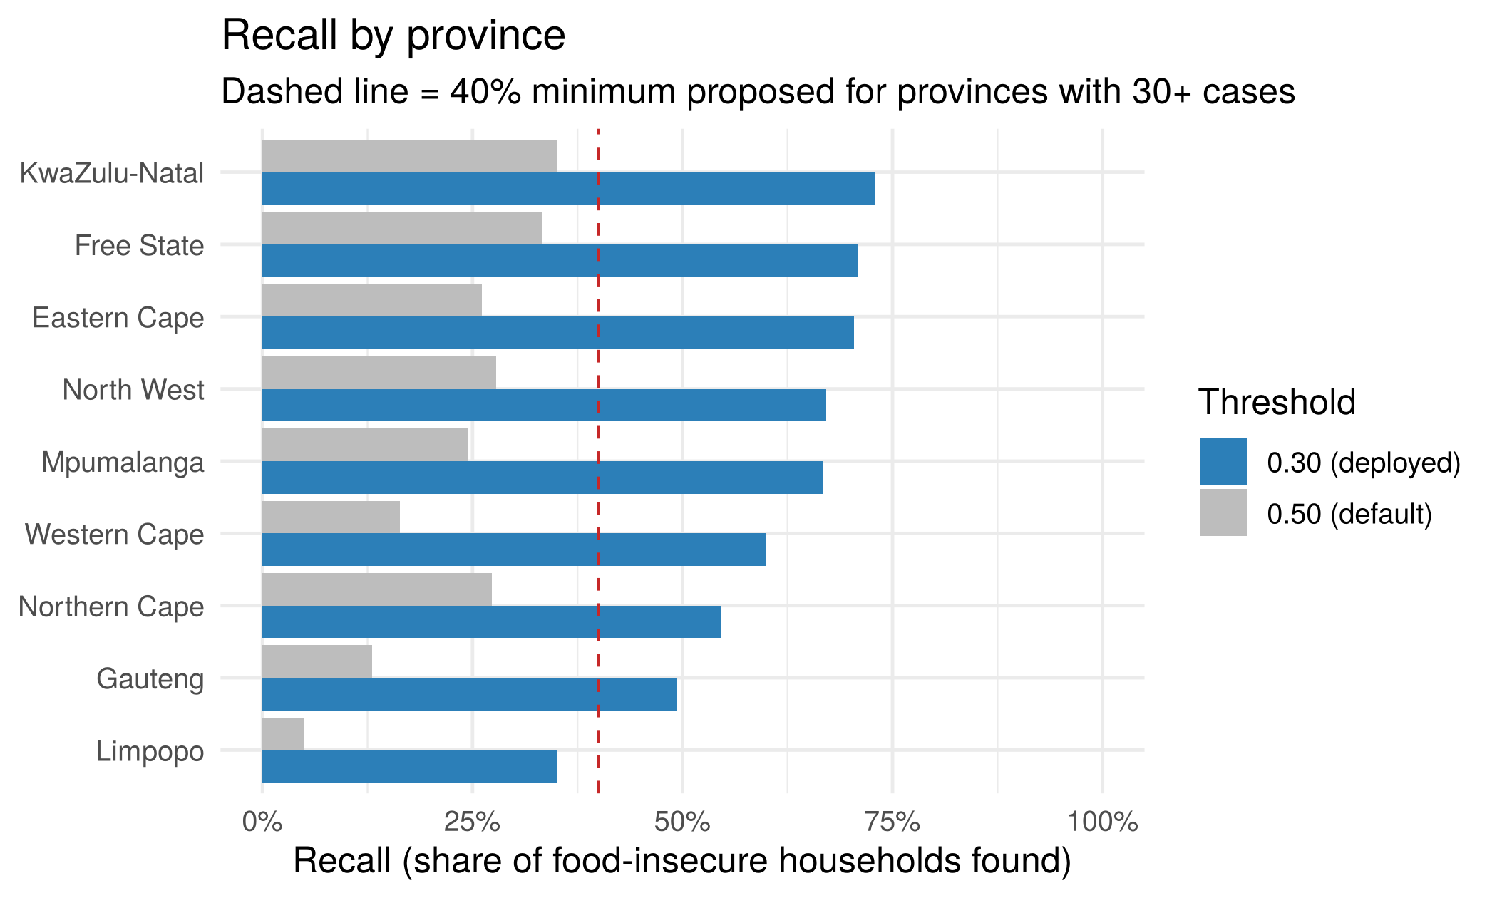
Recall by province at the default (0.50) and deployed (0.30) thresholds.
Fairness. Recall at 0.30 ranges from 73% in KwaZulu-Natal down to 49% in Gauteng and 35% in Limpopo, where there are only 20 food-insecure test households (interval about 18-57%) and the food-insecurity rate is around 4%. By sex of household head it's 60% against 67%, and by geography type 59% against 70%. Population groups 3 and 4 only have 1 and 4 food-insecure households, so we can't judge them at all. Lowering the threshold narrows the province gap we saw at 0.50 but doesn't close it, which is why the app carries a caveat and the monitoring plan tracks province recall.

5. What drives the predictions
Permutation importance puts income first (income per capita, household income and salary income), followed by dwelling quality (wall, roof and floor condition), province (the Limpopo indicator), household assets, expenditure band, perceived income and grant income. The built-in impurity measure ranks head age and mean household age 3rd and 4th, but they drop to 15th and 17th once we shuffle variables, because impurity importance tends to favour continuous variables. We went with the permutation ranking. This fits our Milestone 1 hypotheses and the logistic regression, but remember these are associations from one survey year. They don't tell us what would happen if a household's circumstances changed.
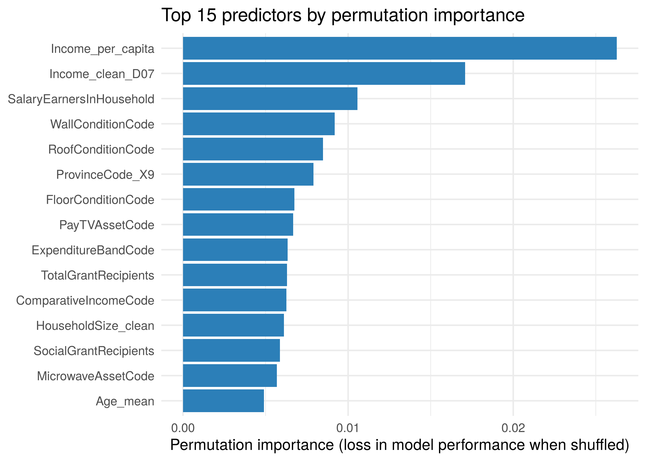
Top 15 predictors by permutation importance (final model, training data).

6. R/Shiny component and code quality
We tested the deployed app from start to finish and fixed what we found. A hard-coded Windows setwd() path at the top of app.R was a syntax error in R (\U isn't a valid escape) and would have crashed the app on every machine, so we removed it along with an automatic package install at start-up. We also added range checks to the validation function (an implausible value like a head of household aged 200 becomes missing and is reported), stopped skip-logic fields from triggering a false "predictions are less reliable" warning, and added a clear message when no file has been uploaded. preprocess.R now loads only the packages it needs. tests/test_deployment.R runs 12 automated checks covering score reproduction, the monitoring baselines, how validation copes with bad input, and all 13 app outputs, and they all pass. The app starts with shiny::runApp() and every tab renders.

7. Limitations and future work
. One survey year and one split. We don't know how it will perform in a future year, and the test figures carry some sampling uncertainty.
. Survey weights were not used. So results describe the sampled households, not weighted population totals.
. Skip-logic missingness is imputed. We'd like to test an explicit "not applicable" category.
. Uneven accuracy by province. Worth testing province-specific thresholds and getting more data for Limpopo and small population groups.
. Correlated income variables. Salary, grant and total income overlap, so don't read too much into the split of importance between them.
. Associations, not causes. The what-if tab holds the salary and grant columns at typical values, so it only illustrates how the model behaves.

Responsible AI usage log
Item | Entry
Tool | Claude (Anthropic), used as an assistant in October 2026.
Used for | Drafting the R Markdown analysis, supporting scripts and automated tests; recomputing test-set metrics, calibration, subgroup tables and confidence intervals; checking and fixing the Shiny app; and drafting this section.
Checked and decided by me | I (person 2) ran the train_model.R, knitted the Rmd and ran the tests on my own machine; that the figures match the group's results; the choices on threshold, imbalance handling and tuning grid were agreed with the group; and the text was edited into my own words and referenced.
Risks considered | Human error.  AI-written code and text may contain errors; the data-naming finding (Rand amounts in count-named columns) and all monitoring limits are proposals to be confirmed against the data dictionary and our group.

References
Protection of Personal Information Act 4 of 2013 (South Africa).
Statistics South Africa. General Household Survey. https://isibaloweb.statssa.gov.za/
Wirth, R. and Hipp, J. (2000) 'CRISP-DM: Towards a standard process model for data mining', Proceedings of the 4th International Conference on the Practical Applications of Knowledge Discovery and Data Mining, pp. 29-39.
Wright, M.N. and Ziegler, A. (2017) 'ranger: A fast implementation of random forests for high dimensional data in C++ and R', Journal of Statistical Software, 77(1), pp. 1-17.
Kuhn, M. and Wickham, H. (2020) Tidymodels: a collection of packages for modeling and machine learning using tidyverse principles. https://www.tidymodels.org

