Computational Neuroscience Coursework 3: [L and F/STDP](https://www.ole.bris.ac.uk/webapps/assignment/uploadAssignment?content_id=_4239253_1&course_id=_237240_1&group_id=&mode=view)

# Chanthru Uthaya-Shankar: 51722

## Part A: Integrate and Fire Neurons

Question 1:

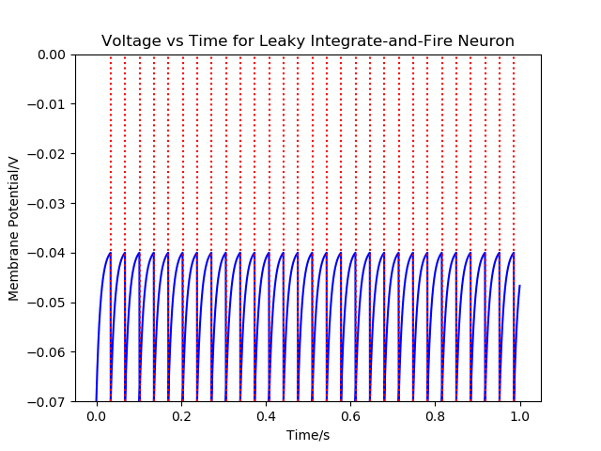

Figure 1

Question 2

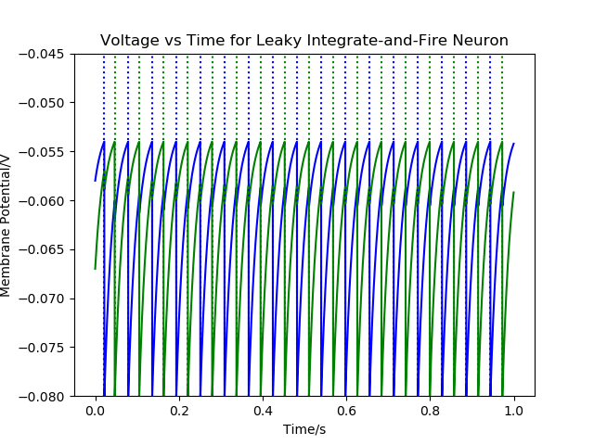

Figure 2

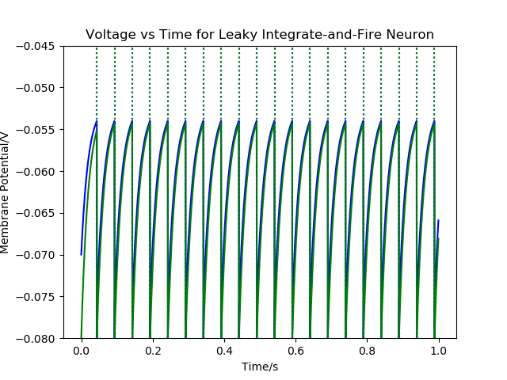

Figure 3

Figure 2 shows when Es is set to -80mV and Figure 3 shows when Es is set to 0mV. When Es is set to -80mV both neurons fire in an out of sync fashion, where as when Es is set to 0mV the 2 neurones firing times almost immediately sync up firing patterns. The Sync up is due to the neuron being excitatory so when one neuron fires the current in the other increases, eventually this continual pattern results in the 2 neurons firing patterns to sync up. Whereas when they fire out of sync the neurons are the de- excitatory when one neuron fires the current in the other decreases eventually causing the 2 neurons to fire out of sync.

## Part B: STDP

Question 1

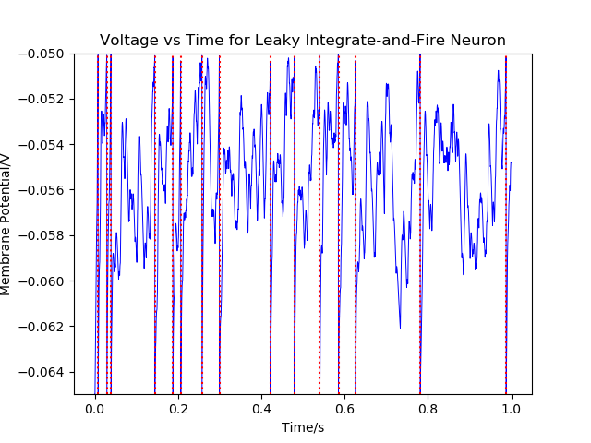

Figure 4

Question 2

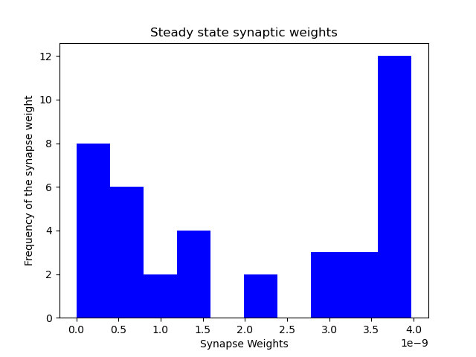

Figure 5

The synaptic strength distribution converges towards a Beta-distribution

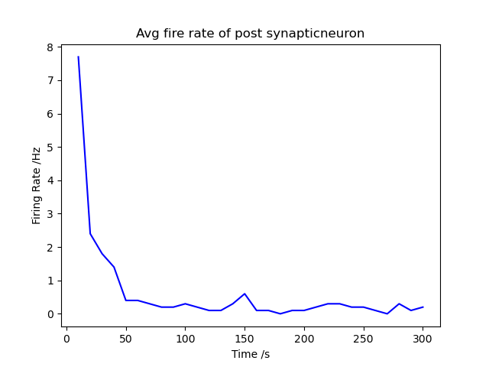

Figure 6 – STDP: On

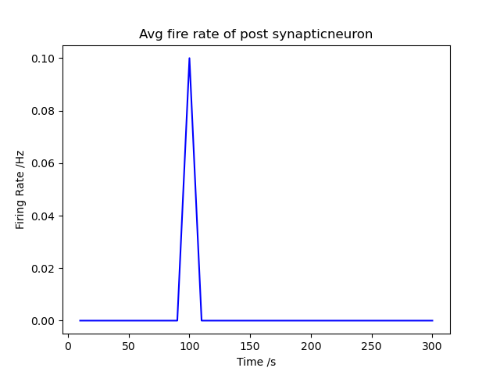

Figure 7- STDP: Off

The steady state firing average over the last 30s: STDP on 0.1Hz, STDP off 0Hz.

Question 3

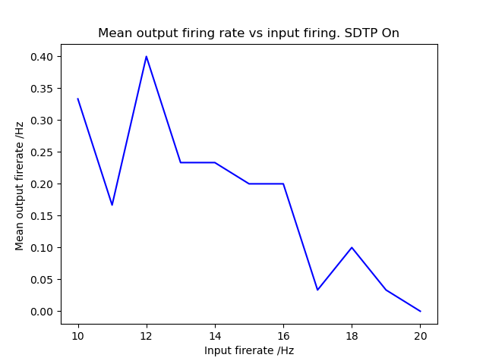

Figure 8

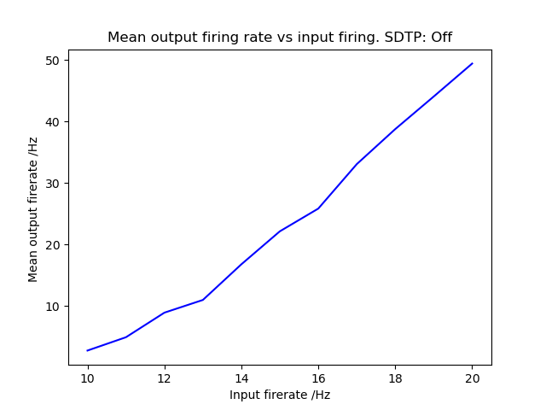

Figure 9

As you can see by figure 8 when STDP is on as the input fire rate is increased the general trend is that the mean output fire rate decreases. Where as in the case when STDP is Off in Figure 9 as the input rate increases so does the mean output fire rate.

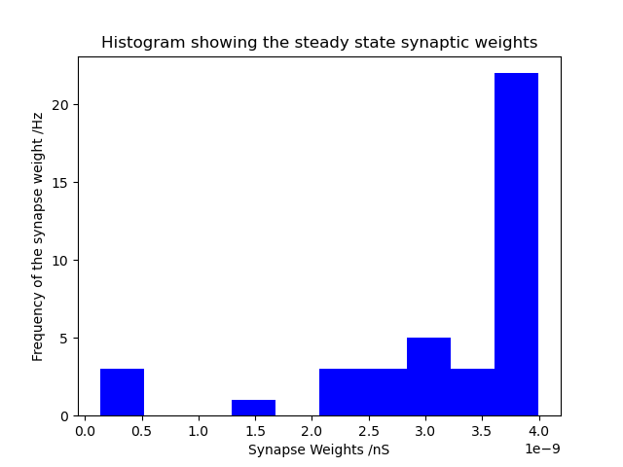

Figure 11 – Steady state synaptic weights when r = 10

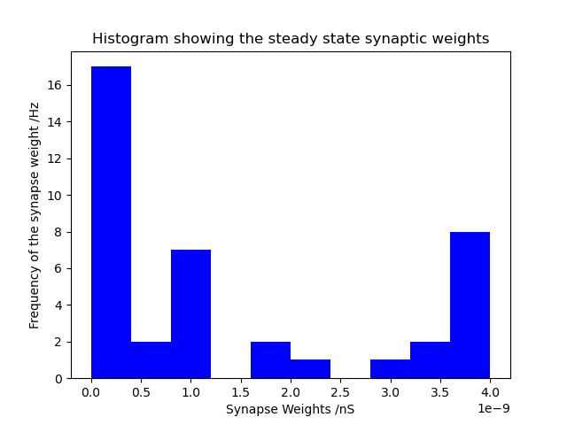

Figure 12 – Steady state synaptic weights when r = 20

Whether out of the synapses that is connected fires depends on a random value between r*timestep, when r is 10 compared to 20 this value of r*timestep is a lot lower meaning synapses have a greater probability of firing. This means they will fire more often and the synapse will be strengthened more resulting in a larger frequency in higher strength synapse weights. Where as when r is smaller r*timestep is larger so synapse will fire with a lower probability. Synapses fire less often causing strengths to be smaller resulting in the distribution shown in Figure 12. Comparing the graphs of when r is 10 and 20 it is clear to see that the average weightings are much higher when r is 10.

Question 4

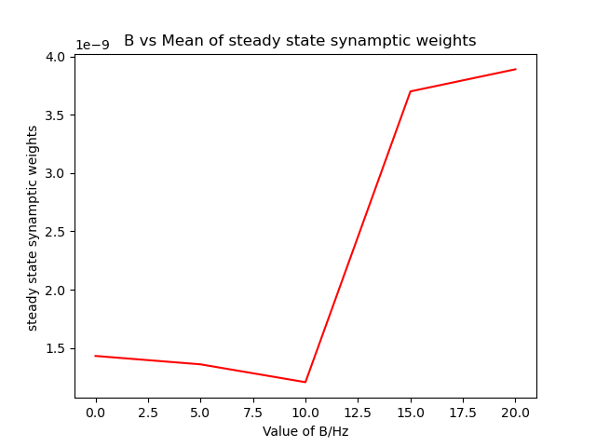

Figure 13- Degree of correlation vs Mean of synaptic weights

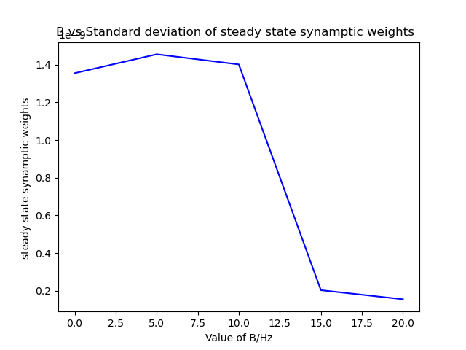

Figure 14 – Degree of correlation vs Standard Deviation of synaptic weights

The graphs above show that as the degree of correlation increases the mean of the synaptic weights increases, this shown by the upward trend shown in figure 13, and the standard deviation of the weights decreases shown by the downward trend. Overall, this shows that as the degree of correlation increases the synaptic weights get stronger and closer together.

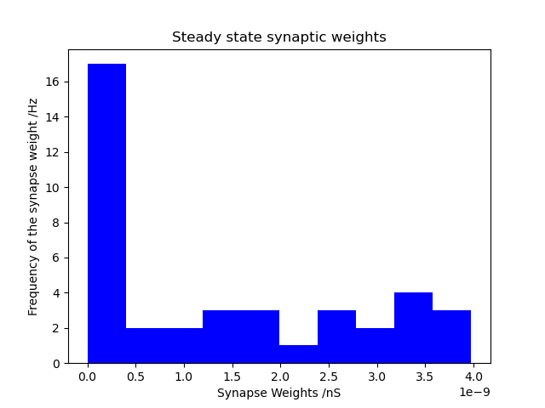

Figure 15 – B = 0

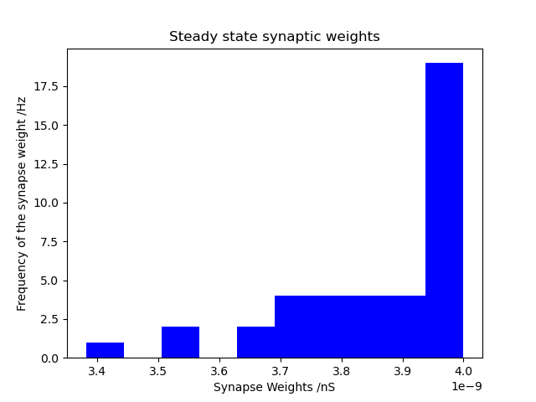

Figure 16 – B = 20

The value of r now varies as a sinusoidal wave dependant on the value of t. This means that the value of r increases and decreases in a sinusoidal pattern. The value of B then determines the amplitude of this sine wave, the max value as well as the min value. As the value of B increases the minimum value of r also decreases. The min value is largest at B = 0 and smallest at B = 20 in both cases as t goes to infinity the average is the same, it is r0. This means that the Smaller minimum value of r when B is 20 causes a high rate of fire which in turn means synapse strengthen more, resulting in a higher frequency of synapse strengths towards the larger values.