Step 1: Setting Up the Project Directory:
Created the main project directory named DockerIntegration, which contains three subfolders for each team member: Rohit, Dilpreet, and Jaskaran. Each folder includes a Dockerfile and a requirements.txt file to manage dependencies for the respective applications.
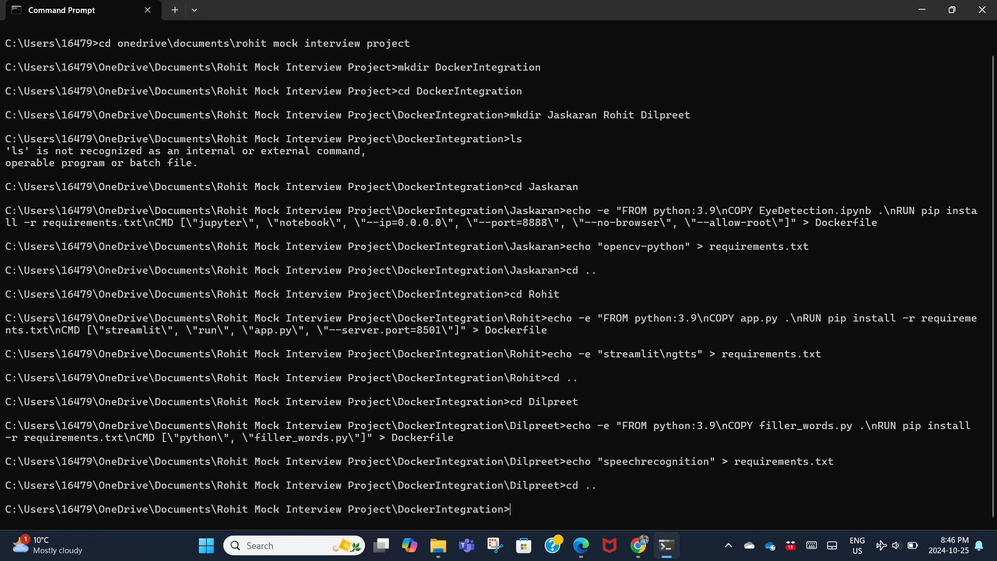

Step 2: Configuring Dockerfiles and Cloning GitHub Repositories
Dockerfiles in each subfolder are configured to set up the environment, clone the GitHub repository, and download specific application files.
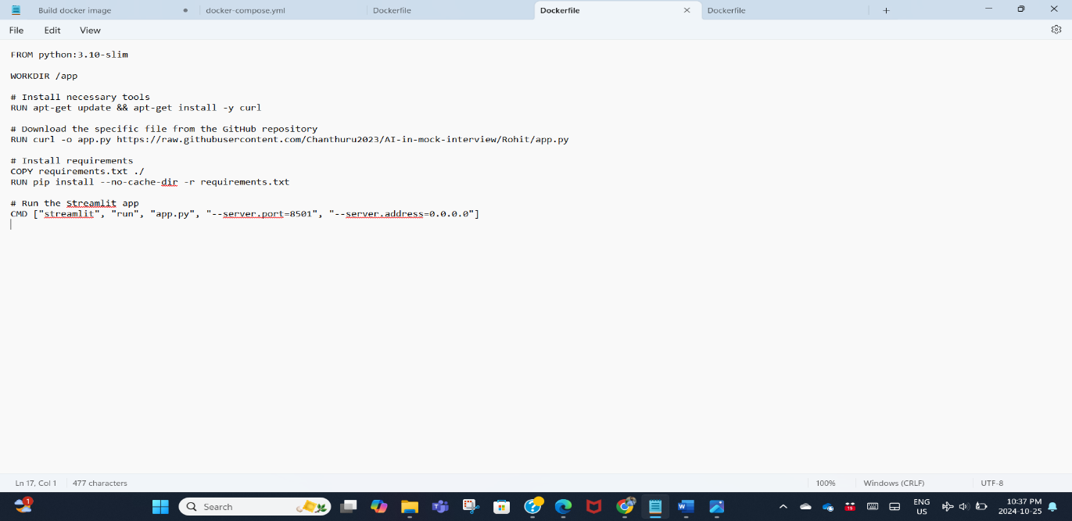
Step 3: Building Containers with Docker Compose
The docker-compose build command was executed to build all three containers, each configured with the respective application files cloned from the GitHub repository.
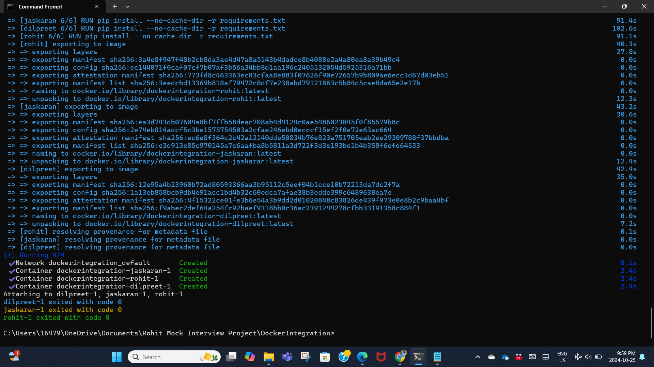

Step 4: Accessing the Applications
Upon running the containers, Docker Compose provided the URLs for accessing each application from the respective Git branches.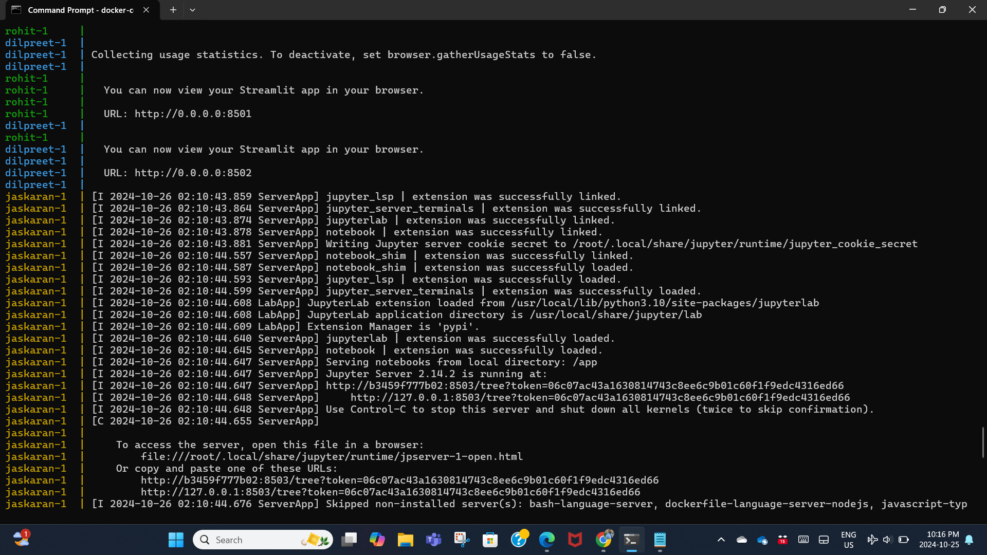
Step 5: Viewing Docker Images and Containers
The created Docker images and containers can be accessed through the Docker application, providing a visual overview of the setup. This allows for easy management and monitoring of the deployed applications.
