**Arrays**

**Introduction**

* Array is a data structure which stores the data items of the same data type.
* Array stores all the data items in continuous memory locations.

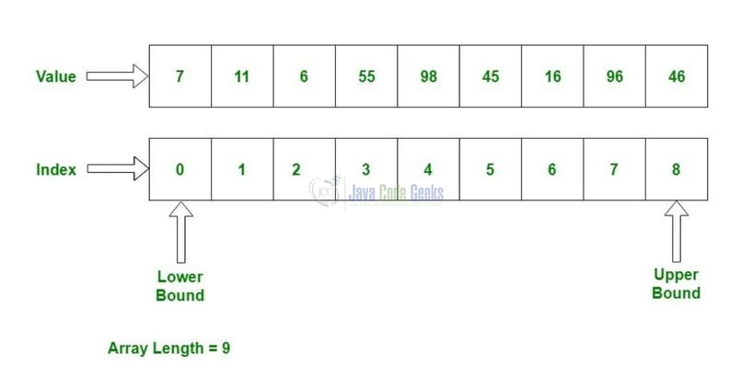

**Defining Arrays**

* To define a array, we need to specify the type of data elements , name and the number of elements (size).

int c[8]

* The above definition reserves 8 elements for integer array c.
* Array name, like other variables can contain only letters, digits and underscore and cannot begin with a digit.

**Using Arrays**

* To refer to a particular location or element in the array, we need to specify array’s name followed by the position number (index, subscript) of the particular element in square brackets.
* First element in the array is the zeroth element. Last element is size – 1.

c[0], c[1], c[2],c[3]..............c[7]

* Print the first element in the array.

printf(“%d”, c[0]);

* Print the sum of first three elements in the array.

printf(“%d”, c[0] + c[1] + c[2]);

* Add 2 to the fifth element

c[4] += 2;

**Defining and initializing an array**

//initializing the elements of an array to zeros # include <stdio.h>

int main(void)

{

int n[ 5 ]; // n is an array of 5 integers int i; // counter

//initialize elements of array n to 0 for( i = 0; i < 5; ++i)

n[ i ] = 0;

printf(“%s%13s\n”, “Element”, “ Value”);

//output contents of array n in a tabular format

for( i = 0; i < 5; ++i)

printf(“%7d %13d\n”, i , n[ i ]);

return 0;

}

**Initializing array using an initializer list**

/*initializing the elements of an array using an initializer list */

# include <stdio.h>

int main(void)

{

int n[5] = {5, 12, 34, 56, 23};

int i;

printf(“%s%13s\n”, “Element”, “ Value”);

//output contents of array n in a tabular format

for( i = 0; i < 5; ++i)

printf(“%7d %13d\n”, i , n[ i ]);

return 0;

}

**Specifying an array’s size with a symbolic constant**

# include <stdio.h> # define SIZE 10

int main(void)

{

int a[ SIZE ];

int j; // counter

for( j = 0; j < SIZE; ++j)

a[ j ] = 2 + 2 * j;

printf(“%s%13s\n”, “Element”, “ Value”); for( j = 0; j < SIZE; ++j)

printf(“%7d %13d\n”, j , a[ j ]);

}

**Summing the Elements of an Array**

# include <stdio.h> # define SIZE 12 int main(void)

{

int a[ SIZE ] ; int i;

int total = 0; // sum of array

for( i = 0; i < SIZE; ++i)

{

printf(“\na[ i ] = “);

scanf(“%d”, &a[ i ]);

}

for( j = 0; j < SIZE; ++j)

total += a[ j ];

printf(“Total of array elements is %d \n”, total);

}

**Storing *strings* in character arrays**

* A string can be stored in a character array as follows:

Char string1 [ ] = “first”;

Char string1 [ ] = {‘f’, ‘i’, ‘r’, ’s’, ’t’, ‘\0’};

scanf( “%19s”, string1);

* Function scanf will read characters until space, tab, newline or end-of-file indicator is encountered.

**Display character strings**

* A character array representing a string can be printed as follows:

printf(“string1 is : %s\n”, string1);

for ( i= 0; i < SIZE && string1 [ i ] != ‘\0’; ++i){

printf(“%c”, string1[ i ]);

}

**Function strcpy**

* strcpy copy the entire string in array x into y

# include < stdio.h> # include <string.h> # define SIZE1 25 int main ( void )

{

char x[ ]= “Happy Birthday to You”;

char y[ SIZE1];

strcpy( y , x );

printf(“The string in array y is : %s\n”, y);

return 0;

}

Output

The string in array y is : Happy Birthday to You

**Function strlen**

* strlen takes a string as an argument and return the number of characters in the string.

# include < stdio.h>

# include <string.h>

int main ( void )

{

char string1[ ]= “I love C programming”;

printf(“The length of string1 is %d”,

strlen(string1));

return 0;

}

Output

The length of string1 is 20

**Passing Arrays to Functions**

# include <stdio.h>

# define SIZE 5

void modifyArray( int b[ ], int size);

int main(void)

{

int a[ SIZE ] = {0, 1, 2, 3, 4};

int i; // counter

//output original array for( i = 0; i < SIZE; ++i)

printf(“%3d”, a[ i ]);

puts(“ “); modifyArray( a , SIZE);

// output modified array

for( i = 0; i < SIZE; ++i)

printf(“%3d ”, a[i ]);

}

Output

Original Array : 0 1 2 3 4

Modified Array : 0 2 4 6 8

**Multidimensional Arrays**

* C language have arrays with multiple subscripts.
* These arrays are refers to as multidimensional arrays.
* Multidimensional arrays are used to represent table of values consisting of information arranged in rows and columns.
* A array with two subscripts is called **double-subscripted or Two-Dimensional**

array.

**Two-Dimensional Array**

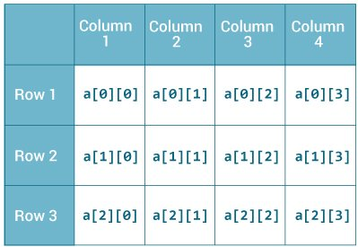

**Summing the Elements of a 2D Array**

# include <stdio.h> # define SIZE 12 int main(void)

{

int row. column; int a[ 2][3];

int total = 0;

for( row = 0; row < =1; ++row){

for( column = 0; column <= 2; ++ column)

{

printf(“\na[ row][column ] = “, row, column); scanf(“%d”, &a[ row ][column ]);

}

for( row = 0; row < =1; ++row)

for( column = 0; column <= 2; ++ column) total += a [row] [column];

pritntf(“The total of the elements of the array : %d”, total); return 0;

}