Physics Division -- Fast Electronics Group

Description and Instructions
For the
FADC Pulse Compression

July 2018

Hai Dong

Introduction
This document specifies the pulse compression for FLASH250 firmware. In addition to implement the pulse compression algorithm as described in FADC Compression Algorithm document by Gaggik Gavalianit also manages other functions such as either passing Event Header Data or suppressing Pulses Parameter Data. The data output format will be slightly different than the document description to accommodate the header and ADC channel information to.

- Pulse Compressing Algorithm
  - Description
The algorithm takes in N (in multiple of 16) 12-bits samples of ADC, compresses in group of 16 samples, and write out results in 32 bits format to be transfer to the VME bus. The steps are as follow:
    - Find the minimum values of the pulses (Raw Data Word 2-N) Only bits 11-0 are used Min Value
    - Subtract the minimum value of the pulse from the sample Sub Values
    - Isolate lower 4 bits and upper 8 bits of Sub Values into two arrays.
    - Create an array of 32 bits words contain lower 4 bits Low Array
    - Create an array of 32-bits words contain non-zero upper 8 bits of Diff Value Up array
    - Write Min Value, Low Array, Up Array, the number of zero before 1st non-zero upper 8 bits, and the number of 32-bits word for Up array in the format shown below
    - RESTRICTION
      - Number of ADC Sample has to be in multiple of 16
      - In Mode “01” the Number of ADC Sample * Number of active ADC has to be less than or equaled to 1536.

  - Compressing Algorithm Output for FLASH250
Table 1 shows the data output of the compressing algorithm for FLASH250
Bits 35 to 32 of ADC Channel Header word , Low Array words, and High Array word(s) are 1111.

Table 1: Data Output Format 36-bits (BITS 35-32 ARE EITHER PASSED THROUGH or Zero)
Word Number | Function
0 | Event Header
1 | Trigger Time Word 1
2 | Trigger Time Word 2
3 | ADC Channel A Header (of 1st pulse)
4 | ADC Channel A Low Array #7-0. Low nibble is in bit 3-0.
5 | ADC Channel A Low Array #15-8.
6 | ADC Channel A Up Array #x-0. Low byte is in bit 7-0. If number of byte < 4, unused bytes are zero. x is the last byte
:
:
N/4 + 7 (N=number of non-zero 8-bits) | ADC Channel A Up array of last 4 byte (or byte). Unused bytes are zeroes
N/4 + 8 | ADC Channel A Header (of 2nd pulse if existed)
N/4 + 9 | ADC Channel A Low Array #7-0. Low nibble is in bit 3-0.
:
:
K = Depend on Number of Pulses in Channel A | ADC Channel B Header (of 1st pulse)
K +1 | ADC Channel B Low Array #7-0. Low nibble is in bit 3-0.
K + 2 | ADC Channel B Low Array #15-8.
K + 3 | ADC Channel B Up Array #x-0. Low byte is in bit 7-0. If number of byte < 4, unused bytes are zero. x is the last byte
:
:
N/4 + 6 + K | ADC Channel B Header (of 2nd pulse if existed)
:
:
Depend on number of channel having pulse and number of pulses in each channel | Last ADC Channel Up Array of last 4 bytes
Last Word | Event Trailer

  - ADC Channel X Header
Bits 35-32 => 1111
Bits 31 => 1 (beginning of compress data of group of 16 samples)
Bits 30-27 => 0101 (Compress Data)
Bits 26-23 => ADC Channel Number
Bit22 => ‘0’
Bit21 => Number of leading zero bytes in Up Array(bit 4)
Bit 20 => Minimum Value bit 12 (overflow)
Bits 19-8 => Minimum Value bits 11-0
Bits 7-4 => Number of leading zero bytes in Up Array(bits 3-0)
Bit 3 => ‘0’
Bits 2-0 => Number of 32-bits words in Up Array

- Example Showing Data Output of each stage of compression
The following example shows raw data from ADC channel 1 and ADC channel 16 and the outputs from each compression step. ADC channel 1 and 16 have the same data.
  - 32 Samples Inputs in HEX (1 long and no pulse) for both channel
      - Sample Number 12 13 14 15 16
    - 01D 02E 03F 050 061 00C 00D 00E 0A5 0B6 0C7 0D8 0E9 0FA 10B 00C
    - 00E 010 010 00C 00D 00E 00F 010 011 002 003 004 005 006 007 00C
  - Minimum Value =
    - 00C for 1st 16 samples
    - 002 for 2nd 16 samples
  - Subtract Min Value from sample in HEX
    - For 1st 16 samples
011 022 033 044 055 000 001 002 099 0AA 0BB 0CC 0DD 0EE 0FF 000
    - For ^{2nd} 16 samples
00C 00E 00E 00A 00B 00C 00D 00E 00F 000 001 002 003 004 005 00A
  - Low Array
    - For 1st 16 samples
21054321
0FEDCBA9
    - For 2nd 16 samples
EDCBAEEC
A543210F
  - Up Array
    - For 1st 16 samples
04030201
00000005
0C0B0A09
000F0E0D
    - For 2nd 16 samples
NONE
    - Number of leading zero and number of 32-bits words for Up Array
    - 1st 16 samples = 0 ; 4
    - 2nd 16 samples= 16 ; 0
  - Compression efficiency
    - Input = 16 Sample * 12 bits/sample = 192 bits
    - Over Head output:
      - Low Array = 64 bits
      - Min Value = 12 bits
      - Number Of leading Zero = 5 bits
      - Number Of Words in Up array 3
      - Total = 84 bits
    - 1st 16 samples
      - Up Array = 128
      - Total bits = 128 + 84 = 212
      - Efficiency = (1- 212/192) * 100 = -10.42 %
    - 2nd 16 samples
      - Up Array = 0 bits
      - Total bits = 84 bits
      - Efficiency = 56.25 %
    - Total Efficiency for Channel 1 = 45.85 %
    - Total Efficiency for Channel 16 = 45.85 %

  - 32-bits Data Output
    - Name Value
    - Event Header Pass through
    - Trigger Time #1 Pass through
    - Trigger Time #2 Pass through
    - Ch one header for 1st 16 samples FC0000C04
    - Ch one 1st 16 sample low array F21054321
    - Ch one 2nd 16 sample low array F0FEDCBA9
    - Ch one 1st 16 sample up array F04030201
    - Ch one 2nd 16 sample up array F00000005
    - Ch one 3rd 16 sample up array F0C0B0A09
    - Ch one 4th 16 sample up array F000F0E0D

    - Ch one header for 2nd 16 samples FC0200200
    - Ch one 2nd 16 sample low array FEDCBAEEC
    - Ch one 2nd 16 sample low array FA543210F

    - Ch 16 header for 1st 16 samples FC7800C04
    - Ch 16 1st 16 sample low array F21054321
    - Ch 16 2nd 16 sample low array F0FEDCBA9
    - Ch 16 1st 16 sample up array F04030201
    - Ch 16 2nd 16 sample up array F00000005
    - Ch 16 3rd 16 sample up array F0C0B0A09
    - Ch 16 4th 16 sample up array F000F0E0D

    - Ch 16 header for 2nd16 samples FC7A00200
    - Ch 16 2nd 16 sample low array FEDCBAEEC
    - Ch 16 2nd 16 sample low array FA543210F

    - Event Trailer 2E8000000

- Firmware Architecture
  - Top Level Firmware Architecture
Figure 1 shows the top level firmware architecture.
There are 3 Modes of operation:
- Mode = “00” Data In is Pass through to Data Out.
- Mode = “01” Data In is output to Data Out and is followed by Compress Data. In this mode, the number of active channel * number of ADC sample (PTW + 1) has to be less than 1537. This mode only run when PTW + 1 is multiple of 16
- Mode = “10” Only Compress Data is output to Data Out. This mode only run when PTW + 1 is multiple of 16
When DataValid is high DataIn is accepted.
When PTW + 1 (number of sample) is NOT a multiple of 16 and Mode != “00”, CE Error is high. PTW is the user programmable parameter.

Figure1 : Top Level Firmware Architecture
CA Fifo WrEn
CA Data
32
9
Mode
36
Compressing Architecture
Data
In
PTW
(Number of sample)
FIFO 36x1K
Data Out
0
1
Data Valid
CA Error
1
Fifo Empty
Busy
Fifo almost full

  - Compressing Architecture
Figure2 shows the Compressing Architecture (CA). The behavior of the CA depends on bits Comp Enable, PTW, and DataIn 35-27 as shown in Table 1 and Table 2.

Figure2 : Compressing Architecture
3
CA Error
PTW
(Number of sample)
9
Enable
36
Data
In
CA Data

Decode
Bit 35-27
Compressing Engine
0
1
CA Fifo WrEn
Mode

Table 2: Behavior of CA when Data Valid is 1
Mode | PTW | DataIn 31-27 | CA Error | CA Fifo WrEn | CA Data
00 | x | x | 0 | 1 | DataIn
01 | Not multiple of 16 | x | 1 | 1 | Only DataIn
01 | Multiple of 16 | See Table 3 | 0 | 1 for Datain to CA data  See Table 3 for compress data | DataIn. Compress Data
10 | Not multiple of 16 | x | 1 | 0 | No output
10 | Multiple of 16 | See Table 3 | 0 | See Table 3 | See Table 3

Table 3: Behavior of CA when Data Valid is 1, Mode is “10” and PTW is even
Data In 35-27 | CA Fifo WrEn | CA Data | Comment
0000 1 0010 | 1 | DataIn | Event Header
0000 1 0011 | 1 | DataIn | Trigger Time Word 1
0000 0 0000 | 1 | DataIn | Trigger Time Word 2 (only when immediately follow 1 0011
0000 1 0100 | 1 | DataIn | Window Raw Data Word 1. Contains (PTW+1) and channel number.
0000 0 0000 | 1 | Compress Engine | Window Raw Data Word 2 - N
0000 1 1001 | 0 | DataIn | Pulse Parameter Word 1
0000 1 1xxx | 0 | DataIn | Pulse Parameter Word 2(only when immediately follow 1 1001
0000 0 0000 | 0 | DataIn | Pulse Parameter Word 2 (only when follow 1 1001 by 1 word)
0010 1 1101 | 1 | DataIn | Event Trailer

C. Compressing Engine
The Compressing Engine executes the Pulse Compressing Algorithm as described in SECTION 2 above

D. Steps to input data into Firmware
- Select Mode
- = pass through;
- = pass through and follow by compress data
- = compressing data only
- Set PTW
- Wait until Busy and Fifo Almost Full are
- When Data Valid is one, DataIn will be acted upon. In other word Data Valid is used as Data strobe signal
- The first 3 words HAS to be header, trigger time 1, trigger time 2
- The last word has to be End of Event “2E8000000”

H. Steps to read data
- When Fifo Empty is low, read Data Out

Resource Utilization
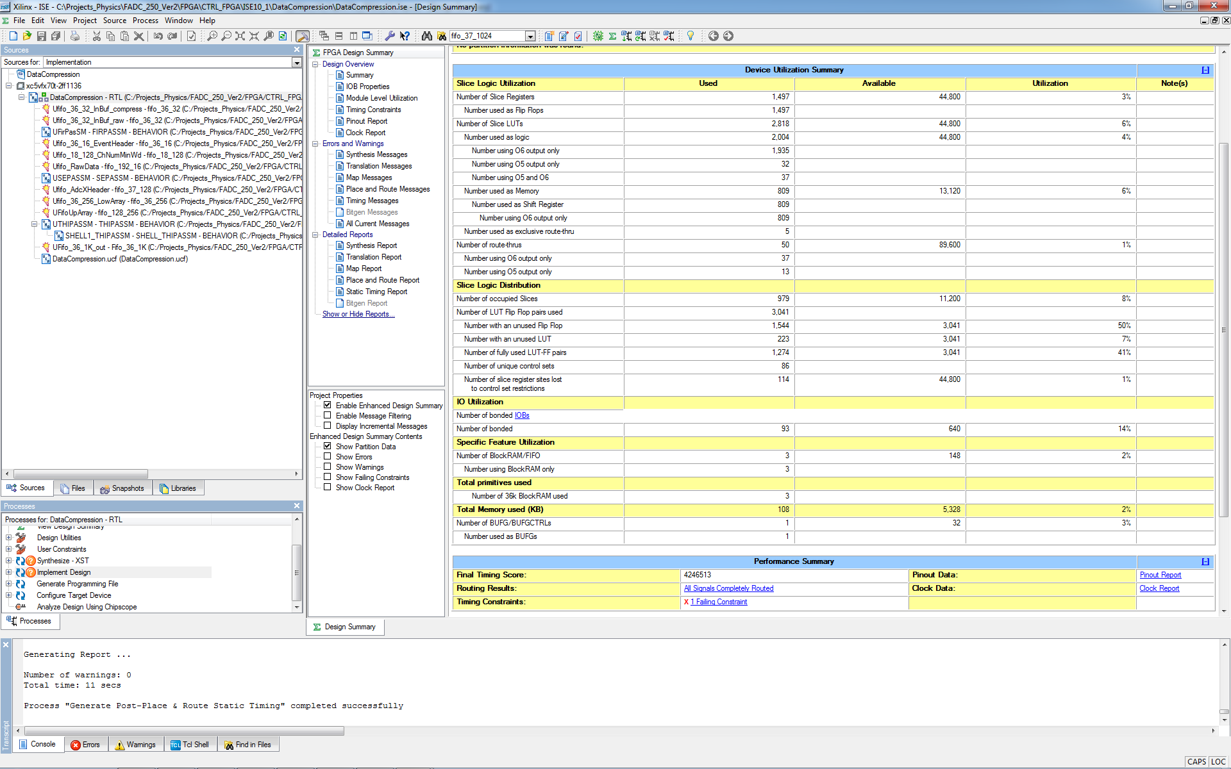
Max Clock
