**Matplotlib图表各个部分详解**

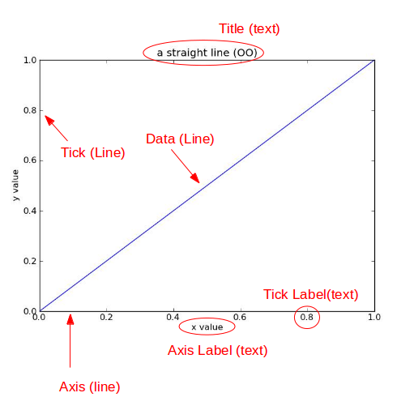

title为图像标题，Axis为坐标轴, Label为坐标轴标注，Tick为刻度线，Tick Label为刻度注释

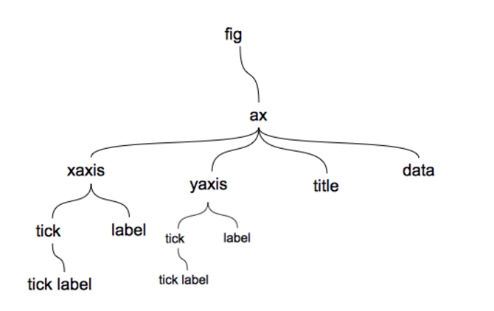

**可用颜色**

cnames = {

'aliceblue': '#F0F8FF',

'antiquewhite': '#FAEBD7',

'aqua': '#00FFFF',

'aquamarine': '#7FFFD4',

'azure': '#F0FFFF',

'beige': '#F5F5DC',

'bisque': '#FFE4C4',

'black': '#000000',

'blanchedalmond': '#FFEBCD',

'blue': '#0000FF',

'blueviolet': '#8A2BE2',

'brown': '#A52A2A',

'burlywood': '#DEB887',

'cadetblue': '#5F9EA0',

'chartreuse': '#7FFF00',

'chocolate': '#D2691E',

'coral': '#FF7F50',

'cornflowerblue': '#6495ED',

'cornsilk': '#FFF8DC',

'crimson': '#DC143C',

'cyan': '#00FFFF',

'darkblue': '#00008B',

'darkcyan': '#008B8B',

'darkgoldenrod': '#B8860B',

'darkgray': '#A9A9A9',

'darkgreen': '#006400',

'darkkhaki': '#BDB76B',

'darkmagenta': '#8B008B',

'darkolivegreen': '#556B2F',

'darkorange': '#FF8C00',

'darkorchid': '#9932CC',

'darkred': '#8B0000',

'darksalmon': '#E9967A',

'darkseagreen': '#8FBC8F',

'darkslateblue': '#483D8B',

'darkslategray': '#2F4F4F',

'darkturquoise': '#00CED1',

'darkviolet': '#9400D3',

'deeppink': '#FF1493',

'deepskyblue': '#00BFFF',

'dimgray': '#696969',

'dodgerblue': '#1E90FF',

'firebrick': '#B22222',

'floralwhite': '#FFFAF0',

'forestgreen': '#228B22',

'fuchsia': '#FF00FF',

'gainsboro': '#DCDCDC',

'ghostwhite': '#F8F8FF',

'gold': '#FFD700',

'goldenrod': '#DAA520',

'gray': '#808080',

'green': '#008000',

'greenyellow': '#ADFF2F',

'honeydew': '#F0FFF0',

'hotpink': '#FF69B4',

'indianred': '#CD5C5C',

'indigo': '#4B0082',

'ivory': '#FFFFF0',

'khaki': '#F0E68C',

'lavender': '#E6E6FA',

'lavenderblush': '#FFF0F5',

'lawngreen': '#7CFC00',

'lemonchiffon': '#FFFACD',

'lightblue': '#ADD8E6',

'lightcoral': '#F08080',

'lightcyan': '#E0FFFF',

'lightgoldenrodyellow': '#FAFAD2',

'lightgreen': '#90EE90',

'lightgray': '#D3D3D3',

'lightpink': '#FFB6C1',

'lightsalmon': '#FFA07A',

'lightseagreen': '#20B2AA',

'lightskyblue': '#87CEFA',

'lightslategray': '#778899',

'lightsteelblue': '#B0C4DE',

'lightyellow': '#FFFFE0',

'lime': '#00FF00',

'limegreen': '#32CD32',

'linen': '#FAF0E6',

'magenta': '#FF00FF',

'maroon': '#800000',

'mediumaquamarine': '#66CDAA',

'mediumblue': '#0000CD',

'mediumorchid': '#BA55D3',

'mediumpurple': '#9370DB',

'mediumseagreen': '#3CB371',

'mediumslateblue': '#7B68EE',

'mediumspringgreen': '#00FA9A',

'mediumturquoise': '#48D1CC',

'mediumvioletred': '#C71585',

'midnightblue': '#191970',

'mintcream': '#F5FFFA',

'mistyrose': '#FFE4E1',

'moccasin': '#FFE4B5',

'navajowhite': '#FFDEAD',

'navy': '#000080',

'oldlace': '#FDF5E6',

'olive': '#808000',

'olivedrab': '#6B8E23',

'orange': '#FFA500',

'orangered': '#FF4500',

'orchid': '#DA70D6',

'palegoldenrod': '#EEE8AA',

'palegreen': '#98FB98',

'paleturquoise': '#AFEEEE',

'palevioletred': '#DB7093',

'papayawhip': '#FFEFD5',

'peachpuff': '#FFDAB9',

'peru': '#CD853F',

'pink': '#FFC0CB',

'plum': '#DDA0DD',

'powderblue': '#B0E0E6',

'purple': '#800080',

'red': '#FF0000',

'rosybrown': '#BC8F8F',

'royalblue': '#4169E1',

'saddlebrown': '#8B4513',

'salmon': '#FA8072',

'sandybrown': '#FAA460',

'seagreen': '#2E8B57',

'seashell': '#FFF5EE',

'sienna': '#A0522D',

'silver': '#C0C0C0',

'skyblue': '#87CEEB',

'slateblue': '#6A5ACD',

'slategray': '#708090',

'snow': '#FFFAFA',

'springgreen': '#00FF7F',

'steelblue': '#4682B4',

'tan': '#D2B48C',

'teal': '#008080',

'thistle': '#D8BFD8',

'tomato': '#FF6347',

'turquoise': '#40E0D0',

'violet': '#EE82EE',

'wheat': '#F5DEB3',

'white': '#FFFFFF',

'whitesmoke': '#F5F5F5',

'yellow': '#FFFF00',

'yellowgreen': '#9ACD32'}

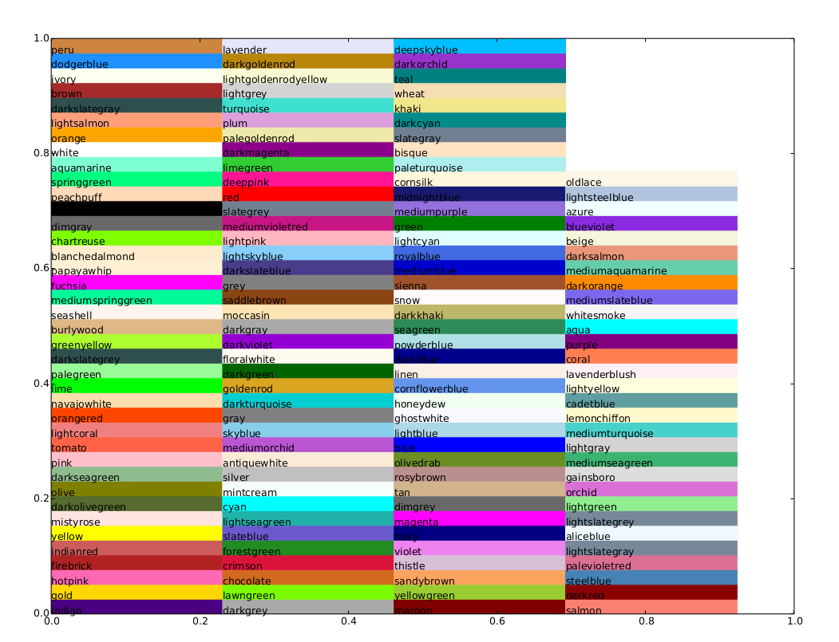

**可也直接输入英文**

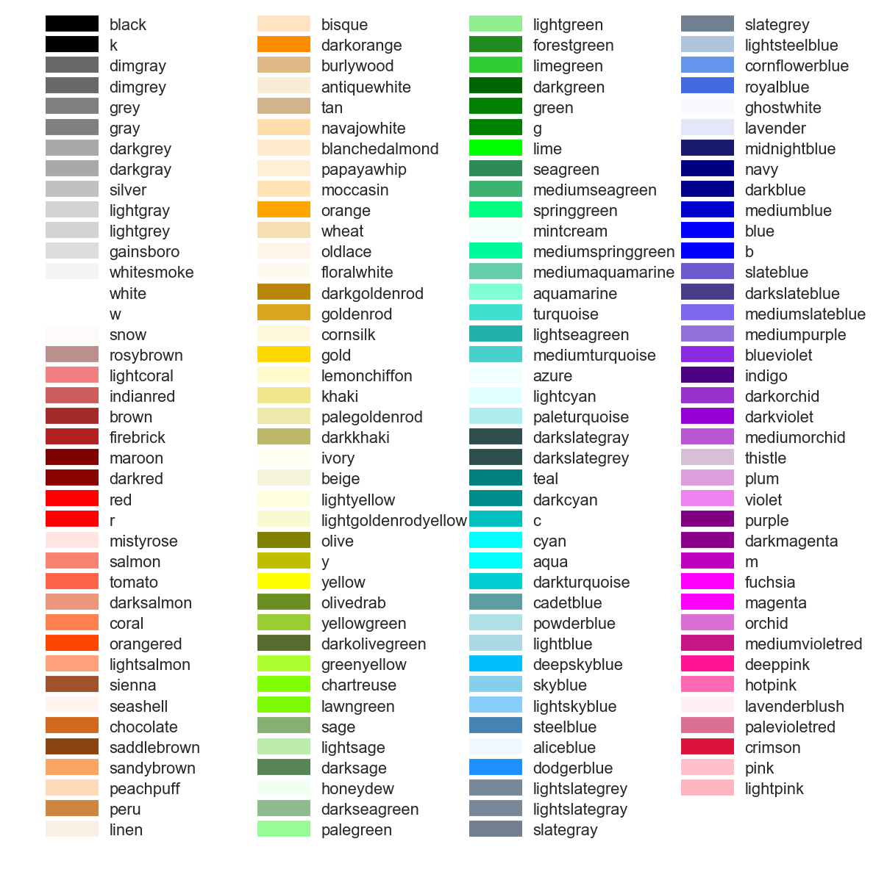

颜色板: <https://matplotlib.org/examples/color/colormaps_reference.html>

