**VIETNAM NATIONAL UNIVERSITY – HO CHI MINH CITY INTERNATIONAL UNIVERSITY  
SCHOOL OF COMPUTER SCIENCE AND ENGINEERING**



Semester 1 (2024-2025)

**ARTIFICIAL INTELLIGENCE**

IT097IU

**FINAL REPORT**

**TRAFFIC DENSITY DETECTION**

|  |  |  |
| --- | --- | --- |
| No. | Full name | ID |
| 1 | Trần Thế Phong | ITCSIU21215 |
| 2 | Đỗ Gia Thụy | ITCSIU21237 |
| 3 | Nguyễn Bình Phương Huy | ITCSIU21189 |

Instructor: Assoc. Prof. Nguyen Trung Ki

Table of Contents

1. Introduction 3

1.1 Overview of the System 3

1.2 Problem Statement 4

2. Related Work 4

2.1 Existing work and solution 4

3. Methodology 6

3.1 Proposed Method 6

3.2 Data and tools 6

3.3 System architecture 7

3.4 Challenges and Assumptions 7

4. Results and Evaluation 8

4.1 Implementation and demo 8

5. Evaluation and Conclusion 16

5.1 Evaluation the System: Accuracy of 81.25% 16

5.2 Conclusion 16

Table of Figures

Figure 1: Install Kaggle 9

Figure 2: Upload dataset 9

Figure 3: Data Loading and Processing 9

Figure 4: Define CNN model 10

Figure 5: Set up early stopping if the accuracy is not improved. 11

Figure 6: Prepare for training 11

Figure 7: Training loop 12

Figure 8: The results of training 13

Figure 9: Plot the result 14

Figure 10: Test model 15

Figure 11: Reload model 15

Figure 12: Run the model 16

Figure 13: The results 16

1. Introduction
   1. Overview of the System

Scope:

The scope of this project is focus on creating a Traffic jams detection system based on Convolutional Neural Network (CNNs). This system classifies status into different categories based on the sparseness of the road. The system is created to adjust the number of vehicles stably which avoid the “overload” status.

The scope of the project:

**Dataset Consideration:** The system will rely on the large dataset about traffic congestion. The dataset will cover all of types of traffic congestion in Kaggle.

**Technology platform:** The system is developed as a web-based platform. The primary technologies include Python, OpenCV, scikit-image, PyTorch, and matplotlib.

Objective:

The primary objectives of this project are:  
**Automated traffic congestion detection:** Develop an intelligence system which can automated detect traffic congestion to notice and adjust the number of vehicles which will go to the other roads in purpose reducing traffic congestion.

**High-performance model:** Utilize CNNs to build robust and high-performance traffic density detection models that can classify a large of traffic density.

**Accurate and Reliable Diagnosis:** Achieve high diagnostic accuracy to ensure that the system can be integrated in Maps-application to identify the status in a road. The system will provide confidence scores with predictions and make it easy to identify the density.

Solution

The proposed solution to the problem of traffic density detection is deep learning-based image classification system that leverages CNNs to process and classify images of traffic congestion. Components of solution:

Data Collection and Preprocessing:

We will use a publicly available dataset in Kaggle, traffic_dataset_v1 which contains tested and trained images.

The images will undergo preprocessing steps (standard size, normalization of pixel values) to optimize the robustness of the model.

Model Architecture:

A Convolutional Neural Network (CNN) will be used as the main of the classification system. We will use a pre-trained model which has been demonstrated to perform well on image classification tasks.

The model will have layers specifically to capture the status in the roads before analysis and identify the density.

Model Training and Evaluation:

The model will be trained on training set and evaluated using a test set of traffic density image.

* 1. Problem Statement

Problem Analysis:

The traffic condition is one of the most important problems in the world, especially in urban area. Every year, countries waste thousands of hours because of this problem. To solve the problem, this project is created to adjust number of vehicles, especially rush hour. The system will notice about the way which is having traffic jams, and the driver will receive that information to go to the low-density roads.

Key problems in Traffic Density Detection:

**Choosing the best but not suitable way:** Driver, they always choose the shortest road because they think it is the best way which spend time most. However, there are too many vehicles make the density increase and it will lead to traffic congestion.

**Density changes suddenly:** In some situations, the limited roads which is damaged or lockdown by some internal and external factors like festivals, limited roads or maintenance also causes density in a road decrease. If there is no notice before, it will lead to congestion.

1. Related Work
   1. Existing work and solution

Evaluation of the Application:

The Traffic Density Detection seeks to address the problems by automating the process of traffic density identification through IoT and machine learning. By providing the accurate and reliable dataset, this system can notice to driver timely and reduce the traffic congestion.

Application Evaluation:

Scalability: The system is scalable and can handle large datasets. The more images are provided, the more accuracy the system is. With a large data, it will provide enough cases, and make the system get the better knowledge.

Practical Impact: By offering an affordable and accessible solution, the system can significantly reduce wasted time for countries, ensuring that everyone who use it can get benefit. The driver can have more free time, and work effectively. Governments and companies also solve a dilemma.

Analysis and evaluation of the Tools and Techniques:

The heart of the traffic density detection system is computer vision and deep learning, specifically CNNs. This system has so many advantages like automatic feature extraction, highly accurate at image recognition and classification, weight sharing, minimizes computation, use same knowledge across all image locations, ability to handle large dataset and hierarchical learning.

Techniques:

The Convolutaional Neutral Networks (CNNs): used to classify density images into different categories. Their ability to automatically learn spatial hierarchies of features from images makes them ideal for task.

* These models have highly effective in tasks includes image recognition, so it makes ideal in this project.

Transfer Learning: In this system, training dataset is available divided from a large, general-purpose dataset. This approach reduces the amount of labeled data and speeds up the training process.

* This leads to classification can work with the low-cost and time required for training.

Tools:

Python: This programming language due to its widespread use in AI. It has a variety of library which help created system easily such as OpenCV, scikit-learn. Besides, it has simple and readable syntax, strong community support, platform independence, data analysis and visualization

* There are many advantages which can make completing project fast, effectively, and high accuracy

OpenCV: short for Open-Source Computer Vision Library, is an open-source computer vision and machine learning software library. Originally developed by Intel, it is now maintained by a community of developers under the OpenCV Foundation.

* OpenCV is a great computer vision library when it comes to regular computer vision tasks and image processing. Its main advantages are speed, multiple language support, and a variety of image-processing functions that it implements.

Scikit-learn: One of the main benefits of Scikit-learn is its simplicity and consistency. Scikit-learn follows a clear and uniform API that makes it easy to use and understand. You can apply the same methods and conventions to different types of models and data, such as fit, predict, transform and score.

* Scikit-learn is a fantastic tool for exploring, transforming and classifying data. But it is optimized for learning algorithms

Pytorch: PyTorch’s flexible and dynamic nature allows researchers to develop complex architectures.

* This framework maximizes both flexibility and performance for machine learning project. Embrace its dynamic computation graph, explore its native optimization library, and leverage GPU acceleration to build efficient and effective deep learning models.

1. Methodology
   1. Proposed Method

The methodology for developing the traffic density detection system involves designing a robust pipeline based on Convolutional Neural Networks (CNNs). The process includes data preparation, model design, training, and evaluation to ensure accurate and reliable detection of traffic congestion.

* 1. Data and tools

The system relies on a dataset obtained from Kaggle's "traffic-density-Singapore" collection. The dataset includes categorized images representing varying levels of traffic density, providing a foundation for training and evaluation.

**Data Preprocessing**:

Resize all images to a consistent size (128x128 pixels) to ensure uniformity across the dataset.

Normalize pixel values to scale them between -1 and 1, enhancing the training stability.

**Tools and Frameworks:**

Programming Language: Python.

Deep Learning Framework: PyTorch.

Libraries: OpenCV, matplotlib, and scikit-learn for preprocessing and visualization.

Apply data augmentation techniques, such as random horizontal flips, rotations, and crops, to improve model generalization and tackle dataset imbalances.

* 1. System architecture

The system uses a CNN-based architecture tailored for image classification tasks. Key components include:

* **Convolutional Layers**: Extract spatial features from images.
* **Batch Normalization**: Standardize intermediate outputs to stabilize and accelerate training.
* **Pooling Layers**: Down-sample feature maps and reduce computational complexity.
* **Fully Connected Layers**: Combine features for final classification.

This architecture is designed to efficiently classify traffic density into multiple categories.

* 1. Challenges and Assumptions

The project faces several challenges, including:

**Dataset Imbalance**: Traffic density categories may not be evenly distributed. To address this, oversampling of underrepresented classes and data augmentation are applied.

**Model Overfitting**: Implementing techniques such as dropout layers and early stopping ensures the model generalizes well to unseen data.

**Scalability**: The model must handle real-time traffic data efficiently. Future iterations will explore optimizations for inference speed.

1. Results and Evaluation
   1. Implementation and demo

Figure 1: Install Kaggle

Figure 2: Upload dataset

Figure 3: Data Loading and Processing

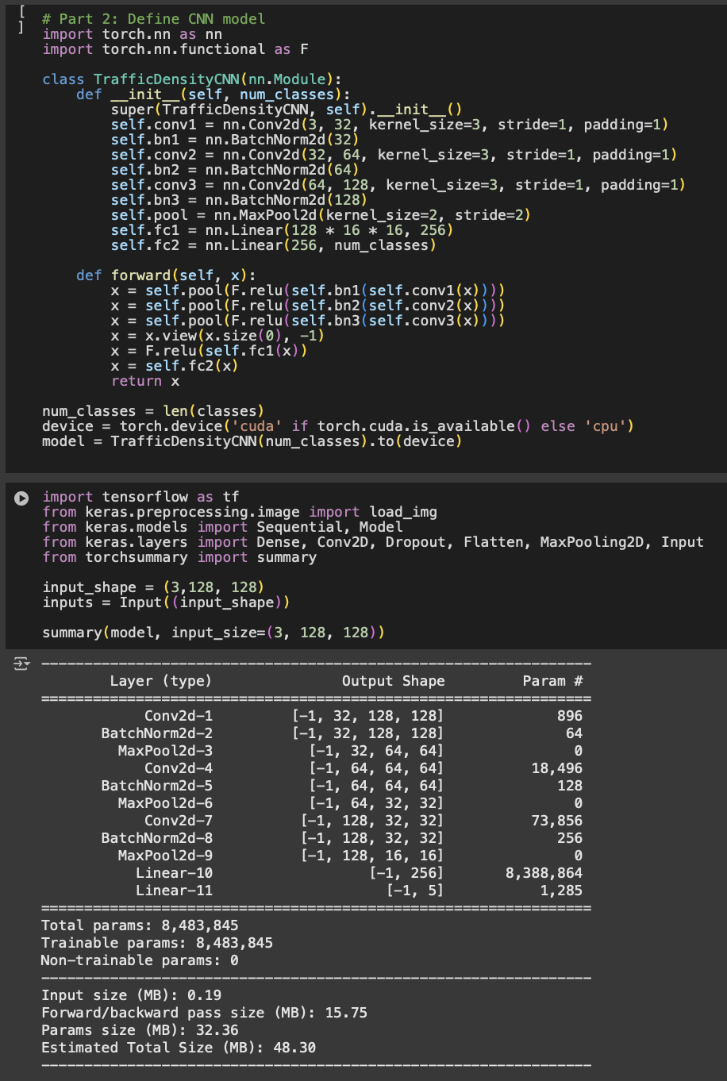

Figure 4: Define CNN model

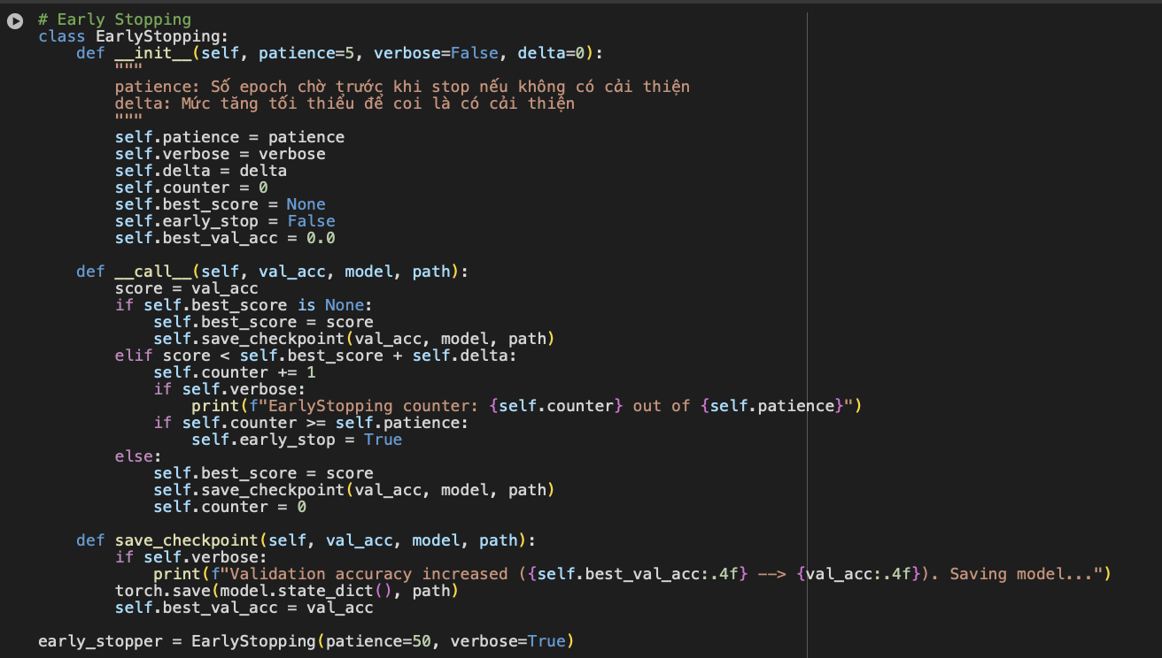

Figure 5: Set up early stopping if the accuracy is not improved.

Figure 6: Prepare for training

Figure 7: Training loop

Figure 8: The results of training

Figure 9: Plot the result

Figure 10: Test model

Figure 11: Reload model

Figure 12: Run the model

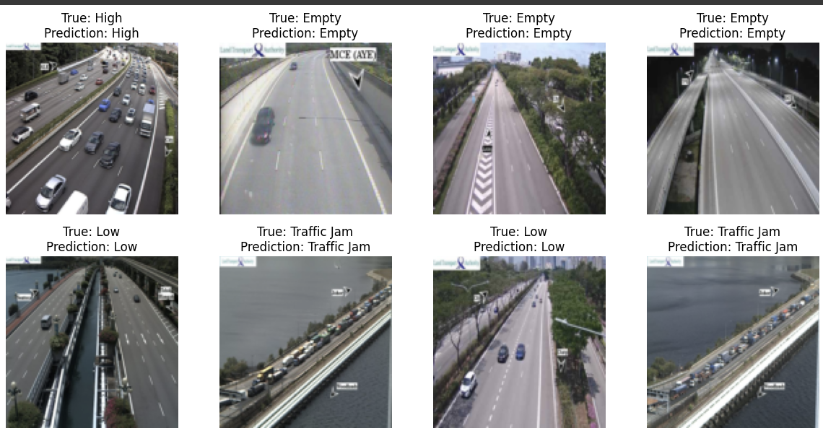

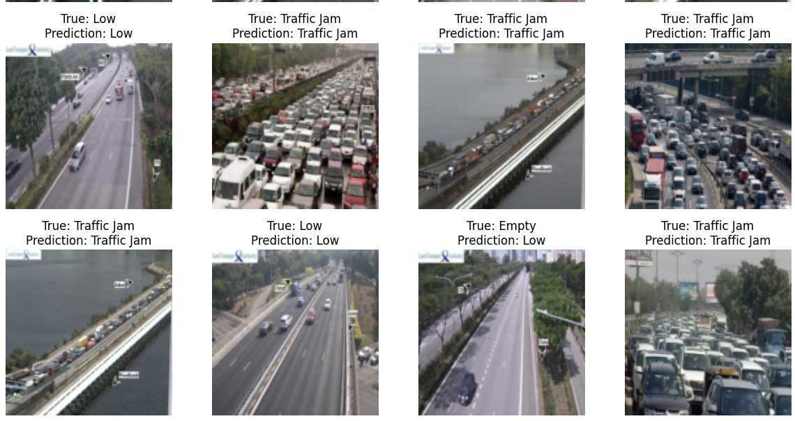

Figure 13: The results

1. Evaluation and Conclusion
   1. Evaluation the System: Accuracy of 81.25%

The accuracy of 81.25% indicates a moderate to string performance of the model on the given dataset. However, to reach the 90%, building or adjusting the models is the main method to improve the accuracy. Besides, the larger dataset is also necessary to get the higher result.

The Overview:

The Traffic Density Detection aims to detect the density in a road which will notice to driver to reduce congestion. The primary goal of this system is helping people can save their time and work effectively for companies and government.

Analysis the Model Performance

Accuracy: The model gets 81.25% accuracy on the test case. It shows that the models learn key features for density identification.

Generalization: Achieving 81.25% accuracy on the test case is indicative of good generalization to unseen data. The models have knowledge about density identification to give a good instroducion.

* 1. Conclusion

This achieved accuracy show that the model has a strong knowledge about traffic density, reflect both generalization and the effective use of training models. However, there are still some problems need to be improved:

Adjusting the models and use a better dataset to get the higher accuracy

Improve, apply and focus on precision, recall, and F1 score. Incorporating more diverse augmentation techniques and testing to ensure a robust relationship between theory and real-world problem.

Future work of this project is improving model performance, integrated with maps application, maintain the reliable and predict the suitable way for driver early.