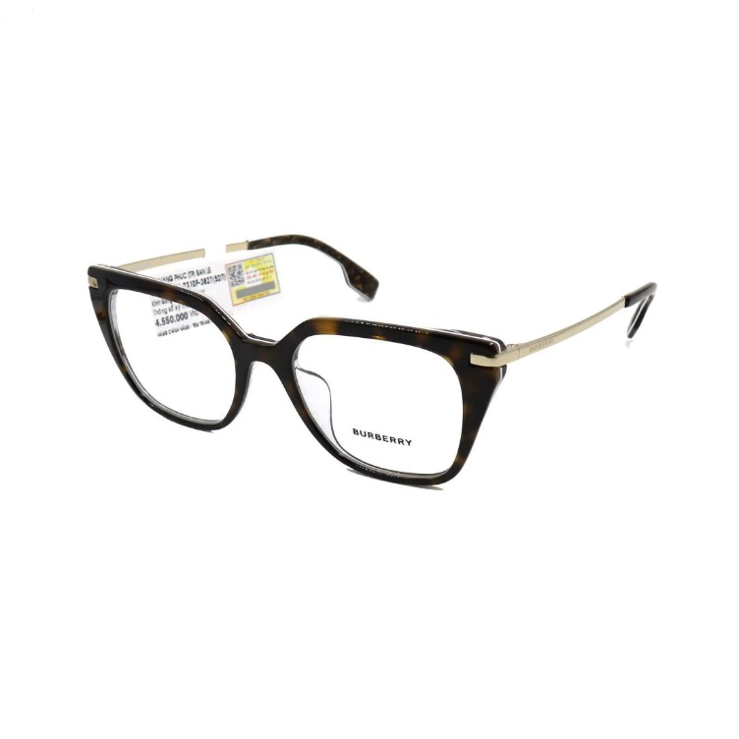
BBR_10
Price: 499$
Size: Medium
Material: Acetate, Plastic
Shape: Rectangle
Spring Hinges: No
Color: Tortoise
Eligible for Progressive / Bifocal: Yes
Gender: Men
Type: Full Frame

