# A **Tutorial**: Computing QNMs for a Silver Grating in Air

## 1. Introduction

In this document, we present how, with **QNMEig,** computing QNMs for a 1D Ag grating. Since we provide all details about implementing **QNMEig** with COMSOL Multiphysics in the document*''QNMEig_Sphere.pdf*", we do not repeat here the steps that are already documented in *''QNMEig_Sphere.pdf*" and we only give the essential details. This document should be read in conjugation with the COMSOL model sheet ***''QNMEig_1Dgrating.mph".*** This tutorial has been established in relation with Ref. [1].

## 2. Model Definition

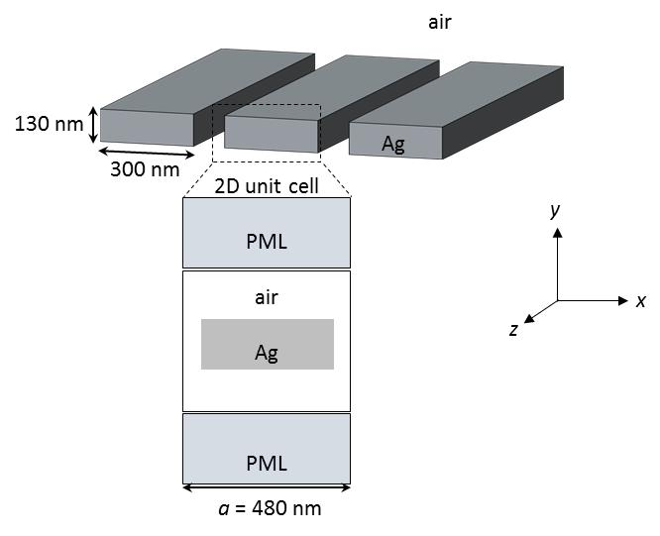

Figure 1. Geometry of a 1D Ag grating surrounded by air.

1 Ag has permittivity

$ε_{Ag}=ε_{∞,Ag}[1-\frac{ω_{p,Ag}^{2}}{ω^{2}-ω_{0,Ag}^{2}+iωγ_{Ag}} ]$, (1)

with $ε_{∞,Ag}=1$, $ω_{p,Ag}=1.35e16 [rad/s]$ corresponding to $λ_{p,Ag}=138$ nm in vacuum, $γ_{Ag}=0.0023ω_{p,Ag}$, and $ω_{0,Ag}=0$.

2 We compute TM-polarized Bloch modes, with electric fields only having *x, y* components that are in the same plane as the 2D unit cell in Fig. 1. The magnetic field is parallel to the slits. Owing to the periodicity in the *x* direction, see Fig. 1, the electric fields of the Bloch modes take the form

${\tilde{E}}_{k_{b}}\left(r\right)={\tilde{u}}_{k_{b}}\left(r\right)e^{-jk_{b}x}$, (2)

where $k_{b}∈[-π/a, π/a]$ is called the Bloch wavenumber, and it is a free parameter input by the user; ${\tilde{u}}_{k_{b}}\left(r\right)$ is a periodical function satisfying ${\tilde{u}}_{k_{b}}\left(r\right)={\tilde{u}}_{k_{b}}\left(r+a\right)$, where *a* is the grating periodicity.

## 3. Modelling Instructions

Open **COMSOL Multiphysics**. From its **File** menu, choose **New**.

### NEW

In the **New** window, click **Model** **Wizard**.

### MODEL WIZARD

1 In the **Model** **Wizard** window, click **2D**.

2 We choose two physics modules: 1/ **Radio Frequency-**>**Electromagnetic** **Waves**, **Frequency** **Domain (emw)**; 2/ **Mathematics-**>**PDE** **Interfaces**, **Weak** **Form** **PDE**, with dependent variables named ***P1x***, ***P1y***, defined by

$P1=-\frac{ω_{ p,Ag}^{2}}{ω^{2}-ω_{0,Ag}^{2}+iωγ_{Ag}}E$, (3)

in the Ag domain.

3 We choose the **Eigenfrequency** study.

### DEFINITIONS

All global parameters with their descriptions can be found in the COMSOL model sheet *''QNMEig_1Dgrating.mph*". Here, we only emphasize important parameter, $k_{b}$, the Bloch wavenumber, which is defined in Eq. (1) and is chosen to have a value *0.2*pi/a* (*a* denotes the grating periodicity)in the *''QNMEig_1Dgrating.mph*". This parameter is later used when imposing the periodic boundary condition for the grating.

### GEOMETRY

The geometry of the built 2D unit cell is given below.

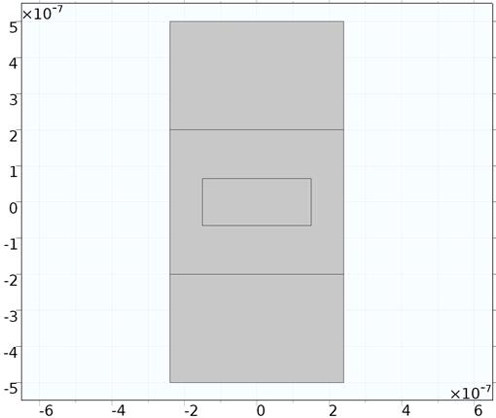

### MATERIALS

We set relative permittivity of Ag with its non-dispersive permittivity, $ε_{∞,Ag }$.

### DEFINITIONS (Local)

In the **Model Builder Window->Component 1->Definition**, we define/add the following things:

1 PMLs, chosen to be *Cartesian-type* PMLs.

2 Two sets of variables, {***DP1x, DP1y***} that relate with {***P1x***, ***P1y*** } defined in the Ag domain

DP1x=epsilon0_const*(emw.epsilonrxx*P1x+emw.epsilonrxy*P1y),

DP1y=epsilon0_const*(emw.epsilonryx*P1x+emw.epsilonryy*P1y) .

4 Two integration operators: **intAll,** integration over all domains including PML domains; **intMetal**, integration over the Ag domain.

5 One linear extrusion operator, **linext1**, which maps the fields, e.g., ***E***(*x,y*), to ***E***(*x,y*).

6 QNM normalization factor, **QN.** For a short description of the normalization of Bloch modes , we refer to Section 4 ''**Normalization of Bloch Modes"**.

### MESHES

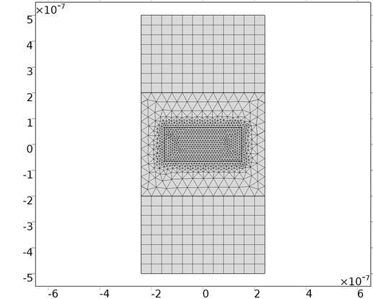

### ELECTROMAGNETIC WAVES, FREQUENCY DOMAIN (EWV)

1 We add one weak contribution in the Ag domain:

mu0_const*QNM_omega^2*(test(emw.Ex)*DP1x+test(emw.Ey)*DP1y) )*pml1.detInvT

2 We impose the **Floquet periodicity** condition for the left and right boundaries of the unit cell. We specify the Bloch-wavevector components[Kx Ky] as

|  |  |
| --- | --- |
| Kx | kb |
| Ky | 0 |

### WEAK FORM PDE FOR AUXILIARY FIELDS P1x, P1y

The input weak formulation is

1/lambda_N^2*((test(P1x)*P1x+test(P1y)*P1y)*(QNM_omega^2-j*gamma_Ag*QNM_omega-omega0_Ag^2)/omegap_Ag^2+(test(P1x)*emw.Ex+test(P1y)*emw.Ey))

### STUDY 1

We ask the eigensolver to compute 80 QNMs around $0.2×ω_{p,Ag}/(2π)$.

### RESULTS

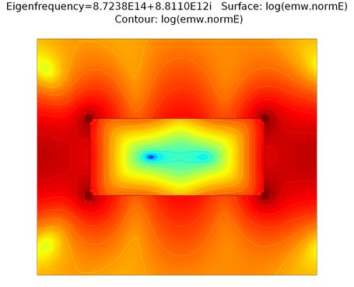

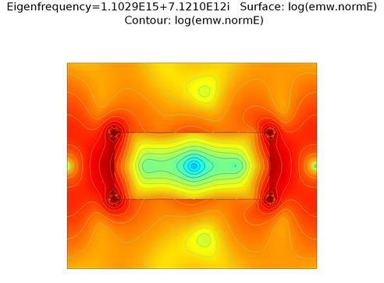

## 4. Normalization of Bloch Modes

The normalization of a Bloch mode ${\tilde{E}}_{k_{b}}$ involve another Bloch mode with the opposite Bloch wavenumber and the same eigenfrequency, ${\tilde{E}}_{{-k}_{b}}$. Specifically, the normalization factor *QN* (see subsection *''****DEFINITIONS (Local)"*** in "***Modelling Instructions"***) is

${QN=∬[\tilde{E}}_{k_{b}}⋅\frac{∂ωε(ω) }{∂ω}{\tilde{E}}_{{-k}_{b}}-{\tilde{H}}_{k_{b}}⋅\frac{∂ωμ(ω) }{∂ω}{\tilde{H}}_{{-k}_{b}}]d^{2}r$, (4)

which, for non-dispersive $μ$, could be simplified to

$QN={∬[2\tilde{E}}_{k_{b}}⋅\frac{∂ω^{2}ε(ω) }{∂ω^{2}}{\tilde{E}}_{{-k}_{b}}]d^{2}r$. (5)

For our Ag grating that has inversion symmetry in the *x* direction, ${\tilde{E}}_{k_{b}}$ and ${\tilde{E}}_{{-k}_{b}}$ are linked by a simple relation

${\tilde{E}}_{{-k}_{b,x}}\left(x,y\right)={-\tilde{E}}_{k_{b,x}}\left(-x,y\right), {\tilde{E}}_{{-k}_{b,y}}\left(x,y\right)={\tilde{E}}_{k_{b,y}}\left(-x,y\right),{\tilde{E}}_{{-k}_{b,z}}(x,y)={\tilde{E}}_{k_{b,z}}(-x,y)$, (6)

where the subscripts *'' $x$", '' $y$", " $z$"* specify the *x, y, z* components of the electric fields. Thus, knowing ${\tilde{E}}_{k_{b}}$, ${\tilde{E}}_{{-k}_{b}}$ is straightforwardly computed from Eq. (6). Technically, Eq. (6) is implemented by defining a linear extrusion operator, **linext1,** see subsection *''****DEFINITIONS (Local)"*** in "***Modelling Instructions"****;* that is ${\tilde{E}}_{{-k}_{b,x}}=-linext1({\tilde{E}}_{k_{b,x}})$**, ${\tilde{E}}_{{-k}_{b,y}}=linext1({\tilde{E}}_{k_{b,y}})$, ${\tilde{E}}_{{-k}_{b,z}}=linext1({\tilde{E}}_{k_{b,z}})$.**

## 5. References

[1] P. Lalanne, W. Yan, A. Gras, C. Sauvan, J.-P. Hugonin, M. Besbes, G. Demésy, M. D. Truong, B. Gralak, F. Zolla, A. Nicolet, F. Binkowski, L. Zschiedrich, S. Burger, J. Zimmerling, R. Remis, P. Urbach, H. T. Liu, and T. Weiss, "Quasinormal mode solvers for resonators with dispersive materials," J. Opt. Soc. Am. A **36**, 686-704 (2019).