# A **Tutorial**: Computing QNMs for a Silver Cube on a Gold Substrate

## 1. Introduction

In this document, we give all the details on how to compute the QNMs of a silver nanocube on a gold Substrate with **QNMEig** and COMSOL Multiphysics. The COMSOL mode sheet for this example is built from the model sheet of a simpler example, a silver sphere in air. In another document *''QNMEig_Sphere.pdf*", we provide all details on the implementation of the sphere case with **QNMEig** with COMSOL Multiphysics. So, in this document, we are not repeating the steps already documented in *''QNMEig_Sphere.pdf*", and we only present the essential elements.

This nanocube example is motivated by the work in G. M. Akselrod et al., *Probing the mechanisms of large Purcell enhancement in plasmonic nanoantennas,* Nat. Photonics 8, 835−840 (2014).

## 2. Model Definition

Figure 1 sketches the 2D cross section of the considered geometry.

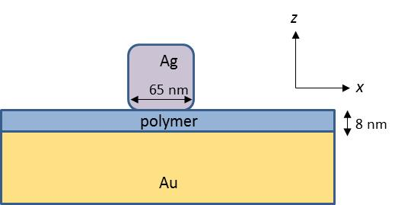

Figure 1. 2D cross section (x-z plane) for a silver cube sitting above a gold substrate.

1 The cube made of Ag has permittivity

$ε_{Ag}=ε_{∞,Ag}[1-\frac{ω_{p,Ag}^{2}}{ω^{2}-ω_{0,Ag}^{2}+iωγ_{Ag}} ]$, (1)

with $ε_{∞,Ag}=1$, $ω_{p,Ag}=1.35e16 [rad/s]$ corresponding to $λ_{p,Ag}=138$ nm in vacuum, $γ_{Ag}=0.0023ω_{p,Ag}$, and $ω_{0,Ag}=0$.

2 The Au substrate has permittivity

$ε_{Au }=ε_{∞,Au}[1-\frac{ω_{p,1,Au}^{2}}{ω^{2}-ω_{0,1,Au}^{2}+iωγ_{1,Au}}- \frac{ω_{p,2,Au}^{2}}{ω^{2}-ω_{0,2,Au}^{2}+iωγ_{2,Au}}]$, (2)

with $ε_{∞,Au}=6$, $ω_{p,1,Au}=5.37e15 [rad/s]$, $ω_{0,1,Au}=0 [rad/s]$, $γ_{1,Au}=6.216e13 [rad/s]$, $ω_{p,2,Au}=2.2636e15 [rad/s]$, $ω_{0,2,Au}=4.572e15 [rad/s]$, $γ_{2,Au}=1.332e15 [rad/s]$.

Note that we use two Lorentz-Drude terms to model the dispersion of gold. The second term characterizes the interband transitions of d-band electrons, which start to contribute significantly for $λ<600$ nm. While for Ag, we do not include the interband-transition term, whose onset is around $λ=300$ nm, far from resonance frequencies of our QNMs of interest.

3 Between the silver cube and the gold substrate, there is a 8-nm-thick polymer layer with permittivity $ε_{gap}=2.25$.

4 The remaining region is air, $ε_{b}=1$.

## 3. Modelling Instructions

Open **COMSOL Multiphysics**. From its **File** menu, choose **New**.

### NEW

1 In the **New** window, click **Model** **Wizard**.

### MODEL WIZARD

We choose three physics modules: 1/ Radio Frequency->Electromagnetic Waves, Frequency Domain (emw); 2/ Mathematics->PDE Interfaces, Weak Form PDE, with dependent variables named *P1x*, *P1y*, *P1z*; 3/ Mathematics->PDE Interfaces, Weak Form PDE, with dependent variables named *P2x*, *P2y*, *P2z*

***P1x***, ***P1y***, ***P1z*** are defined by

$P1=-\frac{ω_{ p,Ag}^{2}}{ω^{2}-ω_{0,Ag}^{2}+iωγ_{Ag}}E$,

and

$P1=-\frac{ω_{ p,1,Au}^{2}}{ω^{2}-ω_{0,1,Au}^{2}+iωγ_{1,Au}}E$,

in the Ag and Au domains (including the PMLs that map the Au substrate), respectively.

***P2x***, ***P2y***, ***P2z*** are defined by

$P2=-\frac{ω_{ p,2,Au}^{2}}{ω^{2}-ω_{0,2,Au}^{2}+iωγ_{2,Au}}E$,

in the Au domain (including the PMLs that map the Au substrate).

### GEOMETRY

Thanks to mirror symmetry, the whole structure is reduced to one quarter for simulations. Specific mirror symmetries with respect to electromagnetic fields are imposed either by **Perfect Electric Conductor** or **Perfect** **Magnetic** **Conductor** boundary conditions.

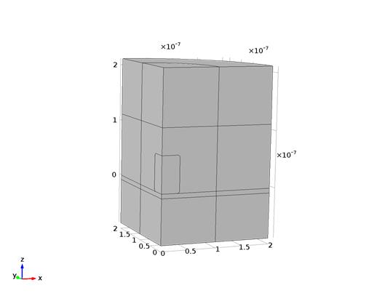

### MATERIALS

We set the relative permittivities of Ag and Au with their non-dispersive permittivities, i.e., $ε_{∞,Ag }$ and $ε_{∞,Au}$.

### DEFINITIONS (Local)

In the **Model Builder Window->Component 1->Definition**, we define/add the following things:

1 PMLs, chosen to be cylindrical-type PMLs.

2 Two sets of variables, {***DP1x, DP1y, DP1z***} that relate with {***P1x***, ***P1y***, ***P1z*** } defined in both in the Ag and Au domains (including the PML that is transformed from the Au substrate), and {***DP2x, DP2y, DP2z***} relating with { ***P2x***, ***P2y***, ***P2z*** } defined in the Au domain (including the PML that is transformed from the Au substrate). Specifically,

DP1y=epsilon0_const*(emw.epsilonrxx*P1x+emw.epsilonrxy*P1y+emw.epsilonrxz*P1z)

DP1y=epsilon0_const*(emw.epsilonryx*P1x+emw.epsilonryy*P1y+emw.epsilonryz*P1z)

DP1z=epsilon0_const*(emw.epsilonrzx*P1x+emw.epsilonrzy*P1y+emw.epsilonrzz*P1z),

and similarly for DP2x, DP2y, DP2z.

3 Another two sets of variables, {***omegap_1, omega0_1, gamma_1***} that relate with the first Lorentz-Drude term of the Ag and Au permittivities, and {***omegap_2, omega0_2, gamma_2***} that relate with the second Lorentz-Drude term of the Au permittivity. Specifically,

$omegap_1=ω_{p,Ag}, omega0_1=ω_{0,Ag}, gamma_1=γ_{Ag}$

in the Ag domain, and

$omegap_1=ω_{p,1,Au}, omega0_1=ω_{0,1,Au}, gamma_1=γ_{1,Au}$

$omegap_1=ω_{p,2,Au}, omega0_1=ω_{0,2,Au}, gamma_1=γ_{2,Au}$

in the Au domain (including the PMLs that map the Au substrate).

4 Three coupling integration operators: **intAll,** integration over all domains; **intMetal1**, integration over the Ag cube and the Au substrate (including the PML of the Au substrate); **intMetal2**, integration over the Au substrate (including the PML of the Au substrate).

5. QNM normalization factor, **QN**.

### MESHES

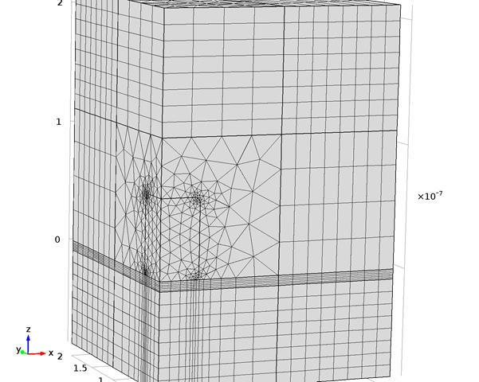

### ELECTROMAGNETIC WAVES, FREQUENCY DOMAIN (EWV)

We add two extra weak contributions:

1 The weak contribution, related to the auxiliary fields ***P1x****,* ***P1y****,* ***P1z***,

mu0_const*QNM_omega^2*(test(emw.Ex)*DP1x+test(emw.Ey)*DP1y+test(emw.Ez)*DP1z)*pml1.detInvT

2 The weak contribution, related to the auxiliary fields ***P2x****,* ***P2y****,* ***P2z****,*

mu0_const*QNM_omega^2*(test(emw.Ex)*DP2x+test(emw.Ey)*DP2y+test(emw.Ez)*DP2z) )*pml1.detInvT

### WEAK FORM PDE FOR AUXILIARY FIELDS P1x, P1y, P1z

This module is defined in the Ag and Au domains, and also the PML of the Au substrate. The weak contribution read as

lambda_N^2*((test(P1x)*P1x+test(P1y)*P1y+test(P1z)*P1z)*(QNM_omega^2-j*gamma1*QNM_omega-omega01^2)/omegap1^2+(test(P1x)*emw.Ex+test(P1y)*emw.Ey+test(P1z)*emw.Ez))

### WEAK FORM PDE FOR AUXILIARY FIELDS P2x, P2y, P2z

This module is defined in the Au-substrate domain and its PML. The weak contribution read as

1/lambda_N^2*((test(P2x)*P2x+test(P2y)*P2y+test(P2z)*P2z)*(QNM_omega^2-j*gamma2*QNM_omega-omega02^2)/omegap2^2+(test(P2x)*emw.Ex+test(P2y)*emw.Ey+test(P2z)*emw.Ez))

### STUDY 1

We ask the eigensolver to compute 4 QNMs around $0.24×ω_{p,Ag}/(2π)$.

### RESULTS

