# QNMEig_grating_theta: a model for computing grating quasinormal modes at fixed incidence

## 1. Introduction

In this document, we present how, with QNMEig, we may compute and normalize grating QNMs for a 1D gold grating illuminated at a fixed incident angle $θ$. This document should be read in conjunction with the COMSOL model sheet “QNMEig_grating_theta.mph”.

## 2. Model Definition

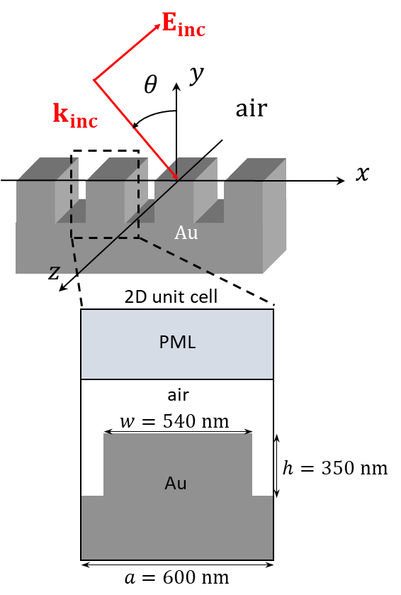

Figure 1 : Geometry of a 1D Au grating with substrate in air.

The gold permittivity is

$ε_{Ag}\left(ω\right)=ε_{∞}\left[1-\frac{ω_{p}^{2}}{ω^{2}-ω_{0}^{2}+iγω}\right]$, (1)

with $ε_{∞}=1, ω_{p}=1.26 {10}^{16} rad.s^{-1},$ corresponding to $λ_{p}=149.6 nm$ in vacuum , $γ=0.0112ω_{p}$ and $ω_{0}=0$.

We compute TM-polarized Bloch modes, with electric fields having only $x$ and $y$ components that are in the same plane as the 2D unit cell in Fig. 1. The magnetic field is parallel to the $z$-axis. Owing to the periodicity in the $x$-direction, the electric fields of the Bloch modes take the form

${\tilde{E}}_{θ}\left(r,ω\right)=e_{θ}\left(r\right)\exp\left(n_{i}\frac{ω}{c}\sin\left(θ\right)x\right)$,(2)

where $θ$ is the incidence angle, and $n_{i}$ is the refractive index of the medium of the (air in the case of this model) superstrate; $e_{θ}\left(r\right)$ is a periodical function, $e_{θ}\left(r\right)=e_{θ}\left(r\right)=\left(r+a\hat{x}\right)$, $a$ being the grating period. Please note that the Bloch phase $\exp\left(n_{i}\frac{ω}{c}\sin\left(θ\right)x\right)$ for these modes is $ω$-dependant.

## 3. Modelling instructions

Unlike most of the models in the QNMEig_package, **QNMEig_grating_theta** employs only the mathematics module.

It also uses the following reduced units:

* 1. The plasma frequency $ω_{p}$ is entered into COMSOL as $2π$ and $c=ε_{0}=μ_{0}=1$.
  2. Every distance is divided by the wavelength $λ_{p}$ corresponding to $ω_{p}$ and entered accordingly. For example, the period of the grating: $a=600.0 nm≅4.0107 λ_{p} \left[SI\right]→a=4.0107$.

### Definitions

All global parameters with their descriptions can be found in the COMSOL model sheet “QNMEig_grating_theta.mph”. Here, we emphasize the important parameter $θ$, the angle of incidence that is chosen equal to $30°$ in the “QNMEig_grating_theta.mph” COMSOL model sheet. The modes computed by the model correspond to those of a grating being illuminated by a source whose wavevector is contained in the plane of the unit cell and whose direction makes an angle $θ$ with the $y$-direction [1].

In the Model Builder Window ->Component 1->Definition, we define the following items:

1. The relative **permittivities** of the **Metal, Air,** and **PML** domains.
2. 2 integration operators: intAll, integration over all domains including PML domains; intMetal, integration over the Au domain.
3. One linear extrusion operator, linext1, which maps the fields, e.g., $e_{x}\left(x,y\right)$ to $e_{x}\left(-x,y\right)$.
4. The QNM normalization factor, **QN.** For a short description of the normalization of the $θ$-modes, we refer to Section 4 **“Normalization of Bloch Modes”**.

### Geometry

The geometry of the unit cell is represented below, in Fig. 2.

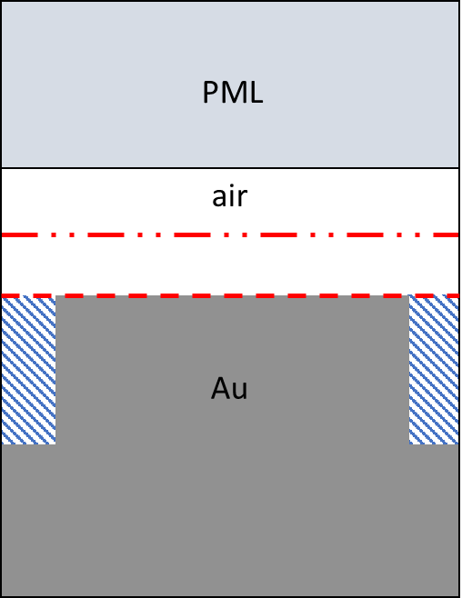

Figure 2 : Geometry of the unit cell in the model.

Alongside recreating the unit cell of the grating, two additional details to be aware of are:

1. In the scattering field formulation, the background is an air-metal interface, and the blue hatched domain (the groove) represents the $Δε$ domain required to compute the modal excitation coefficients. The dashed red line at the top of the ridge delineates that domain. For more information, please refer to “QNMEig_toolbox_grating.pdf”.
2. The red dashed-dotted line above the grating is used to compute the specular reflection of the grating. For more information, please refer to “QNMEig_toolbox_grating.pdf”.

### Meshes

The mesh of the unit cell is given in figure 3.

We note the importance of having the same mesh on the left and right borders of the unit cell, owing to the periodic continuity boundary conditions used to simulate the periodicity of the grating geometry. To this effect, we have used the **Edge** and **Copy Edge** on the left and right borders of the unit cell.

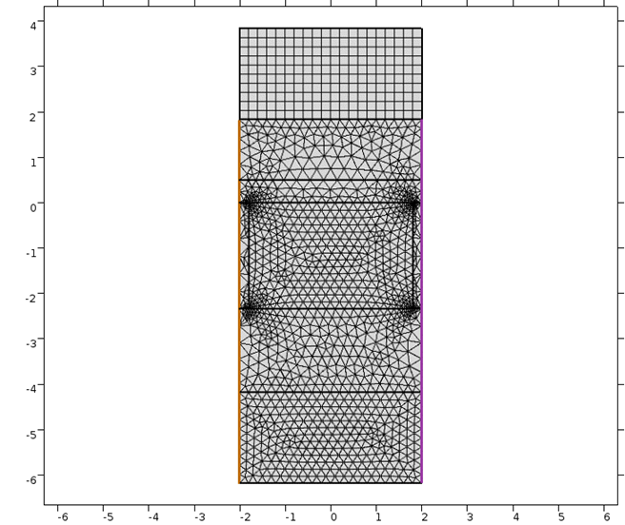

Figure 3 : Example mesh of the grating geometry.

### Weak Form PDE

1. We write the Weak formulation of Maxwell’s equation on all domains:

test(curlEz-i*lambda*sin(theta)*Ey)*(curlEz+i*lambda*sin(theta)*Ey)*1/muzz-lambda^2*(test(Ex)*Ex*epsilonxx+test(Ey)*Ey*epsilonyy)

1. We add one weak contribution to the Au domain:

$-$ lambda^2*test(Ex)*Px*epsilonxx/epsiloninf $-$ lambda^2*test(Ey)*Py*epsilonyy/epsiloninf

1. We impose a **continuity periodic** condition for the left and right boundaries of the unit cell.

### Weak Form PDE for auxiliary fields Px, Py

The input weak formulation is

(lambda^2 $-$ omega0^2+i*lambda*gamma)*(test(Px)*Px+test(Py)*Py)+omegap^2*(test(Px)*Ex+test(Py)*Ey)

### Study 1

We ask the eigensolver to compute 200 QNMs around the central frequency $ω_{c}=2$.

### Results

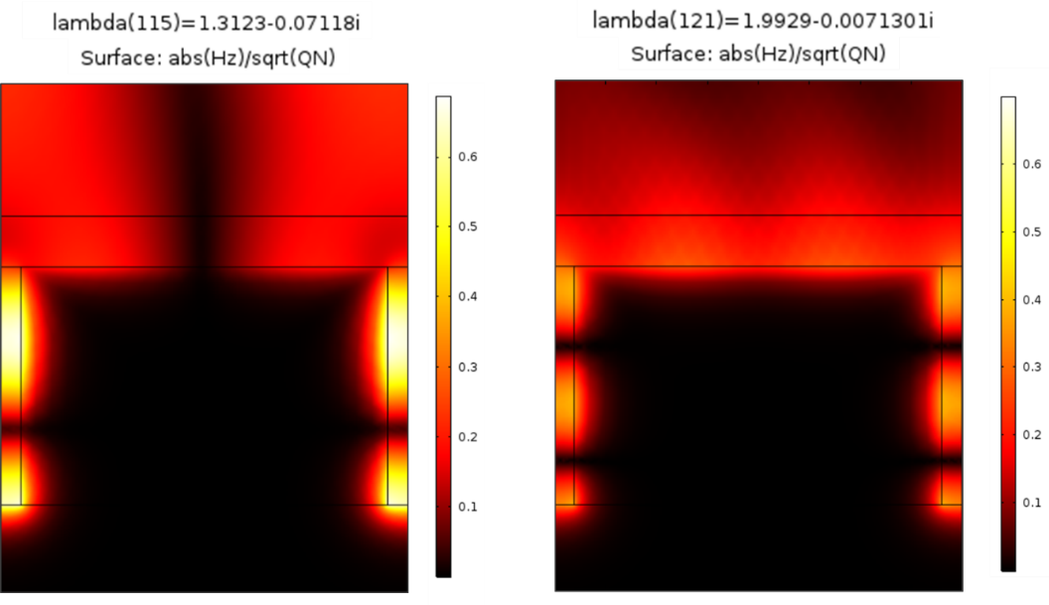

Figure 4 : 2 modes computed by the eigenmode solver for $θ=30°$.

## 4. Normalization of $θ$-modes

The normalization of a $θ$-mode ${\tilde{e}}_{m,θ}$  involves another mode with the opposite incident angle $-θ$ and the same eigenfrequency, ${\tilde{e}}_{m,-θ}$. Specifically, the normalization factor $QN$ is

$QN=∬\left[{\tilde{e}}_{m,θ}∙\frac{∂ωε\left(ω\right)}{∂ω}{\tilde{e}}_{m,-θ}-{\tilde{h}}_{m,θ}∙\frac{∂ωμ\left(ω\right)}{∂ω}{\tilde{h}}_{m,-θ}+\sqrt{n_{i}^{2}μ_{0}}\sin\left(θ\right)\hat{x}⋅\left({\tilde{h}}_{m,-θ}⋅{\tilde{e}}_{m,θ}+{\tilde{e}}_{m,-θ}⋅{\tilde{h}}_{m,θ}\right)\right]d^{2}r$. (3)

For our grating geometry that has inversion symmetry in the $x$-direction, ${\tilde{e}}_{m,θ}$ and ${\tilde{e}}_{m,-θ}$ are linked by a simple relation

${\tilde{e}}_{x;m,θ}\left(x,y\right)={\tilde{e}}_{x;m,-θ}\left(-x,y\right);{\tilde{e}}_{y;m,θ}\left(x,y\right)=-{\tilde{e}}_{y;m,-θ}\left(-x,y\right); {\tilde{h}}_{z;m,θ}\left(x,y\right)={\tilde{h}}_{z;m,-θ}\left(-x,y\right),$ (4)

where the subscripts “ $x$”, “ $y$”, and “ $z$” specify the $x$, $y$, and $z$ components of the electric and magnetic $θ$-QNM. Thus, knowing ${\tilde{e}}_{m,θ}, {\tilde{e}}_{m,-θ}$ is straightforwardly computed from Eq. (4). If the grating has no-symmetry, then the mode with the opposite incident angle $-θ$ should be computed, see details in [2]. Technically, Eq. (4) is implemented by defining a linear extrusion operator linext1, see subsection “Definitions” in “Modelling Instructions”, that is ${\tilde{e}}_{x;m,-θ}=linext1({\tilde{e}}_{x;m,θ})$; ${\tilde{e}}_{y;m,-θ}=-linext1({\tilde{e}}_{y;m,θ})$; ${\tilde{h}}_{z;m,-θ}=linext1({\tilde{h}}_{z;m,θ})$.

## 5. References

[1] A. Gras, W. Yan, and P. Lalanne, "Quasinormal-mode analysis of grating spectra at fixed incidence angles," Opt. Lett. **44**, 3494-3497 (2019).

[2] P. Lalanne, W. Yan, A. Gras, C. Sauvan, J.-P. Hugonin, M. Besbes, G. Demésy, M. D. Truong, B. Gralak, F. Zolla, A. Nicolet, F. Binkowski, L. Zschiedrich, S. Burger, J. Zimmerling, R. Remis, P. Urbach, H. T. Liu, and T. Weiss, "Quasinormal mode solvers for resonators with dispersive materials," J. Opt. Soc. Am. A **36**, 686-704 (2019).