ISTA 303: Assignment 3 Write Up

Nile Grice, Chaoneng Quan

**1. Picture of assembled MeArm**

**2. Schematic**

**3. Kinematics code**

For the code itself, see the Arduino code file.

Diagram of each components

Math calculation for inverse kinematics(How to get B and K+B from r and z)

**4. Demoed in class**

**5. Diagrams, schematics, pictures, etc., of extensions**

Extension: A MeArm controlled catapult

Catapult

Projectile Holder

MeArm at motion

(Grabbing projectile) (launching the catapult)

STL file preview of catapult’s components

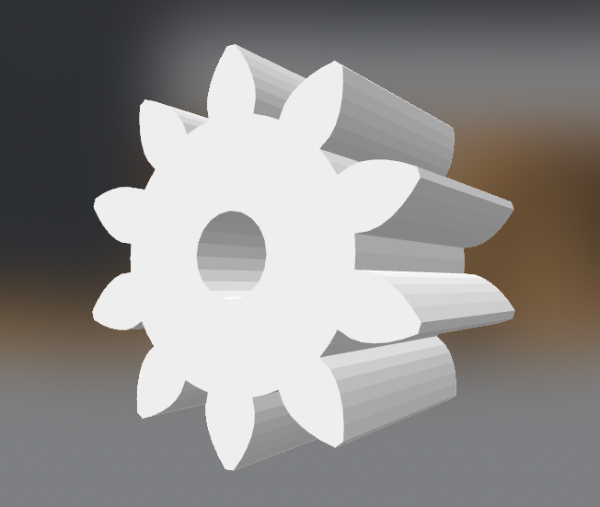

**6. Teamwork statement**

Our workloads were shared around 50% / 50%.

**Extension:**

We extended the MeArm’s functionalities to be able to: 1. Move to a specific location according to user input. 2. Grab an object and moving while holding it. 3. Drop an object to specific location. 4. Push the catapult’s leveler. 5. Repeat all functionalities mentioned above.