ARM
X86 CISC
采用存储程序的方式，微程序
ARM RISC——一条指令完成一个基本操作，多条指令组合完成一个复杂功能reduced instruction set computer
硬布线，相当于把完成复杂任务给编译器或者程序员
指令字定长，只有load、store指令可以访存
需要足够多的通用寄存器
采用优化的编译程序，生成代码较为高效
指令流水线

ARM Exception Model Overview
术语：
异常编号
优先级
同步或异步：被指令触发的就是同步，不是指令触发的就是异步。
异常状态：
Pending - The MCU has detected the exception and scheduled it but has not yet invoked the handler for it.
Active - The MCU has started to run the exception handler but not yet finished executing it. It’s possible for the exception to have been “pre-empted” by a higher priority handler and be in this state.
Pending & Active - Only possible for asynchronous exceptions, this basically means the exception was detected by the MCU again while processing an earlier detected version of the same exception.
Inactive - The exception is neither pending nor active.
以下是不同的异常类型：

Built in Exceptions
Six exceptions are always supported and depending on the Cortex-M variant, additional handlers will be implemented as well. The minimum set is:

Reset - This is the routine executed when a chip comes out of reset.
Non Maskable Interrupt (NMI) - As the name implies, this interrupt cannot be disabled. If errors happen in other exception handlers, a NMI will be triggered. Aside from the Reset exception, it has the highest priority of all exceptions.异常处理程序发生错误
HardFault - The catchall for assorted system failures that can take place such as accesses to bad memory, divide-by-zero errors and illegal unaligned accesses. It’s the only handler for faults on the ARMv6-M architecture but for ARMv7-M & ARMv8-M, finer granularity fault handlers can be enabled for specific error classes (i.e MemManage, BusFault, UsageFault). 硬件故障
SVCall - Exception handler invoked when an Supervisor Call (svc) instruction is executed. 系统服务调用
PendSV & SysTick - System level interrupts triggered by software. They are typically used when running a RTOS to manage when the scheduler runs and when context switches take place.调度

External Interrupts
The Exception Number for external interrupts starts at 16.
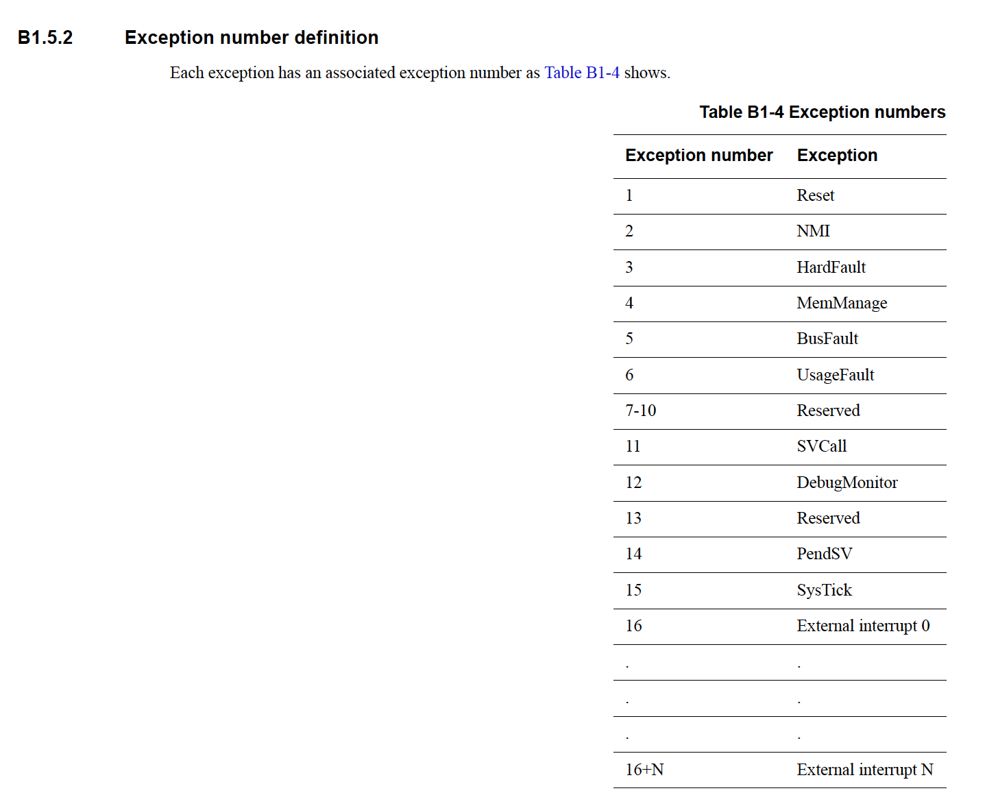

Registers used to configure Cortex-M Exceptions
用于配置Cortex-M异常的寄存器
Exceptions are configured on Cortex-M devices using a small set of registers within the System Control Space (SCS).

Interrupt Control and State Register (ICSR) - 0xE000ED04
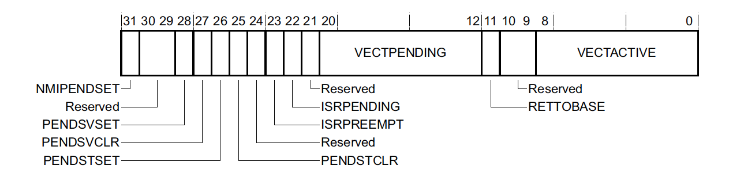
中断控制和状态寄存器
该寄存器可以控制NMI、PendSV和SysTick异常，并查看系统当前中断状态的摘要。
VECTACTIVE - 当前运行中断的异常编号，如果没有活动中断，则为 0。该编号也存储在程序状态寄存器 (xPSR) 的 IPSR 字段中。
RETTOBASE - 值为 0 表示除了当前正在执行的中断外，还有另一个中断处于活动状态。这基本上揭示了是否发生了抢占。ARMv6-M 设备未执行此字段。
VECTPENDING - 最高未执行待处理中断的异常编号，如果没有，则为 0。

Application Interrupt and Reset Control Register (AIRCR) - 0xE000ED0C
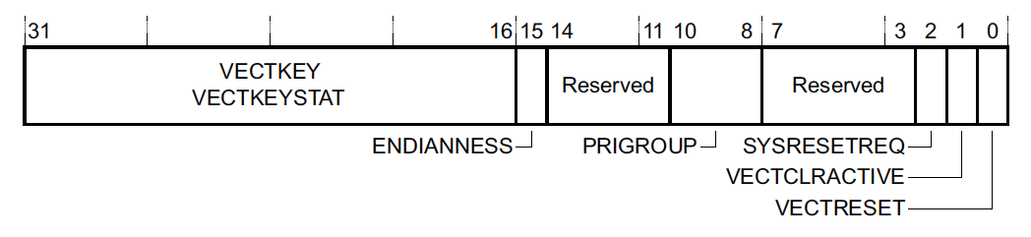
应用程序中断和重置控制寄存器（AIRCR）
SYSRESETREQ - 写 1 将触发系统重置，从而调用系统重置处理程序。
PRIGROUP - 该字段可将异常优先级分为组优先级和子优先级两部分。此处的设置表示子优先级由多少位组成。组优先级用于控制哪些中断可以相互抢占。子优先级控制同组异常的处理顺序。（基于 ARMv6-M 的设备未执行此字段。）
注意：要写入该寄存器，必须将 VECTKEY 字段设置为 0x05FA。

System Handler Priority Register (SHPR1-SHPR3) - 0xE000ED18 - 0xE000ED20
系统处理程序优先级寄存器
该寄存器组允许更新 可配置优先级的系统故障优先级。请注意，寄存器组的索引从 1 开始，而不是从 0 开始，这是因为第一个异常编号（分别对应复位、NMI 和硬故障）没有可配置的优先级，因此写入 SHPR0 中的任何内容都不会产生影响。——也就是说零号寄存器被分配给了Reset, NMI, and Hardfault。（编号分别为1、2、3）
每个优先级配置占用一个寄存器组的 8 位。这意味着异常编号 11 的SVCall 的配置将位于 SHPR2 的第 24-32 位。所有系统异常的默认优先级值都是 0，即可配置的最高优先级。在大多数应用中，通常不需要更改这些值。

System Handler Control and State Register (SHCSR) - 0xE000ED24
系统处理程序控制和状态寄存器
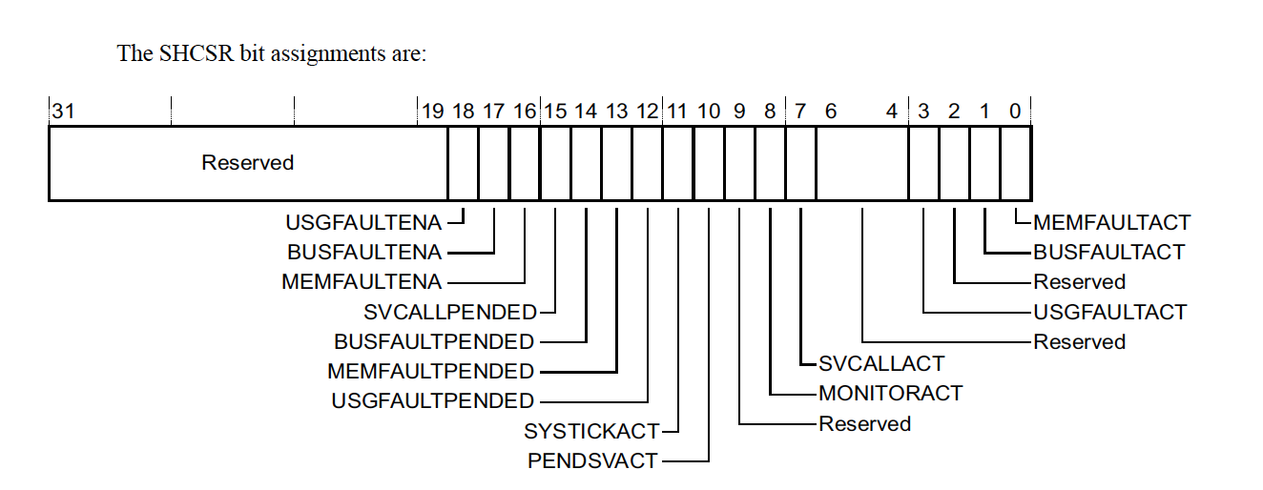
通过该寄存器可以查看或启用各种内置异常处理程序的状态
注意：对于 ARMv6-M 设备，唯一执行的值是 SVCALLPENDED

Interrupt Controller Type Register (ICTR) - 0xE000E004
中断控制器类型寄存器
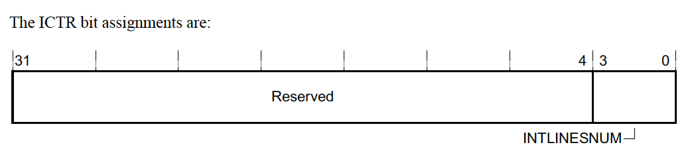
通过该寄存器可以确定实现所支持的外部中断线路总数。对于 ARMv6-M 设备（Cortex-M0、Cortex-M0+），该寄存器不适用，因为其数目始终为 32。对于其他 Cortex-M MCU，最多可支持 496 条中断线！
支持的中断的确切数量很容易计算，即 32 * (INTLINESNUM + 1)——为啥要乘以32啊？？？？

NVIC Registers
NVIC 有几组寄存器用于配置 "外部 "中断线路。地址范围的分配是为了支持可执行的最大外部中断数（496 个），但通常会执行一组较小的寄存器。
其中四种寄存器类型为每个外部中断分配一个位。每种类型都有一个连续的 32 位寄存器组。因此，如果我们要配置外部中断 65，配置位将是该寄存器组中第 3 个 32 位寄存器的第 1 位。外部中断从向量表中的偏移量 16 开始，因此该中断的异常编号（向量表中的索引）为 16 + 65 = 81。——意思是外部中断最多有32*4种？

Interrupt Set-Enable (NVIC_ISER) and Clear-Enable (NVIC_ICER) Registers
中断设置启用（NVIC_ISER）和清除启用（NVIC_ICER）寄存器
写1启用中断或者禁用中断
Writing a 1 to the correct bit offset of the register pair will enable or disable the interrupt and a read will return 1 if the interrupt is enabled.

Interrupt Set-Pending (NVIC_ISPR) and Clear-Pending (NVIC_ICPR) Registers
中断设置待定（NVIC_ISPR）和清除待定（NVIC_ICPR）寄存器
写入 1 将设置或清除中断的挂起状态
Writing a 1 to the correct bit offset of the register pair will set or clear the pending state of the interrupt and a read will return 1 if the interrupt is already pending.

Interrupt Active Bit Registers (NVIC_IABR)
中断活动位寄存器 (NVIC_IABR)
一组只读寄存器，用于返回中断是否激活。需要注意的是，ARMv6-M 架构（Cortex-M0 和 Cortex-M0+）中没有实现该寄存器。

Interrupt Priority Registers (NVIC_IPR)
中断优先级寄存器 (NVIC_IPR)
最后一个 NVIC 配置寄存器用于配置中断的优先级。8 位用于配置每个中断的优先级。支持的优先级数量由执行定义，范围为 4-256。当执行的优先级少于 256 级时，该字段的低位读为零。因此，有点令人困惑的是，如果只执行 2 位，那么从最高优先级到最低优先级的有效值分别为 0b000.0000 (0x0)、0b0100.0000 (0x40)、0b1000.0000 (0x80) 和 0b1100.0000 (0xC0)。

Software Triggered Interrupt Register (STIR) - 0xE000EF00
软件触发中断寄存器（STIR）
该寄存器可用于将 NVIC 中断设置为挂起。需要写入寄存器的值是外部中断编号（异常编号 - 16）。ARMv6-M 体系结构未实施该寄存器

Advanced Exception Topics

Exception Entry & Exit
异常和线程模式代码可以共享同一组寄存器，异常条目可以是常规的 C 函数！对于其他架构，异常处理程序通常必须用汇编编写。

Tail-Chaining
Usually when exiting an exception, the hardware needs to pop and restore at least eight caller-saved registers. However, when exiting an ISR while a new exception is already pended, this pop and subsequent push can be skipped since it would be popping and then pushing the exact same registers! This optimization is known as “Tail-Chaining”.
For example, on a Cortex-M3, when using zero wait state memory, it takes 12 clock cycles to start executing an ISR after it has been asserted and 12 cycles to return from the ISR upon its completion. When the register pop and push is skipped, it only takes 6 cycles to exit from one exception and start another one, saving 18 cycles in total!

Late-arriving Preemption
The ARM core can detect a higher priority exception while in the “exception entry phase” (stacking caller registers & fetching the ISR routine to execute). A “late arriving” interrupt is detected during this period. The optimization is that the higher priority ISR can be fetched and executed but the register state saving that has already taken place can be skipped. This reduces the latency for the higher priority interrupt and, conveniently, upon completion of the late arriving exception handler, the processor can then tail-chain into the initial exception that was going to be serviced.

Lazy State Preservation
ARMv7 & ARMv8 devices can implement an optional Floating Point Unit (FPU) for native floating point support. This comes with the addition of 33 four-byte registers (s0-s31 & fpscr). 17 of these are “caller” saved and need to be dealt with by the ARM exception entry handler. Since FPU registers are not often used in ISRs, there is an optimization (“lazy context save”)⁶ that can be enabled which defers the actual saving of the FPU registers on the stack until a floating point instruction is used in the exception. By deferring the actual push of the registers, interrupt latency can usually be reduced by the push and pop of these 17 registers!

Execution Priority & Priority Boosting
If no exception is active, the current “execution priority” of the system can be thought of as being the “highest configurable priority level” + 1 – essentially meaning if any exception is pended, the currently running code will be interrupted and the ISR will run.
There are a few ways in software that the “execution priority” can be manipulated to be above the default priority of thread mode or the exception that is active. This is known as “priority boosting”. This can be useful to do in software when running code that cannot be interrupted such as the logic dealing with context switching in a RTOS.
Priority boosting is usually controlled via three register fields:
- PRIMASK - Typically configured in code using the CMSIS __disable_irq() and __enable_irq() routines or the cpsid i and cpsie i assembly instructions directly. Setting the PRIMASK to 1 disables all exceptions of configurable priority. This means, only NMI, Hardfault, & Reset exceptions can still occur.
- FAULTMASK - Typically configured in code using the CMSIS __disable_fault_irq() and __enable_fault_irq() routines or the cpsid f and cpsie f assembly instructions directly. Setting the FAULTMASK disables all exceptions except the NMI exception. This register is not available for ARMv6-M devices.
- BASEPRI- Typically configured using the CMSIS __set_BASEPRI() routine. The register can be used to prevent exceptions up to a certain priority from being activated. It has no effect when set to 0 and can be set anywhere from the highest priority level, N, to 1. It’s also not available for ARMv6-M based MCUs.

Interruptible-continuable instructions
Most ARM instructions run to completion before an interrupt is executed and are atomic. For example, any aligned 32-bit memory access is an atomic operation. However, to minimize interrupt latency, some of the longer multi-cycle instructions can be aborted and re-started after the exception completes. These include divide instructions (udiv & sdiv) and double word load/store instructions (ldrd & strd).
Some instructions are also “interruptible-continuable” which means they can be interrupted but will resume from where they left off on exception return. These include the Load and Store Multiple registers instructions (ldm and stm). This feature is not supported for ARMv6-M and instead the instructions will just be aborted and restarted.

Code Examples

