CONTENT
1 INTRODUCTION 2
2 TESTS 3
2.1 Setup 3
2.2 Javascript OOP performance test 5
2.3 Web surfing test 10
2.4 Screenshot capture test 11
2.5 Create/Destroy test 13
CONCLUSIONS 14

1 INTRODUCTION

2 TESTS

2.1 Setup
Picture 2.1.1 shows system on which tests were runned.
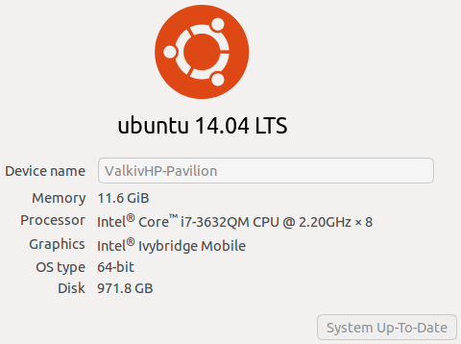
Picture 2.1.1 – System information
Following browsers participating in the tests:
- Phantomjs (latest). Version: 1.9.8;
- Firefox (ubuntu repository). Version: firefox 40.0.3+build1-0ubuntu0.14.04.1;
- Chromium (ubuntu repository). Version 44.0.2403.89 Ubuntu 14.04. ChromeDriver: 2.15;
- Chrome (latest). Version: 44.0.2403.157. ChromeDriver: 2.18.343837.

Each browser was runned on virtual display, which was started by following command:
Xvfb :1 -screen 0 800x600x8

Memory and CPU usage are summed for all subprocesses, that related to WebDriver.
Memory usage in the tests is the sum of “Private_Dirty” fields from “/proc/{pid}/smaps” file, which is equal to “memory” column in gnome-system-monitor tool.
CPU usage in the tests is the sum from “ps -p {pid} -o %cpu” tool (100% means 1 core fully loaded).
Swap file was disabled.
JVM was started with preallocated heap size of 2gb to not use garbage collector and heap allocation during tests.
For each WebDriver window resolution were set to 1336x766.

2.2 Javascript OOP performance test

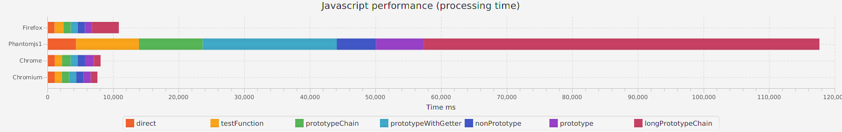
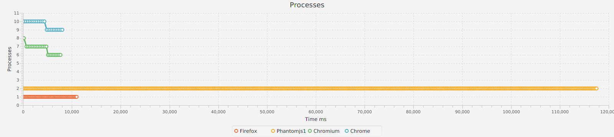
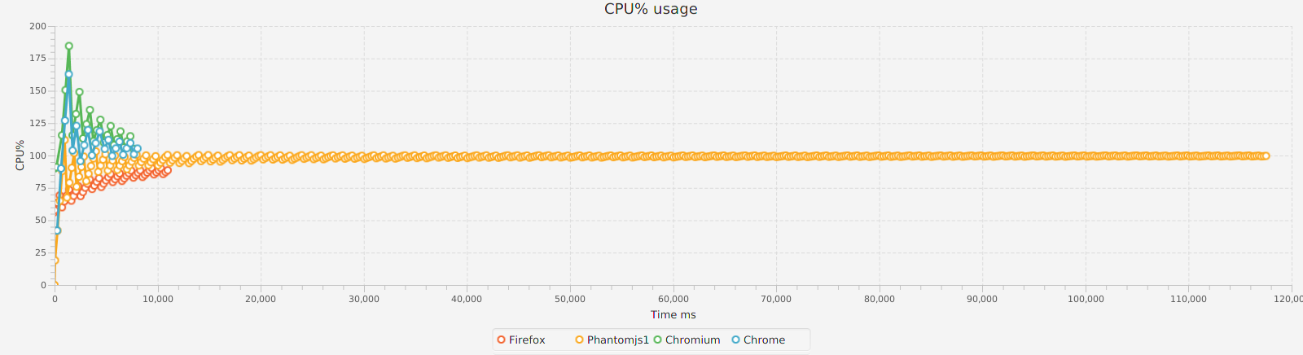
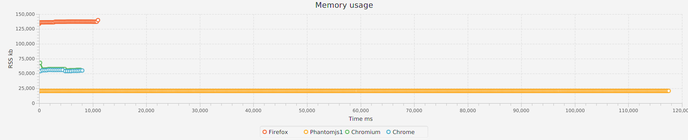
After few relaunches results were as above +-5%.

Below is javascript code which was used for the tests:
function testPerformance() {
return {
direct: getExecutionTime(testDirect),
testFunction: getExecutionTime(testFunction),
nonPrototype: getExecutionTime(testNonPrototype),
prototypeChain: getExecutionTime(testPrototypeChain),
prototype: getExecutionTime(testPrototype),
longPrototypeChain: getExecutionTime(testLongPrototypeChain),
prototypeWithGetter: getExecutionTime(testPrototypeWithGetter)

}
}
var DELTA = 10;
var ITERATIONS = 1000;

function getExecutionTime(f) {
var start = new Date().getTime();
f();
var end = new Date().getTime();
var diff = end - start;
return diff;
}

function testPrototypeChain() {

function Parent() {
this.delta = DELTA;
};

function ChildA() {};
ChildA.prototype = new Parent();

function ChildB() {}
ChildB.prototype = new ChildA();

function ChildC() {}
ChildC.prototype = new ChildB();

function ChildD() {};
ChildD.prototype = new ChildC();

function ChildE() {};
ChildE.prototype = new ChildD();

function nestedFn() {
var child = new ChildE();
var counter = 0;
for (var i = 0; i < ITERATIONS; i++) {
for (var j = 0; j < ITERATIONS; j++) {
for (var k = 0; k < ITERATIONS; k++) {
counter += child.delta;
}
}
}
console.log('Final result: ' + counter);
}
nestedFn();
}

function testPrototype() {
function Parent() {};
Parent.prototype.delta = DELTA;

function ChildA() {};
ChildA.prototype = new Parent();

function nestedFn() {
var child = new Parent();
var counter = 0;
for (var i = 0; i < ITERATIONS; i++) {
for (var j = 0; j < ITERATIONS; j++) {
for (var k = 0; k < ITERATIONS; k++) {
counter += child.delta;
}
}
}
console.log('Final result: ' + counter);
}

nestedFn();
}

function testPrototypeWithGetter() {
function Parent() {};
Parent.prototype.delta = DELTA;
Parent.prototype.getDelta = function() {
return this.delta;
};

function ChildA() {};
ChildA.prototype = new Parent();

function ChildB() {}
ChildB.prototype = new ChildA();

function ChildC() {}
ChildC.prototype = new ChildB();

function ChildD() {};
ChildD.prototype = new ChildC();

function ChildE() {};
ChildE.prototype = new ChildD();

function nestedFn() {
var child = new ChildE();
var counter = 0;
for (var i = 0; i < ITERATIONS; i++) {
for (var j = 0; j < ITERATIONS; j++) {
for (var k = 0; k < ITERATIONS; k++) {
counter += child.getDelta();
}
}
}
console.log('Final result: ' + counter);
}

nestedFn();
}

function testNonPrototype() {
function Parent() {
this.delta = DELTA;
};

function nestedFn() {
var child = new Parent();
var counter = 0;
for (var i = 0; i < ITERATIONS; i++) {
for (var j = 0; j < ITERATIONS; j++) {
for (var k = 0; k < ITERATIONS; k++) {
counter += child.delta;
}
}
}
console.log('Final result: ' + counter);
}

nestedFn();
}

function testFunction() {
function getDelta(object) {
return object.delta;
}

function nestedFn() {
var child = {
delta: DELTA
};
var counter = 0;
for (var i = 0; i < ITERATIONS; i++) {
for (var j = 0; j < ITERATIONS; j++) {
for (var k = 0; k < ITERATIONS; k++) {
counter += getDelta(child);
}
}
}
console.log('Final result: ' + counter);
}

nestedFn();
}

function testLongPrototypeChain() {
function Parent() {};
Parent.prototype.sub = new SubChildE();

function ChildA() {};
ChildA.prototype = new Parent();

function ChildB() {}
ChildB.prototype = new ChildA();

function ChildC() {}
ChildC.prototype = new ChildB();

function ChildD() {};
ChildD.prototype = new ChildC();

function ChildE() {};
ChildE.prototype = new ChildD();

function SubParent() {
this.delta = DELTA;
};

function SubChildA() {};
SubChildA.prototype = new SubParent();

function SubChildB() {}
SubChildB.prototype = new SubChildA();

function SubChildC() {}
SubChildC.prototype = new SubChildB();

function SubChildD() {};
SubChildD.prototype = new SubChildC();

function SubChildE() {};
SubChildE.prototype = new SubChildD();

function nestedFn() {
var child = new ChildE();
var counter = 0;
for (var i = 0; i < ITERATIONS; i++) {
for (var j = 0; j < ITERATIONS; j++) {
for (var k = 0; k < ITERATIONS; k++) {
counter += child.sub.delta;
}
}
}
console.log('Final result: ' + counter);
}

nestedFn();
}

function testPrototypeChain() {
function Parent() {
this.delta = DELTA;
};

function ChildA() {};
ChildA.prototype = new Parent();

function ChildB() {}
ChildB.prototype = new ChildA();

function ChildC() {}
ChildC.prototype = new ChildB();

function ChildD() {};
ChildD.prototype = new ChildC();

function ChildE() {};
ChildE.prototype = new ChildD();

function nestedFn() {
var child = new ChildE();
var counter = 0;
for (var i = 0; i < ITERATIONS; i++) {
for (var j = 0; j < ITERATIONS; j++) {
for (var k = 0; k < ITERATIONS; k++) {
counter += child.delta;
}
}
}
console.log('Final result: ' + counter);
}

nestedFn();
}

function testDirect() {
function nestedFn() {
var delta = DELTA;
var counter = 0;
for (var i = 0; i < ITERATIONS; i++) {
for (var j = 0; j < ITERATIONS; j++) {
for (var k = 0; k < ITERATIONS; k++) {
counter += delta;
}
}
}
console.log('Final result: ' + counter);
}
nestedFn();
}

2.3 Web surfing test

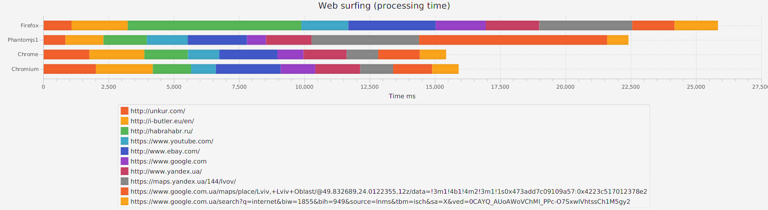
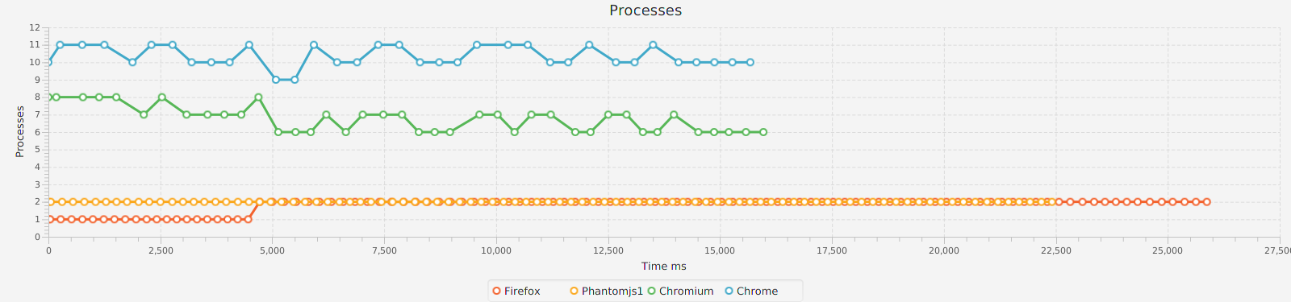
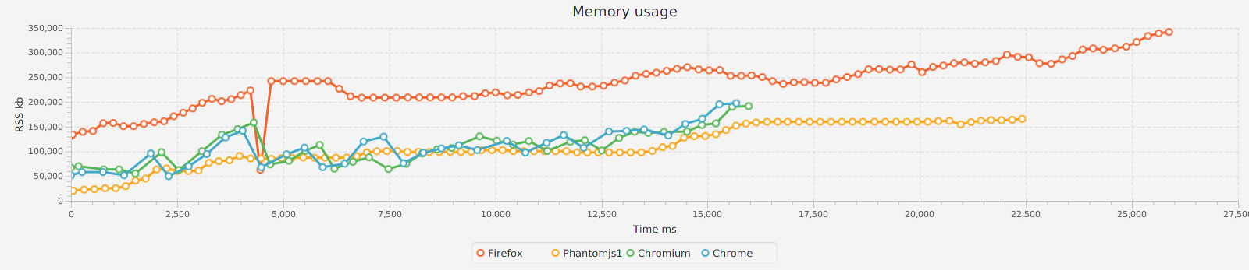
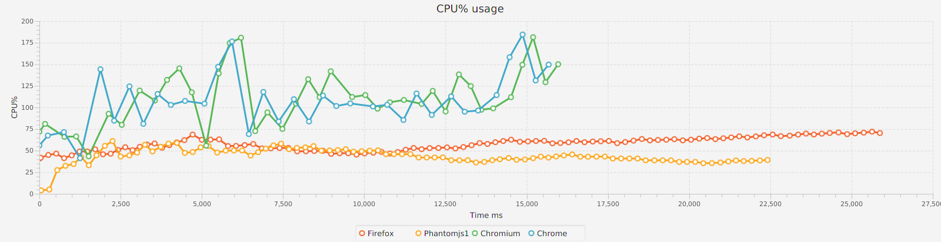
Results of processing time can be completely different for each relaunch, for example one of web drivers could load webpage during 30 sec when with another try in 2 sec. They can differs because of websites on high load during requests, network etc. But in most cases CPU and memory usage near to above.
Few more relaunches:
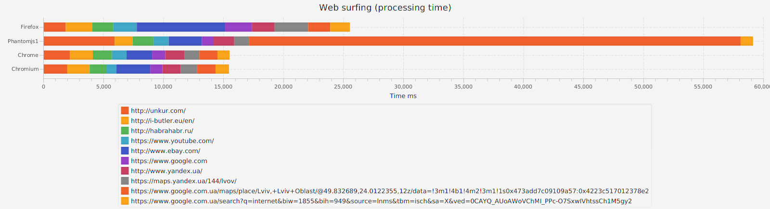
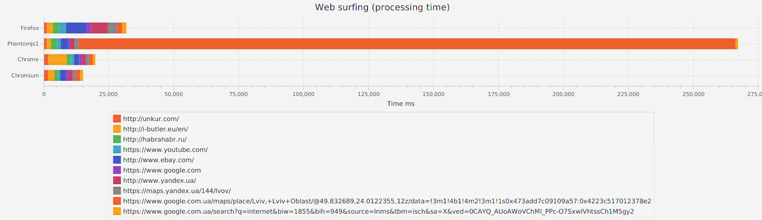
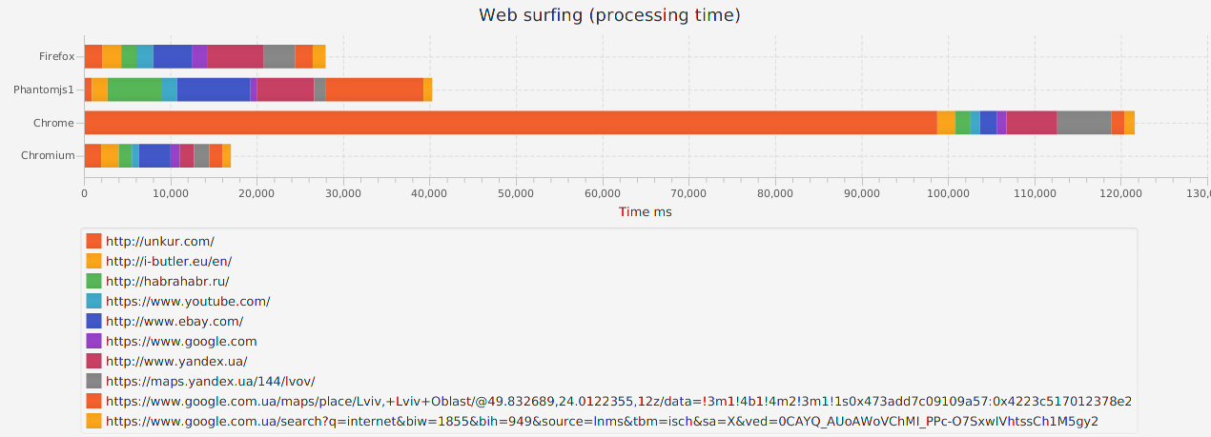

2.4 Screenshot capture test
Phantomjs and firefox WebDrivers capture screenshots of whole page without scroll when chrome driver capture only area which is visible to user together with scroll, can be workaround to capture whole page by increasing window height to document height during capturing screenshot. See pictures 2.4.1-2.4.2.

Picture 2.4.1 – Screenshot by chrome driver


Picture 2.4.2 – Screenshot by phantomjs/firefox driver

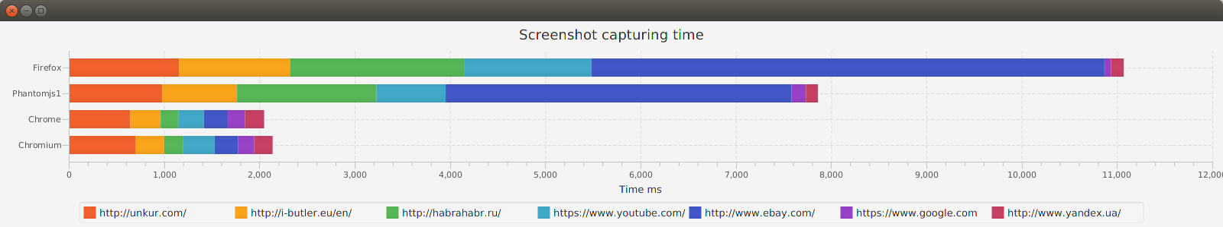

2.5 Create/Destroy test
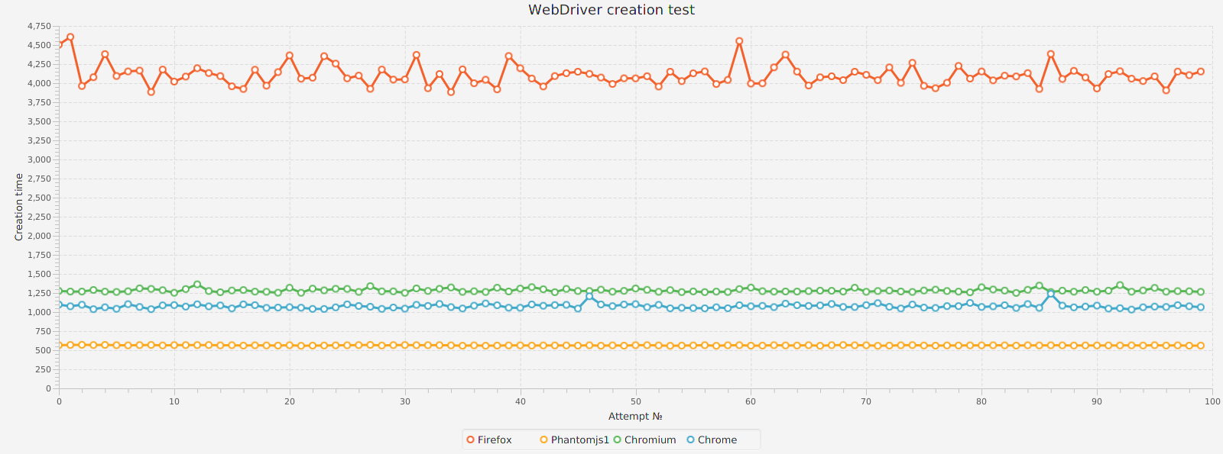
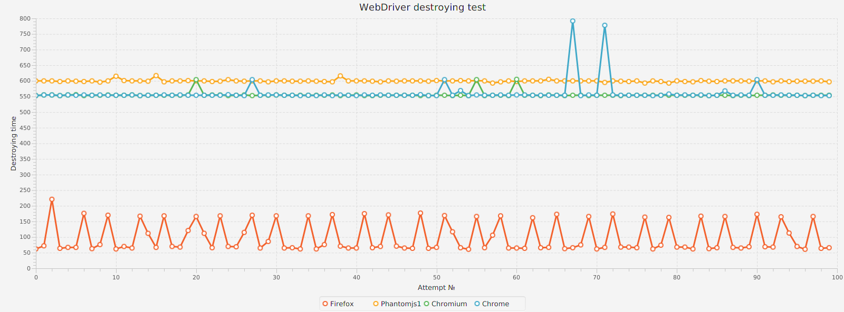

CONCLUSIONS

