**Review of:** Inference of transmission dynamics and retrospective forecast of invasive meningococcal disease

PLOS computational biology (PCOMPBIOL-D-23-00626)

**Authors: Jaime Cascante-Vega, Marta Galanti, Katharina Schley, Sen Pei, Jeffrey Shaman**

*Answer overview:* Thanks both for the comments. In the resubmission files of the Main text and the Supplementary Information, we highlighted changes from the previous submission in red so the reviewers and editor(s) could easily track changes. The principal changes in the Main text include a description of the i) birth and death dynamics in the model description, a description of the SARIMA model,

We updated all the figures, in both the Main text and SI, as the MMEs now include the SARIMA, and birth and death dynamics were included.

**Reviewer 1.***Overview*The authors have developed a novel set of models for simulating and forecasting the spread of invasive meningococcal disease (IMD) in the United States. Their study demonstrates the successful integration of mechanistic (process-based) models and Bayesian inference methods in a model-inference system, which effectively captures IMD dynamics over the past 14 years and provides reliable forecasts of future disease outcomes. While similar model-inference systems have been utilized for parameter estimation, evaluation of counterfactual interventions, and forecasting various diseases such as influenza, SARS-CoV-2, West Nile Virus, malaria and dengue, this is the first instance where such methods have been developed specifically for IMD. The analysis serves as a crucial validation and assessment of the IMD model's performance, which will be essential for future investigations on the impact of the SARS-CoV-2 pandemic and vaccinations on IMD incidence. Although the results presented are valuable, there are several areas of weakness that need to be addressed before the manuscript is suitable for publication.

*Missing demography in process-based models? DONE*

The authors have employed a process-based stochastic model to simulate the transmission of invasive meningococcal disease (IMD) in the United States and forecast its incidence. However, a significant assumption underlying these models, which remains unstated, is the exclusion of demographic processes (i.e., birth and deaths) during the study period. Considering that IMD is an endemic disease with a high fatality rate (10-15%), overlooking demographic rates in the model appears to be a substantial omission. It would be beneficial for the authors to provide insights into why birth and death rates have been excluded from their model. Moreover, since the size of the population at risk for IMD in the United States varies annually throughout the 15-year study period, the authors should consider addressing this by discussing the population dynamics and its potential influence on the seasonal transmission of IMD.

*Answer:* Thanks for making us notice the absence of population dynamics. We included birth and death rates in the model. We assumed all individuals are born susceptible to acquiring the bacteria. We, therefore, model births as $b\sim Binom(N, 1-exp(-μ))$, and deaths $d_{x}$ in each compartment $X$ as $d_{x}\sim Binom(X, 1-exp(-μ))$, where $μ$ is the birth/death rate. We, therefore, ignored further mortality due to IMD. We produced the same inferences as presented with the previous models. We presented simulations with time-varying estimated parameters from an EAKF, the posterior estimate of the state space and simulation with point parameters estimates using an IF-EAFK (figures included in separate pdf file). We found that each individual dynamical model, including births, and deaths, appears to result in sharp simulations while conserving the trend observed in the data. Lastly, we compared the performance measured with the WIS of the models' forecast, including and not including population dynamics (Figure R1). We found that both types of models produce similar results. However, as the forecast horizon increased from 1m to 6m the models, including population dynamics, were slightly better (lower dashed red lines compared to solid black lines).

Figure R. Weigthed interval score (WIS) of models with birth and deaths (BD in legend) indicated with red lines and without BD dynamics, presented with black lines. Forecast horizon evaluated increases from upper to lower rows, we only present 2, 4, and 6 months. In each column, we present one of the dynamical models introduced in the main text: model without seasonality (model 1), model with seasonal transmission rate (model 2), and model with seasonal likelihood of infection (model 3).

*Why ARIMA? DONE*

It is perplexing that the authors opted to use an autoregressive integrated moving average (ARIMA) model for analyzing data that exhibits a strong seasonal signal. Considering the presence of seasonality in the data, it would have been more appropriate to use the Seasonal Autoregressive Integrated Moving Average (SARIMA) model, which accounts for seasonal variations. Without a proper discussion, the choice of ARIMA appears arbitrary at worst and, at best, a weak comparison. To address this concern, I recommend including a comparison with SARIMA to validate the performance of the mechanistic seasonal infection model (iii) and the MME."

*Answer:* Thanks for this comment. Our first rationale was using the simplest model (ARIMA), to compare against the dynamical models. We included comparisons with a SARIMA and validated the performance of all the models and the MME. We used the same data splits introduced in the main text, before the complete vaccination regime (2011), after it, and during the whole study period. We present the performance of all the individual dynamical and statistical models across the 3 different data splits (figures below). We produced the MME using the past performance (See **Multi-model ensemble of forecasting models and evaluation** in section **Materials and Methods** of the Main text) of the 3 individual dynamical models and the 2 statistical models (ARIMA and SARIMA). Visually inspection of the forecast suggest that while the error of the point estimate, the mean, for example, of the SARIMA model is the best (figures). We evaluated the performance with a proper scoring rule for probabilistic forecasts the WIS. We found, as with the previous results, that the dynamical models outcompete the statistical ones. The width of the forecast in both the ARIMA and the SARIMA is penalized by the probabilistic scoring rule. In subsequent figures, we present (1) the mean WIS of all 5 individual models across the data splits and (2) the distribution of the WIS of the models across the data splits. We found a similar result in the manuscript; the individuals’ mechanistic models perform better across the study period and forecast horizons. We found that the SARIMA had a better performance than the ARIMA.

In the new submission of the main text, we included a brief description of the SARIMA model and updated all the figures and tables; this includes figures in the Supplementary Information and the statistical analyses used to assess significant differences between the models.

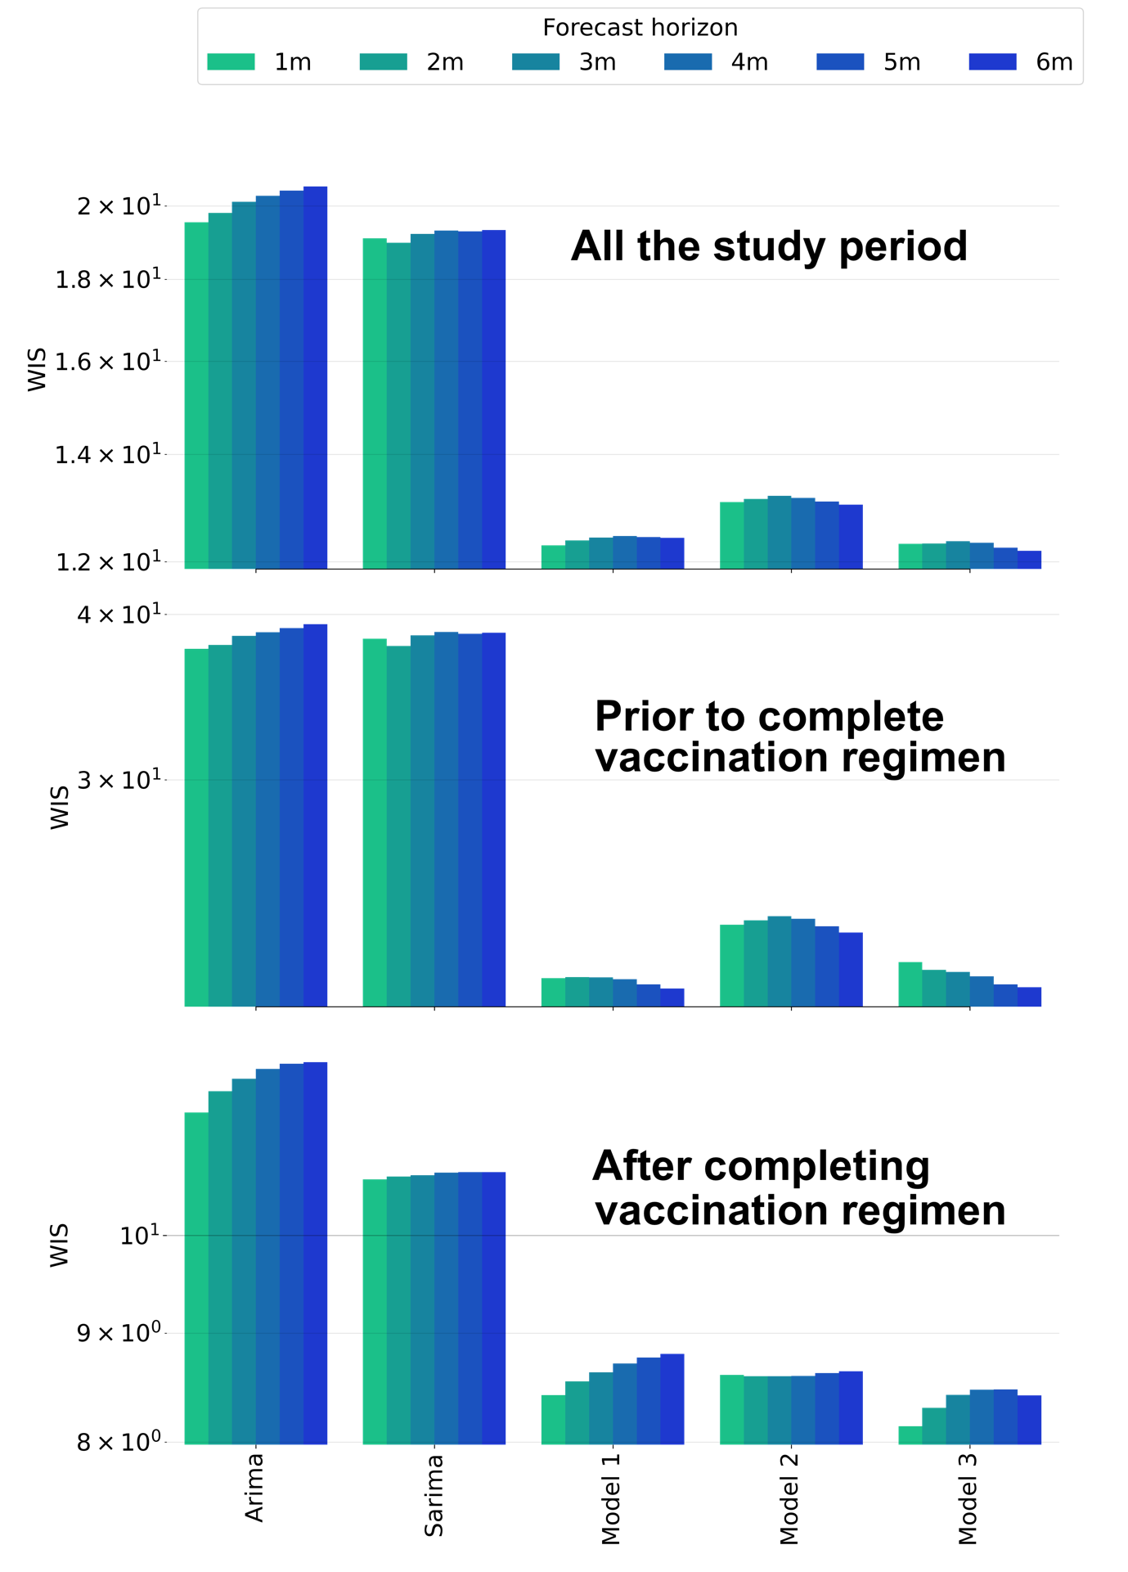

Figure R. Mean weighted interval score (WIS) 3 different data splits. **Upper:** During all the study period. **Middle:** Before completing the vaccination regimen. **Lower:** After completing the vaccination regimen. The forecast horizon is color-coded, and the models' names are indicated on the x-axis and shared between plots.

*How robust is the multi-model ensemble method to missing data? DONE*

The authors claim “For the MME forecasting system based on the past performance of the individual models, the form using all past predictions for establishing component model weights outperformed forms using only recent predictions” What is the basis for this result? Also do you have a way to estimate the marginal gain/loss in performance from increasing/decreasing the number of past predictions? Answering this question could provide help explain contractions found in previous research.

*Answer:* Thanks; it would be helpful to understand the mechanism behind increasing the information to create the MME. In the previous submission, we included in the Supplementary Information figures to back up our claim. In SI Figure 21, we presented the mean WIS of the MME built with the past performance from 1m to 6m. We presented this across the 3 suggested splits marked by the competition of the vaccination regimen.

It is interesting to think of a systematic way to estimate the marginal loss as the number of months used to build the MME in the past decreased. The first approach is a simple linear regression where the predicted variable is the mean WIS, and the predictor is the number of months used to train the MME. In the following figures, we present this approach. We fit different lines considering the 3 data splits introduced and the forecast horizons used to evaluate the models’ performance. We found that for combinations of the 3 different periods and forecast horizons, a line with a negative slope accurately predicts the gain in performance (decrease in WIS). We found that the magnitude of the slope increased as the forecast horizon increased, which translates into a more significant improvement as the MME forecast is interrogated with more data. While lines with negative slope explained the change in performance for all the 3 data periods considered, before the competition of vaccination, after it, and during the study period, the improvement in MME performance was more pronounced (higher magnitude of the slope) for the before the competition of vaccination period. While our approach reveals that increasing information (past number of months to build the MME) increases performance, it does not allow us to understand possible mechanisms, which could be leveraged in future research.

Figure R. Mean weighted interval score (WIS) as the number of past months used to train the MME increased. The data split is indicated in each row and the forecast horizon is indicated in each column. The red dot is the mean WIS of the model trained with all the past performances, located for simplicity at x=7. Regressions were performed with all dots (black continuous line) and with purple dots (dashed purple line) to exclude the performance of the MME trained with all the past performance.

*Unraveling the cause of altered IMD transmission dynamics: how exactly?*

The authors note an interesting pattern in IMD cases after 2011 and propose a potential explanation: “Here, we found a marked seasonality of IMD before 2011 with a 1-year period followed by a decreasing seasonal signal after 2011. This qualitative change coincided with changes in vaccine policy and uptake: teenager vaccination for N meningitidis was introduced in 2005 and was extended with an additional booster in 2011. It is possible that vaccination contributed to this shift in seasonality and to the decrease in overall IMD incidence observed in the last 2 decades”

While the vaccination hypothesis is interesting, its support is limited. The effectiveness of a vaccine hinges on the type of protection it provides. Does it prevent susceptible individuals from becoming carriers, or does it primarily reduce the likelihood of transmission within infected individuals or carrier classes? The CDC website indicates that rates of meningococcal disease have declined in the United States since the 1990s, with much of the decline occurring prior to the routine use of MenACWY vaccines. Furthermore, the decline in serogroup B meningococcal disease occurred despite the availability of MenB vaccines only towards the end of 2014.

https://www.cdc.gov/vaccines/vpd/mening/public/index.html#how-well-they-work

Without detailed demographic data, it is important to propose a potential pathway for how vaccination could have led to the observed changes. One possibility is that vaccination reshaped the age distribution of infection, affecting seasonality. Insights from mathematical models on age structure and seasonally transmitted diseases could provide valuable understanding of IMD transmission patterns across vaccine periods. For example, see the following 2019 measles model with seasonally forced transmission rates

https://royalsocietypublishing.org/doi/10.1098/rsif.2019.0151

*Answer:* Unfortunately, the data available is not stratified by age or age group. However, the CDC Wonder app provides the distribution of infections yearly, but only starting in 2015. The yearly age distribution of infections can be found in the following links, starting in 2015. We compiled the data and plotted the age of infection distribution in the figure below.

https://www.cdc.gov/meningococcal/downloads/NCIRD-EMS-Report-2015.pdf, https://www.cdc.gov/meningococcal/downloads/NCIRD-EMS-Report.pdf, https://www.cdc.gov/meningococcal/downloads/NCIRD-EMS-Report-2017.pdf, https://www.cdc.gov/meningococcal/downloads/NCIRD-EMS-Report-2018.pdf, https://www.cdc.gov/meningococcal/downloads/NCIRD-EMS-Report-2019.pdf, https://www.cdc.gov/meningococcal/downloads/NCIRD-EMS-Report-2020.pdf, https://www.cdc.gov/meningococcal/downloads/NCIRD-EMS-Report-2021.pdf .

However, researchers in the UK have not observed a shift in the age distribution of infections, as you suggest. You could, for example, see (https://www.cambridge.org/core/services/aop-cambridge-core/content/view/97EE1108D65A2303522657E2AD532140/S0950268805005339a.pdf/the-natural-history-of-meningococcal-carriage-and-disease.pdf). We don't think the age distribution of infection changed. Additionally, vaccination prevents disease (https://www.cdc.gov/meningococcal/vaccine-info.html), it does not reduce transmission, which could explain why the distribution remained unaltered.

***Minor comments***

*Introduction*

“While meningococcal disease affects all age groups, infections are reported predominantly in infants, young adults, and adults over 85 years old3, and, in temperate regions, cases are predominant in winter and spring months”

What is the distribution of infections? This seems crucial to later claim that MenACWY vaccine (approved in 2005 and 2011) is likely responsible for the significant decline in cases.

*Results DONE*

Fig 4: The Y-axes have different magnitude. This makes the chart harder to interpret. Suggest rescaling bar charts

“We found that the performance of the MME constructed using all the past performances was better for the entire study period and across all forecast dates and forecast horizons (1 to 6 months). “

Better than what exactly?

*Answer:* Thanks for the suggestion. We presented each data split with its magnitude because IMD incidence numbers were considerably higher before and after 2011 - and we aimed to compare models and MMEs, not between data splits/time periods. The next slide shows the y-axis with the same limits for each data split. As you can see, the visual comparison between models is degraded. We would appreciate your thoughts, and if needed, we would scale the figure, but let us know.

*Missing SI figure DONE*

We also didn't find any available data on vaccination with the exception of data from NIS teen surveys (Figure S28); however, these survey data are not representative of vaccine hesitancy for the US. Limitations affecting.

There is no Fig S28 in the supplementary information.

*Answer:* Excuse us for this error. In this submission, we included the SI Fig S28. Also shown below.

Figure . y-axis presents the fraction of surveyed teens whose parents reported to have taken the Meningococcal vaccine (green line), and whose provider reported having taken the vaccine (red line).

*Discussion DONE*

We also reviewed the literature for other possible determinants of transmission and found there have been multiple outbreaks of IMD among men who have sex with men (MSM) in the last 20 decades.

Surely, 20 decades is a bit much.

*Answer:* Sorry, we meant years - we changed it. The last outbreak in the MSM community was at the beginning of this year (2023) in Florida. We thought it was important to suggest possible super-spreading events that, in the case of IMD could be driven by a specific community. Super-spreading events violate the assumption of perfect population mixing in the compartmental models and could potentially explain poor fit in the unusual peaks in the data, as in 2008.

**Reviewer 2.**

*Overview*

This is a well written manuscript, in which the authors set out to model invasive meningococcal disease in the US, using a simple approach based mainly on seasonality of risk of invasive disease and general carriage trends around vaccine programs.  
I’m not an expert of modeling techniques, in particular not Bayesian methods, so cannot comment on the methodology used.

*Utility of wavelet analysis DONE*

Overall, the authors conclude that a wavelet analysis with seasonality can reasonably well predict overall evolution of IMD case number in the US. However, the utility of such approach is less clear: how does this guide vaccine recommendation, by serogroup and by age group?

*Answer:* While the ultimate goal would be to use methodologies to guide vaccine recommendation by age and serogroup, we don’t think the goal of the LWPS was to provide such insights. Instead, as has been done in many previous infectious disease systems, using a Fourier decomposition or an LWPS as we did has been done to understand seasonal patterns in time. You could see for example (cite, cite). We also used the LWPS to obtain the periodicity to inform the seasonal mechanistic dynamical models. Additional stratification of the time series of IMD incidence by age and serogroup could directly be input to the LWPS to understand seasonal patterns in those time series. The CDC wonder app has stratification by serogroup beginning in 2020. In **Data description** in **Materials and Methods** we wrote: ‘Classification of cases by serogroup (ACWY and B) only began in 2020 and was not used in this study; rather, incidence includes all serogroups’, to indicate one reason by not tracking infections by serogroup. However, low numbers in the stratified data made us think that tracking infections by meningococcal serogroup would not allow us to couple the model with an inference algorithm and explore the ability of dynamical models to forecast previous IMD incidence.

To understand and quantify the relation between the time series of vaccination and IMD incidence, the LWPS needs to be leveraged. One could extend to frequency and power decomposition methods that quantify similarity in both time series. We are unfamiliar with this methodology, but cross-wavelet mean fields (CWMF) could be used. This quantifies the relationship between temperature and dengue incidence in space and time (https://journals.plos.org/plosbiology/article?id=10.1371/journal.pbio.3001160). Further split of the IMD incidence data by age and vaccination data, both unavailable as far as we know, could be used to extend to quantify synchrony across space (age groups) and to quantify the impact of vaccination on IMD incidence.

We appreciate the question as it allows us to think about future avenues of the current work. However, including this in the main text is out of the scope. Please let us know if you want us to expand the discussion toward future frequency/power decomposition methodologies directions.

*Performance on 'outliers' DONE*

Extreme incidences like in 2008-2010 are poorly modeled. This may be explained by one major limitation of the work (recognized by the authors): the fact that the trends in influenza incidences are not included. On the same vein, it appears simplistic not to include strain evaluations or serogroup distributions in the modeling effort.

*Answer:* We are not sure outlier incidences are poorly modeled because we ignored influenza dynamics. Previous research, that we cited, used purely statistical methods and showed correlations between influenza-like illness and hospitalizations of IMD (https://pubmed.ncbi.nlm.nih.gov/25265409/). This made us hypothesize that previous exposure to influenza could increase the likelihood of infection, given colonization. And is perhaps one of the reasons that our suite of models suggests a time-varying likelihood of infection explains the data better. This has been shown for *Streptococcus pneumoniae* using model-inference methods (https://www.science.org/doi/full/10.1126/scitranslmed.3005982). However, spatially finer data of IMD would be needed to confirm this. Another possible source of the unusual peak observed in 2008 could be super-spreading events, which we also discuss - driven by outbreaks of the men who have sex with men (MSM) community.

*Climate change DONE*

I would appreciate a discussion of predictions taking into account climate change in the US: how would this be captured by the model?  
*Answer: (*Jeff D: !) Thanks for this comment; it is important to consider the effect of climate change in the current situation of a warming planet. While our work suggests climate as a possible role in supporting the seasonal likelihood of infection, other possible factors might be in play, as discussed in the 3 and 4th paragraphs of the **Discussion** section. If climate is the main driver of seasonality observed in the IMD system, then it would be crucial to account for climate change in the prediction system. However, the mechanism behind the seasonality remains to be elucidated. Therefore, before taking it into account in the current work, we would rather point to future directions toward understanding it.

*African meningitis belt DONE*

The authors argue for some assumptions with reference to evidence from the African meningitis belt. However, the role of the climate in the carriage and invasive disease is not transposable to the situation of the US, and I recommend being less affirmative in this perspective.

*Answer:* Thanks for pointing this out. We intend to cite and discuss that research to point out possible explanations providing evidence on why a seasonal likelihood of infections might be important - and was the best explanation we found. It was not to translate findings from the African meningitis belt to the US but to highlight different possible mechanisms behind seasonality in infection. Please let us know if we should remove this.

*Predicted prevalence matches empirical observations? DONE*

It is not clear in how far the predicted carriage prevalences are compatible with observed data – this would be important to address.

*Answer:* Thanks for making us notice that this is not clearly stated. We selected the initial conditions of the prevalence sampled uniformly between 5% and 30% following (cite @Marta). We further: “derived a prior range of parameters and variables by imposing at equilibrium that the basic reproductive number and the carriage prevalence is around 20%, we study the sensitivity of the restriction to different decolonization periods (See Supplementary Information Figures SI2-SI4)”. However, we are unaware of any studies systematically reporting carriage data across time. Consequently, we could not validate the estimated prevalence in time.

*COVID19 DONE*

From the manuscript, it remains unclear how the incidence of IMD changed across the Covid-19 pandemic, during and following the restrictions. This should be specifically addressed, globally in the US and regarding local outbreaks.

*Answer:* Understanding the effect of non-pharmaceutical interventions (NPIs) on the carriage prevalence of N. meningitidis and on IMD incidence would be cool. For this, we first extended our analyses until 2022, and showed that the model-inference system does not assimilate changes in prevalence or likelihood of infection. However, as you suggest, a deeper understanding of local outbreaks contextualized with knowledge of city and state-level NPIs is needed. We don’t think this is one of the objectives of our work, but we agree that it would be interesting to expand in future research. Some modeling studies in the UK, accounting for the possible effects of vaccination, suggested that NPIs in scenarios both with high and low vaccine uptake take reductions on carriage prevalence; it is not clear the effect on IMD (https://pubmed.ncbi.nlm.nih.gov/37259803/#:~:text=In%20all%20scenarios%20modelled%2C%20pandemic,published%20case%20data%20for%20England.). However, modeling results should be interrogated with data to produce further inferences.

*Coverage estimates of meningococcal vaccines DONE*  
Finally, please provide coverage estimates for the recommended and not systematically recommended meningococcal vaccines in the US.

*Answer:* In Supplementary Information Fig S28 we provided coverage estimates of vaccine in teenagers of the recommended vaccine. This is available in the NIS teens survey. We could not find estimates of the not systematically recommended meningococcal vaccine. Please let us know if you know of any possible source to include it.

*Supplementary material artifact DONE*  
In the supplementary material, some models show an IMD peak in 2019 – is this an artefact? Please comment on this observation in the discussion.

*Answer:* Sorry for this, we first did our analyses with data until 2020. When we extended with new data until 2022 we found the CDC corrected some cases. It was an artifact in the CDC wonder app; we corrected this but forgot updating some Supplementary Information figures. Many apologies, we corrected this.