Reviewers response
We sincerely thank the Editor and both reviewers for their careful evaluation of our manuscript and for their constructive and insightful comments. Their suggestions have significantly strengthened the clarity, methodological rigor, and transparency of our work. In response, we have restructured the manuscript, expanded the data and methods sections, clarified key definitions, strengthened the statistical analyses, and improved the presentation of figures and results. Below, we provide a detailed, point-by-point response to each comment and indicate where corresponding revisions have been made in the revised manuscript.
Reviewer 1
General Comment
This article tackles a critically important public health question: evaluating the impact of non-pharmaceutical interventions, specifically local lockdowns, on the effective reproductive number (Re). The topic is highly relevant, and the authors present a case study of the COVID-19 outbreak in Bogotá, Colombia. The manuscript is clearly written, and there are no apparent ethical concerns. However, the study's scientific rigor and the persuasiveness of its conclusions are significantly undermined by insufficient methodological detail and inadequate statistical justification. In its current form, the analysis is not fully replicable, and the claims extend beyond what the presented evidence robustly supports.
Major Concerns and Suggestions for Revision
Comment 1, R1. Structural and Organizational Clarity. While the manuscript includes key elements, it would benefit from a more conventional and explicit structure. It is strongly recommended to adopt a standard format: Introduction, Background/Literature, Data, Methodology, Results, Discussion, and Conclusions. This would immediately improve readability and ensure all necessary components are fully developed in their logical place.
Answer. Thanks for the suggestion. We have now restructured the paper into the suggested format.
Comment 2, R1. Data Description and Preprocessing (Critical Addition):
The Data section must be substantially expanded. Authors should provide a comprehensive description of the dataset, including:
- Source and Type: Origins of the case numbers/Re estimates.
- Temporal and Spatial Resolution: The frequency (e.g., daily, weekly) and geographic granularity (e.g., by city neighborhood, hospital district).
- Preprocessing Steps: A clear, step-by-step account of any filtering, smoothing, imputation of missing values, or adjustment procedures applied to the raw data. Transparency here is essential for replicability and for assessing potential biases.
Answer. Thanks for the suggestion. We have now expanded the description of the data section. Providing a better description of the spatial and temporal resolution of the data, and a better description of the biases and all the details to improve transparency. ​​The updated descriptions appear in the Data description section, including the subsections “Mobility data,” “Surveillance epidemiological data,” and “Socioeconomic data,” spanning lines 138–183 of the revised manuscript.
Comment 3, R1. Methodological Rigor and Replicability (Core Issue). The current Methodology description ( "Materials and Methods" section) is the manuscript's primary weakness. It must be revised to allow for independent replication.
- Formal Presentation: All derived statistics, metrics, and model equations must be formally defined.
- Software and Implementation: Specify the software and key packages/functions used. The core analytical steps performed by the software should be conceptually explained, not just named.
- Assumptions and Justifications: Explicitly state the statistical and epidemiological assumptions underlying the chosen methods. Justify ‘why’ these methods are appropriate for this specific data and research question.
- Limitations: Discuss the limitations of the chosen methodologies in the context of the data's characteristics (e.g., reporting delays, noise), and you can expand this discussion in Conclusions.
Answer. Thank you for the suggestion. Indeed, the methods did not follow the same structure as the results. We also added more details to the main text without making it overly complicated.
Comment 4, R1. Results Interpretation and Statistical Support. The figures are a good start for presenting results. However, the interpretation of some figures, for instance, the claims based on Figure 1B, requires stronger statistical underpinning.
- Formalizing Comparisons: Assertions about differences between groups (under lockdown restrictions vs. not restricted) should be supported by formal statistical comparisons or a defined distance metric, not just visual inspection.
- Accounting for Variability: The analysis must acknowledge and incorporate the inherent sampling distribution and variability. Statements about changes should reflect this uncertainty.
Answer. We thank the reviewer for making us improve the credibility of the patterns presented. In Figure 1, we presented the mean daily changes between the localities locked down and those without restrictions. This average is applied to the pair of localities in the case of External mobility, and to the number of localities, restricted or not, in the case of Internal mobility. We first use a T-Test to compare means within each group, treating each day as a replicate. In Table R1 below, we present the value of the t-statistic, the p-value,e, and the degrees of freedom (df) of the test for the External movement. We computed the t-statistic using the SciPy package in Python, which allows us to specify samples with different variances. As the p-value suggests, differences in external mobility between lockdown and non-restricted localities were significant in all but the last group, whereas internal mobility was significantly different only in the first group of lockdowns.
As the reviewer suggested and as we mentioned, the results were averaged either over pairs of localities for external mobility, or over the number of localities in each group and outside for internal mobility. To account for this additional source of variability, we treat each pair as a replicate on each day for the external, and each locality as a replicate within the internal mobility. We first test for differences in variances using a Levene test at the 0.05 significance level. Then apply a t-test each day, either assuming equal or different variance depending on the p-value of the Levene test (non-equal variance if p-value <0.05, equal otherwise). In Figures R1 and R2 below, we present the t-statistics for this experiment for external and internal mobility, respectively. Because the statistic can have different degrees of freedom, we highlight the days on which it was significant (p-value of the t-test < 0.05), i.e., the days on which mobility changes differed between restricted and free localities.
We find that external mobility differed on most days across all groups (solid dots in the scatter plot). In groups 1, 2, and 3, only one day the difference was non-significant on only one day (faded dots), and in group 4, on two days. This result, two days with significantly equal differences in external mobility, may explain the non-significance found in group 4 when considering each day as a replicate (Table R1). For internal mobility, we found that all days were not statistically significant across all groups except group 4. In this last group, internal mobility was significantly different only between locked-down localities and those free of restrictions on 6 of 13 days: the first 4 days and 2 others.
In conclusion, this additional analysis, which formalizes differences in mean external and internal mobility changes while controlling for variability within days and within pairs of localities or, when restricted to a single locality, the number of localities, supports our claim: the rotational lockdowns effectively changed external mobility, but internal mobility was unchanged. They also show an interesting pattern: the t-statistic increases over time for external mobility. This could suggest changes in the effectiveness of the restriction within its time period. We won’t discuss this further in the main text, as more analysis would be needed.
In the new version of the main text, we have added an additional sentence to the first paragraph of the Results section, from line 282 to line 287. We have also included Table S1 and Figures S3-S4 as supplementary material.
“We used a t-test to assess differences in mobility between localities under lockdown and those not under lockdown, and found that rotational lockdowns effectively reduced external mobility but did not affect internal mobility. This result was corroborated by controlling for variability within days and within pairs of localities, or, for number-of-localities-restricted analyses, by restricting the number of localities (SM Table S1, Figures S3 and S4).”
Table R1. Statistical differences of internal and external mobility between groups (under lockdown restrictions vs. not restricted). T-test assuming different sample variances for changes in external and internal mobility. In this test, each day is treated as a separate replicate, as shown in Figure 1C of the Main text.
 | T-statistic (external/internal) | p-val | df
Group 1 | -2.190 / 3.019 | 0.038 / 0.006 | 25.629 / 22.859
Group 2 | -3.053 / 1.611 | 0.006 / 0.118 | 21.773 / 27.957
Group 3 | -3.124 / 1.190 | 0.004 / 0.245 | 27.438 / 27.151
Group 4 | -1.130 / 0.476 | 0.269 / 0.639 | 25.819 / 20.785
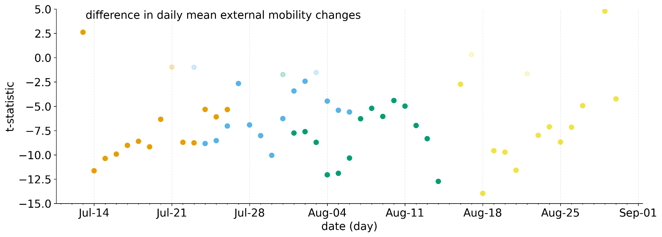Figure R1. Statistical difference in the mean daily external mobility. Each pair of localities is treated as a replicate each day, and the difference in variance is assessed using a Levene test at the 0.05 significance level. The y-axis shows the t-statistic, computed assuming equal or unequal variance depending on the p-value of the Levene test (unequal if p-value < 0.05, equal otherwise) for samples of localities under lockdown and those not restricted. The color of the dot indicates the restriction group (indicated in Figure 1 of the main text), the significance of the t-test is indicated with the opacity of each dot; solid if p-value<0.05, and faded otherwise.
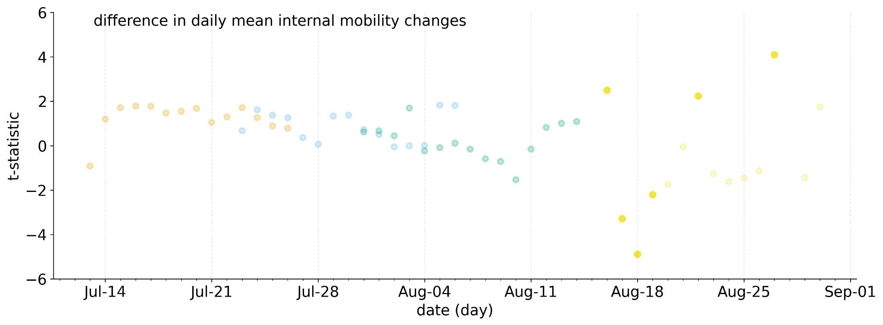
Figure R2. Statistical difference in the mean daily internal mobility. Each locality is treated as a replicate each day, and the difference in variance is assessed using a Levene test with a significance level of 0.05. The y-axis shows the t-statistic, computed assuming equal or unequal variance depending on the p-value of the Levene test (unequal if p-value < 0.05, equal otherwise) for samples of localities under lockdown and those not restricted. The color of the dot indicates the restriction group (indicated in Figure 1 of the main text), the significance of the t-test is indicated with the opacity of each dot; solid if p-value<0.05, and faded otherwise.
Comment 5, R1. Discussion of Limitations and Bias. The Conclusions/Discussion section should include a dedicated paragraph addressing the potential biases in the data (e.g., under-reporting, testing rate changes) and the analytical limitations noted above. This contextualizes the findings and strengthens the manuscript's scholarly integrity.
Answer. We thank the reviewer for this valuable comment. We included a paragraph in the Discussion explicitly addressing data-related biases and analytical limitations. The new text appears in lines 533–549 of the revised manuscript and reads:
“Future research could investigate how transmission within specific communities shapes behavioral responses that are not fully captured by aggregate mobility data. While our estimates control for changing population susceptibility at the scale of the implemented restrictions, susceptibility and exposure are likely clustered at finer spatial and social scales associated with socioeconomic conditions, household structure, and occupation. As a result, observed mobility reductions may not fully reflect compliance or contact patterns among under-represented populations, particularly in lower-SES localities. In addition, temporal variation in testing capacity and case detection, along with potential under-reporting during epidemic peaks, may introduce bias in locality-level transmission estimates despite accounting for reporting delays. Our counterfactual simulations further assume stationary transmission in the absence of interventions and time-invariant infection fatality rates, which may overestimate intervention impacts if spontaneous behavioral changes or healthcare system saturation altered transmission or mortality dynamics. Together, these limitations suggest that differential compliance and unobserved heterogeneity at finer spatial scales may partly explain why later interventions appeared less effective than initial lockdowns, underscoring the need for future work integrating high-resolution behavioral, socioeconomic, and surveillance data to inform more adaptive, equitable control strategies.”
Reviewer 2
General comment
In the manuscript titled “Understanding the mechanisms behind rotational and localized lockdowns: How mobility and spatial disparities modulate COVID-19 transmission”, the authors discuss how NPIs applied at final spatial scales may be utilized to control disease transmission.
I believe the results of the paper may be structured in 3 sections:
Purely descriptive results of the pandemic situation in Bogota. The authors describe the incidence, the rotational lockdown (groups 1-4), how this affected internal/external mobility, and the effective r-value in the different localities
The authors discuss counterfactual simulations in which interventions are introduced 2 weeks earlier than in reality
Relation of effective R-value and sociodemographic attributes via a linear model.
I agree with the authors that the effectiveness of localized, nuanced NPIs should be evaluated and understood better to increase pandemic preparedness and limit economic/social/psychological burdens during the next outbreak.
However, I would like to address the following points:
Minor comments
Comment 1, R2. Abstract. Line 21 → Please explicitly state what is meant by “commuting changes”. What is assumed as baseline? Is this an absolute or relative change?
Answer. We have clarified that “commuting changes” in the abstract section (between lines 20 and 23) refer to relative variations in mobility compared to a pre-intervention baseline, defined as the average movement during the 14 days preceding each restriction. We also specified that changes were expressed as percentage differences from this baseline. The Facebook data shows the number of devices that logged in when moving between two specific locations. We aggregated this data at the locality scale to quantify the number of devices that moved from one locality to another, or moved between two different places inside a locality, in a day. This definition allows us to define any baseline that, for our analysis,s we assumed was 14 days (2 weeks) before each restriction started.
This also aligns with Comment 4 from Reviewer 1. We invite the reviewer to review our response on this point as well.
Comment 2, R2. Line 25 ff → You state that interventions affected inter-locality mobility, but only minimally affected within-locality movement. As far as I understand from the later parts of the manuscript, this is a purely descriptive result. Please state as such and quantify the strength of the effect.
Answer. We revised the abstract to indicate that this finding is descriptive and quantified the effect: inter-locality mobility decreased by up to 40%, while within-locality movement changed by less than 5% on average.
Comment 3, R2. Introduction.
Line 35: On March 6, 2020, the first Colombian case was detected.
Line 54: Public transport routes are structured at this scale, and reductions in mobility during the first month of the pandemic followed these spatial patterns → Please elaborate. What kind of mobility reductions? How did they follow this pattern? I don’t find this clear
Answer. We revised this sentence to clearly describe the type of mobility reductions observed during the first month of the pandemic, differentiating between inter- and within-locality movements, and to explain how these reductions aligned with the locality-scale organization of public transport routes. This comment also strengthens the connection between early mobility patterns and the subsequent design of the rotational lockdown policy.
Comment 4, R2. Line 63/64: I would refrain from calling COVID-19 the “most severe pandemic”. Potentially rephrase and explicitly state which societal aspects were affected. Line 65: NPIs were also introduced because vaccines and other treatments were simply not available
Answer: We thank the reviewer for bringing this potential mischaracterization of the pandemic to our attention. We have revised the Introduction to avoid describing COVID-19 as the “most severe pandemic” and instead explicitly detail its impacts on public health systems, economic activity, education, and social life. We also clarified that NPIs were implemented during a period when vaccines and effective pharmaceutical treatments were not yet available.
The revised text appears in lines 37–42 of the Introduction and now reads:
“The rapid global spread of SARS-CoV-2 triggered a pandemic with far-reaching consequences for public health systems, economic activity, education, and social life worldwide. In response, non-pharmaceutical interventions (NPIs) were implemented across countries and at multiple spatial scales to control transmission, particularly during the early phases of the pandemic when vaccines and effective pharmaceutical treatments were not yet available…”

Comment 5, R2.
Paragraph starting line 72: You discuss compartmental models and later metapopulation models, but completely forget about the role mobility data plays in agent-based models. Here are some pre-COVID-19 examples:
- Timo Smieszek. A mechanistic model of infection: why duration and intensity of contacts should be included in models of disease spread. Theoretical Biology and Medical Modelling, 6(1), November 2009. http://dx.doi.org/10.1186/1742-4682-6-25.
- Jürgen Hackl and Thibaut Dubernet. Epidemic spreading in urban areas using agent-based transportation models. Future Internet, 11(4):92, April 2019. http://dx.doi.org/10.3390/
fi11040092.
And here are some COVID-19 examples:
Kerr CC, Stuart RM, Mistry D, Abeysuriya RG, Rosenfeld K, Hart GR, et al. (2021) Covasim: An agent-based model of COVID-19 dynamics and interventions. PLoS Comput Biol 17(7): e1009149. https://doi.org/10.1371/journal.pcbi.1009149
- Müller SA, Balmer M, Charlton W, Ewert R, Neumann A, Rakow C, et al. (2021) Predicting the effects of COVID-19 related interventions in urban settings by combining activity-based modelling, agent-based simulation, and mobile phone data. PLoS ONE 16(10): e0259037. https://doi.org/10.1371/journal.pone.0259037
Kerkmann, David, et al. "Agent-based modeling for realistic reproduction of human mobility and contact behavior to evaluate test and isolation strategies in epidemic infectious disease spread." Computers in biology and medicine 193 (2025): 110269.
Please consider adding a handful sentences of the integration of mobility data into ABMs.
Answer. We thank the reviewer for pointing out that we did not introduce the past use of ABM. In particular, how they have been used to answer questions about the role of mobility and contact frequency in the transmission of communicable diseases such as COVID-19. We now included a sentence in the introduction and cited some of the works the reviewer suggested. Starting in line 80, the reviewer can see the modified sentence that addresses this comment.
Comment 6, R2. - Line 81: Please provide a motivation why “ideally” interventions would target the finest spatial scales
Answer. Thanks for the comment. We have added to the discussion (lines 503 to 518) on how local interventions could help to better control the disease.
Comment 7, R2. Results
- Line 123: Although you partially describe what is meant by “changes in mobility” in the methods, I believe more precision is necessary in the results, too. Please describe what kind of mobility measure you are considering (trip length, trip duration, commuting patterns, out-of-home duration), if you are considering absolute or relative change, what the baseline is etc.
Answer. Thanks for pointing out that this was not clear. This comment aligns with Comment 4 of Reviewer 1; however, you also point to the variable shown in Figure 1B. The data from facebook provide the number of devices moving between two specific locations. We aggregated this data at the locality scale to quantify the number of devices that moved from one locality to another, or moved between two different places inside a locality, in a day. This definition allows us to set a baseline of 14 days (2 weeks) before each restriction started, which we assumed for our analysis. In the results.
Comment 8, R2.
- Line 130: Maybe I received incorrect labels, but for me plot 1B is not a map plot
Answer. We thank the reviewer for pointing out this error. We were referring to Figure 1C. We have now corrected this error.
Comment 9, R2.
- Line 132/133: Please motivate why you differentiate between within-locality and between-locality mobility patterns. How do either of them affect transmission dynamics?
Answer. We thank the reviewer for pointing out that we did not explicitly justify the choice of spatial scale used to distinguish mobility patterns. We have revised the Results section to clearly motivate the distinction between within-locality and between-locality mobility and to link each component to its respective transmission mechanism. Because communities in Bogotá are socially and economically segregated at the locality level [1], we interpret between-locality mobility as a driver of spatial coupling between communities, while within-locality mobility more directly reflects local contact frequency and transmission intensity. This clarification strengthens the interpretation of the observed mobility patterns and their epidemiological relevance.
The revised text appears in lines 277–295 of the main text (Results) and reads:
“We identified four regions, each representing a distinct pattern in mobility dynamics, distinguishing between within-locality (internal) and between-locality (external) movements, as these mobility components capture different mechanisms of disease transmission. External mobility reflects commuting flows that connect local transmission processes across the city and facilitate the spatial spread of infection between populations, whereas internal mobility more directly influences contact rates within communities and thus local transmission intensity. In Figure 1C, we present maps highlighting the intervened localities. During the first restriction round, commuter flows between localities declined substantially, whereas internal movements within locked-down localities increased, consistent with a redistribution of daily activities toward residential spaces. In localities without restrictions, external mobility showed day-to-day fluctuations, whereas internal movement remained largely unchanged. During the second round, restricted localities again showed…”
Comment 10, R2.
- Line 137/140: Why are you not discussing the fourth round of restrictions? Please go beyond simple descriptive statistics.
Answer. We have revised the paragraph to explicitly discuss the third and fourth rounds of restrictions and to move beyond descriptive statistics by interpreting the observed mobility patterns in terms of diminishing behavioral responses and their implications for transmission dynamics. This revision clarifies why later intervention rounds were less effective in altering mobility and how this relates to the reduced epidemiological impact observed in subsequent analyses.
Comment 11, R2.
- Line 172/Figure 2: Please fix the typo in the legend. Please increase the labels of the x- and y-axis, they are extremely hard to read. Also please use a consistent color scheme across figures. Furthermore: You discuss the different localities, but for a non-local it might be hard to understand which of these localities belongs to which of the four groups. One idea would be to split the plot into four panels. It would also be interesting to quantify if interventions introduced in 1st group affected the R-values of group 1 more than the R-values of the remaining groups. I believe there’s more interesting questions to be asked that go beyond a temporal analysis.
Answer. Thanks for letting us know Figure 2 was hard to interpret. We modified the Figure presenting it with 4 panels. And to clarify the content of the Figure, we present the results of a Tukey HSD statistic to quantify differences between the locatities in each time period. This is shown in the second plot in Figure 2b (see below). As Figure 2 shows, regardless of the restriction group all localities follow the same trajectory. However, the localities in group 4 showed no significant differences with any other period except the post-lockdown period. These results suggest that the rotational lockdowns affected most localities but not those in group 4. It also suggests the last two rounds of lockdowns reduced $R_{eff}$ very little, as differences are close to zero (4th and last subplots in Figure 2b). We find that the combination of the first and second lockdowns appears to be almost additive: the first reduced the city-level $R_{eff}$ by 0.07, and the second reduced it to 0.13 relative to the baseline (pre-lockdown) (first subplot of Figure 2b). In addition, we find that the effectiveness of the first and second lockdowns remained high even in the post-lockdown period, with the difference approaching 0 from below (second and third subplots of Figure 2b).
As the reviewer suggested, it is of interest to quantify whether interventions introduced in group 1 affected its Reff-values more than those of the remaining groups. To do this, we use the Tukey HSD test to quantify differences between localities within each group over the study period. We compare each group to the other localities that were not restricted during that particular lockdown group. This experiment is presented in Figure R3 below. Two interesting patterns emerge: the first and second groups (first and second columns of Figure R3) of restrictions do not show statistically significant differences in either the change within the locked-down localities (first row) or between the locked-down and the free (second row). These results, in combination with the results of Figure 2B, suggest that the first two restrictions reduced in similar amounts the $R_{eff}$ of both the restricted localities and of the whole city. This reduction across scales is contrary to the 3rd and 4th group of lockdowns; in these, the difference was significantly and positive, thus non-restricted localities had a higher $R_{eff}$ than those restricted. Another Interesting result is that the localities restricted in group 1 kept reducing their $R_{eff}$ until the last group of lockdowns, although the change between the 3 and 4 time periods was minimal. This result is consistent with the localities restricted in the second group, although the change was smaller. Lastly, we find by the end of the restriction the $R_{eff}$ of all localities increased almost to the value during the first restrictions or higher.
In conclusion, these results support two of our main claims: first, NPIs at a finer scale have city-level reductions in $R_{eff}$ , and these reductions are all across the city, with heterogeneity, the change. As the susceptibility is controlled by in $R_{eff}$ it is likely that this heterogeneity emerges from other uncontrolled sources of variability, such as socio-economic status or population density. We also find support for our claim that only the first and second rounds of lockdowns effectively reduced the $R_{eff}$. Note that we are not claiming that the last 2 rounds of lockdown were ineffective; it is possible that such changes in mobility kept $R_{eff}$ values at their pre-lockdown levels, rather than continuing to reduce them.

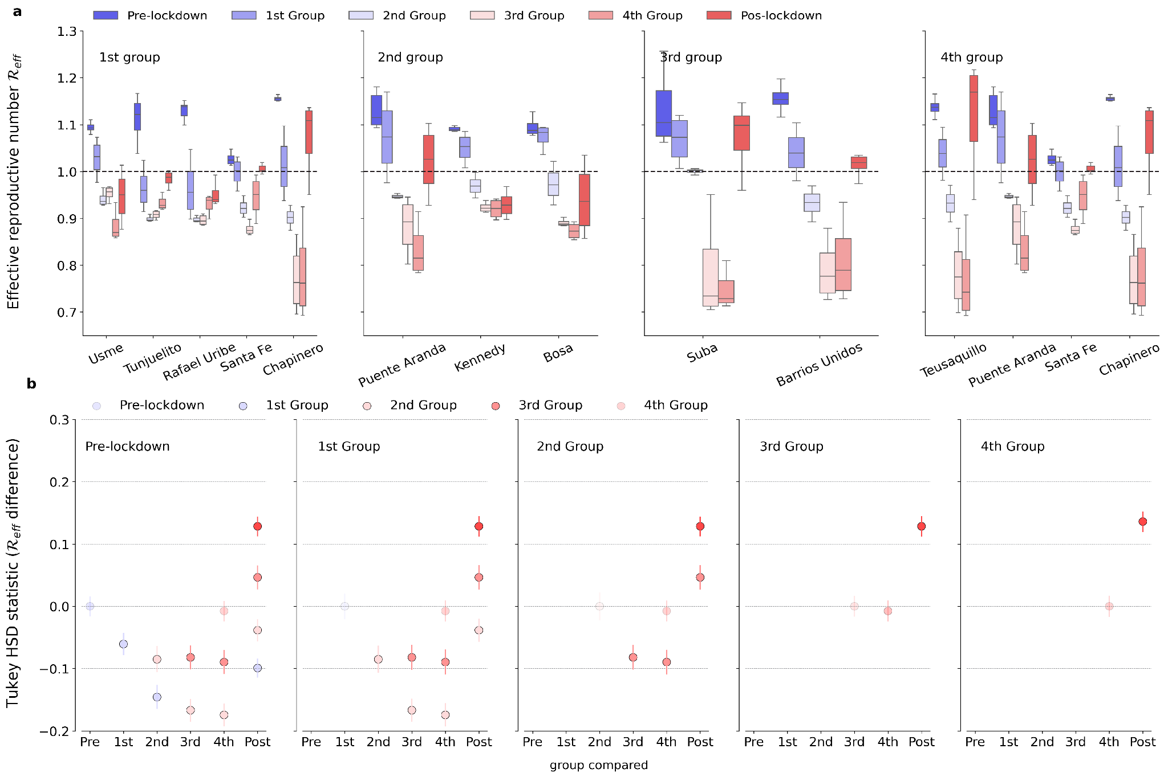Figure 2. Spatiotemporal variation and statistical difference in effective reproductive number. a) Each subplot shows the estimated effective reproductive number ($R_{eff}$) of the localities in each restriction group as indicated with an inset text during the course of the rotational lockdowns. Pre-lockdown refers to 14 days (2 weeks) before the interventions started, and post-lockdown refers to 2 weeks after. b) Pairwise statistical difference in $R_{eff}$ using a Tukey HSD statistic. Groups of localities are indicated by colors in the legend; for example, the 1st group is the $R_{eff}$ set of localities restricted to group 1 (Figure 1), and so on. The y-axis is the difference between the group in each subplot, as indicated with an inset text, and the group in the x-axis. For reference, we set differences within the same group to 0, e.g., pre-lockdown (first column) vs. pre-lockdown (first dot on the x-axis). Statistical significance was significant (p-value<0.05) if the dots are solid, and faded otherwise. For the pre-lockdown subplot, we compare differences across all localities between the Reff pre-lockdown and during the remaining periods of the rotational lockdowns. For the first group, we include only the localities that were locked down in Group 1; the same applies to the rest of the subplots in panel b.
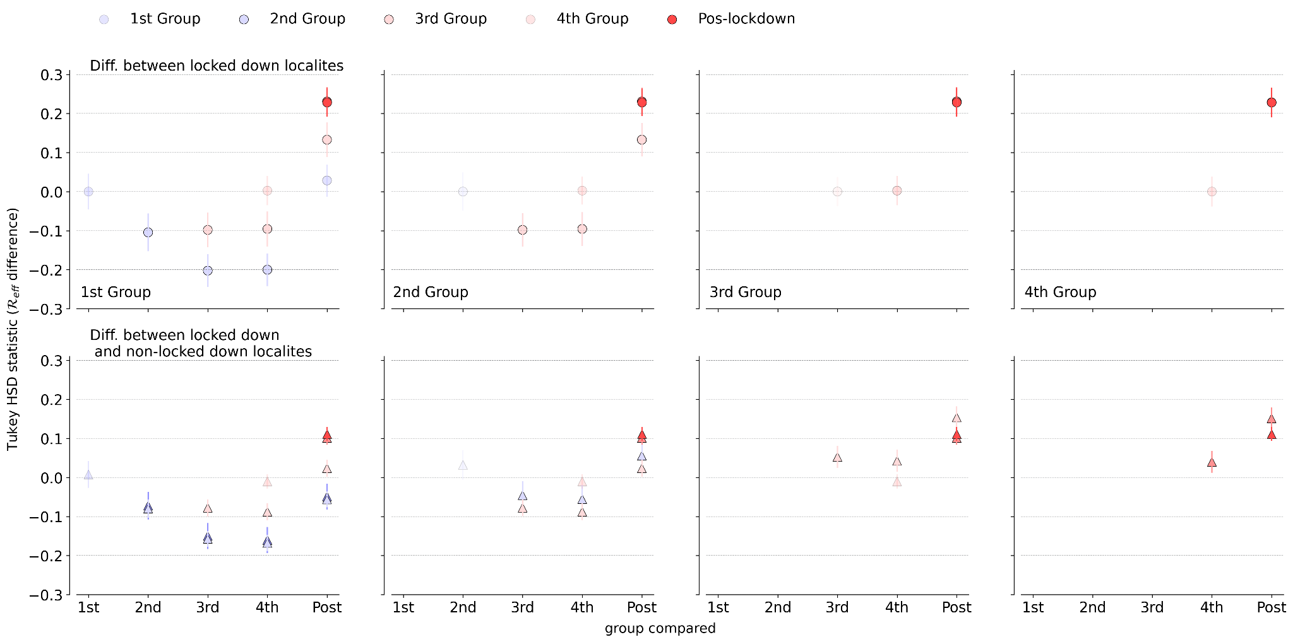
Figure R3. Statistical difference in effective reproductive number between localities locked down and those free. The first row shows the difference within the locked down localities. And the lower row the difference between the restricted localities and all the other non-locked down during that specific group (each column). From the left to right, subplots we present the localities in each group (Figure 1C) as indicated with an inset text. The y-axis is the difference in $R_{eff}$ quantified with a Tukey HSD test, and in the x-axis the time evolution during the study period as indicated with the time of restriction, we include the post-lockdown periods. Statistically significant differences are shown with a solid dot (p < 0.05); otherwise, they are faded.
Comment 12, R2.
- Line 177: Please define clearly what you mean by counterfactual. It is in the methods, but I believe the readability would be improved if you also clearly stated this here
Answer. We thank the reviewer for this suggestion. We have revised the Counterfactual projections and inference subsection to explicitly define the term “counterfactual” at its first occurrence. The added sentence appears in line 212 of the revised manuscript and reads:
“By counterfactual, we refer to simulated epidemic trajectories under a hypothetical scenario in which no lockdown interventions were implemented, with transmission rates held constant at the average level estimated during the week preceding the intended start of each restriction.”
This clarification improves readability and ensures consistency with the definition used throughout the manuscript.
Comment 13, R2.
- Figure 3: Unfortunately, I have a hard time understanding figure 3. You somewhat discuss the different rows, but not the different columns? I believe the caption and description must be significantly improved, before feedback can be provided
Answer. Thanks for letting us know the Figure was not conveying the intended message. We changed the caption to explain the variation in rows (epidemiological indicators) and columns (restrictions), as shown in Figure 1. Rows are different epidemiological indicators (reported incident cases for the first row, COVID-19 mortality in the second, and Rₑ in the last). In the columns, we present the counterfactual scenarios for each intervention group (Figure 1). We also added details on how to interpret the confidence intervals and observed data. We hope this modified version is easy to interpret.
Comment 14, R2.
Line 204: Socioeconomic attributes are often strongly correlated. What steps were taken to ensure that the model does not suffer from severe confounding?
Answer. We thank the reviewer for highlighting the need to clarify how we addressed potential multicollinearity among predictors. As suggested, we describe our approach to inspecting and reducing correlations among socioeconomic covariates before model selection. First, we conducted a preliminary assessment of pairwise Pearson correlations and excluded highly collinear variables from inclusion in the same model. We then applied a stepwise backward selection procedure based on WAIC to retain only the most predictive and non-redundant covariates, thereby minimizing confounding and improving model stability.
This clarification has been added in lines 398–402 of the revised manuscript, which now read:
“To address potential multicollinearity among socioeconomic covariates, we examined pairwise correlations prior to model fitting and excluded highly correlated variables. Additionally, we applied a stepwise backward selection procedure based on WAIC to retain only the most predictive and non-redundant covariates, minimizing confounding and ensuring model stability.”
Comment 15, R2.
- The separate file I received does not contain Figure 4. Therefore, I cannot comment on either your modeling approach or the findings.
Answer. Thank you for catching this inconsistency. The error was limited to the figures file, where Figure 4 had been incorrectly labeled as Figure 5. This has now been corrected in the figures document, and the figure numbering in the manuscript text was already consistent.
Comments on section: Materials and methods
- I believe this section needs the most revisions.
Comment 16, R2.
- Line 366: I am not sure if the labels were mixed up while separating the files, but for me Figure 1C does not contain any red
Answer. We thank the reviewer for pointing out this inconsistency. The original text incorrectly referred to restricted localities as being highlighted in red. We have revised the description of Figure 1C to accurately reflect the figure, clarifying that each lockdown group is shown using a distinct color while non-restricted localities are shown in grey.

Comment 17, R2.
- Line 371: I believe the description of the data must be severely improved. Unfortunately, the authors fail to discuss the bias of their sample (which often arises when using data from Facebook). Has this data been validated in any way? Compared to e.g. google mobility trends? It is mentioned that there exists some sort of baseline, but it is not defined. Is the baseline simply shortly before the pandemic? The same time during the previous year? Please be more specific. Furthermore, it needs to be defined what is meant by “location” here. Do you mean a visit to a specific point of interest (POI) or simply stationarity in a locality? What is the precision of the data source? There are so many important details that unfortunately, are not discussed yet
Answer. We thank the referee for this detailed and constructive comment. We have substantially revised the Mobility data subsection in the Methods to improve clarity and transparency regarding the Facebook GeoInsights data, explicitly addressing potential sample biases, the definition of the mobility baseline, the meaning of “location,” data precision, and privacy-related limitations. We now describe how the baseline is constructed by Facebook (averaged device presence and transitions by week and time of day), clarify that mobility reflects aggregated stationarity and transitions between spatial units rather than visits to specific points of interest, and discuss known sources of bias associated with Facebook-derived mobility data, including demographic and socioeconomic skew, privacy noise, and spatial aggregation.
The revised text appears in lines 146–163 of the manuscript and reads:
“We used Facebook's data from the GeoInsights portal (https://dataforgood.facebook.com/dfg/tools), which consists of aggregate and anonymized location data from Facebook app users. We employed movement and population datasets to measure mobility variation across Bogotá. Facebook provides a baseline for each location, calculated as the average number of devices in that area or making transitions during a specific week and time, based on user data from the Facebook app. This mobility data offers aggregated, location-enabled movement patterns, including origin-destination matrices, short- to mid-range flows, and stay durations at various scales. Collected from anonymized device pings and protected by privacy measures like differential privacy, these data reveal broader mobility trends and contact opportunities relevant to public health, urban planning, and transportation. However, biases exist, such as skewed samples toward younger, urban, and digitally connected users, regional and socioeconomic disparities, privacy noise, behavioral shifts, and coarse spatial detail due to privacy safeguards. Access, managed by a private company, can hinder long-term studies and reproducibility. Best practices include documenting data aggregation, privacy settings, preprocessing steps, and cross-validating with independent sources to reduce biases.”
These revisions directly address the reviewer’s concerns and improve the methodological transparency and interpretability of the mobility data used in our analysis.
Comment 18, R2.
- Line 429: Very little model details are provided beyond it being a “spatiotemporal Bayesian hierarchical model”. Please provide further details on the model, the data used, give an exploratory analysis. What language was the model written in? Did you use MCMC to infer your model parameters? Was convergence ensured?
Answer. We thank the referee for suggesting that we expand the explanation of the spatiotemporal Bayesian hierarchical model. In response, we have substantially revised the Methods section to include a more detailed description of the model structure, data sources, covariates, priors, and inference procedure. These additions clarify how spatial and temporal dependencies are modeled and how parameter uncertainty is quantified.
The expanded description appears in lines 241–770 of the revised manuscript, in the subsection “Statistical associations between transmission changes and sociodemographic factors”, and reads:
“We quantified how mobility changes and socioeconomic factors (see the Mobility data and socioeconomic data sections above) explained the spatial and temporal changes of the effective reproduction number ($R_{eff}$) during the lockdowns. For this, we used a spatiotemporal Bayesian hierarchical model ⁴⁹ to quantify how much of the variation in the mean weekly $R_{eff}$ was explained by these factors. In the model, the $R_{eff}$ is modeled with a normal distribution with a mean and a standard deviation. The Bayesian hierarchical model is a generalized linear regression model that predicts the mean weekly $R_{eff}$ for a total of T=18 weeks. We used sociodemographic factors that could potentially explain differences $R_{eff}$ between localities. Specifically, the linear model includes 9 spatiotemporal covariates, and we use data from T=18 weeks and S=20 localities to estimate the model coefficients$X_{jik}$ (j=1...,9 covariates; i=1...,18 weeks; j=1...,20 localities). The model then incorporated both fixed effects (e.g., household size, mobility indicators (internal and external), and socioeconomic variables) and random effects to capture spatial and temporal dependencies. Spatial correlation was modeled using an intrinsic conditional autoregressive (ICAR) prior based on neighborhood adjacency derived from Bogotá’s locality shapefile, while temporal variation was handled through repeated measures across dates. We implemented a spatiotemporal Bayesian hierarchical model in R using the NIMBLE package, which allows flexible specification of hierarchical structures and custom priors. In Section 2 of the SM, we present a full description of the spatiotemporal Bayesian hierarchical model.

Parameter inference was performed via Markov Chain Monte Carlo (MCMC) sampling with four parallel chains, each initialized with dispersed starting values to ensure robust exploration of the posterior space. We ran 160,000 iterations per chain with a burn-in of 80,000 and thinning to reduce autocorrelation. Convergence was assessed using the Gelman–Rubin diagnostic and visual inspection of trace plots, which confirmed that all monitored parameters exhibited satisfactory mixing and convergence. Model comparison was conducted using the Watanabe–Akaike Information Criterion (WAIC) in a stepwise backward selection procedure to identify the most predictive set of covariates. Finally, 95% credible intervals for fixed-effect coefficients were obtained from the posterior distributions, assuming conditional modes of random effects remained fixed across units.”
We also refer readers to Section 2 of the Supplementary Material, which provides a mathematical description of the model.

Bibliography

- Dueñas, M., Campi, M., & Olmos, L. E. (2021). Changes in mobility and socioeconomic conditions during the COVID-19 outbreak. Humanities and Social Sciences Communications, 8(1).

