V-Ray for MotionBuilder prototype help

Installation

Open the vray4mobu_<date> folder that you unzipped and run “install_2014” or “install_2015”, depending on your MotionBuilder (MoBu) version. The script uses the default Program Files install path, so if your MoBu is somewhere else, you will need to edit that path in the script. It only copies a few files. There is no uninstall option. You can just overwrite a previous install by running the install script again.

Running

You need to use the “run_2014” or “run_2015” script to run V-Ray in Mobu. It sets some necessary environment variables. You can permanently set these variables from the Windows Control panel if you prefer and then you will be able to start Mobu directly.

Note: The install script puts an “init_vray.py” file into <MotionBuilder>\bin\config\PythonStartup. This file automatically loads V-Ray when Mobu starts up. If you don’t want this or it doesn’t work, you can move the file out of this folder. Then you’ll need to type “import vray4mobu” into the Python editor in Mobu to load V-Ray.

Note: If V-Ray doesn’t load up at startup, you can check for errors in Windows->Python Editor.

Usage

Note: The V-Ray VFB will show up and instantly hide on startup. This is normal.
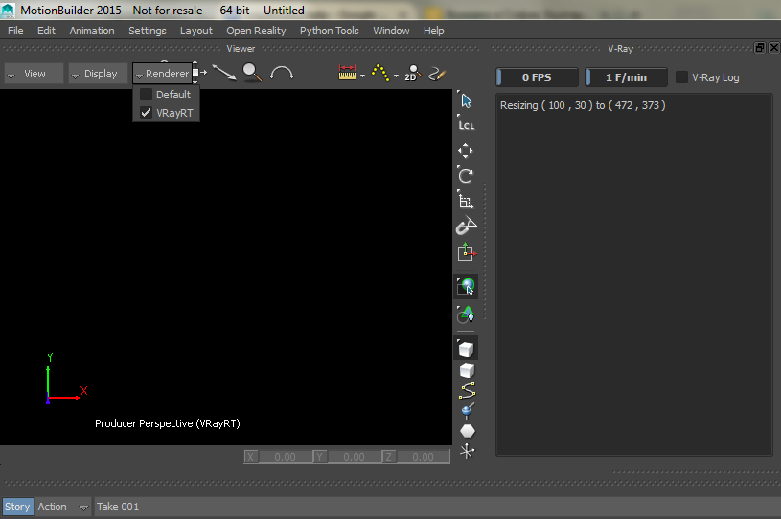Fig. 1 - V-Ray viewport on startup
Fig. 1 shows roughly what you should see when V-Ray starts up with Mobu as the viewport renderer. If you can’t see the “V-Ray” dockable window, it should be available from Python Tools->V-Ray.
The main V-Ray renderer options and actions are accessible from the custom renderer object in the scene as seen on Fig.2 (with an open Property View window). The options (marked with “[V]”) work as follows:
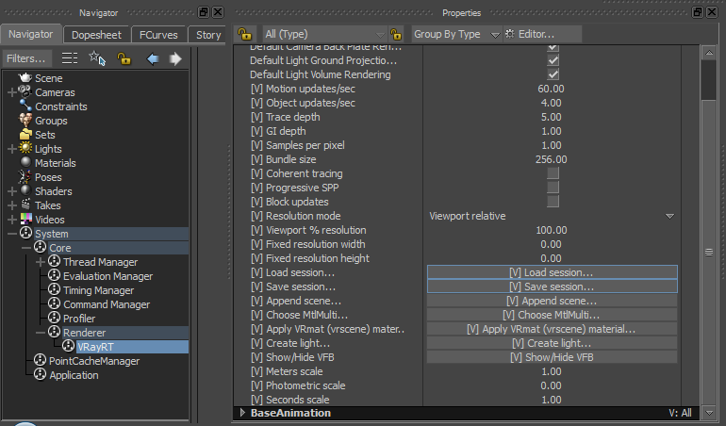Fig. 2 - V-Ray renderer object with Options
- Motion updates/sec – How often the exporter updates object positions (default should be fine)
- Object updates/sec – How often the exporter checks for new or deleted objects in the scene (default should be fine)
- Trace, GI depth – Standard render options as documented at http://docs.chaosgroup.com/
- Samples per pixel – Another regular V-Ray option, but very important for real-time performance
- Bundle size – Controls the size of tasks sent to the GPU. Very low and very high values decrease performance.
- Coherent tracing – Experimental option which may improve performance in interior scenes with multiple light bounces at the cost of reduced quality when samples are few.
- Progressive SPP – If set, and “Samples per pixel” is more than 1, each consecutive refinement frame will use more samples, starting from 1, up to the value of SPP. This is useless if the renderer is hooked up to live data, because the scene constantly changes and you will always get 1 SPP.
- Block updates – A very useful option that temporarily prevents V-Ray from applying updates to the rendered scene, so that it would be able to make multiple sampling passes and clean up the noise. Set up your live scene, block updates, make creative decisions and resume updates. No changes are lost while the updates are blocked – they are only queued up.
- Resolution mode – Whether to use a fixed pixel resolution for the actual V-Ray render process or some fraction of the Mobu viewport resolution. May be used to increase framerate with lower resolutions, but at the cost of reduced quality, due to interpolation of the rendered image to fit the viewport.
- Viewport % res. and Fixed res. - The actual resolution setting. The one that is not selected as “Resolution mode” is ignored.
- Meters, Photometric, Seconds scale – The parameters for the SettingsUnitsInfo V-Ray plugin, translating native scene scale to V-Ray scene scale. Related to Physical camera parameters.
There are also several buttons, but first a few words about scene objects and materials:
This prototype uses the native MotionBuilder scene objects for exporting geometry, positions and some camera settings. We also support creation of some lights as scene objects, which remain saved with the scene. Renderer settings are also saved with the scene. The major exception are materials. They are not part of the native scene and we have a limited import functionality using vrscenes. You have two options: the first is to use Vrmats (aka vismats) which also allows for setting a vrscene file instead of a vrmat. If you set a vrscene in the vrmat path, you will be given a list of MtlSingleBRDF materials contained in that vrscene. You could export such materials i.e. from Max or Maya (with the separate files option, choosing only materials, textures and bitmaps). The second option is to again export materials into a vrscene from another application, but this time using MtlMulti which would allow sub-object mapping. Since these two material workflows are not integrated with the native Mobu scene, we've added a way to save material setups in additional files (See the Save/Load session buttons).
Having this in mind, this is what the buttons in the VRayRT properties do (in reverse order):
- Show/Hide VFB – Shows or hides the V-Ray standalone VFB window.
- Create light – Shows a dialog for creating a light object. The light has a MotionBuilder type which is disregarded. Instead, it has its own custom attributes, one of which is the V-Ray type and the rest are the corresponding type specific parameters. Common basic parameters like “color” and “visible” are taken from the native Motionbuilder properties. See the note below.
- Apply VRmat material – Opens a dialog window. It lets you choose a vrmat/vismat/vrscene file and lists the materials that it contains. The scene objects you can apply it to are listed on the left. You can multi-select from them, select a material from the list on the right and click apply. You could do this multiple times, i.e. when you have many materials from one file. Remember to click “Apply” (takes some time to load up and appear in the viewport render) and then click “Close”.
- Append scene – Use this to append a vrscene file with MtlMulti materials.
- Choose MtlMulti – Opens a dialog window similar to the VRmat dialog. It lists all the available Multi-materials from appended vrscenes. You have the same list of all geometry objects in the scene to apply materials to as with the VRmat dialog.
- Save session – Save a .json text file which lists all the appended vrscene files and all applied Vrmat and Multi materials.
- Load session – Load a material setup from a .json file saved with the Save session button.
Note: V-Ray light and Physical camera properties are implemented as custom object properties in Mobu. You may need to set the Property View filter to “All” instead of “Default” to be able to see them! The V-Ray properties are marked with “[V]”. See Fig. 3 for illustration.

When there is no V-Ray light in the scene, a default directional light attached to the current camera is used. It is disabled when a light is created. New lights are placed at coordinates (0, 0, 0) so you may see a black screen at first, if some object obstructs the light. Created lights are automatically selected by default, so you can just move the light to its proper position. Since you may not be able to see a lit scene while moving it, you may need to switch back to the OpenGL renderer to move the light properly.
To switch between V-Ray and the OpenGL renderer, use the Renderer drop-down above the viewport. Note however, that this will reset all materials you might have set. You will need to set them again (easier if you use the Load session feature).
MotionBuilder may reset back to OpenGL when you load a scene, so you may have to choose V-Ray as renderer again. In any case, loading a new scene resets the V-Ray renderer and appended materials are also deleted from memory.

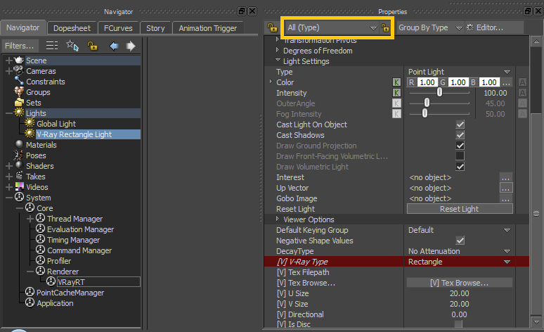Fig. 3 - Light properties example
Using physical camera for DOF, exposure, etc:
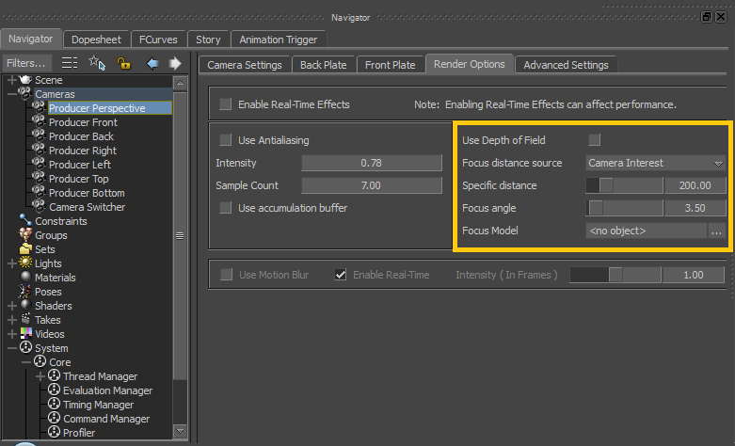Fig. 4 - Setting camera DOF
The V-Ray for MotionBuilder exporter uses the native Mobu camera depth of field parameters for the V-Ray camera (see Fig. 4), but only if “physical camera” mode is enabled (off by default). To enable it, open the current camera properties and check the “Use Physical” checkbox (see Fig. 5). All options below “Use Physical” are used only if it is checked. The blue “F-Number” property is an alias to the “Focus angle” native Mobu camera property.
When you enable the physical camera, you will probably see two immediate effects: framerate will drop and exposure will go off (if “Exposure Correction” is still checked). If you don't need the extra features, better leave physical off for better framerates. If you need exposure correction, you will also need to set appropriate meters/photometric/seconds scale values from the VRayRT renderer object (Navigator->System->Core->Renderer->VRayRT).
Known Issues
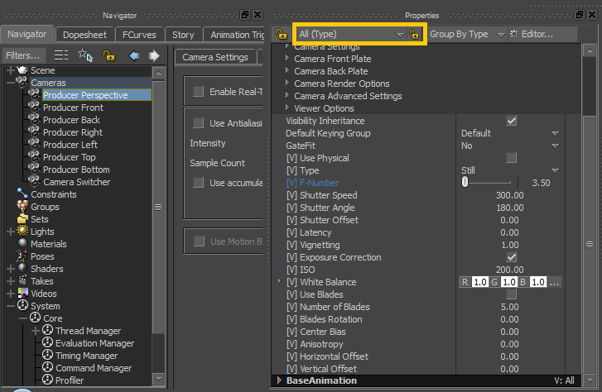Fig. 5 - V-Ray physical camera properties

- Setting scene units may be buggy – not applying correctly or at the right time. Also the editboxes for the values truncate small numbers, so for example 0.0001 will be seen as 0.00, although the value is still 0.001.
- Lights with set texture (dome, rectangle) render way too slow. We know why this happens and we are going to fix it.
- Native Mobu lights (those not created with V-Ray's “Create light” button) do not get exported to V-Ray and there is currently no option to convert existing lights to V-Ray lights.
Crashes

In case of a crash, Mobu dumps files to <My Documents>\MB\2015-x64. We may need those for debugging. V-Ray itself may write a dump to %TEMP%\VRay.dmp.

