CMSC203 Assignment 3 Documentation
(Change File name to FirstInitialLastName_Assignment3_Documentation.docx)

Class: CMSC203 CRN 21305
Program: Assignment 3
Instructor: Professor Grinberg
Summary of Description: lots of cryptography tools
Due Date: 10/12/2026 (<09/27/2026>)
Integrity Pledge: I pledge that I have completed the programming assignment independently.
I have not copied the code from a student or any source.
Student Name: Jacen Cheskin

Part 1: Pseudo Code:

//CAESAR CIPHER
ALGORITHM caesarEncryption(plainText, key)
IF NOT isStringInBounds(plainText) THEN RETURN ERROR_MSG
shift ← ((key MOD 26) + 26) MOD 26 // normalize key (handles negatives)
cipher ← ""
FOR i FROM 0 TO LENGTH(plainText) - 1
newPos ← (ORD(plainText.charAt(i)) - 65 + shift) MOD 26
cipher ← cipher + CHR(65 + newPos)
END FOR
RETURN cipher
END

ALGORITHM caesarDecryption(encryptedText, key)
shift ← ((key MOD 26) + 26) MOD 26
plain ← ""
FOR i FROM 0 TO LENGTH(encryptedText) - 1
newPos ← (ORD(encryptedText.charAt(i)) - 65 - shift + 26) MOD 26
plain ← plain + CHR(65 + newPos)
END FOR
RETURN plain
END

// VIGENERE CIPHER
ALGORITHM vigenereEncryption(plainText, key)
IF NOT isStringInBounds(plainText) THEN RETURN ERROR_MSG
IF key IS NULL OR LENGTH(key) = 0 THEN RETURN ERROR_MSG //check for division by 0
cipher ← ""
FOR i FROM 0 TO LENGTH(plainText) - 1
kPos ← ORD(key.charAt(i MOD LENGTH(key))) - 65 // key wraps around
newPos ← (ORD(plainText.charAt(i)) - 65 + kPos) MOD 26
cipher ← cipher + CHR(65 + newPos)
END FOR
RETURN cipher
END

ALGORITHM vigenereDecryption(encryptedText, key)
IF key IS NULL OR LENGTH(key) = 0 THEN RETURN ERROR_MSG
plain ← ""
FOR i FROM 0 TO LENGTH(encryptedText) - 1
kPos ← ORD(key.charAt(i MOD LENGTH(key))) - 65
newPos ← (ORD(encryptedText.charAt(i)) - 65 - kPos + 26) MOD 26
plain ← plain + CHR(65 + newPos)
END FOR
RETURN plain
END

// PLAYFAIR CIPHER, private helpers
ALGORITHM buildPlayfairGrid(key)
IF key IS NULL THEN key ← ""
seen ← EMPTY LIST
grid ← EMPTY 8x8 ARRAY
FOR EACH ch IN key DO
IF ch NOT IN ALPHABET64 OR ch ALREADY IN seen THEN CONTINUE
ADD ch TO seen
PLACE ch IN NEXT EMPTY SLOT OF grid
END FOR
FOR EACH ch IN ALPHABET64 DO
IF ch NOT IN seen THEN PLACE ch IN NEXT EMPTY SLOT OF grid
END FOR
RETURN grid
END

ALGORITHM preparePlayfairText(text)
text ← KEEP ONLY CHARACTERS 'A'–'Z' FROM text
REPLACE EVERY 'J' IN text WITH 'I' // J was removed from the grid, so J→I
pairs ← ""
prev ← NONE
FOR EACH ch IN text DO
IF prev = ch THEN pairs ← pairs + "X" // insert filler between double letters
END IF
pairs ← pairs + ch
prev ← ch
END FOR
IF LENGTH(pairs) IS ODD THEN pairs ← pairs + "X" // pad so length is even
END IF
RETURN pairs
END

ALGORITHM playfairEncryptPair(grid, a, b)
(ra, ca) ← POSITION OF a IN grid
(rb, cb) ← POSITION OF b IN grid
IF ra = rb THEN // same row → shift RIGHT
RETURN grid[ra][(ca + 1) MOD 5] + grid[rb][(cb + 1) MOD 5]
ELSE IF ca = cb THEN // same column → shift DOWN
RETURN grid[(ra + 1) MOD 5][ca] + grid[(rb + 1) MOD 5][cb]
ELSE // rectangle → swap columns
RETURN grid[ra][cb] + grid[rb][ca]
END IF
END

ALGORITHM playfairDecryptPair(grid, a, b)
(ra, ca) ← POSITION OF a IN grid
(rb, cb) ← POSITION OF b IN grid
IF ra = rb THEN // same row → shift LEFT
RETURN grid[ra][(ca - 1 + 5) MOD 5] + grid[rb][(cb - 1 + 5) MOD 5]
ELSE IF ca = cb THEN // same column → shift UP
RETURN grid[(ra - 1 + 5) MOD 5][ca] + grid[(rb - 1 + 5) MOD 5][cb]
ELSE
RETURN grid[ra][cb] + grid[rb][ca] // rectangle → swap columns
END IF
END

// PLAYFAIR CIPHER, public methods
ALGORITHM playfairEncryption(plainText, key)
IF NOT isStringInBounds(plainText) THEN RETURN ERROR_MSG
grid ← buildPlayfairGrid(key)
text ← preparePlayfairText(plainText)
cipher ← ""
FOR i FROM 0 TO LENGTH(text) - 1 STEP 2
cipher ← cipher + playfairEncryptPair(grid, text.charAt(i), text.charAt(i + 1))
END FOR
RETURN cipher
END

ALGORITHM playfairDecryption(encryptedText, key)
IF encryptedText IS NULL THEN RETURN ""
grid ← buildPlayfairGrid(key)
text ← encryptedText, keep only 'A'–'Z', replace every 'J' with 'I'
IF LENGTH(text) IS ODD THEN DROP LAST CHARACTER OF text // orphan can't form a pair
plain ← ""
FOR i FROM 0 TO LENGTH(text) - 1 STEP 2
plain ← plain + playfairDecryptPair(grid, text.charAt(i), text.charAt(i + 1))
END FOR
RETURN plain
END
Part 2: UML Class Diagram:;

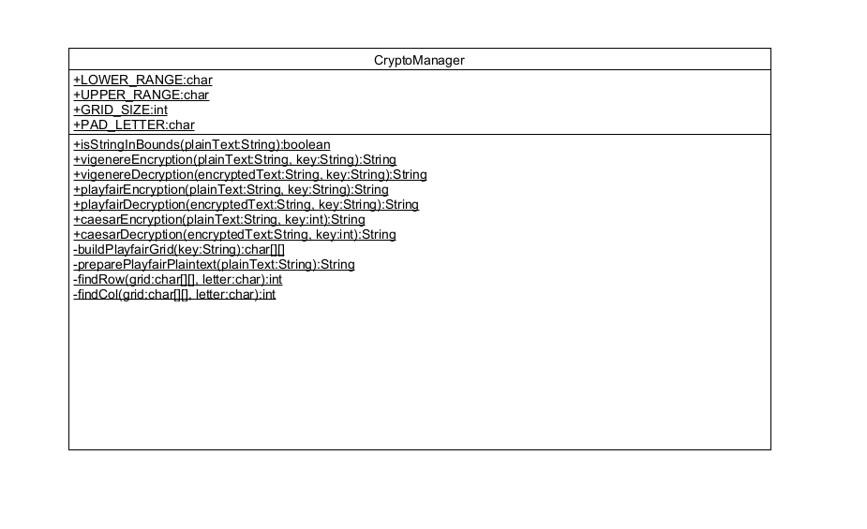

Part3: Comprehensive Test Plan
A good test plan should be comprehensive. This means you should have a few test cases that cover when the input is in-range, out-of-range, division by 0, incorrect Data type, etc.(Provide valid and invalid input).

Cases | Input | Expected Output | Actual Output | Did Test Pass?
Case 1 | HELLO with key 3 ceaser cipher | KHOOR | KHOOR | Yes
Case 2 | DATA 123  Key: JACEN  Vigenere | .27&N[SV | .27&N[SV | Yes
Case 3 | 123456  Key: MONTGOMERY | 2345X# | 2345X# | Yes
Case 4 | AB`  Key JACEN  Playfair | The selected string is not in bounds, Try again. | The selected string is not in bounds, Try again. | Yes

Part4: Screenshots:

        - Screen snapshots of outputs from Eclipse based on your Test Plan
(both encrypt and decrypt are shown where applicable)
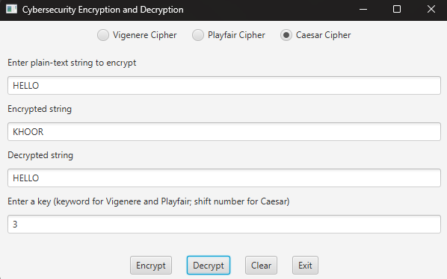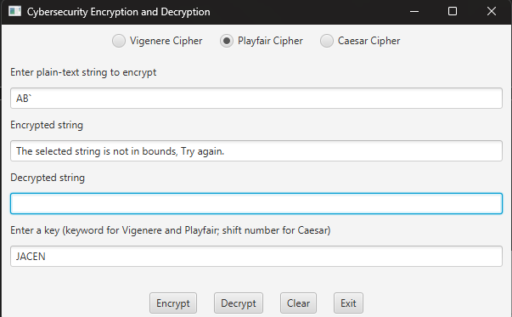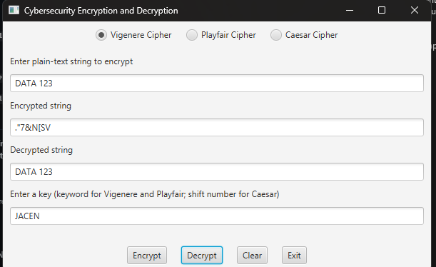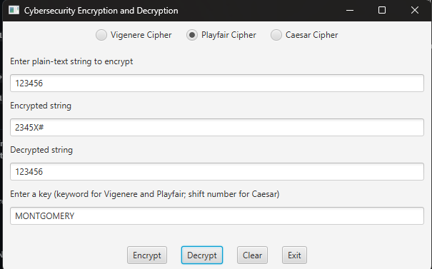

        - Screen snapshots of JUnit tests with extended methods’ tests
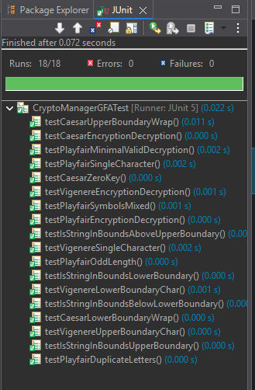
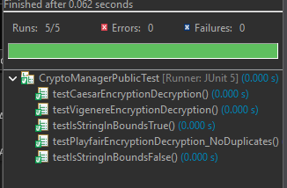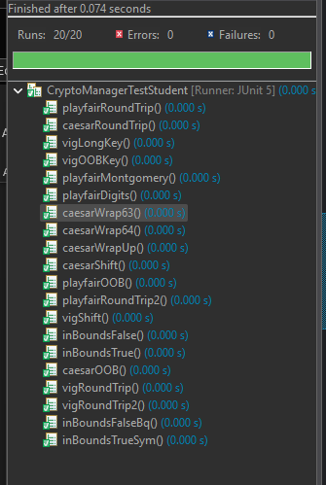
        - Screenshot of src folder files in your GitHub repository.

Lessons Learned <Provide answers to the questions listed above>:

Write about your Learning Experience, highlighting your lessons learned and learning experience from working on this project.

What have you learned?
I need to time manage better and double check my pseudocode, and maybe have a third party review it.
What did you struggle with?
I struggled with a lot of the checks on keys and making sure they were valid.
What would you do differently on your next project?
I would be more careful on the pseudocode portion of the project
What parts of this assignment were you successful with, and what parts (if any) were you not successful with?
My pseudocode was sloppy and rushed. When I needed to convert to real code I noticed many errors that I should have seen.
Provide any additional resources/links/videos you used to while working on this assignment/project.
https://www.vogella.com/tutorials/JUnit/article.html
Check List: <Provide answers to the column Y/N or N/A >:

# |  | Y/N
 | Assignment files:
 | - FirstInitialLastName_ Assignment3_Complete.zip | Y
 | - FirstInitialLastName_Assignment3.docx/.pdf | Y
 | - Source Java files | Y
 | - FirstInitialLastName_ Assignment3_JavaFiles.zip | Y
 | Program compiles
 | Program runs with desired outputs related to a Test Plan
 | Documentation file:
 | - Comprehensive Test Plan | Y
 | - Screenshots from IDE | Y
 | - Screenshots of your GitHub account with submitted Assignment# (if required) | Y
 | - UML Diagram | Y
 | - Pseudocode | Y
 | - Lessons Learned | Y
 | - Checklist is completed and included in the Documentation | Y

