CMSC203 Lab 1 Template

Class: CMSC203 CRN XXXX
Program: Lab 1
Instructor:
Summary of Description: (Give a brief description for each Program)
Due Date: MM/DD/YYYY
Integrity Pledge: I pledge that I have completed the programming assignment independently.
I have not copied the code from a student or any source.

Complete the following three parts of Lab 1. Name your file as FirstInitialLastName_Lab1.docx

Task 1
Provide the screenshots from Task 1 here:
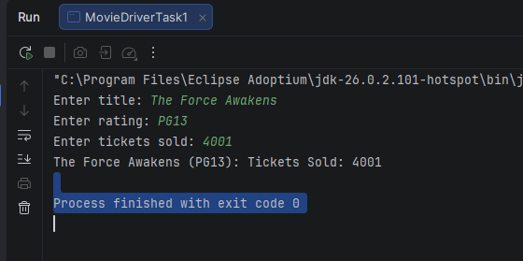
Submit both Java files from Task 1, even though you have not changed Movie.java

Task 2
Provide the screenshots from Task 2 here:
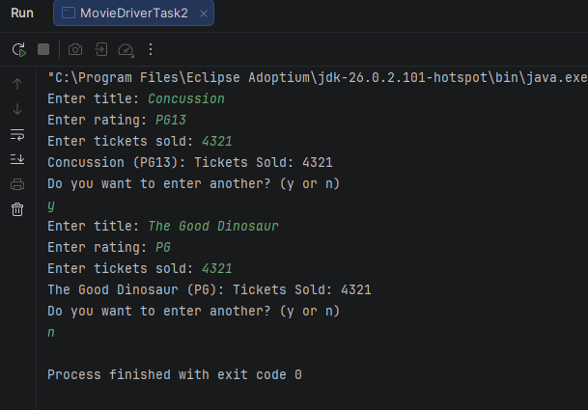
Submit both Java files from Task 2, even though you have not changed Movie.java

Task 3
Provide the screenshots from Task 3 here:

Lessons Learned <Provide answers to the questions listed below>:

Write about your Learning Experience, highlighting your lessons learned and the learning experience from working on this assignment.

What have you learned?

What did you struggle with?

What parts of this assignment were you successful with, and what parts (if any) were you not successful with?

Provide any additional resources/links/videos you used while working on this assignment.

Deliverables for Lab1:
Submit FirstInitiallastName_Lab1.zip
Include the following files in your zip file:
1.1 FirstInitiallastName_Lab1.doc based on a provided template:
1.2 Both Java files from Task 1, with the names Movie.java, MovieDriver_Task1 (even though you have not changed Movie.java)
1.3 Both Java files from Task 2, with the names Movie.java, MovieDriver_Task2 (even though you have not changed Movie.java)

Check List: <Provide answers to the column Y/N or N/A >:

# |  | Y/N | Comments
 | Lab 1 files:
 | - FirstInitialLastName_Lab1.docx/pdf
 | - Source Java files from Task 1
 | - Source Java files from Task 2
 | Program compiles
 | The program runs with the desired outputs
 | Documentation file: Screenshots of
 | - Task1
 | - Task2
 | - Task3
 | - Lessons Learned
 | - Checklist is completed and included in the Documentation

