CMSC203 Lab 2

Class: CMSC203 CRN 21305
Program: Lab 2
Instructor:
Summary of Description: makes a GUI with buttons that change the langauge
Due Date: 09/26/2026
Integrity Pledge: I pledge that I have completed the programming assignment independently.
I have not copied the code from a student or any source.

Task 1
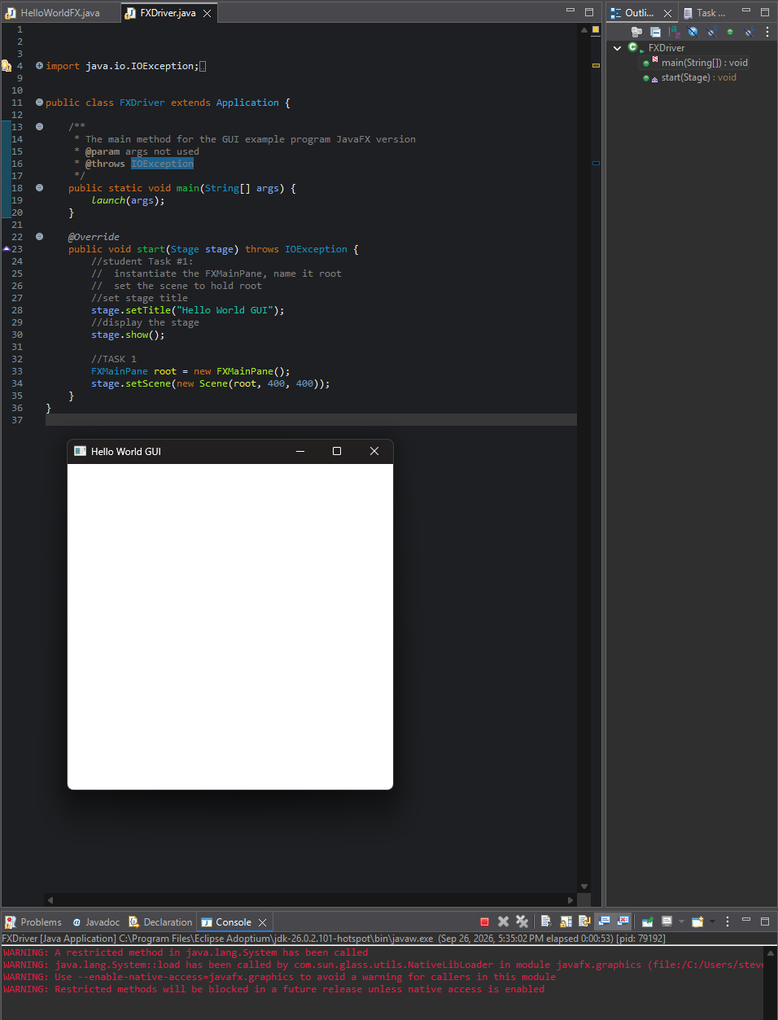

Task 2
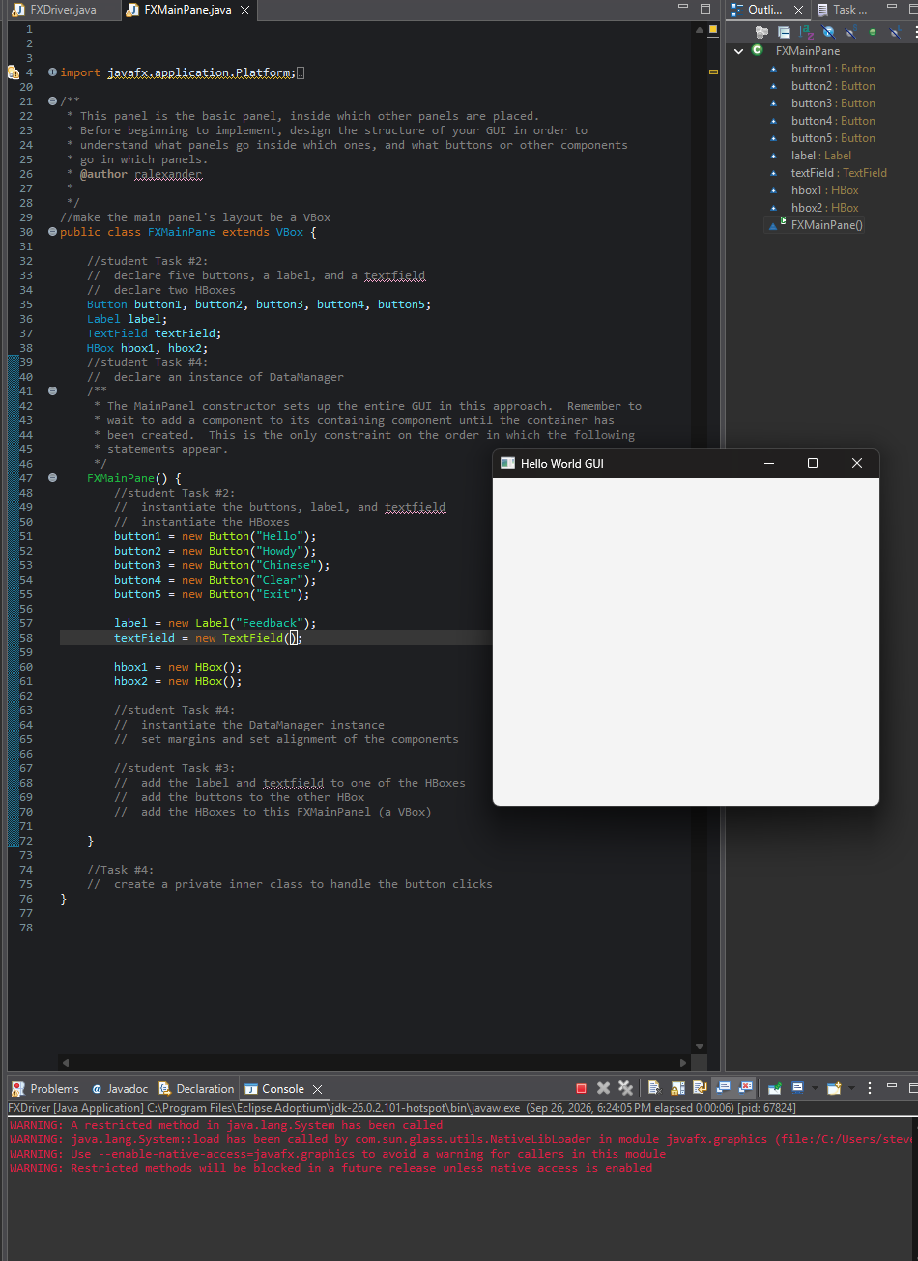

Task 3

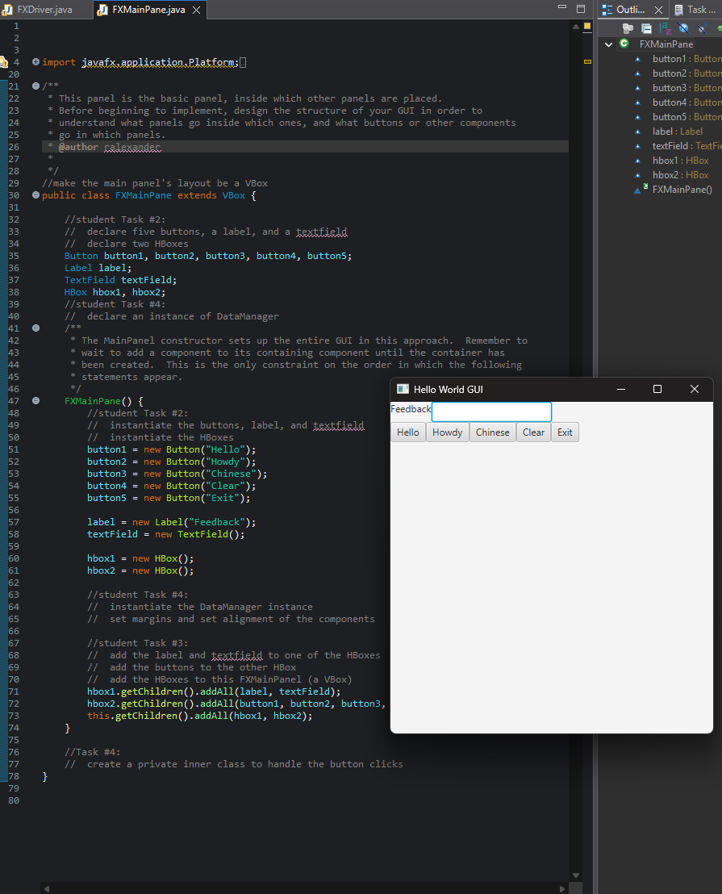

Task 4
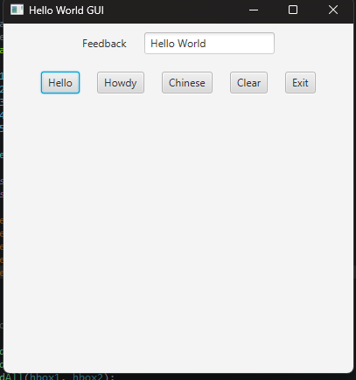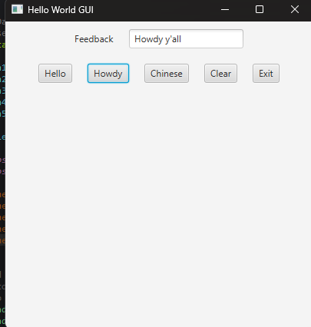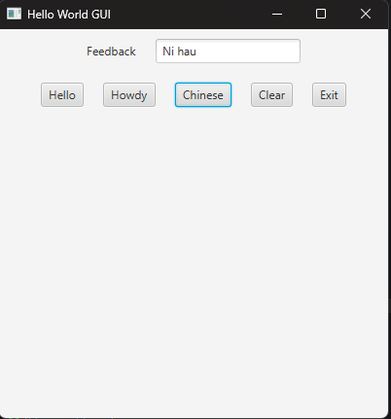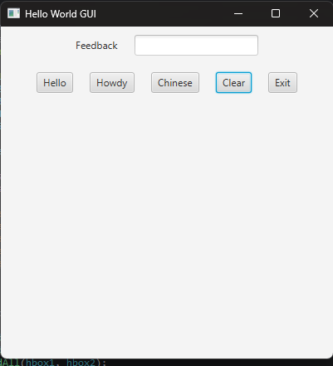

Github
