CMSC203 Lab 1 Template

Class: CMSC203 CRN 21305
Program: Lab 1
Instructor: Grinberg
Summary of Description: Movie class is an object that contains movie information. MovieDriverTask1 is a program that asks the user for inputs to put in a movie class. MovieDriverTask2 is the same as MovieDriverTask1 but repeats.
Due Date: 09/26/2026
Integrity Pledge: I pledge that I have completed the programming assignment independently.
I have not copied the code from a student or any source.

Complete the following three parts of Lab 1. Name your file as FirstInitialLastName_Lab1.docx

Task 1
Provide the screenshots from Task 1 here:
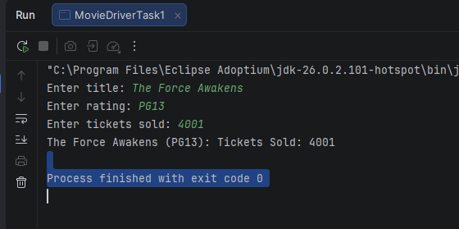
Submit both Java files from Task 1, even though you have not changed Movie.java

Task 2
Provide the screenshots from Task 2 here:
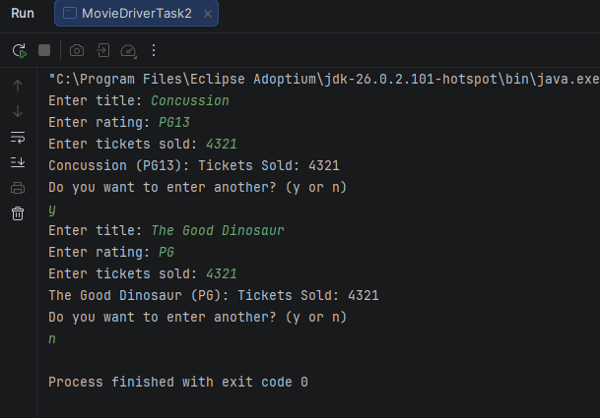
Submit both Java files from Task 2, even though you have not changed Movie.java

Task 3
Provide the screenshots from Task 3 here:
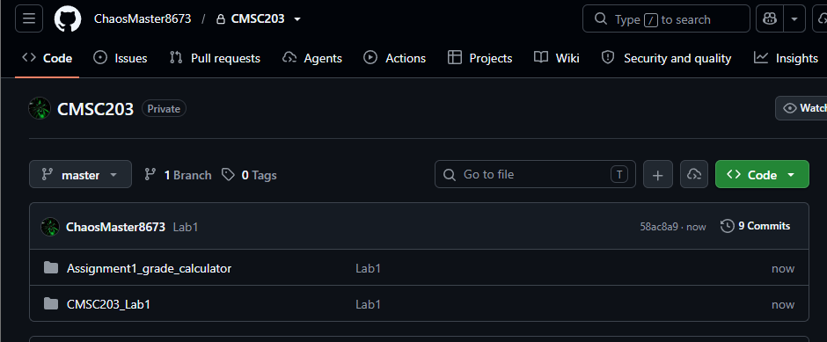

Lessons Learned <Provide answers to the questions listed below>:

Write about your Learning Experience, highlighting your lessons learned and the learning experience from working on this assignment.

What have you learned?
I learned how to make objects and use their mutator and accessor methods.
What did you struggle with?
Nothing
What parts of this assignment were you successful with, and what parts (if any) were you not successful with?
I was successful with reading inputs and managing the object.
Provide any additional resources/links/videos you used while working on this assignment.

Deliverables for Lab1:
Submit FirstInitiallastName_Lab1.zip
Include the following files in your zip file:
1.1 FirstInitiallastName_Lab1.doc based on a provided template:
1.2 Both Java files from Task 1, with the names Movie.java, MovieDriver_Task1 (even though you have not changed Movie.java)
1.3 Both Java files from Task 2, with the names Movie.java, MovieDriver_Task2 (even though you have not changed Movie.java)

Check List: <Provide answers to the column Y/N or N/A >:

# |  | Y/N | Comments
 | Lab 1 files:
 | - FirstInitialLastName_Lab1.docx/pdf | Y
 | - Source Java files from Task 1 | Y
 | - Source Java files from Task 2 | Y
 | Program compiles
 | The program runs with the desired outputs
 | Documentation file: Screenshots of
 | - Task1 | Y
 | - Task2 | Y
 | - Task3 | Y
 | - Lessons Learned | Y
 | - Checklist is completed and included in the Documentation | Y

