CMSC203 Lab 1 Template

Class: CMSC203 CRN 21305
Program: Lab 2
Instructor:
Summary of Description: (Give a brief description for each Program)
Due Date: 09/26/2026
Integrity Pledge: I pledge that I have completed the programming assignment independently.
I have not copied the code from a student or any source.

Task 1
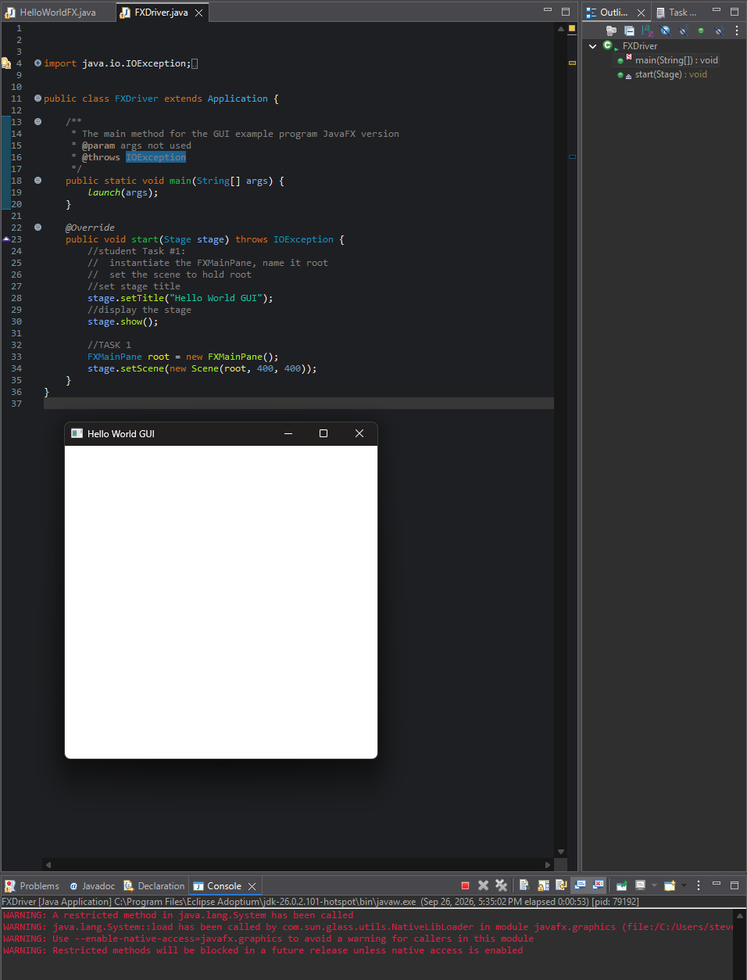

Task 2
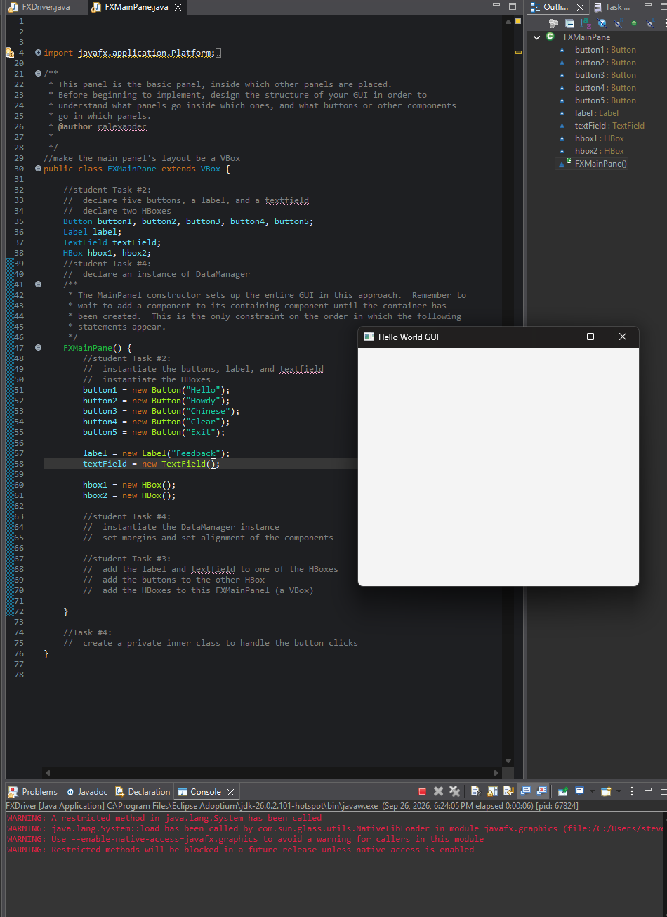

Task 3

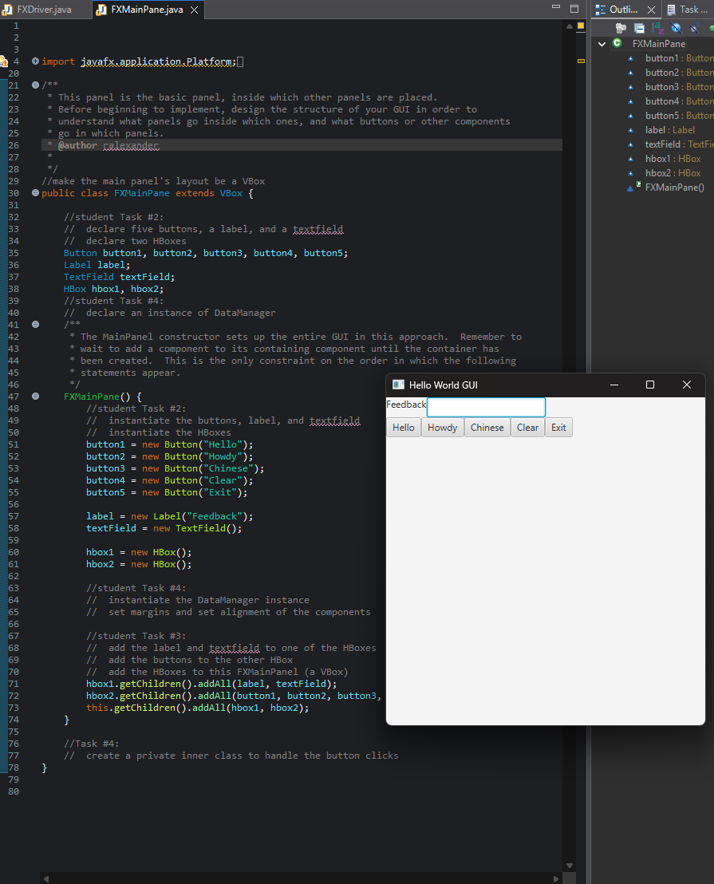

Task 4
