Montgomery College
CMSC 203
Assignment 4 Design

Class: CMSC203 CRN 21305
Program: Assignment 4 Design
Instructor: Professor Grinberg
Summary of Description: (Give a brief description for a Program)
Due Date 11/18/2024
Integrity Pledge: I pledge that I have completed the programming assignment independently.
I have not copied the code from a student or any source.
Student: Jacen Cheskin

Part 1: Create UML diagrams for all the classes in this assignment.
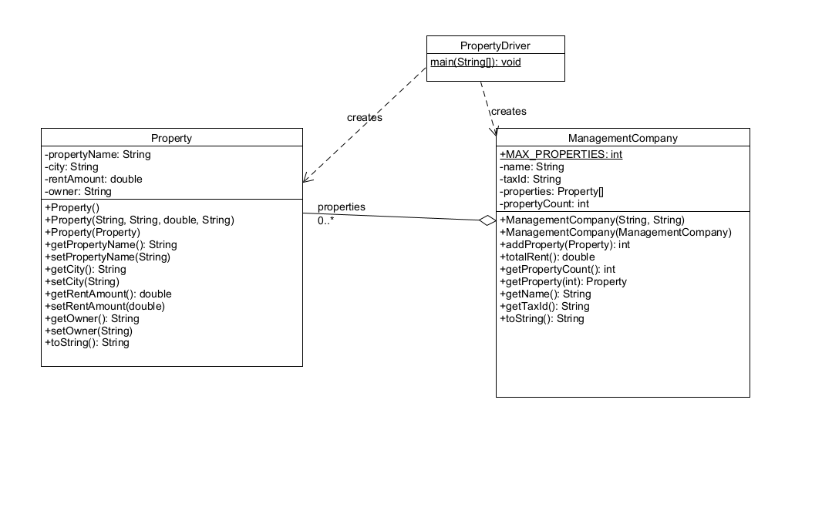
Refer to the UML Tutorial on how to create UML diagrams.
Notes: To create a UML Diagram, you can use a simple free tool UMLSculptor for Windows
https://sourceforge.net/projects/umlsculptor/
See attached examples
Part 2: Pseudo Code for the primary methods specified in ManagementCompany.java and Plot.java in a Word document. Do not just list what gets read in a printed-out, but explain the algorithm being used.
Refer to the Pseudocode Guideline on how to write Pseudocode:
There is no Plot.java, so the Pseudocode is for the classes I made the pseudocode for the three classes in the UML.
ManagementCompany
// storing the object directly would let the Property object be modified outside the class so it must be copied.
addProperty(p):
if propertyCount is equal to MAX_PROPERTIES then
set result to -1 // array is full, signal the error
else
create pCopy as a copy of p using the Property copy constructor
store pCopy in properties at position propertyCount
increment propertyCount
set result to propertyCount minus 1 // index where it was stored
return result

//Since the array might not be full, we only add to propertyCount-1 and not the total size of the array
totalRent():
set sum to 0
repeat for i from 0 to propertyCount minus 1
add the rent amount of properties[i] to sum
end repeat
return sum
//The deep copy constructor. The constructor is rebuilt with the values. You need to create a new array of properties because otherwise it would point to the same point in memory. All properties must also be new copies.
ManagementCompany(other):
set name to other's name
set taxId to other's taxId
set propertyCount to other's propertyCount
create properties as a brand-new array of size MAX_PROPERTIES
repeat for i from 0 to propertyCount minus 1
create a new Property copied from other.properties[i] using the Property copy constructor
store that new Property in properties at position i
end repeat

Property
//properties copy constructor. Sets all values of the new object to the values of the object given.
Property(other):
set propertyName to other's propertyName
set city to other's city
set rentAmount to other's rentAmount
set owner to other's owner
//The format from the examples and tests.
toString():
builds a display string in this order:
the property name, a comma and space,
the city, a comma and space,
"Rent: $" followed by the rent amount with 2 digits after the decimal point,
a comma and space,
"Owner: " followed by the owner's name
return the display string

Property Driver //calls the other classes to print out the example’s format
main(args):
create company as a new ManagementCompany named "Campus Realty" with tax ID "123-45-6789"
set running to true
while running is true do
print the banner:
"===================================="
" Assignment 4: Property Manager"
"===================================="
"1 - Add Property"
"2 - Display All Properties"
"3 - Show Total Rent"
"4 - Exit"
prompt "Enter choice (1-4): " and read the choice
if the choice is 1 then
prompt for and read the property name
prompt for and read the city
prompt for and read the monthly rent as a number
prompt for and read the owner name
create newProperty as a new Property from those four values
set result to company's addProperty called with newProperty
if result is -1 then
print that the company's property list is full and nothing was added
else
print "Property added at index " followed by the result
else if the choice is 2 then
print the company's full description using its toString
else if the choice is 3 then
print "Total rent: $" followed by the company's totalRent formatted with 2 decimal places
else if the choice is 4 then
set running to false
else
print that the choice is invalid and a number from 1 to 4 is required
end while
Pseudocode Guideline
Pseudocode is code written for human understanding, not a compiler. You can think of pseudocode as “English code,” code that can be understood by anyone (not just a computer scientist). Pseudocode is not language specific, which means that given a block of pseudocode, you could convert it to Java, Python, C++, or whatever language you so desire.
Pseudocode will be important to your future in Computer Science. Typically, pseudocode is used to write a high-level outline of an algorithm.
As you may already know, an algorithm is a series of steps that a program takes to complete a specific task. The algorithms can get very complicated without a detailed plan, so writing pseudocode before actually coding will be very beneficial.
How to Write Pseudocode
There are no concrete rules that dictate how to write pseudocode, however, there are commonly accepted standards. A reader should be able to follow the pseudocode and hand-simulate (run through the code using paper and pencil) what is going to happen at each step. After writing pseudocode, you should be able to easily convert your pseudocode into any programming language you like.
We use indentation to delineate blocks of code, so it is clear which lines are inside of which method (function), loop, etc. Indentation is crucial to writing pseudocode. Java may not care if you don't indent inside your if statements, but a human reader would be completely lost without indentation cues.
Remember: Human comprehension is the whole point of pseudocode. So, what does pseudocode look like?
Pseudocode | Real Code in Java
Declare an integer variable called n  Declare an integer variable sum.  Declare an integer variable f1  Declare an integer variable f2  If n is less than 2  sum =n  else  set sum to 0  set f1 and f2 to 1  repeat n times  sum = f1 + f2  f2 = f1  f1 = sum  end loop  print sum | int n,k, f1, f2, sum;  if ( n < 2 )  sum =n;  else  {  sum=0;  f1 = f2 = 1;  for(k=2; k<n; k++)  {  sum = f1 + f2;  f2 = f1;  f1 = sum;  }  }  System.out.println("Fibonacci of number " + n + " is "+ sum);
Finding the Fibonacci numbers till n:
Remember that pseudocode is not language specific, so we are not looking for “almost Java” code, but instead, we are looking for a strong understanding of the algorithm at hand.

