CMSC203 Assignment 4 Implementation (Documentation)

Class: CMSC203 CRN 21305
Program: Assignment 4
Instructor:
Summary of Description: A program that manages property objects owned by a management company.
Due Date: 10/26/2026
Integrity Pledge: I pledge that I have completed the programming assignment independently.
I have not copied the code from a student or any source.
Student: Jacen Cheskin

Part1: Pseudo Code: Here is pseudo code for the Assignment 4 program:

ManagementCompany
// storing the object directly would let the Property object be modified outside the class so it must be copied.
addProperty(p):
if propertyCount is equal to MAX_PROPERTIES then
set result to -1 // array is full, signal the error
else
create pCopy as a copy of p using the Property copy constructor
store pCopy in properties at position propertyCount
increment propertyCount
set result to propertyCount minus 1 // index where it was stored
return result

//Since the array might not be full, we only add to propertyCount-1 and not the total size of the array
totalRent():
set sum to 0
repeat for i from 0 to propertyCount minus 1
add the rent amount of properties[i] to sum
end repeat
return sum
//The deep copy constructor. The constructor is rebuilt with the values. You need to create a new array of properties because otherwise it would point to the same point in memory. All properties must also be new copies.
ManagementCompany(other):
set name to other's name
set taxId to other's taxId
set propertyCount to other's propertyCount
create properties as a brand-new array of size MAX_PROPERTIES
repeat for i from 0 to propertyCount minus 1
create a new Property copied from other.properties[i] using the Property copy constructor
store that new Property in properties at position i
end repeat

Property
//properties copy constructor. Sets all values of the new object to the values of the object given.
Property(other):
set propertyName to other's propertyName
set city to other's city
set rentAmount to other's rentAmount
set owner to other's owner
//The format from the examples and tests.
toString():
builds a display string in this order:
the property name, a comma and space,
the city, a comma and space,
"Rent: $" followed by the rent amount with 2 digits after the decimal point,
a comma and space,
"Owner: " followed by the owner's name
return the display string

Property Driver //calls the other classes to print out the example’s format
main(args):
create company as a new ManagementCompany named "Campus Realty" with tax ID "123-45-6789"
set running to true
while running is true do
print the banner:
"===================================="
" Assignment 4: Property Manager"
"===================================="
"1 - Add Property"
"2 - Display All Properties"
"3 - Show Total Rent"
"4 - Exit"
prompt "Enter choice (1-4): " and read the choice
if the choice is 1 then
prompt for and read the property name
prompt for and read the city
prompt for and read the monthly rent as a number
prompt for and read the owner name
create newProperty as a new Property from those four values
set result to company's addProperty called with newProperty
if result is -1 then
print that the company's property list is full and nothing was added
else
print "Property added at index " followed by the result
else if the choice is 2 then
print the company's full description using its toString
else if the choice is 3 then
print "Total rent: $" followed by the company's totalRent formatted with 2 decimal places
else if the choice is 4 then
set running to false
else
print that the choice is invalid and a number from 1 to 4 is required
end while

UML
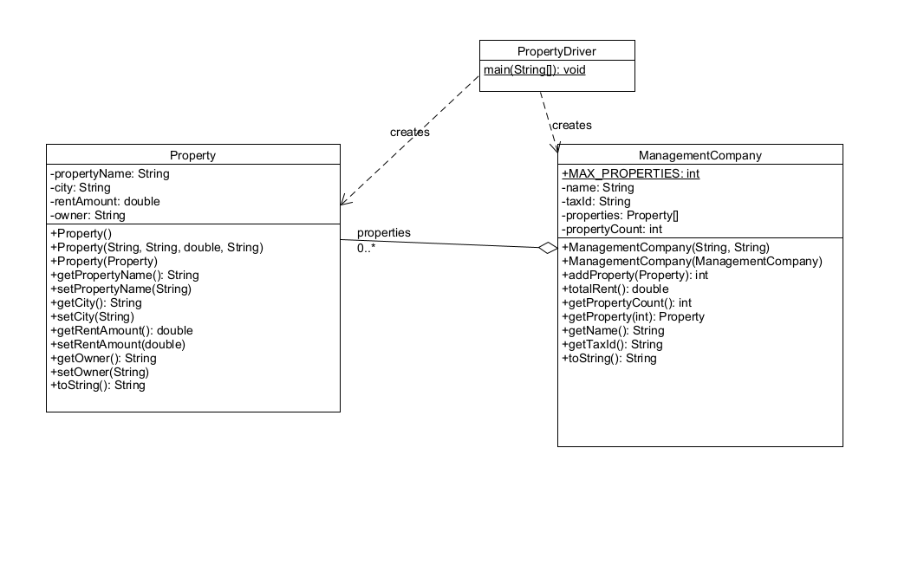
Part2: Comprehensive Test Plan
A good test plan should be comprehensive. This means you should have a few test cases that test when the input is in and out of range, division by 0, incorrect Data type, etc. (Provide valid and invalid input)
Cases | Input | Expected Output | Actual Output | Did Test Pass?
Case 1 | add Property-1 (Rockville, 3500, Joe) + Property-2 (Gaithersburg, 2500, Mary), then option 2 (Display All), then option 3 (→ $6000.00) | Management Company: Campus Realty (Tax ID: 123-45-6789)  Properties:  0: Property-1, Rockville, Rent: $3500.00, Owner: Joe  1: Property-2, Gaithersburg, Rent: $2500.00, Owner: Mary  Total Rent: $6000.00  and Total rent: $6000.00 | Management Company: Campus Realty (Tax ID: 123-45-6789)  Properties:  0: Property-1, Rockville, Rent: $3500.00, Owner: Joe  1: Property-2, Gaithersburg, Rent: $2500.00, Owner: Mary  Total Rent: $6000.00  and Total rent: $6000.00 | yes
Case 2 | add 5 properties, then a 6th → "The company's property list is full. Nothing was added." | The company's property list is full. Nothing was added. | The company's property list is full. Nothing was added. | yes
Case 3 | enter 9 → "Invalid choice. Please enter a number from 1 to 4.", menu re-displays | Invalid choice. Please enter a number from 1 to 4. | Invalid choice. Please enter a number from 1 to 4. | yes
Case 4 | enter 4 → program ends | Programmers name (Jacen Cheskin) | Jacen Cheskin | yes

Part3: Screenshots related to the Test Plan:
Case 1
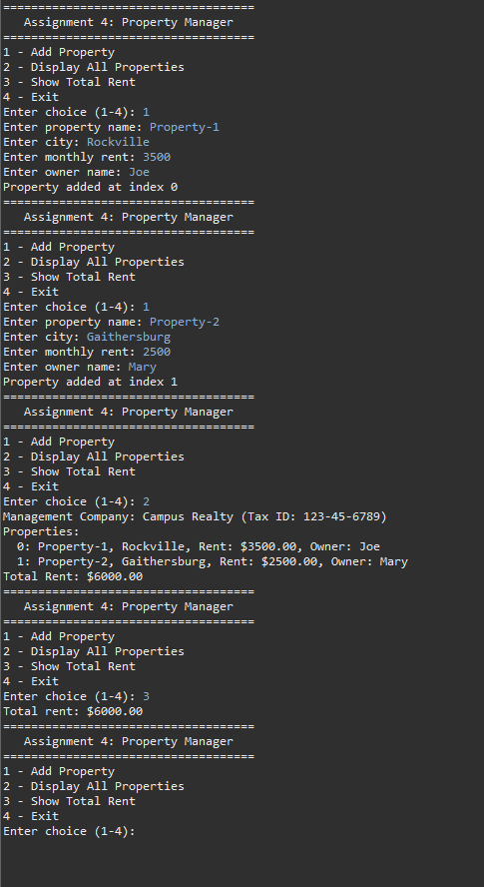
Case 2
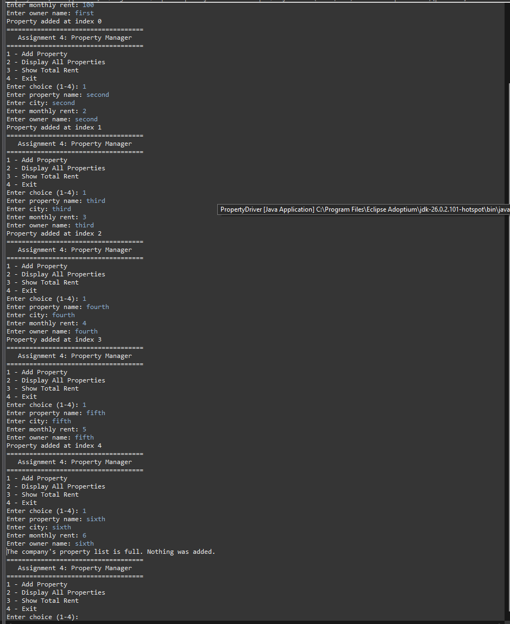
Case 3
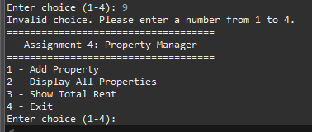
Case 4
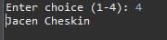

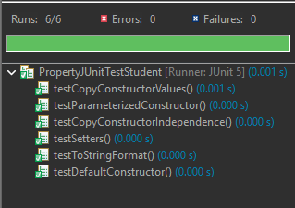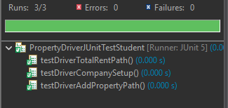
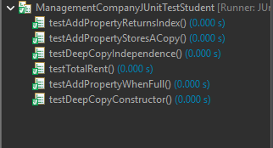

Lessons Learned <Provide answers to the questions listed above>:

Write about your Learning Experience, highlighting your lessons learned and learning experience from working on this project.

What have you learned?

What did you struggle with?

What would you do differently on your next project?

What parts of this assignment were you successful with, and what parts (if any) were you not successful with?

Provide any additional resources/links/videos you used to while working on this assignment/project.

Check List: <Provide answers to the column Y/N or N/A >:

# |  | Y/N | Comments
 | Assignment files:
 | - FirstInitialLastName_Assignment4_Complete.zip | Y
 | - FirstInitialLastName_Assignment4_JavaFiles.zip | Y
 | - FirstInitialLastName_Assignment4.docx/.pdf | Y
 | - Source java files | Y
 | Program compiles | Y
 | Program runs with desired outputs related to a Test Plan | Y
 | Documentation file:
 | - Comprehensive Test Plan | Y
 | - Screenshots related to the Test Plan | Y
 | - Screenshots of your GitHub account with submitted Assignment# (if required) | Y
 | - UML Diagram (if required) | Y
 | - Algorithms/Pseudocode (if required) | Y
 | - Flowchart (if required)
 | - Lessons Learned | Y
 | - Checklist is completed and included in the Documentation | Y

