An error message "Unable to complete cellular number change" appears.
This error message is related to installation failure and may be caused by the following factors:
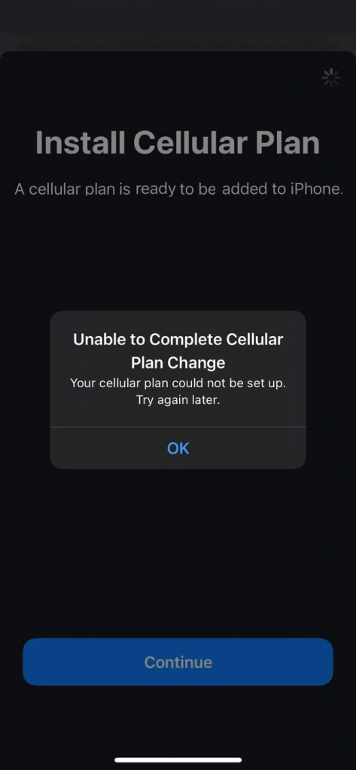
1. Too many eSIMs are installed on your device. eSIM-compatible devices allow you to install multiple eSIMs, but the number of eSIMs that can be active simultaneously may vary depending on the device model. For example, an iPhone can store 5 to 10 eSIMs, depending on the device's storage space. For details, please contact your phone manufacturer.

• If you confirm that your device's eSIM storage space is full, you can remove the old eSIM from your device. You can see instructions for removing an eSIM here: How do I remove an eSIM from my device?

2. Cellular/Mobile data is disabled in the device's settings.

3. The eSIM being tried to install has been previously installed: Most eSIMs can only be installed once.

• You can verify if the eSIM is installed on your device by going to Settings > General > About > Scroll down to find the ICCID (it's a 20-digit number that starts with 89XXXXXXXXXXXXXXXXXX and ends with a random extra number). If you've confirmed that the ICCID is installed, some adjustments may be needed to establish a connection. The eSIM installation page contains all the details.

4. The connection is unstable when trying to install the eSIM. This usually happens when using onboard Wi-Fi or public Wi-Fi. If the problem persists, please contact the support team.

