An error message "Unable to add cellular plan for this carrier" appears.
This error may occur when attempting to install an eSIM on a network-locked device.
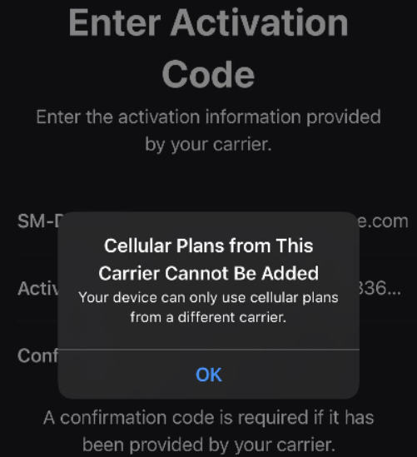
You can check if your device is locked by following these steps:
1. Go to Settings > General, and tap About.

2. Under Carrier Lock, you should see "No SIM card restrictions". If you don't see this, please contact your carrier to unlock your device. If your current provider confirms your device is unlocked, please contact their support team.

