An error message "This code is no longer valid" appears.
This error message occurs when you try to add a previously added eSIM or when an unstable connection causes an incomplete QR code scan.
To verify that your eSIM is installed, do the following:
- Go to Settings
- Go to General
- Tap About, then swipe down
If your eSIM is installed and enabled, you should see ICCID [NUMBER] + one extra digit, provided the eSIM number is "On" under Cellular.
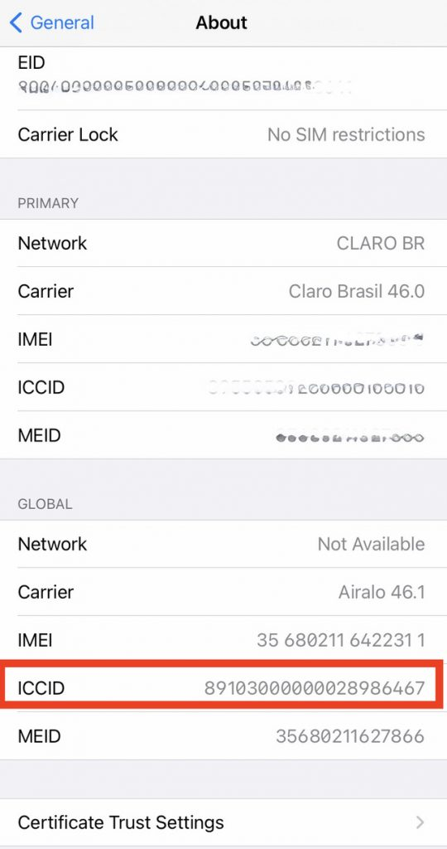
Note that if your eSIM has been removed, you cannot reinstall it!

However, if this is your first time installing an eSIM, this error message may be due to an unstable connection, a VPN enabled, or too many eSIMs installed on your device.

Please follow these steps to properly install your eSIM:

1. Disable VPN

2. Ensure a good, stable internet connection

3. Remove any eSIMs you no longer use

4. Check that your software is updated to the latest version

5. Try installing your eSIM using a different method than before.

If you need assistance, please contact us.

