**Wrapper Class**

A Wrapper class is a class whose object wraps or contains a primitive data types. When we create an object to a wrapper class, it contains a field and in this field, we can store a primitive data types. In other words, we can wrap a primitive value into a wrapper class object.

Need of Wrapper Classes

1. They convert primitive data types into objects. Objects are needed if we wish to modify the arguments passed into a method (because primitive types are passed by value).
2. The classes in java.util package handles only objects and hence wrapper classes help in this case also.
3. Data structures in the Collection framework, such as ArrayList and Vector, store only objects (reference types) and not primitive types.
4. An object is needed to support synchronization in multithreading.

Primitive Data types and their Corresponding Wrapper class

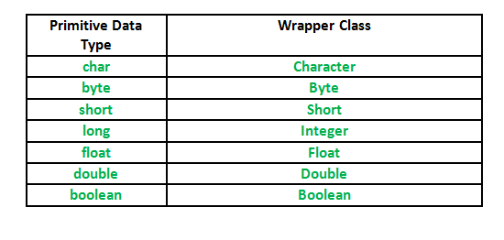

Autoboxing and Unboxing

Autoboxing: Automatic conversion of primitive types to the object of their corresponding wrapper classes is known as autoboxing. For example – conversion of int to Integer, long to Long, double to Double etc.  
Example:

|  |
| --- |
| // Java program to demonstrate Autoboxing    import java.util.ArrayList;  class Autoboxing  {  public static void main(String[] args)  {  char ch = 'a';;  // Autoboxing- primitive to Character object conversion  Character a = ch;  ArrayList<Integer> arrayList = new ArrayList<Integer>();  // Autoboxing because ArrayList stores only objects  arrayList.add(25);  // printing the values from object  System.out.println(arrayList.get(0));  }  } |

Output:

25

Unboxing: It is just the reverse process of autoboxing. Automatically converting an object of a wrapper class to its corresponding primitive type is known as unboxing. For example – conversion of Integer to int, Long to long, Double to double etc.

|  |
| --- |
| // Java program to demonstrate Unboxing  import java.util.ArrayList;  class Unboxing  {  public static void main(String[] args)  {  Character ch = 'a';  // unboxing - Character object to primitive conversion  char a = ch;  ArrayList<Integer> arrayList = new ArrayList<Integer>();  arrayList.add(24);  // unboxing because get method returns an Integer object  int num = arrayList.get(0);  // printing the values from primitive data types  System.out.println(num);  }  } |

Output:

24

Wrapper classes in Java

Implementation

|  |
| --- |
| // Java program to demonstrate Wrapping and UnWrapping  // in Java Classes  class WrappingUnwrapping  {  public static void main(String args[])  {  // byte data type  byte a = 1;  // wrapping around Byte object  Byte byteobj = new Byte(a);    // int data type  int b = 10;    //wrapping around Integer object  Integer intobj = new Integer(b);  // float data type  float c = 18.6f;  // wrapping around Float object  Float floatobj = new Float(c);  // double data type  double d = 250.5;  // Wrapping around Double object  Double doubleobj = new Double(d);  // char data type  char e='a';  // wrapping around Character object  Character charobj=e;  // printing the values from objects  System.out.println("Values of Wrapper objects (printing as objects)");  System.out.println("Byte object byteobj: " + byteobj);  System.out.println("Integer object intobj: " + intobj);  System.out.println("Float object floatobj: " + floatobj);  System.out.println("Double object doubleobj: " + doubleobj);  System.out.println("Character object charobj: " + charobj);  // objects to data types (retrieving data types from objects)  // unwrapping objects to primitive data types  byte bv = byteobj;  int iv = intobj;  float fv = floatobj;  double dv = doubleobj;  char cv = charobj;  // printing the values from data types  System.out.println("Unwrapped values (printing as data types)");  System.out.println("byte value, bv: " + bv);  System.out.println("int value, iv: " + iv);  System.out.println("float value, fv: " + fv);  System.out.println("double value, dv: " + dv);  System.out.println("char value, cv: " + cv);  }  } |

Output:

Values of Wrapper objects (printing as objects)

Byte object byteobj: 1

Integer object intobj: 10

Float object floatobj: 18.6

Double object doubleobj: 250.5

Character object charobj: a

Unwrapped values (printing as data types)

byte value, bv: 1

int value, iv: 10

float value, fv: 18.6

double value, dv: 250.5

char value, cv: a