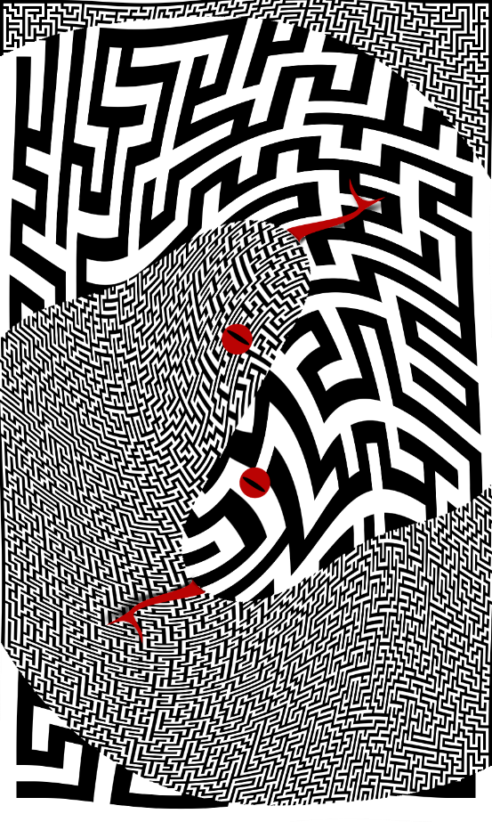

Contents

License 1

About the Author 1

Acknowledgements 1

About this Deck 2

Using this Guide 2

The Major Arcana 3

The Minor Arcana 7

Past / Future 8

Risk / Reward 11

Science / Magick 14

Self / Shadow 17

An Example Spread 20

# License



Creative Commons

Attribution 4.0

International Public License

The latest version of this deck can always be found at:

<https://github.com/ChaoteCruithne/FalseDichotomyTarot>

# About the Author

The Chaote, Cruithne

Pronounced: kay-oat, crew-in-ay

Pronouns: any / all

# Acknowledgements

Chaos Times font by Ablaze

<https://www.dafont.com/chaos-times.font>

# About this Deck

Like traditional tarot decks, this one contains 22 Major Arcana and 56 Minor Arcana across four suits of 14 cards. However, the similarities largely end there. There’s a few reasons for that. Firstly, while there is a certain timeless quality to the traditional tarot deck, the metaphors and iconography always felt outdated to me. It was when I started using the Tarot of the Origins with it’s unique take on the suits that I realized how the practice of tarot could be made more contemporary without losing what made it special. Secondly, I wanted to get away from the numerology and linearity of the traditional structure, as my mundane life revolves around math. This had the added benefit of making the deck much more plainspoken. Thirdly, as a practitioner of chaos magick, I believe its important to create one’s own tools (which is also why this deck has an open license for remixing!) The juxtaposition of opposites and the deconstruction of false dichotomies are central to how I view the world, so my personal tarot deck should reflect that. In summary, three key design principles are used throughout:

1) The imagery and language tries to be simple and to the point. While this guide provides some extra hints, I hope that you can use the deck the first time intuitively with very little practice.

2) There is not a linear journey through the cards. For example, each Minor Arcana doesn’t have numbered rank as you see in traditional tarot decks.

3) The “opposites” presented on each card have as much in common as in contrast. There is not an “upright” or “reversed” state for the cards in a traditional sense, because that applies a moral judgement to things that aren’t inherently good or bad. I like to use face-down cards to represent the energy of the card being in some way “off.”

# Using this Guide

Each card will have a box like the following:

|  |  |
| --- | --- |
| **Title at One End** | **Title at the Other** |
| This section will talk about the shared meaning or overlap between the two concepts. | |
| This section will talk about the meaning specific to one end. | This section will talk about the meaning specific to the other. |

Each card has more than one meaning and can be used more than one way, so the details below are just a starting point for interpretation. Allow the card to mean what it wants to mean in each unique context.

# The Major Arcana

|  |  |
| --- | --- |
| **Action** | **Intention** |
| Is it what we do or what we meant to do that matters? | |
| Shoot first, and ask questions later. Face down, trigger happy. | Measure twice, cut once. Face down, a flaw in the blueprint itself. |

|  |  |
| --- | --- |
| **Creator** | **Created** |
| Art is self-expression, but it has a life of its own. | |
| What matters is who says it. Face down, writer’s block. | What matters is what is said. Face down, the message is a waste of paper. |

|  |  |
| --- | --- |
| **Death** | **Rebirth** |
| Endings are often beginnings | |
| The end of a chapter. Face down, a difficult or drawn-out transition. | The start of the next chapter. Face down, an unexpected new turn. |

|  |  |
| --- | --- |
| **Desire** | **Addiction** |
| Do you want to do it do you need to do it? | |
| What gets you out of bed. Face down, shame. | What you can’t live without. Face down, dependence. |

|  |  |
| --- | --- |
| **Feast** | **Famine** |
| “Just enough” is rarely what we get. | |
| Save it or share it. Face down, binging. | Ration it to make it last.  Face down, purging. |

|  |  |
| --- | --- |
| **Forest** | **Trees** |
| Top-down or bottom-up? | |
| Recognizing the big picture. Face down, overgeneralizing. | Recognizing unique details. Face down, nitpicking. |
| **Incense** | **Perfume** |
| Giving ourselves breathing room, but is it comfort or truth? | |
| A heightened state of consciousness. Face down, hallucinations not visions. | A more pleasant environment. Face down, can’t cover every stink. |

|  |  |
| --- | --- |
| **Martyr** | **Zealot** |
| Sacrifices are sometimes necessary. | |
| I would die for the cause. Face down, playing victim. | I would kill for the cause. Face down, making enemies. |

|  |  |
| --- | --- |
| **Mission** | **Obsession** |
| Would anything change if you reached your goal? | |
| Onward despite distractions.  Face down, skipping to the last page of the book. | Onward despite adversity. Face down, unable to let go. |

|  |  |
| --- | --- |
| **Omen** | **Evidence** |
| Sometimes a cigar is just a cigar | |
| The sign you’ve been waiting for. Face down, coincidence. | The signs we leave behind. Face down, a calling card. |

|  |  |
| --- | --- |
| **Patron** | **Supplicant** |
| Everyone has a price; will it be a fair one? | |
| Sharing what you have. Face down, strings are attached, quid pro quo. | Asking for what you need. Face down, choosing beggars. |

|  |  |
| --- | --- |
| **Pleasure** | **Pain** |
| Both the carrot and the stick can be motivating, but one person’s torture is another person’s kink. | |
| A reminder of how good life can be. Face down, coddled. | A reminder of our limits. Face down, being held back. |
| **Predator** | **Prey** |
| Checks and balances in an ecosystem. | |
| The strong conquer the weak. Face down, bullying or aggression. | The clever conquer the foolish. Face down, feigning helplessness. |

|  |  |
| --- | --- |
| **Rule** | **Exception** |
| No system is perfect, but perfection is no accident. | |
| A well-oiled machine. Face down, an orphan crushing machine. | Break the mold. Face down, main character syndrome. |

|  |  |
| --- | --- |
| **Soma** | **Panacea** |
| A cure for what ails you. Face down, sometimes the cure is worse than the disease. | |
| Treating the symptoms | Treating the cause. |

|  |  |
| --- | --- |
| **Speaking** | **Listening** |
| What is said and what are heard can be different. | |
| Getting a message out. Face down, a lot of words to say nothing. | Getting the real scoop. Face down, in one ear and out the other. |

|  |  |
| --- | --- |
| **Swarm** | **Gestalt** |
| The whole is greater than the sum of the parts. Face down, the individual lost in the group. | |
| Directed by shared tendency, like drops of water in a river. | Directed by shared goal, like players on a team. |

|  |  |
| --- | --- |
| **Taboo** | **Tradition** |
| We inherit many of our ideas. Face down, but we often don’t realize where the idea started. | |
| The must not’s | The must do’s |
| **Truth** | **Honesty** |
| Just because it isn’t a lie doesn’t mean you can take it at face value. | |
| Cold, hard facts. Face down, only *technically* not a lie. | What you really think. Face down, oversharing. |

|  |  |
| --- | --- |
| **Unity** | **Proximity** |
| Being together doesn’t always mean being in this together. | |
| Working hand-in-hand. Face down, a marriage of convenience | Working side-by-side. Face down, guilt by association. |

|  |  |
| --- | --- |
| **Watcher** | **Seer** |
| Perception is everything. Misperception doubly so. | |
| Observation. Face down, oblivious to deeper meaning. | Insight. Face down, oblivious to literal face value. |

|  |  |
| --- | --- |
| **Wilderness** | **Metropolis** |
| The jungle, but is it more Rudyard Kipling or Upton Sinclair? | |
| A need for solitude or connection with nature. Face down, lost in the isolation. | A need for community or connection with society. Face down, lost in the crowd. |

# The Minor Arcana

While the Major Arcana stand alone, the Minor Arcana have two organizing principles. First are the suits: Shadow/Self, Science/Magick, Risk/Reward, Past/Future, which will be discussed more in the appropriate section. Also are the 14 prepositions, explained briefly below:

|  |  |  |
| --- | --- | --- |
| **Word** | **Symbol** | **Example Meaning** |
| Against | Shield | Resisting an impulse |
| Amidst | Venn diagram | Experiencing a moment |
| Beyond | Closed door | Crossing a threshold |
| Despite | Ball and chain | Enduring a burden |
| For | Pennant | Fulfilling a purpose |
| From | Sealed scroll | Receiving a message |
| Like | Mask | Cultivating a perception |
| Of | Heart | Setting the standard |
| Since | Book | Justifying an approach |
| Through | Key | Seizing an opportunity |
| Towards | Compass | Finding a direction |
| Until | Lit fuse | Anticipating a change |
| Upon | Pillar | Building a foundation |
| Without | Shackles | Managing an absence |

## Past / Future

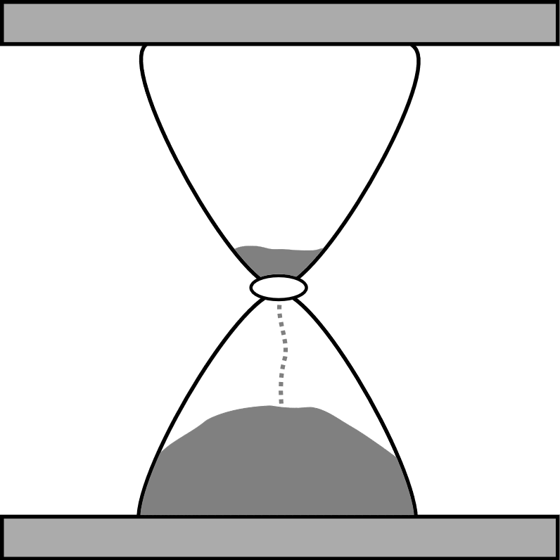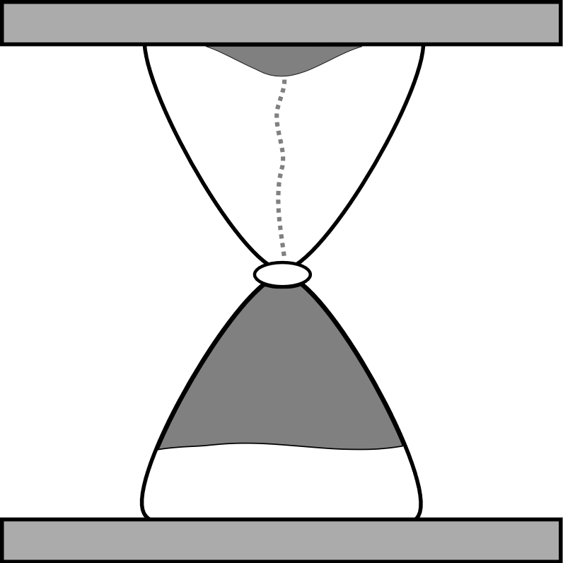We are not who we were or who we will be, but we spend an awful lot of time fretting about those versions of ourself. Likewise, the reading is for the person who can see the cards now, but there might be messages from or about other times.

The Past is where we’ve already made our decisions and our mistakes. Looking there can be painful, because that is where our trauma, baggage, and cringe lives. However, we mostly were doing the best we could, and we don’t grow until we fully process what has already happened. The past can be beautiful too, because we remember those precious few moments that we cherish. Caution is needed to prevent self-reflection from becoming false nostalgia, as that overlooks the bigger picture and can make the present seem harsh.

The Future is where the unknown lives. Looking there can be painful, because we recognize that we are not ready for it yet or that more mistakes are inevitable. However, if you don’t prepare now, you’ll never be ready. The future can be beautiful too, as that is where hope lives. Caution is needed to avoid living in a castle made of clouds or making self-fulfilling prophecies of doom.

|  |  |
| --- | --- |
| **Against the Past** | **Against the Future** |
| Ensuring that now is not as it was / will be. | |
| Making amends. Face down, for someone else’s faults. | Holding back the tide. Face down, stunting your growth. |

|  |  |
| --- | --- |
| **Amidst the Past** | **Amidst the Future** |
| Imagining another time. | |
| How it was. Face down, inaccurate recollections. | How it could be. Face down, impossible expectations. |

|  |  |
| --- | --- |
| **Beyond the Past** | **Beyond the Future** |
| Seeing the big picture. Face down, overwhelmed by it. | |
| What caused all this? | What comes after that? |

|  |  |
| --- | --- |
| **Despite the Past** | **Despite the Future** |
| Time waits for nobody. Deal with the here and now. | |
| Learning from mistakes. Face down, trauma. | Needing to act now. Face down, procrastination. |

|  |  |
| --- | --- |
| **For the Past** | **For the Future** |
| Promises have a way of transcending time. | |
| Keeping a promise. Face down, maybe can’t be kept? | Making a promise. Face down, maybe don’t make? |

|  |  |
| --- | --- |
| **From the Past** | **From the Future** |
| Echoes of another time often impact us today. | |
| A reminder. Face down, stuck in a loop. | A premonition. Face down, time is running out. |

|  |  |
| --- | --- |
| **Like the Past** | **Like the Future** |
| Sometimes a good story beats a true one. Face down, but a good story is sometimes just a lie. | |
| “I meant to do that” | “I can do this” |
| **Of the Past** | **Of the Future** |
| Not everyone goes through life at the same pace. Face down, being unable to cope with change. | |
| Bringing that retro style back. | Being ahead of your time. |

|  |  |
| --- | --- |
| **Since the Past** | **Since the Future** |
| A defining moment. Face down, stuck in a moment. | |
| A known past | An expected future |

|  |  |
| --- | --- |
| **Through the Past** | **Through the Future** |
| Solve today’s problems with a solution from another time. | |
| Repeating what you know has worked in similar circumstances before. | Working backwards from the end to figure out what you need right now. |

|  |  |
| --- | --- |
| **Towards the Past** | **Towards the Future** |
| Pursuing a desired change. Face down, never content. | |
| Regaining something that has been lost | Building something we don’t yet have. |

|  |  |
| --- | --- |
| **Until the Past** | **Until the Future** |
| Waiting on conditions. Face down, you might be waiting a long time or not appreciating what you have. | |
| For a return to normalcy | For a new circumstance |

|  |  |
| --- | --- |
| **Upon the Past** | **Upon the Future** |
| A decision point, do you press on or turn back? | |
| The Safe. Face down, stuck in your comfort zone. | The Unknown. Face down, going unprepared. |

|  |  |
| --- | --- |
| **Without the Past** | **Without the Future** |
| Live in the moment. Face down, life is a blur. | |
| Try as if for the first time. | Try like there is no tomorrow. |

## Risk / Reward

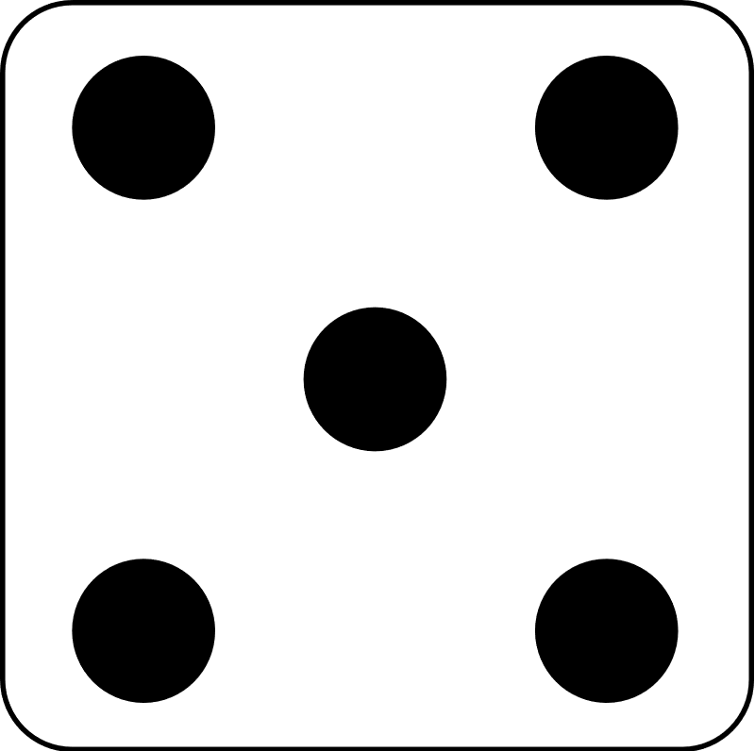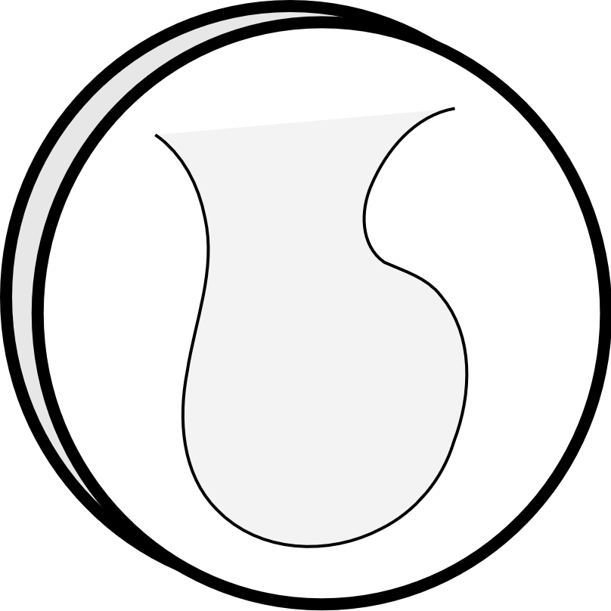Everyone is constantly asking themselves questions like “What’s the catch?” or “What’s in it for me?” This balancing act of “the pros” versus “the cons” is succinctly called Risk and reward. It is worth noting that everyone has a slightly different ratio of risk and reward that makes them comfortable. For example, a thrill-seeker might want to take as much risk as possible, whereas a wallflower doesn’t want any risk at all, at least when it comes to social situations.

Risk comes in many forms, such as time, money, or just plain old effort. In most situations there is some truth to the phrase “nothing ventured, nothing gained,” but it’s also entirely natural to try to get “something for nothing.” When we are too risk averse, we become paralyzed, typically by fear but also by frustration. When we are too risk tolerant, we end up being a danger to ourselves and others.

Reward, also, is also very subjective - “one person’s trash is another person’s treasure,” as they say. When we are too reward-seeking, we can seem greedy or desperate. When we devalue rewards, we can become apathetic or cynical.

|  |  |
| --- | --- |
| **Against Risk** | **Against Reward** |
| Trying to beat the odds | |
| Battening down the hatches. Face down, overcautious. | Resisting a temptation. Face down, self-sabotage. |

|  |  |
| --- | --- |
| **Amidst Risk** | **Amidst Reward** |
| Dealing with the consequences of our actions. | |
| Rolling the dice. Face down, instant karma. | Hitting the jackpot. Face down, your “just deserts.” |

|  |  |
| --- | --- |
| **Beyond Risk** | **Beyond Reward** |
| History is written by winners. Face down, but at what cost? | |
| The ends justify the means. | The means justify the ends. |

|  |  |
| --- | --- |
| **Despite Risk** | **Despite Reward** |
| If you are going to do it, do it on the principle of the thing. | |
| Bravery is facing fear. Face down, foolishness is no fear. | The treasure was the friends we made along the way. Face down, a pyrrhic victory. |

|  |  |
| --- | --- |
| **For Risk** | **For Reward** |
| What is the real reason you are doing this? | |
| Facing your fears. Face down, punishing yourself. | Earning your due. Face down, sense of entitlement. |

|  |  |
| --- | --- |
| **From Risk** | **From Reward** |
| A taste of what is to come. | |
| A warning shot. Face down, maybe all bark no bite? | A down payment. Face down, maybe all you will get? |

|  |  |
| --- | --- |
| **Like Risk** | **Like Reward** |
| Not all is as it seems. Face down, someone misled you. | |
| A risk as a “loss leader.” | Is that gold or fool’s gold? |
| **Of Risk** | **Of Reward** |
| Obvious pros and cons. Face down, under/overestimated. | |
| What you give. | What you get. |

|  |  |
| --- | --- |
| **Since Risk** | **Since Reward** |
| Expecting lightning to strike twice. Face down, expecting karma to balance out suddenly. | |
| Once bitten, twice shy. | On a winning streak. |

|  |  |
| --- | --- |
| **Through Risk** | **Through Reward** |
| A fork in the road. Face down, making the choice blindly. | |
| A shortcut through a dark, spooky forest. | The long way through a field of flowers. |

|  |  |
| --- | --- |
| **Towards Risk** | **Towards Reward** |
| Focus your attention. Face down, wearing blinders. | |
| Keep your eyes on the enemy. | Keep your eyes on the prize. |

|  |  |
| --- | --- |
| **Until Risk** | **Until Reward** |
| Waiting for the other shoe to drop. Face down, you might be waiting a long time or not appreciating what you have. | |
| Brace for impact | The finish line is close. |

|  |  |
| --- | --- |
| **Upon Risk** | **Upon Reward** |
| Life is a not one but a series of adventures. Face down, but this adventure may not be over yet. | |
| Gaining experience by learning from mistakes. | Investing your reward on the next adventure. |

|  |  |
| --- | --- |
| **Without Risk** | **Without Reward** |
| Would you do it if… | |
| …it was totally safe? Face down, recklessness. | …nobody paid you? Face down, unsustainable. |

## Science / Magick



While the common idea of being “left brained” or “right brained,” is an oversimplification of the beautiful complexity of our brains, there is a seed of truth to it. Our brains really do process the world in lots of ways at once, and one part doesn’t always agree with how another part sees the world.

In the context of this deck, Science represents the way humans try to understand the world, and it helps us convert the unknown to the known, especially in the face of change. It is at its best when it has lots of solid data about quantifiable things like “how many.” However, the “rational” parts of our brain sometimes forget not all data is good, accurate, or complete. In a worst-case scenario, this can lead to unhealthy thinking that sounds sensible, but is just prejudiced or even unethical.

Contrastingly, Magick represents our intuitive, emotional, and aesthetic judgments. Magick is the way we try to relate to the world, and it can help us face the unknowable or uncontrollable. Rituals and faith can be comforting or transformative, but they can cause us to be unrealistic and reject the evidence of our eyes in favor of fantasies and wishful thinking.

|  |  |
| --- | --- |
| **Against Science** | **Against Magick** |
| Problematic mental habits. | |
| Looking a gift horse in the mouth. Face down, “burn the books” | Expecting something for nothing. Face down, “burn the witches” |

|  |  |
| --- | --- |
| **Amidst Science** | **Amidst Magick** |
| Rolling up your sleeves and getting caught up on your work. | |
| Face down, lost in the details. | Face down, lost in a glamour. |

|  |  |
| --- | --- |
| **Beyond Science** | **Beyond Magick** |
| Need a change in tactics. Face down, beating a dead horse. | |
| The need to take a leap of faith when the data runs out. | The need to count pennies when the luck runs out. |

|  |  |
| --- | --- |
| **Despite Science** | **Despite Magick** |
| Facing external forces. Face down, head in the sand. | |
| Defying the odds and breaking the pattern | Defying the gods and breaking the prophecy |

|  |  |
| --- | --- |
| **For Science** | **For Magick** |
| Curiosity killed the cat, but satisfaction brought it back. | |
| Pursuit of knowledge. Face down, pursuit of control. | Pursuit of wonder. Face down, pursuit of the forbidden. |

|  |  |
| --- | --- |
| **From Science** | **From Magick** |
| The product of our labor. | |
| Technology, medicine, law, etc. Face down, mad science. | Art, miracles, mercy, etc. Face down, a monkey’s paw. |

|  |  |
| --- | --- |
| **Like Science** | **Like Magick** |
| A fake. Face down, an intentional fraud. | |
| Sounds reasonable but there’s no proof or the logic is flawed. | Seems miraculous, but there’s only smoke and mirrors. |
| **Of Science** | **Of Magick** |
| Perfection. Face down, the perfect is the enemy of the good. | |
| Platonic ideals, like a circle so perfect it couldn’t be drawn. | Mythical ideals, like seeing your true love for the first time. |

|  |  |
| --- | --- |
| **Since Science** | **Since Magick** |
| See from a new viewpoint. Face down, spoiling the old view. | |
| Finding out how the rabbit is pulled from the hat. | Finding the whimsical or absurd in “serious business” |

|  |  |
| --- | --- |
| **Through Science** | **Through Magick** |
| Using your talents to the fullest. Face down, malpractice. | |
| Technical skills and logic. | Artistic skills and intuition. |

|  |  |
| --- | --- |
| **Towards Science** | **Towards Magick** |
| How to solve a mystery or a problem. | |
| Following the facts. Face down, relying on bad data. | Following the signs. Face down, leaf on the wind of fate. |

|  |  |
| --- | --- |
| **Until Science** | **Until Magick** |
| Waiting for a key ingredient. Face down, you might be waiting a long time or not appreciating what you have. | |
| Hoping for some funding | Hoping for a shooting star |

|  |  |
| --- | --- |
| **Upon Science** | **Upon Magick** |
| Honing skills. Face down, double-edged swords | |
| Sharpening your scalpel | Sharpening your athame |

|  |  |
| --- | --- |
| **Without Science** | **Without Magick** |
| Forced to face a situation with one hand tied behind your back. Face down, both hands tied. | |
| Forget everything you know. | Forget how you feel about it. |

## Self / Shadow

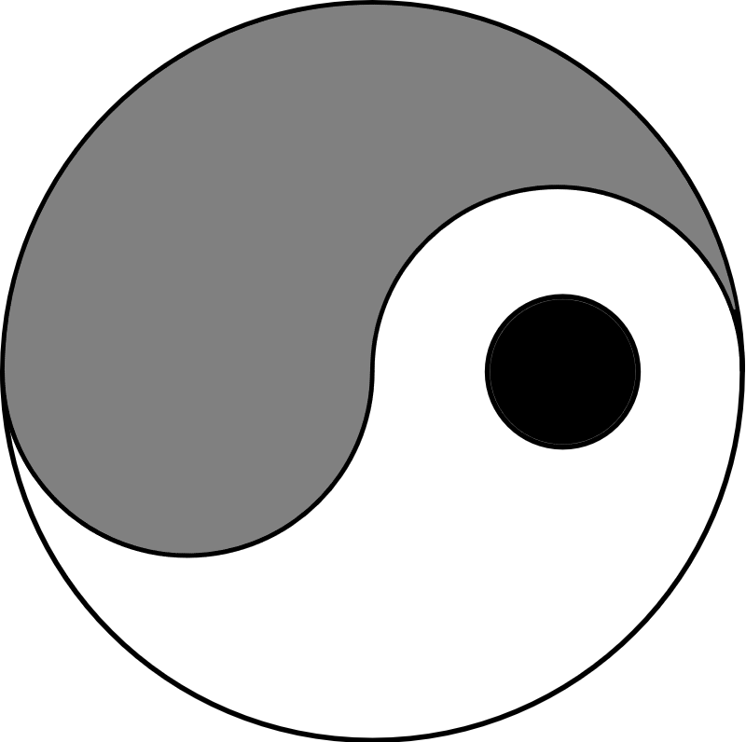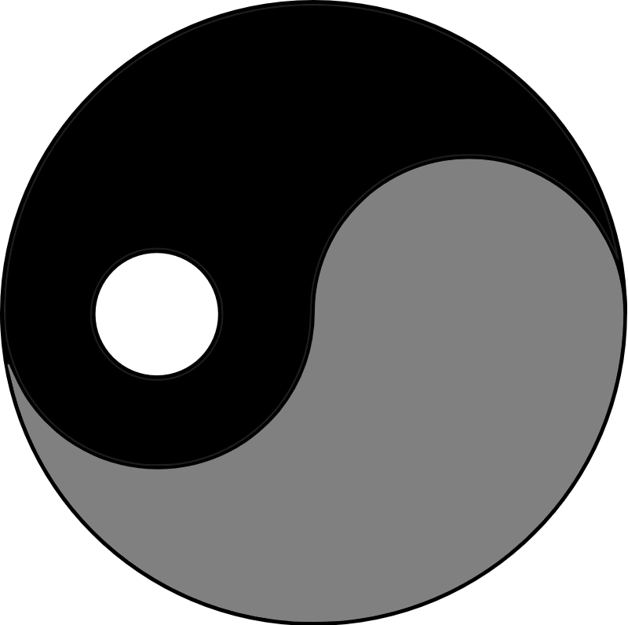

We are all complex, multifaceted beings. However, it is seldom possible or desirable to show all of ourselves all the time. For example, the way we talk and act in front of a boss is different than how we talk and act in front of our drinking buddies. While it is impossible to list all such possible ways to subdivide ourselves, this suit focuses on “the Self” and “the Shadow.”

The Self is the part of ourselves we show the world. In many ways, it is the idealized version of who we want to be. Just like a movie trailer often makes a movie out to be way more epic than it turns out to be, the Self can be a hard standard to achieve. As a result, it’s not inherently good. If we are not careful, the Self can become deceptively bigger than life. The Shadow is the part of ourselves we hide from the world (and sometimes from ourselves, as well). It’s not necessarily bad, but we are often embarrassed about the desires it contains.

As an example, imagine a buff, macho, biker dude. His Self likely includes black leather and the open road. His Shadow might include his secret joy of dainty tea parties with his young daughter. Neither is good or bad, but one is easier to see.

|  |  |
| --- | --- |
| **Against the Self** | **Against the Shadow** |
| Ignoring the angel and the devil on each shoulder | |
| Ignoring stated ideals. Face down, self-sabotage. | Resisting hidden desires. Face down, harsh self-denial. |

|  |  |
| --- | --- |
| **Amidst the Self** | **Amidst the Shadow** |
| When your personality is “dialed up to 11” | |
| Being on your A game. Face down, fooled by your own hype. | Getting down with your bad self. Face down, doubling down. |

|  |  |
| --- | --- |
| **Beyond the Self** | **Beyond the Shadow** |
| Personal growth, often letting go, that will let you do more. | |
| Seeing others’ views. Face down, a need for humility. | The cloud’s silver lining. Face down, a need for self-love. |

|  |  |
| --- | --- |
| **Despite the Self** | **Despite the Shadow** |
| Break the letter of the law to fulfill the spirit of the law. | |
| Getting your hands dirty. Face down, going rogue. | Holding to the code. Face down, the enemy of my enemy. |

|  |  |
| --- | --- |
| **For the Self** | **For the Shadow** |
| Sometimes you must put your own needs first. Face down, too often. | |
| Have a night in. | Have a night out. |

|  |  |
| --- | --- |
| **From the Self** | **From the Shadow** |
| Asking yourself, “Is this who I really am?” | |
| Remembering your ideals. Face down, broken promises. | Remembering your desires. Face down, forgotten dreams. |

|  |  |
| --- | --- |
| **Like the Self** | **Like the Shadow** |
| Putting on a mask in the hope that nobody notices the truth. | |
| Poker face. Face down, hollow inside. | Acting out. Face down, about to boil over. |
| **Of the Self** | **Of the Shadow** |
| You at your most stereotypical. Face down, to a fault. | |
| The “movie poster” version of you | The “secret diary” version of you. |

|  |  |
| --- | --- |
| **Since the Self** | **Since the Shadow** |
| What you gave up to be you. Face down, a needless sacrifice. | |
| When you held yourself to a higher standard. | When you bent rules to do what you had to do. |

|  |  |
| --- | --- |
| **Through the Self** | **Through the Shadow** |
| Be true to who your really are. | |
| Acting like everyone is watching. Face down, fake it til you make it. | Acting like nobody is looking. Face down, turn off the lights. |

|  |  |
| --- | --- |
| **Towards the Self** | **Towards the Shadow** |
| Cultivating the perceptions others have of you. | |
| Smoothing out your rough bits. Face down, your own worst critic. | Sharpening your pointy bits. Face down, burning bridges. |

|  |  |
| --- | --- |
| **Until the Self** | **Until the Shadow** |
| Waiting to be the “real you.” Face down, you might be waiting a long time or not appreciating what you have. | |
| After reaching a long-sought goal. | After dropping a long-held burden. |

|  |  |
| --- | --- |
| **Upon the Self** | **Upon the Shadow** |
| Only you can do this. Face down, needless seclusion. | |
| Trust yourself. | Convince others to trust you. |

|  |  |
| --- | --- |
| **Without the Self** | **Without the Shadow** |
| It’s not always about you. | |
| Avoid ego. Face down, too humble. | Avoid guile. Face down, too honest. |

# An Example Spread

I use a three-by-three spread as illustrated below. Each position has a recommended order for placement/reading and a brief prompt for the position’s use in a reading.

|  |  |  |
| --- | --- | --- |
| 9  “If nothing changes, then…” | 2  “You will need help from…” | 6  “This all started when…” |
| 4  “What you are avoiding is…” | 1  “The center of the issue is…” | 5  “What you are seeking is…” |
| 8  “You’ll have to choose between…” | 3  “You are being held back by…” | 7  “You noticed the problem when…” |

While each card has some guidance in preceding pages, the cards (particularly the Minor Arcana) are designed to be almost conversational when in a spread. For example, “Despite Risk” in position #2 could easily be said out loud as something in the ballpark of “You will need help from something worth doing, despite the risk.”

I consider #8 to be the most important card in this spread, and I try to stress that both choices are valid. The universe will not make the choice for you, nor does it see one choice as “good” or “bad.” This reading is to provide some context so the person can choose not to make the choice for them.