| **Project Data** | |
| --- | --- |
| **Name** | Time Management System |
| **Project Members** | Luis Urbitsch, Enrico Belgiovine, Emir Mahmutovic, Malte Budig, Connor Schwab, Yael Glaser |
| **Beginning** | 10.10.2022 |
| **Expected Completion** | Week 8 of WS22/23 |
| **Customer** | STC Coporation |

## Purpose

Provide a Time Management System (TMS) for the small, but growing, technology company STC.

## Background/Motivation

The company currently has a laborious and error prone system for tracking the working time of its employees. The employees manually have to write their working times in a Microsoft-Excel sheet. This is regarded as unnecessarily effortful for both the employees and their supervisor(s). Planning vacation, reporting sick and documenting duration and purpose of work, should be made a lot easier for a growing company.

## Goals

Our softwares goal is it, to allow the companies employees, their supervisor(s) and the HR-Department to manage and administrate working times, vacations, sicknesses and special time bookings (e.g. for work on customer projects).

Further we want to provide a centralised software, which can be used to consistently store the accruing data. To make this software as safe as possible, we will only allow login via the company’s VPN and the users individual credentials.

## Stakeholders

The Stakeholders of the systems are:

- our client: the STC corporation

- our customer: Prof. Dr. Mirko Sonntag

- employees of STC

- the employees supervisor(s)

- the company’s HR-Department

## Tracking the work time

The employees can register their worked hours every day and send their timesheet at the end of the month. After this transmit, the work times can no longer be changed by the employee.

After one employee sent in their working hours, the software sends a notification to the supervisor, who then can review the submitted times. The supervisor has the ability to reject the submitted hours via the TMS, if incorrect. This process results in a notification for the mentioned employee, who receives a second chance to correct his working times and to submit them.

This process should only take place in the first week of the following month.

## Planning vacation

Employees can submit plans for vacation to their supervisor, who can accept or reject those plans. Also, the employees are able to delete a planned vacation, with agreement of their supervisor. This needs to happen in form of a calendar so the the supervisor has a general overview.

## Reporting sickness

Employees reporting sick will be managed by the HR-Department of the company.

The supervisor of the ill employee will be informed of the sick leave by a notification via the system.

Submitting doctors notices through the system won’t be necessary.

## Statistics

Both, employee and supervisor, should be allowed to see their flex time account (range -100 to +100 hours), status of vacation days (e.g. taken, approved, planned, rejected…), sum of worked hours (monthly) and their off days.

The supervisor also has the possibility to check whether an employee works too much, according to the companies rules and federal laws. Notification for supervisor in this case needs to happen with the monthly review.

## Further Functional Requirements

* Left over vacation days from the previous year need to be transfered into the new year. Days need to be added to vacation day counter. There is no time limit in which those days (from the old year) have to be taken.
* No work clock. Employee is responsible for putting in the start, end and breaks of his working day
* Supervisor monthly report includes:
  + Date, Weekday, Begin, End, Break, Hours Target, Hours As-Is, +/-, Absence, Comment
* Notification for supervisor if there is more than 10 days left of vacation after the middle of the year
* One supervisor per employees
* Person/Employee/User needs to be able to have several rules/access restrictions -> further description in NFR

## Non Functional Requirements

1. Look and Feel

* The client had no special wishes regarding the color pallet/style of the application
* Application is only to be in form of a web application.

1. Usability and Humanity
   * No complete user guide is needed. However, short explanation about one function / feature is needed.
2. Performance
   * The application is set to run on one of the servers of the company (not neccessary in this project)
   * The application needs to use central data base as a storage system
   * Application needs to work for approximately 200 employees
3. Operational and Environmental

* As stated above, the application is set to be only a web application which means there is no restriction on compatibilty for the operating systems.
* The development team is free of choice regarding the development language of the application
* Application rollout by the end of this semester

1. Maintainibility and Support
   * Client stated that the server for the data base is not our responsibility
2. Security
   * Username and password as login credentials
   * Types of users needed:
     + Employee -> basic access to only fill in work time, absence time & book vacation
     + Supervisor -> advanced access with possibility to approve vacation days & work times of employees
     + HR & Admin is combined/at the same time -> admin access

# UML Diagramm

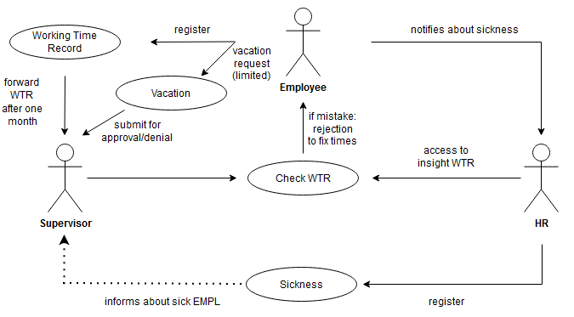

# Personas

## Chris Williams:Chris Williams

Name: Chris Williams

Age: 26 y/o

Job: Software Engineer

Income: 60.000€

Experience: Been working for STC since 2020

Status: Single

Behaviors: not the fully organized type of guy, spontaneous, finished his work even if he must stay a little bit longer

His thoughts on the Time Management system:

* Thinks it’s a shame for the company, that time management is still managed through Excel sheets
* often just fills in blank columns from the days before -> leads to wrong working time proof
* confused about remaining vacation days and flex time, always has to count that up through his Excel sheets
* wants more flexibility regarding his vacation planning

## Anna Smith

Ein Bild, das Person, draußen, Mädchen, lächelnd enthält.
Name: Anna Smith  
  
Age: 32 y/o  
  
Job: HR Management  
  
Income: 55.000 €  
  
Experience: Been working for STC since  
 2019  
  
Status: Single  
  
Behaviors: loves to work with People, likes  
 management and helping  
 others

Her thoughts about Time Management:

* She has no problems documenting sickness days but there is no way to view them collectively
* Dependent on the employee
* The workload is Always in the beginning of the month

## Stefan Mueller

## Name: Stefan Mueller Age: 43 y/o Job: Project supervisor Income: 90.000 € Experience: Been working for STC since 2015 Status: married with kids Behaviors: loves to organize project, he prioritizes his employees before the project, likes being a leader His thoughts about Time Management:Ein Bild, das Person, draußen, Mann, Baum enthält. Automatisch generierte Beschreibung

* The current time management system cost valuable productive time for his employees and himself
* He knows the ins and outs of the system
* There is no good overview of vacation and sickness Days, which makes it harder to reliably plan them
* There is no good way to list under-or overtime, because months are stored in different excel sheets
* He wants to be messaged in one place if there are problems or to be vacation approvals

# Scenarios

## Work time tracking scenario:

Current:

The employee fills out an excel sheet with his work times. The spreadsheet is sent to the supervisor who reviews it and signs it. The supervisor hands the sheet over to the HR who calculate the state of the flex account.

Future:

The employee logs into the system using his username and password. The employee logs into the corporate network via VPN.

The employee documents his working time each day and submits it to his supervisor at the end of the month. The supervisor gets notified about the submission and reviews the documentation.

After reviewing the work times of the employee, the supervisor either approves or rejects the monthly work time. In most cases the times get approved but could sometimes be rejected due to mistakes/errors.

In case of a rejection, the employee gets notified and an opportunity to submit the times anew.

After the approval of the supervisor, the document gets forwarded to HR. HR then calculates the new state of the "flex time account".

## Vacation tracking scenario:

Current:

The employee prints out a vacation request document and fills it out with the vacation dates. The document is given to the supervisor for approval. In case of approval, the supervisor notifies both the employee and HR.

In the work time sheet the employee needs to fill out his vacation days by himself.

Future:

The employee submits a vacation request with the corresponding dates. The supervisor gets notified and reviews the request. The supervisor either approves of the request and notifies both the HR and the employee or rejects it and notifies the employee.

The employee should have the ability to cancel/delete his already approved vacations or the vacation requests.

## Sickness scenario:

Current:

The employee informs HR via call, email. HR informs the supervisor. Just like vacation days, the employee marks his sick days by himself in his work time excel sheet.

Future:

In case of sickness of an employee, the employee informs the HR who register it into the system. The supervisor of the sick employee gets notified.

## Other features:

The employees, supervisors and HR should all be able to see the employees' statistics such as flex time account, vacation days (open, planned, taken), working times, etc.

Additionally, the supervisors should get notified if an employee works more than 8 hours a day.