1 Summary Statistics
1.1. Number of significantly upregulated and downregulated genes (based on p-value and fold change thresholds) for each comparison.
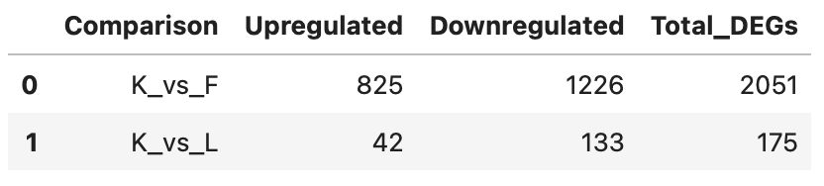
1.2. Summary of p-values and log fold changes across all genes for each comparison.
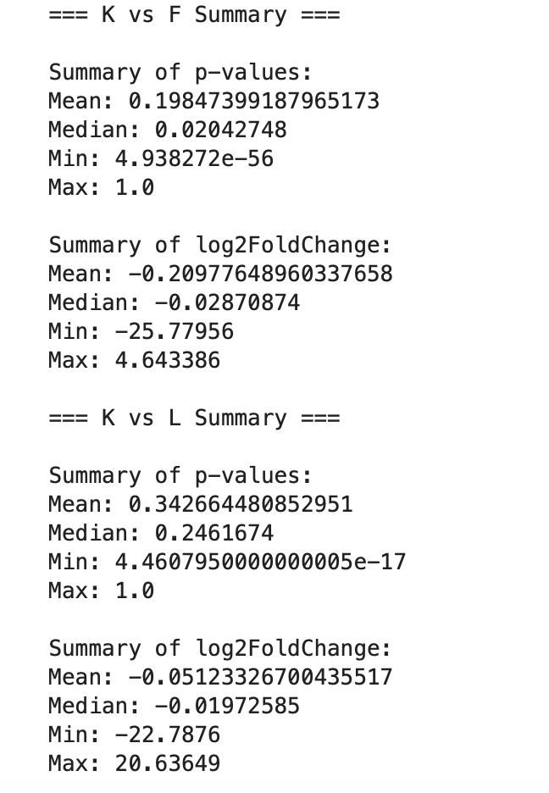

2 Plots
2.1Volcano plots to visualize the significance and magnitude of changes in gene expression for each comparison.
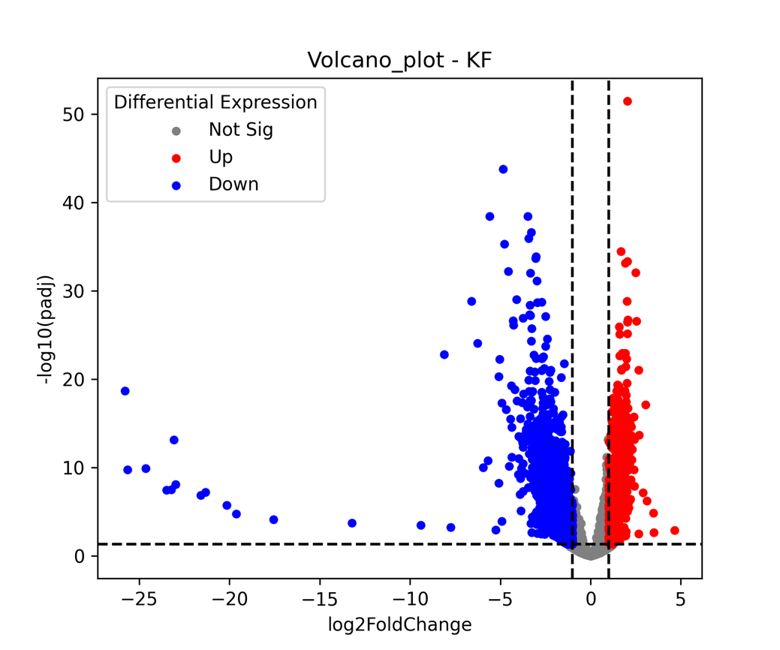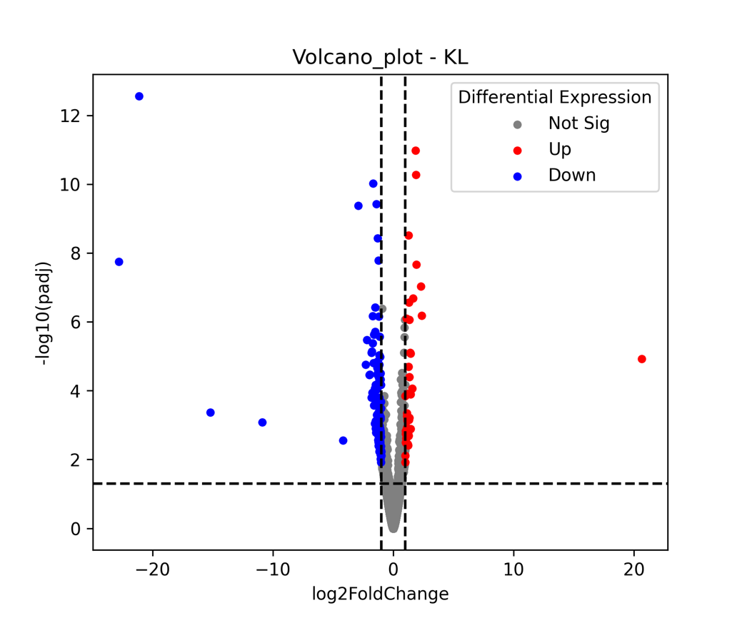

2.2 MA plot to display the relationship between the log fold change and mean expression.
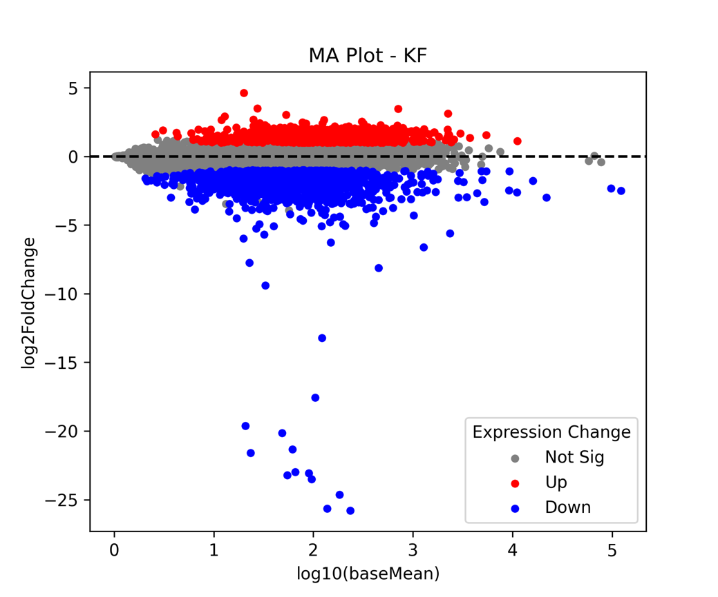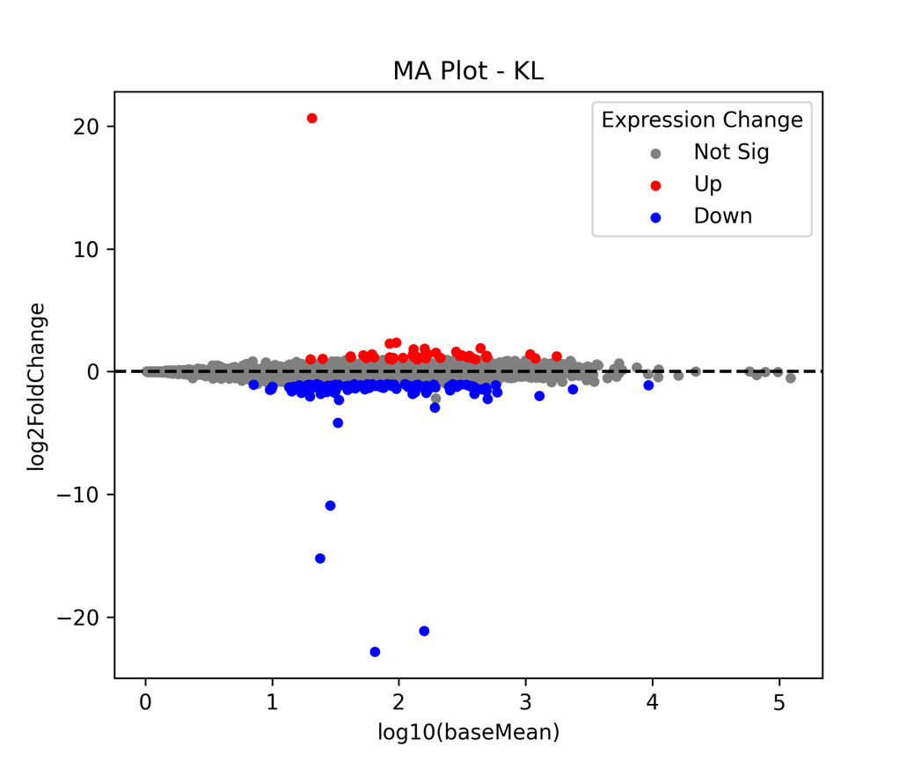

2.3 Histogram of p-values to assess the distribution of statistical significance
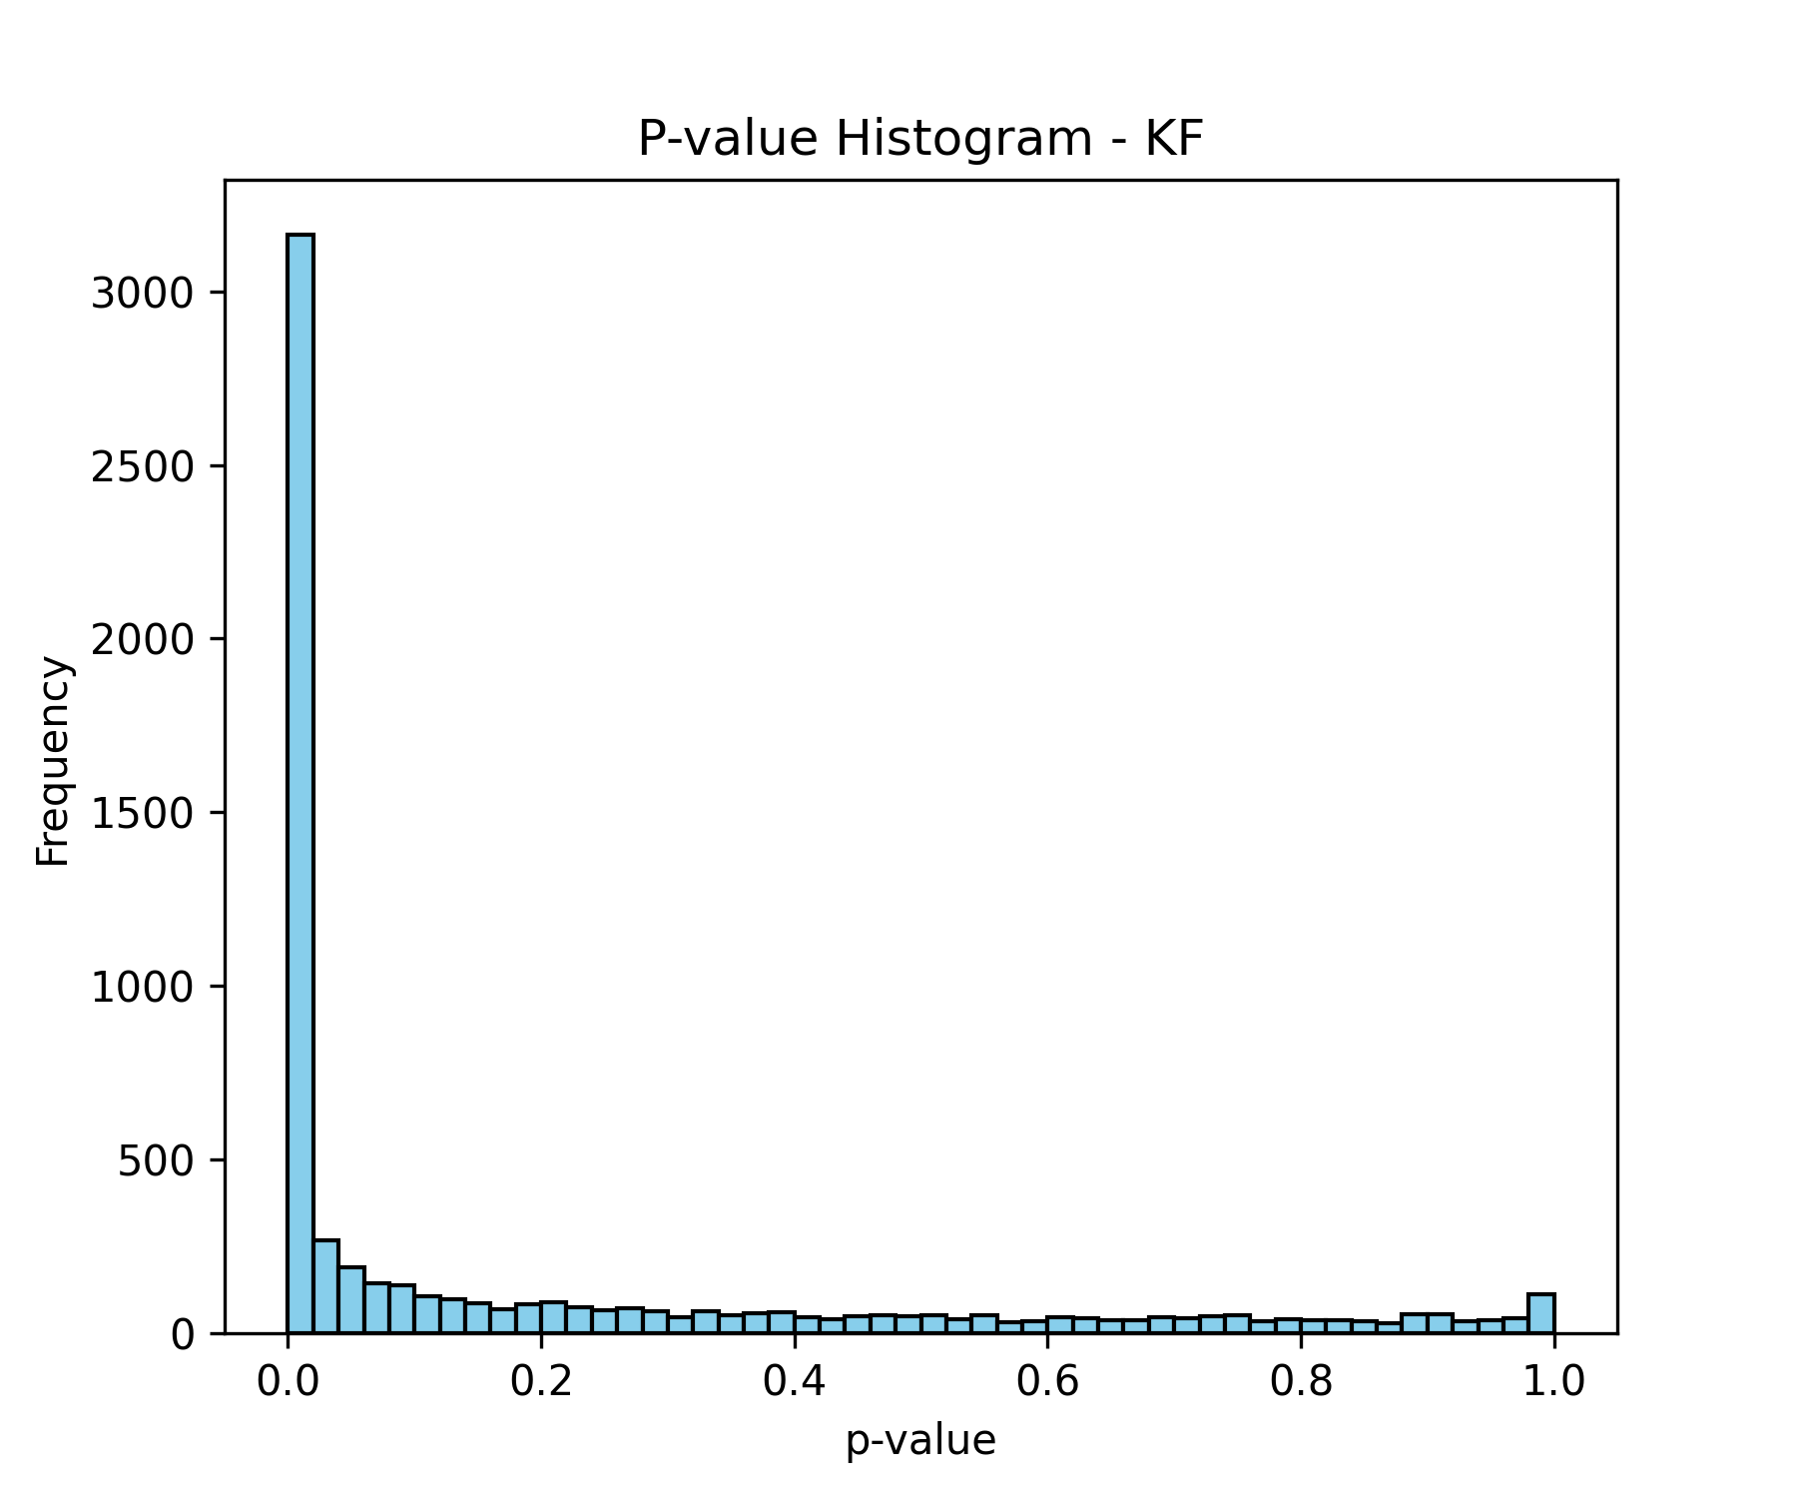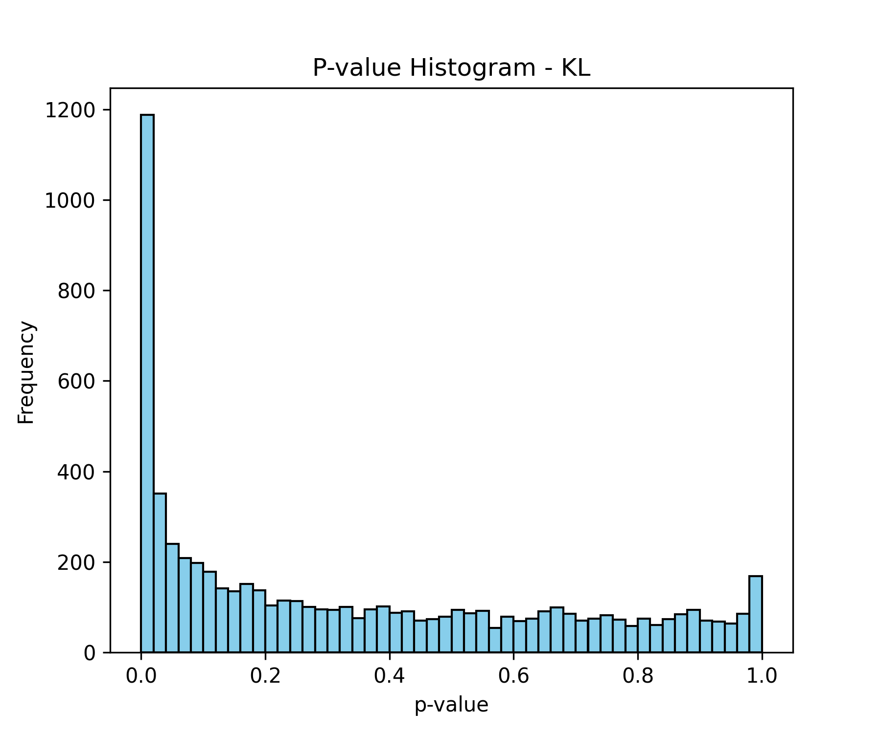

2.4 Heatmap of the top differentially expressed genes to illustrate gene expression patterns across the condition.
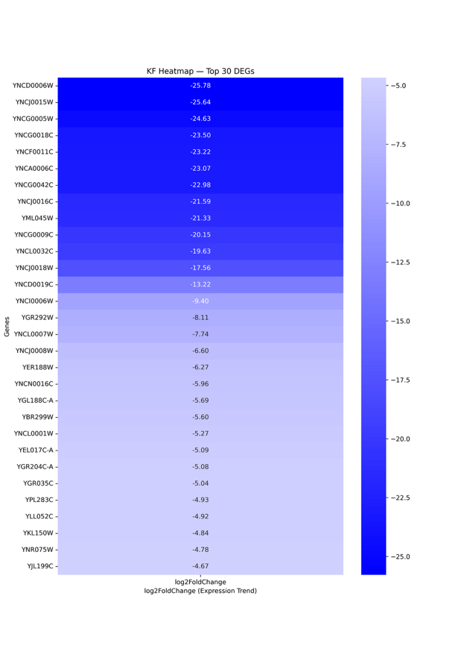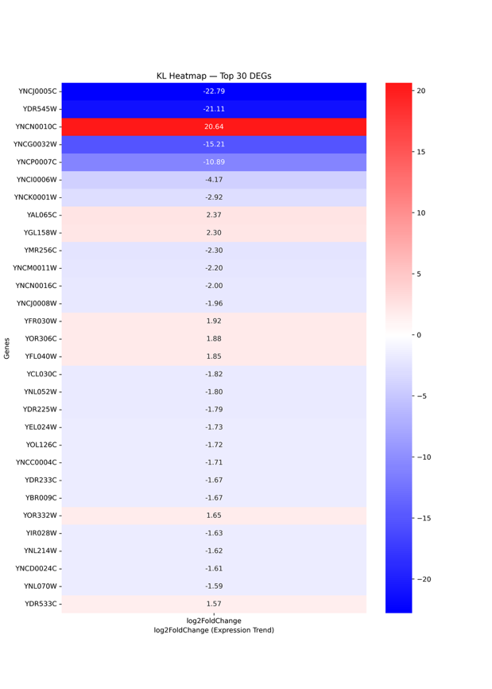
3 Significant Gene Lists
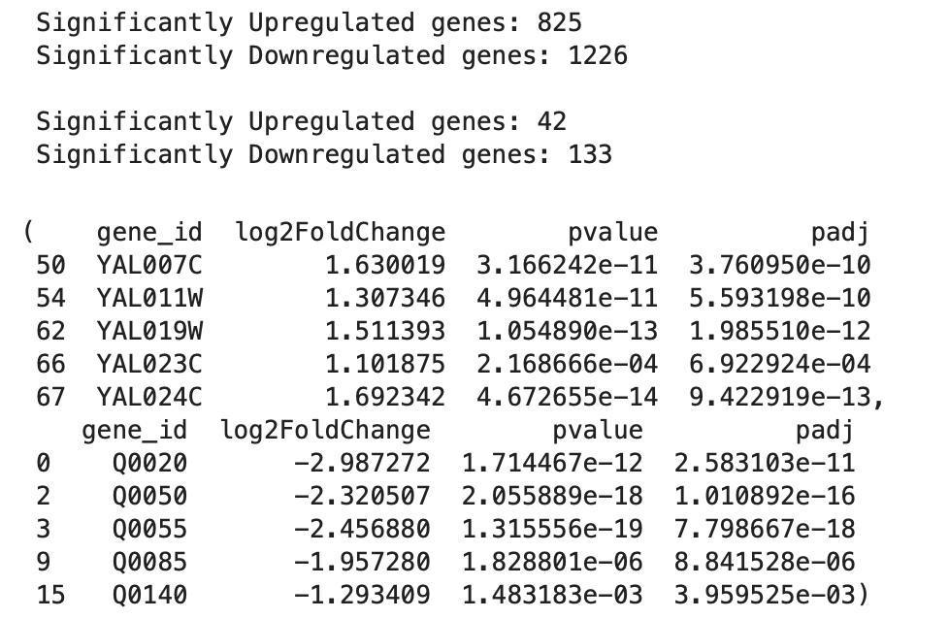
4 Additional Analyses
Based solely on visual output, the experimental condition triggers non-random gene expression shifts, resulting in clear separation of regulated genes.
Clustering patterns indicate that DEGs are functionally connected rather than independent responders.
The system likely undergoes pathway-level regulation, where groups of genes are switched ON/OFF to adapt to the condition.

