Q2: Identify the heaviest pumpkin grown in any of the competitions –
what variety was it? Where was it from and whe n was it grown?

A2:
Variety: Dill's Atlantic
From: Belgium
When:2016
Q3 and 4: weight and weight class
A3 and 4:
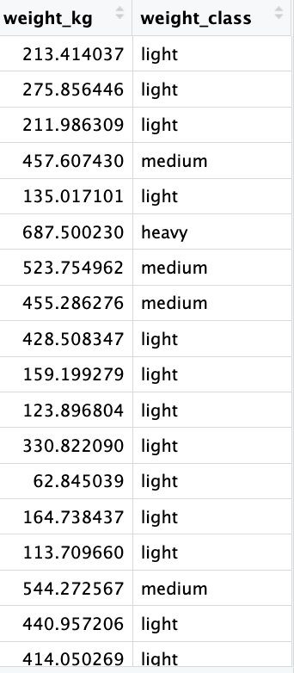

Q5:the relationship between the estimated weight and actual weight of the pumpkins.
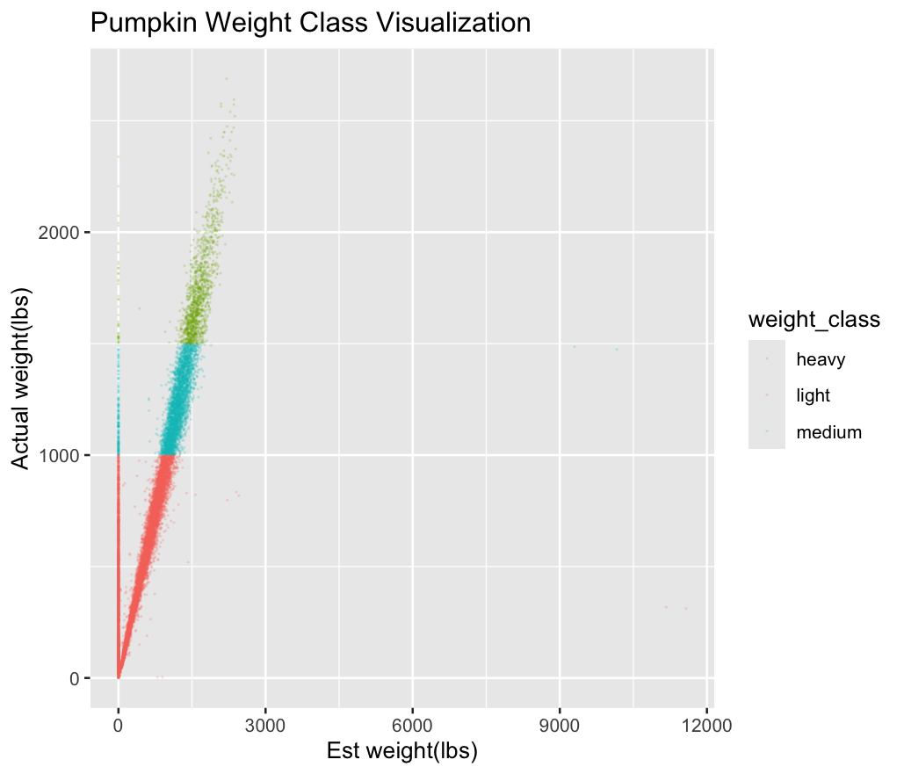
Summarise: This plot shows that estimated weight strongly correlates with actual weight
Points form a diagonally upward pattern — heavier pumpkins generally have larger estimated values. Light pumpkins dominate the dataset. Red points are most abundant; light class pumpkins are by far the majority category. Medium and heavy pumpkins cluster more tightly.Their distribution is more linear, suggesting more consistent estimation at higher weights.。Some points appear far right (>6000–12000 lbs est_weight) or unusually high in weight.
Q6:The data shows in file: R-Pumpkins

Q7: Summarise your filtered dataset from question 6:
a. Identify the mean weight of pumpkins for each of your three countries. Which country had the highest mean pumpkin weight?
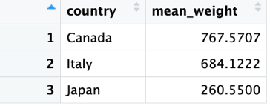
7a: Canada had the highest pumpkin weight.
b: Identify the mean weight for each variety of pumpkin for each of your countries. Which variety in which country had the lowest mean weight?

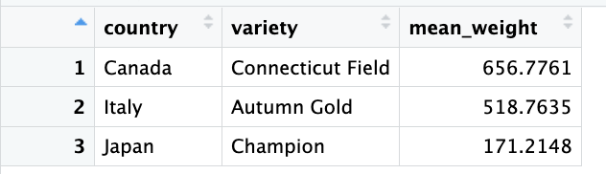
7b: Champion in Japan had the lowest mean weight

Q8: Using your filtered data set from question 6, plot pumpkin weight distributions (in either lbs or kg) for your three countries as a boxplot. Ensure the plot has appropriate axis labels and is clear and well presented. Save this boxplot to your computer.
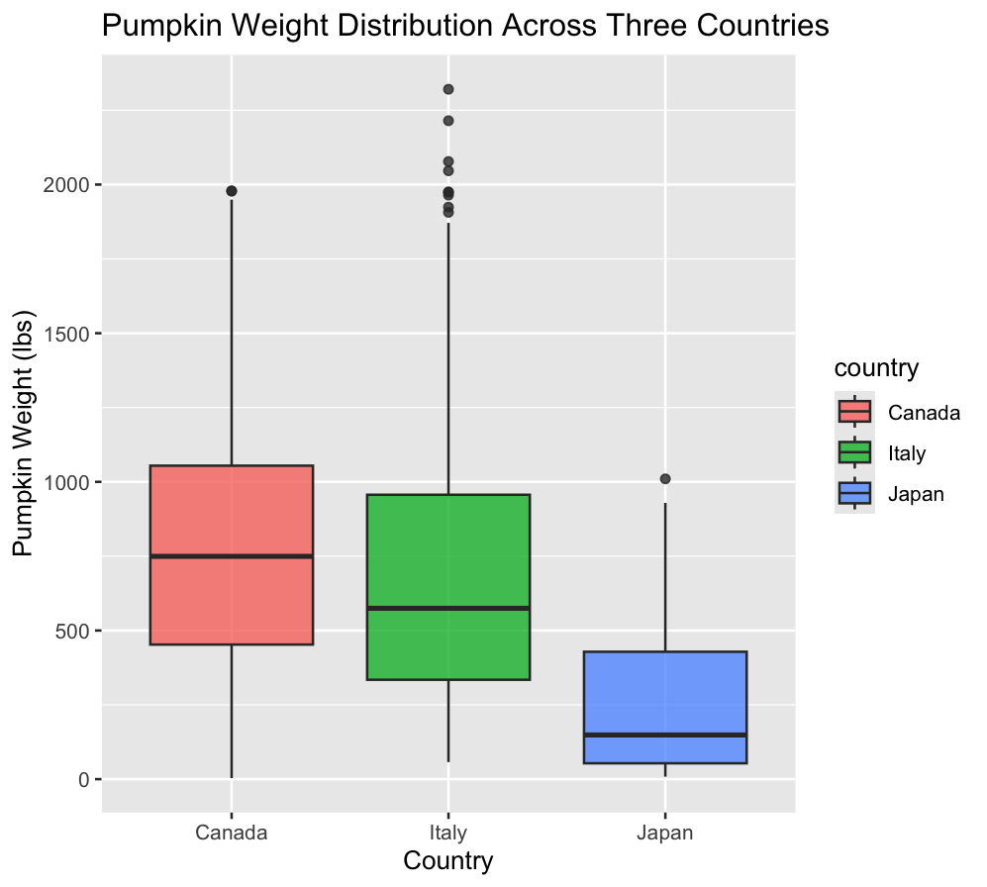
Summarise: This boxplot compares pumpkin weights from Canada, Italy, and Japan, allowing visual comparison of central tendency (median), variability (IQR), and outliers across the three countries.
Canada has the highest median pumpkin weight, Central distribution around ~750 lbs, suggesting consistently larger pumpkins. Italy shows the widest variation
IQR range is large with numerous heavy outliers beyond 1800 lbs. Japan has the lowest overall weights, Most pumpkins fall below 300 lbs, with a tight clustering near the bottom.

Q9: Redraw your plot from question 8 as a facet plot showing the data from each variety of pumpkin as a separate sub-plot. Save this plot to your computer.

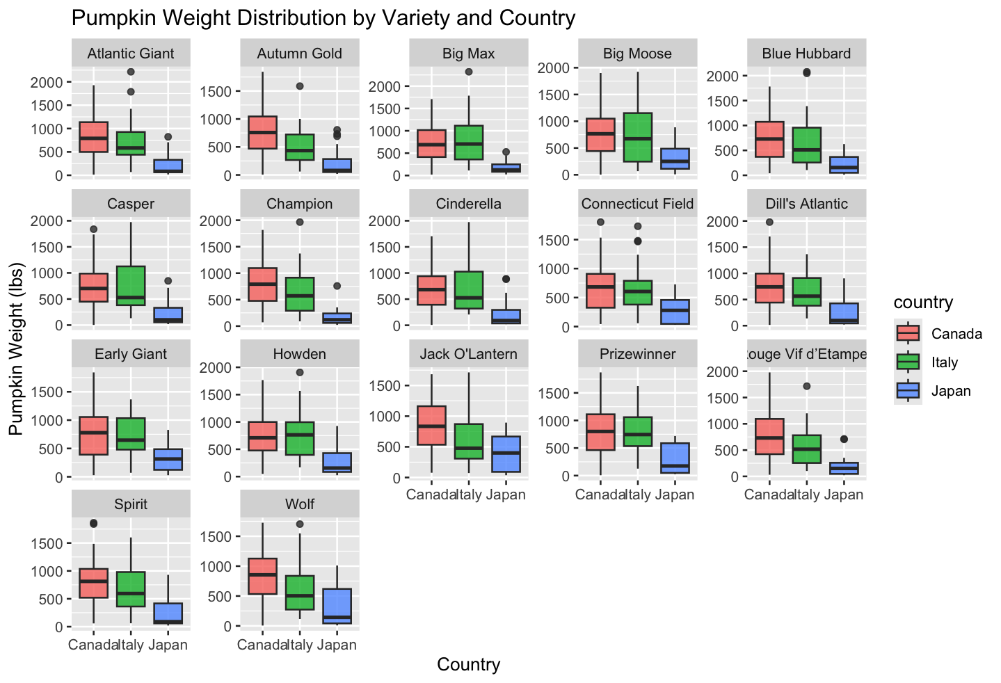
Summarise: This facet plot displays pumpkin weight across different varieties, split into sub-panels, with each panel comparing Canada, Italy, and Japan.
This allows direct visual comparison of how each variety performs in each country.
Canada and Italy generally produce heavier pumpkins, Across nearly all varieties (Atlantic Giant, Big Max, Champion, Early Giant etc.), Canada and Italy both show higher medians and wider ranges than Japan. Japan consistently produces smaller pumpkins, In almost every panel, Japan displays a much lower median and narrower IQR, indicating more uniform but lighter production. Certain varieties show extreme high outliers in, Dill’s Atlantic show multiple values exceeding 1500 lbs.

