Phase 1: Login/Signup Page Dependencies and Overview

Project Structure
jwtlogin/
├── client/ → Html
└── server/ → Streamlit and Mysql.

Backend Dependencies (Streamlit + Mysql)
- Streamlit
- Purpose:Build interactive web UIs in Python.
- Use:Display user interface for user registration, login, and JWT display.
- Mysql
- Purpose:Store and manage user data securely.
-Use:Handle database operations like creating tables, adding and fetching users.
3. jsonwebtoken
- Purpose: Generate and verify JWT tokens.
- Use: Auth token creation and protected route validation..

JWT Authentication Flow
1. Signup: User fills form → Backend hashes password → Saves user to Mysql.
2. Login: User provides email/password → Backend verifies → Sends signed JWT.
3. Protected Routes: JWT is sent in `Authorization` header → Backend verifies before responding.

Installation Commands
Backend:
cd project
python -m venv .venv
source .venv/bin/activate
pip install -r requirements
Requirement - streamlit
mysql-connector-python
PyJWT
pyttsx3

To Run the file: streamlit run <file name>

Sample Output
Login page-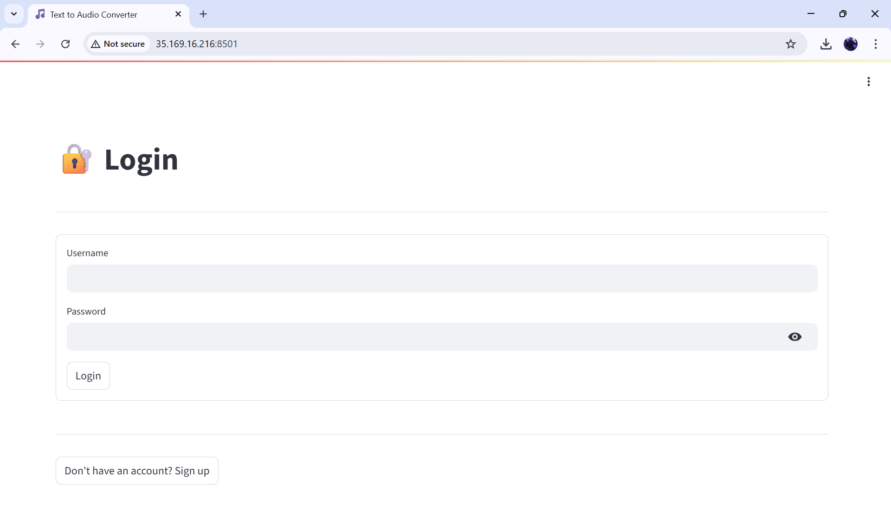

Signup page -
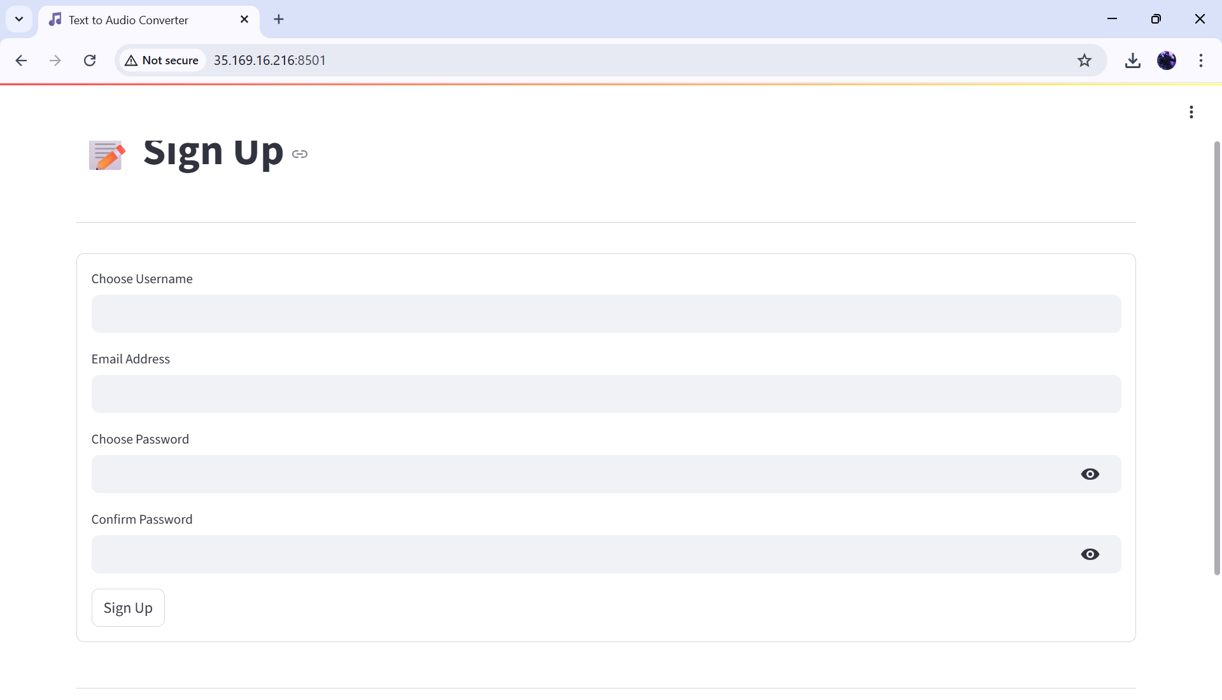
Home page-