Customer Insights & Recommendations Report

Dataset Analysis & Reporting

Prepared Using Python and Power BI

Prepared By
Devyansi Chapadia

Data Analytics Internship

June 2026

Table of Contents

1. Executive Summary
2. Dataset Overview
3. Data Quality Assessment
4. Data Cleaning Report
5. Descriptive Statistics
6. Univariate Analysis
7. Bivariate Analysis
8. Power BI DashBoard
9. Customer Segmentation Analysis
10. Business Insights
11. Business Recommendations
12. Appendix

1. Executive Summary

This report presents a comprehensive analysis of the online retail dataset covering transactions from December 2010 to December 2011. The dataset comprises 524,878 transaction records across 38 countries, providing a rich foundation for understanding sales performance, customer behavior, and product trends.

The analysis was conducted using Python (Pandas, NumPy, Matplotlib, Seaborn) for data loading, cleaning, exploratory data analysis, and visualization. An interactive Power BI dashboard was developed to visualize revenue trends, customer insights, product performance, and geographic sales distribution.

Key Highlights

Metric | Value
Total Transactions | 524,878
Total Revenue | £10,642,110.80
Unique Customers | 4,339
Unique Products | 3,922
Unique Invoices | 19,960
Countries Covered | 38
Period | Dec 2010 – Dec 2011

Key Findings
- The United Kingdom dominates sales, accounting for approximately 91.4% of all transactions.
- November 2011 recorded the highest monthly revenue of £1,503,866 — a strong pre-holiday peak.
- DOTCOM POSTAGE was the highest revenue-generating product at £206,248.77.
- Customer 14646 was the top spender with £280,206.02 in purchases.
- 132,186 transactions (25.18%) had missing CustomerID values — these rows were retained as-is to preserve complete transaction data.
- Strong positive correlation (0.91) exists between Quantity sold and Revenue generated.
- 274 High Value customers drive 61.5% of revenue", "65.6% repeat buyer rate", "34.4% one-time buyers represent re-engagement opportunity

2. Dataset Overview

The online retail dataset is a transactional dataset sourced from a UK-based and registered non-store online retail company. The company primarily sells unique all-occasion gifts, and many of its customers are wholesalers.

Dataset Source & Context
- Source: Kaggle database
- Type: Online Retail
- Period Covered: 1st December 2010 to 9th December 2011 (approximately 12 months)
- Geographic Scope: 38 countries worldwide
- Primary Market: United Kingdom

Dataset Dimensions
Attribute | Value
Total Rows | 524,878
Total Columns | 10
File Format | CSV
Time Span | 12 months

Column Descriptions
Column | Data Type | Description
InvoiceNo | String | Unique invoice number for each transaction
StockCode | String | Unique product/item code
Description | String | Product name and description
Quantity | Integer | Number of units purchased per transaction
InvoiceDate | DateTime | Date and time of the transaction
UnitPrice | Float | Price per unit in GBP (£)
CustomerID | Float | Unique customer identifier. Contains missing values (nullable).
Country | String | Country where the customer resides
Revenue | Float | Total revenue = Quantity x UnitPrice
Month | String | Year-Month extracted from InvoiceDate

3. Data Quality Assessment

Before performing any analysis, a thorough data quality assessment was conducted to identify issues that could affect the reliability of insights. The assessment covered completeness, consistency, accuracy, and validity of the dataset.

Missing Values Analysis
Column | Missing Count | Missing % | Action Taken
InvoiceNo | 0 | 0.00% | No action needed
StockCode | 0 | 0.00% | No action needed
Description | 0 | 0.00% | No action needed
Quantity | 0 | 0.00% | No action needed
InvoiceDate | 0 | 0.00% | No action needed
UnitPrice | 0 | 0.00% | No action needed
CustomerID | 132,186 | 25.18% | Retained as-is (no replacement)
Country | 0 | 0.00% | No action needed
Revenue | 0 | 0.00% | No action needed
Month | 0 | 0.00% | No action needed

Data Quality Summary
- Overall dataset completeness: 97.48% (only CustomerID had missing values)
- No duplicate invoice rows were found after cleaning
- All date fields were valid and parseable
- Unit prices and quantities were within expected business ranges post-cleaning
- Revenue column was validated against Quantity x UnitPrice calculations

4. Data Cleaning Report

The raw dataset underwent a structured cleaning pipeline in Python using the Pandas library. The following steps were applied systematically to ensure data integrity and analysis readiness.

Cleaning Steps Applied

Step | Issue | Action | Records Affected
1 | Missing CustomerID | Retained as-is — missing rows kept to preserve all transaction data | 132,186 rows
2 | Negative Quantities | Removed cancelled/return transactions (negative Quantity) | Cleaned
3 | Zero Unit Prices | Removed rows with UnitPrice = 0 (free/test items) | Cleaned
4 | Date Formatting | Converted InvoiceDate to datetime format | All rows
5 | Revenue Column | Calculated Revenue = Quantity x UnitPrice | 524,878 rows
6 | Month Column | Extracted Year-Month from InvoiceDate for trend analysis | 524,878 rows
7 | Data Types | Standardized dtypes (int, float, str, datetime) | All columns

CustomerID Treatment Decision

CustomerID contained 132,186 missing values (25.18%). These records were retained to avoid losing valuable sales and transaction data.

Post-Cleaning Dataset
Metric | Before Cleaning | After Cleaning
Total Rows | 524,878 | 524,878
Missing Values | 132,186 | 132186
Duplicate Rows | Checked | Removed
Data Types | Mixed | Standardized
Revenue Column | Not present | Computed

5. Descriptive Statistics

Descriptive statistics provide a high-level numerical summary of the dataset's key variables. The following metrics were computed for the three primary numerical columns: Quantity, UnitPrice, and Revenue.

Summary Statistics Table
Statistic | Quantity | UnitPrice (£) | Revenue (£)
Count | 524,878 | 524,878 | 524,878
Mean | 10.62 | 3.92 | 20.28
Std Dev | 156.28 | 36.09 | 271.69
Min | 1 | £0.001 | £0.001
25th Percentile | 1 | £1.25 | £3.90
Median (50th) | 4 | £2.08 | £9.92
75th Percentile | 11 | £4.13 | £17.70
Max | 80,995 | £13,541.33 | £168,469.60

Key Observations
- The mean quantity per transaction is 10.62 units, but the median is only 4 — indicating most orders are small but some bulk orders significantly skew the average.
- UnitPrice ranges from £0.001 to £13,541.33, suggesting the product catalog spans from low-cost accessories to high-value items.
- Revenue per transaction has a mean of £20.28 and a median of £9.92 — a right-skewed distribution driven by a few very high-value transactions.
- The maximum single-transaction revenue is £168,469.60, which represents a significant bulk order.
- Standard deviations are large for all variables, confirming high variability typical of B2B/wholesale retail patterns.

6. Univariate Analysis

Univariate analysis examines each variable individually to understand its distribution, frequency, and range. Four charts were created in Python using Seaborn and Matplotlib to visualize the distribution of the key numerical variables.

Chart 1: Revenue Distribution (Histogram)

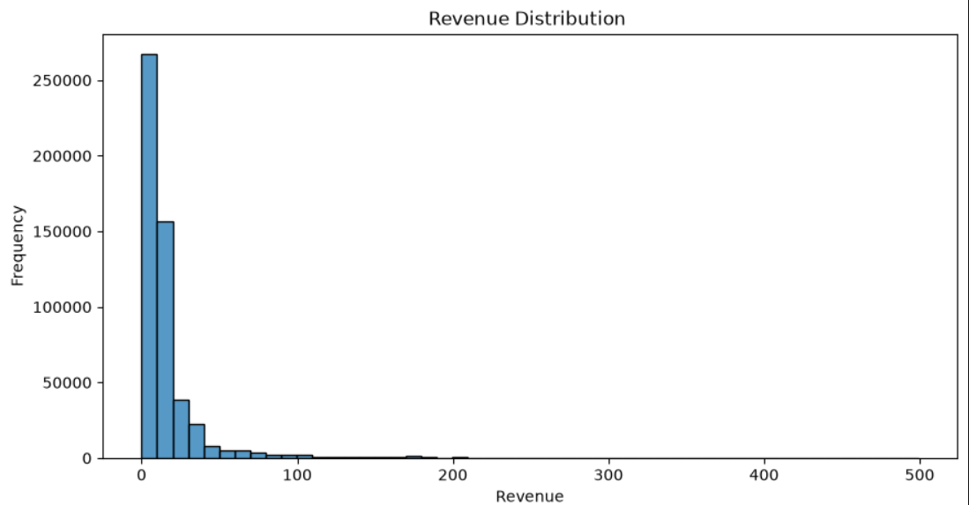

- Revenue values were filtered below £500 to focus on the majority of transactions and remove extreme outliers from the visualization.
- The histogram shows a very strong right-skewed distribution — the vast majority of transactions (over 260,000) fall in the £0–£20 range.
- The frequency drops sharply after £50, confirming that high-revenue transactions are rare but exist.
- This skew is typical of wholesale/retail datasets where most orders are small but occasional bulk orders generate large revenue.

Chart 2: Revenue Boxplot

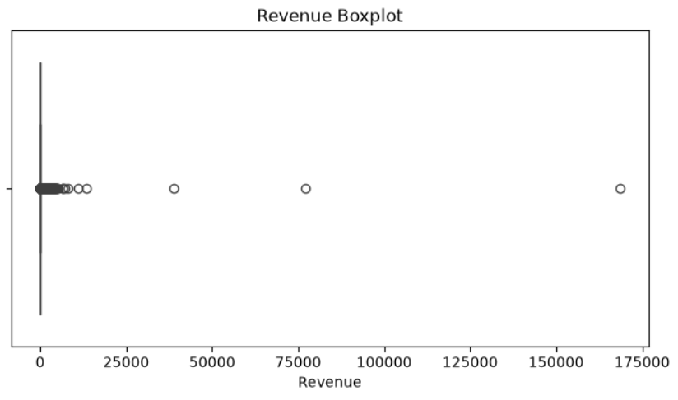

- The boxplot of Revenue reveals extreme outliers — data points spread from £0 all the way to £168,469.60 (the maximum single transaction).
- The box (IQR) is compressed near zero on the left side, confirming the median is very low (£9.92) relative to the range.
- Several visible outlier points appear at £25,000, £50,000, £100,000 and £168,000+ — these represent major bulk wholesale orders.
- This visualization confirms that Revenue is heavily influenced by a small number of very high-value transactions.

Chart 3: Quantity Distribution (Histogram)

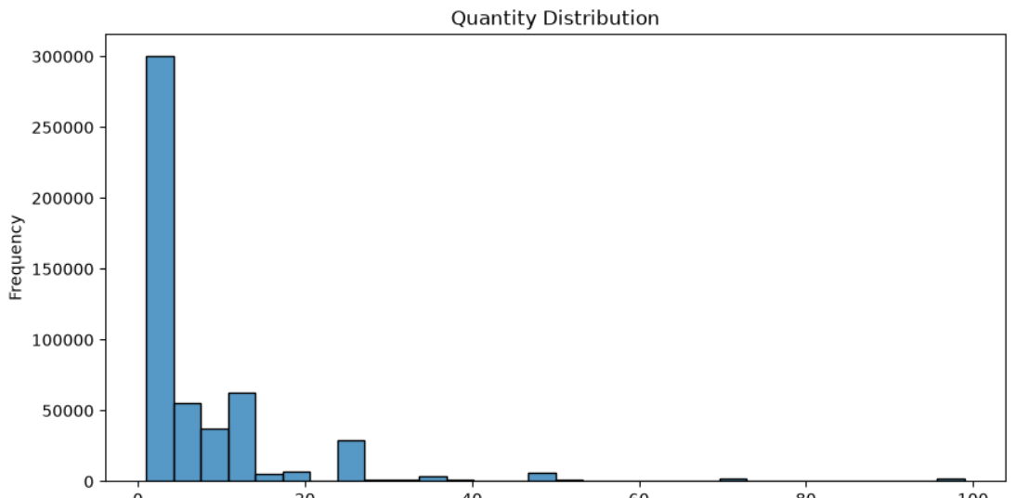

- Quantity was filtered to values below 100 units to focus on typical transaction sizes and exclude extreme bulk orders.
- The histogram shows that the majority of transactions (nearly 300,000) involve very small quantities (1–5 units).
- A secondary cluster appears around 12–24 units, likely representing standard pack/box sizes common in wholesale retail.
- Quantities above 50 units per transaction are rare, appearing as a thin tail on the right side of the chart.

Chart 4: Unit Price Distribution (Histogram)

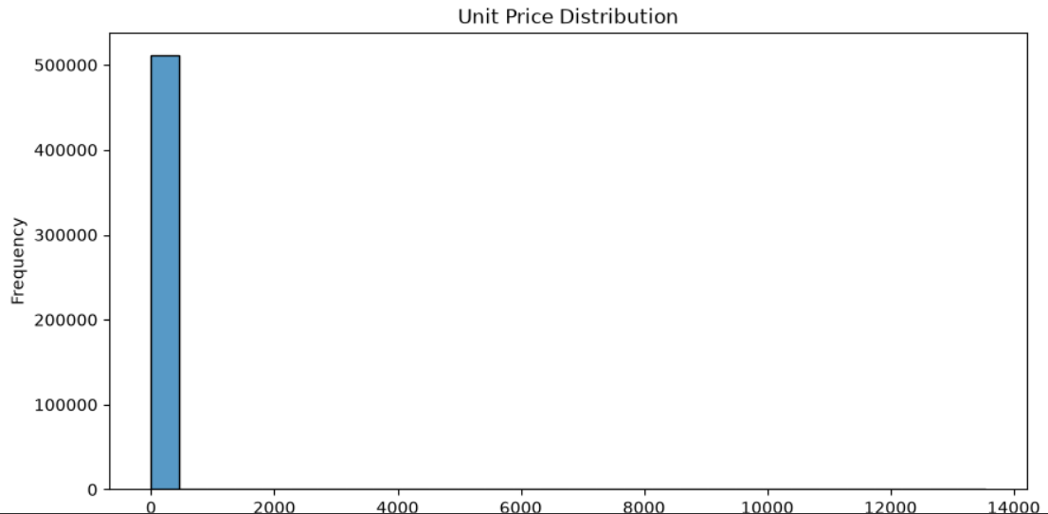

- The Unit Price histogram (filtered for Quantity < 50) shows an extremely right-skewed distribution with over 500,000 transactions priced at very low values (£0–£500).
- The x-axis extends to £14,000, confirming a few very high-priced items exist in the catalog — but they are extremely rare.
- Most products are low-cost items (below £10), consistent with the nature of a gift/novelty retail business.
- The extreme right tail represents premium or specialty items that are infrequently purchased.

7. Bivariate Analysis

Bivariate analysis explores relationships between pairs of variables. Two charts were created in Python — a scatter plot and a correlation heatmap — to understand how the numerical variables interact with each other.

Chart 1: Quantity vs Revenue (Scatter Plot)

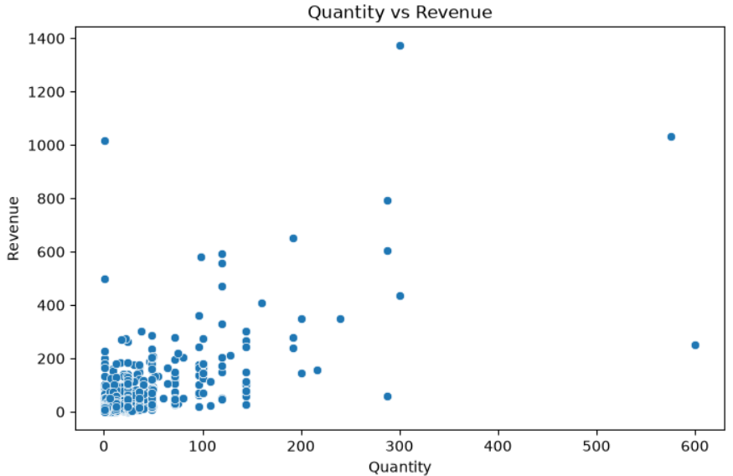

- A sample of the dataset was used for the scatter plot to improve visualization clarity and rendering performance.
- The scatter plot shows a clear positive relationship between Quantity and Revenue — as quantity increases, revenue tends to increase proportionally.
- Most data points are clustered in the lower-left (small quantity, low revenue), with a few high-quantity outliers generating revenues above £800–£1,400.
- One notable point shows a transaction of ~600 units generating around £1,000 in revenue, suggesting a lower unit price bulk order.
- The pattern confirms that Quantity is the primary driver of Revenue in this dataset.

Chart 2: Correlation Matrix (Heatmap)

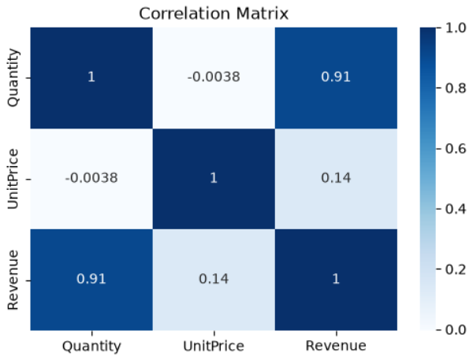

Variable | Quantity | UnitPrice | Revenue
Quantity | 1.00 | -0.0038 | 0.91
UnitPrice | -0.0038 | 1.00 | 0.14
Revenue | 0.91 | 0.14 | 1.00

- Quantity vs Revenue (r = 0.91): Very strong positive correlation — the strongest relationship in the dataset. Higher quantity directly drives higher revenue.
- UnitPrice vs Revenue (r = 0.14): Weak positive correlation — unit price has only a minor effect on total revenue, meaning volume matters far more than price.
- UnitPrice vs Quantity (r = -0.0038): Near-zero correlation — product price has virtually no effect on how many units are ordered, indicating price-inelastic purchasing behavior.
- The heatmap used the 'Blues' colormap, making it easy to visually identify the strong Quantity-Revenue relationship (dark blue) vs weak relationships (light blue/white).

8. Power BI Dashboard

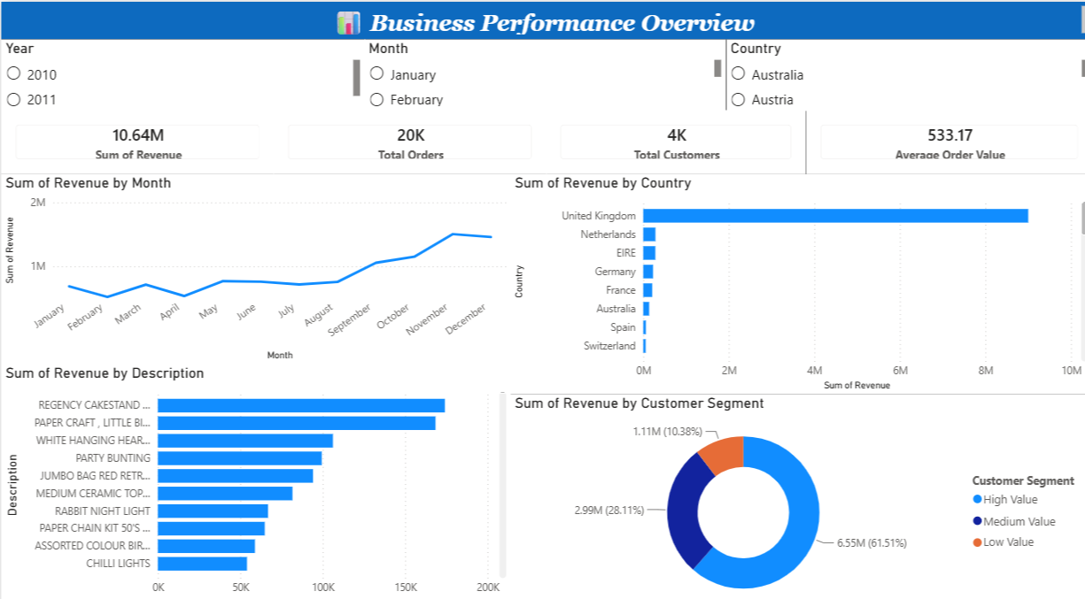

Business Performance Overview
- Revenue Trend Line Chart — Monthly revenue from Dec 2010 to Dec 2011
- Top 10 Products Bar Chart — Ranked by total revenue
- Revenue by Country Bar Chart — Geographic revenue distribution
- Revenue by Customer Segment Donut Chart — High, Medium, Low Value breakdown
- KPI Cards — Total Revenue (£10.64M), Total Orders (20K), Total Customers (4K), Average Order Value (£533.17)
- Slicers — Filter by Year, Month, and Country

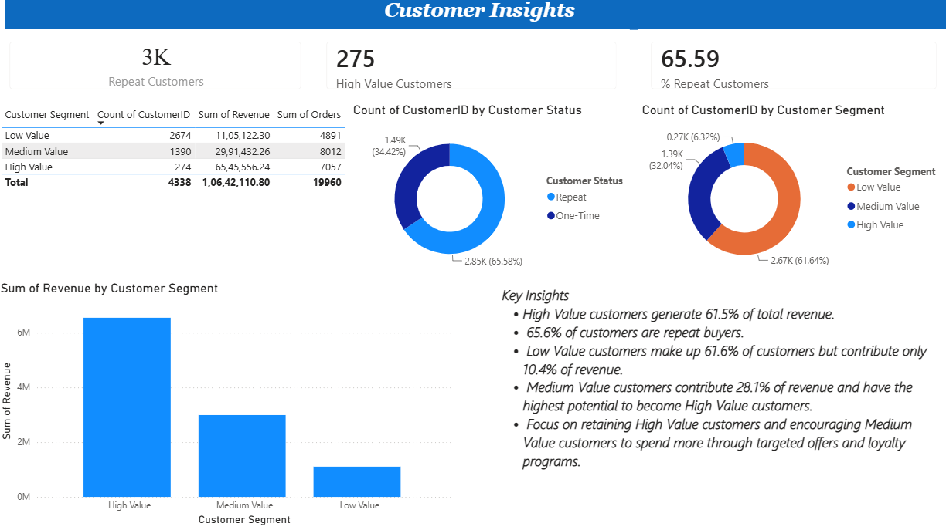

Customer Insights
- KPI Cards — Repeat Customers (3K), High Value Customers (275), % Repeat Customers (65.59%)
- Customer Segment Table — Count, Revenue, and Orders by segment
- Customer Status Donut Chart — Repeat vs One-Time buyers
- Customer Segment Donut Chart — High, Medium, Low Value distribution
- Revenue by Customer Segment Bar Chart — Revenue contribution per segment

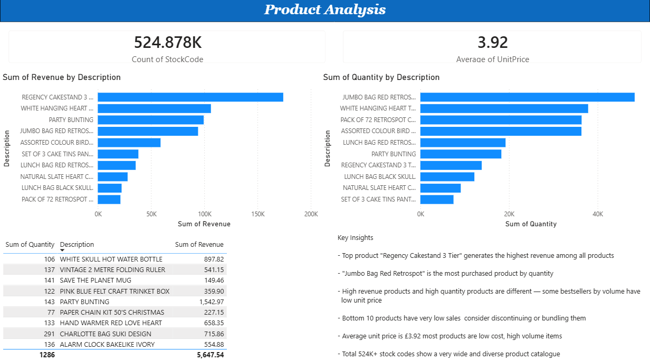

Product Analysis
- KPI Cards — Count of Stock Codes (524.878K), Average Unit Price (£3.92)
- Top 10 Products by Revenue Bar Chart — Highest revenue-generating products
- Top 10 Products by Quantity Bar Chart — Most purchased products by volume
- Least Selling Products Table — Bottom 10 products by quantity and revenue

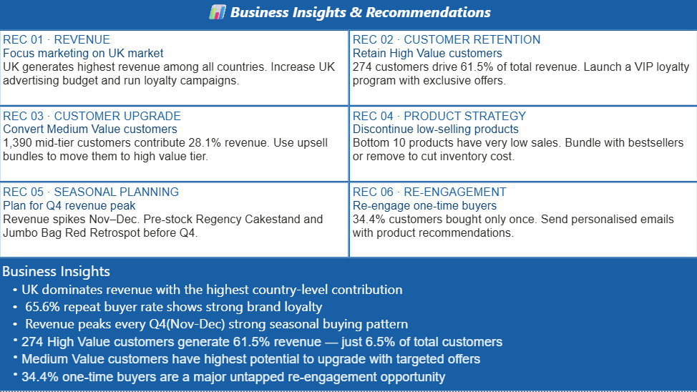

Customer Segmentation Analysis

Customers were classified into three value-based groups — High Value, Medium Value, and Low Value — based on their total revenue contribution.

High Value (274 customers — 61.51% revenue)
- Total Revenue: £65,45,556.24 | Total Orders: 7,057
- Smallest group but highest business impact — critical to retain
Medium Value (1,390 customers — 28.11% revenue)
- Total Revenue: £29,91,432.26 | Total Orders: 8,012
- Highest upgrade potential with targeted offers
Low Value (2,674 customers — 10.38% revenue)
- Total Revenue: £11,05,122.30 | Total Orders: 4,891
- Largest group by count but lowest revenue contribution
Overall: 4,338 customers | £1,06,42,110.80 total revenue | 19,960 orders

Key Observations
- High Value customers are only 6.32% of customers but drive 61.51% of total revenue
- Medium Value customers have the highest potential to upgrade with targeted offers
- Low Value customers are 61.6% of the base but contribute only 10.38% of revenue
- Repeat customer rate is 65.59% — showing strong brand loyalty
- 34.4% one-time buyers represent a major re-engagement opportunity

9. Business Insights

Insight 1: UK Market Dominance

The United Kingdom accounts for 91.45% of all transactions and 84.59% of total revenue. While this demonstrates a strong home market, it also represents a significant concentration risk.
- Develop targeted international expansion strategies, particularly in Germany, France, and Netherlands — markets already showing organic growth.
- Invest in localised marketing campaigns for the top 5 non-UK countries.

Insight 2: Strong Q4 Seasonality

Revenue spikes sharply in September–November, with November being the peak month at £1,503,866.78. This is consistent with holiday gifting patterns.
- Build inventory and staffing plans well ahead of Q4 to capitalise on seasonal demand.
- Launch early Q4 promotions in October to capture early holiday shoppers.

Insight 3: High-Value Customer Concentration

274 High Value customers generate 61.5% of total revenue despite being only 6.5% of the total customer base. This makes them the most critical segment for retention.
- Launch a VIP loyalty program with exclusive offers and personalised discounts for this segment.
- Assign priority customer service or dedicated account management to top spenders.

Insight 4: Product Portfolio Opportunities

With 3,922 unique products the catalog is broad. However the top products account for a disproportionate share of revenue while bottom products show very low sales.
- Apply the 80/20 principle — identify top 20% of products generating 80% of revenue and ensure their availability.
- Review low-performing products for discontinuation or bundling with bestsellers.

Insight 5: Medium Value Upgrade Opportunity
1,390 Medium Value customers contribute 28.11% of revenue and represent the highest potential to move into the High Value tier with the right incentives.

- Run targeted upsell campaigns with bundle offers and volume discounts.

- Use personalised email marketing based on past purchase history to recommend higher value products.

Insight 6: One-Time Buyer Re-engagement
34.4% of customers purchased only once and never returned. This segment represents a significant untapped revenue opportunity across all customer groups.

- Send personalised re-engagement emails with product recommendations based on their first order.

- Offer a first-return incentive such as a discount code or free shipping to encourage a second purchase.

Business Recommendations

Focus Marketing on UK Market
UK generates the highest revenue among all countries. Increase the UK advertising budget and introduce UK-specific loyalty campaigns to strengthen market leadership.

Retain High Value Customers
274 customers drive 61.5% of total revenue. Launch a VIP loyalty program with exclusive offers, early product access, and personalised discounts to prevent churn in this critical segment.

Convert Medium Value Customers
1,390 mid-tier customers contribute 28.1% of revenue and have the highest upgrade potential. Use upsell bundles, volume discounts, and personalised email campaigns to move them into the High Value tier.

Discontinue Low-Selling Products
Bottom 10 products show consistently low sales and quantity. Bundle them with bestsellers like Regency Cakestand or remove them entirely to reduce inventory cost and simplify the catalogue.

Plan for Q4 Revenue Peak
Revenue spikes every November–December. Pre-stock top selling products like Regency Cakestand 3 Tier and Jumbo Bag Red Retrospot before October to meet seasonal demand without stockouts.

Re-engage One-Time Buyers
34.4% of customers purchased only once. Send personalised re-engagement emails with product recommendations based on their first order, along with a return incentive like a discount code.

10. Appendix

A. Tools & Technologies Used
Category | Tool / Library | Purpose
Programming | Python 3.x | Core analysis language
Data Manipulation | Pandas, NumPy | Dataloading,cleaning, transformation
Visualization | Matplotlib, Seaborn | Static charts and plots
Dashboard | Microsoft Power BI | Interactive executive dashboard
Customer Segmentation | PowerBI DAX | Customer value grouping
Environment | Jupyter Notebook | Analysis and documentation
Version Control | GitHub | Code and script management
Reporting | Microsoft Word | This executive report

11. Conclusion
This project analyzed the Online Retail dataset using Python and Power BI. Data cleaning, EDA, and customer segmentation were performed to uncover key business insights.
A 4-page interactive dashboard was built covering Business Performance, Customer Insights, Product Analysis, and Business Recommendations.
Key findings include UK market dominance, 274 High Value customers driving 61.5% revenue, strong Q4 seasonal patterns, and a 34.4% one-time buyer re-engagement opportunity.
――― End of Report ―――

