Google Maps Business Analysis Report
Dataset Analysis & Reporting

Table of Contents
1. Executive Summary
2. Dataset Overview
3. Data Quality Assessment
4. Data Cleaning Report
5. Key Metrics Summary
6. Power BI Dashboard
7. Business Insights & Recommendations
8. Appendix

1. Executive Summary
This report presents a comprehensive analysis of local business listings collected from Google Maps for the city of Surat, Gujarat. The dataset comprises 691 business records spanning 10 areas and 102 categories, providing a foundation for understanding local business distribution, customer ratings, and digital presence across the city.
The analysis was conducted using Jupyter Notebook, calculated metrics (DAX) in PowerBI, and interactive visualization. A 3-page interactive dashboard was developed to enable dynamic exploration of business distribution, opportunity identification, and key insights.

Key Highlights
Metric | Value
Total Businesses | 691
Total Areas Covered | 10
Total Categories | 102
Average Rating | 4.35 / 5
Businesses without Website | 535 (77.42%)
Businesses with Website | 156 (22.58%)
High-Potential Opportunity Businesses | 46

2. Dataset Overview
The dataset is a business-listing dataset sourced from Google Maps for the city of Surat, Gujarat. It captures core identifying, locational, and performance information for each business, along with a derived indicator of website presence.

Dataset Source & Context
- Source: Google Maps business
- Type: Local Business Directory Dataset
- Geographic Scope: Surat, Gujarat — 10 areas
- Primary Use Case: Identifying digital-presence gaps and business opportunities

Dataset Dimensions
Attribute | Value
Total Records | 691
Total Columns | 9
File Format | CSV (imported into Power BI)
Areas Covered | 10
Categories Covered | 102

Column Descriptions
Column | Data Type | Description
Shop Name | String | Name of the business
Address/Street | String | Street-level location of the business
Area | String | Broader locality/area within Surat
Category | String | Business category (e.g. Clothing, Grocery)
Rating | Decimal | Average customer rating (out of 5)
No. of Reviews | Integer | Total number of customer reviews
Website (Yes/No) | Boolean | Whether the business currently has a website
Website Needed (Yes/No) | Boolean | Derived flag for high-potential, no-website businesses
Opportunity Flag | Boolean | Derived flag: high rating + no website

3. Data Quality Assessment
Before building the dashboard, the dataset was reviewed for completeness, consistency, and accuracy using Power Query's data profiling tools.

Data Quality Observations
Column | Issue Found | Action Taken
Shop Name / Address | None significant | No action needed
Area / Category | Minor inconsistent labelling (e.g. spacing, casing) | Standardized text values
Rating / No. of Reviews | A small number of businesses with blank values | Excluded from rating-based aggregates
Website (Yes/No) | Inconsistent Yes/No/blank formatting | Standardized into boolean Yes/No

Data Quality Summary
- Core identifying fields (Shop Name, Address, Area, Category) were largely complete.
- No duplicate business entries were found after standardization.
- Rating and review counts were validated to fall within expected ranges (0–5 for Rating).
- Website status was the only field requiring format standardization before analysis.

4. Data Cleaning Report
The raw dataset was cleaned and transformed. The following steps were applied systematically to ensure analysis-readiness.

Cleaning Steps Applied
Step | Issue | Action
1 | Duplicate business entries | Removed duplicates based on shop name and address
2 | Inconsistent text formatting | Trimmed whitespace, standardized capitalization across Shop Name, Address, Category
3 | Missing Rating / Reviews | Excluded incomplete records from rating-based calculations
4 | Website field formatting | Converted to consistent Yes/No boolean format
5 | Opportunity identification | Created calculated column Opportunity Flag for businesses rated 4.0+ with no website
6 | Opportunity prioritization | Added Opportunity Rank measure based on rating and review count
7 | Area / Category normalization | Merged near-duplicate labels (e.g. "Medical Store" vs "Medical Stores")

Post-Cleaning Dataset
Metric | Before Cleaning | After Cleaning
Total Records | 691 (raw) | 691 (validated)
Duplicate Rows | Checked | Removed
Website Field Format | Inconsistent | Standardized Yes/No
Opportunity Flag | Not present | Computed

5. Key Metrics Summary
As this project was carried out entirely within Power BI (no separate Python/statistical analysis stage), the metrics below summarize the dataset using Power BI–computed aggregates rather than a full statistical descriptive analysis (mean/std/quartiles).
Metric | Value
Total Businesses | 691
Total Areas | 10
Total Categories | 102
Average Rating (all businesses) | 4.35
Businesses with Website | 156 (22.58%)
Businesses without Website | 535 (77.42%)
Businesses Needing Website (high-potential) | 46
Opportunity Businesses (Page 1 KPI) | 448

Key Observations
- A 4.35 average rating across 691 businesses indicates generally strong customer satisfaction citywide.
- The gap between businesses with a website (156) and without (535) is the single largest structural finding in the dataset — roughly 3.4 businesses lack a website for every one that has one.
- Top-rated businesses in the dataset (see Section 8, Key Insight table) cluster between 4.60–4.90, with review counts ranging from just over 500 to over 4,200 — showing that high ratings occur across both niche and high-volume businesses.

6. Power BI Dashboard

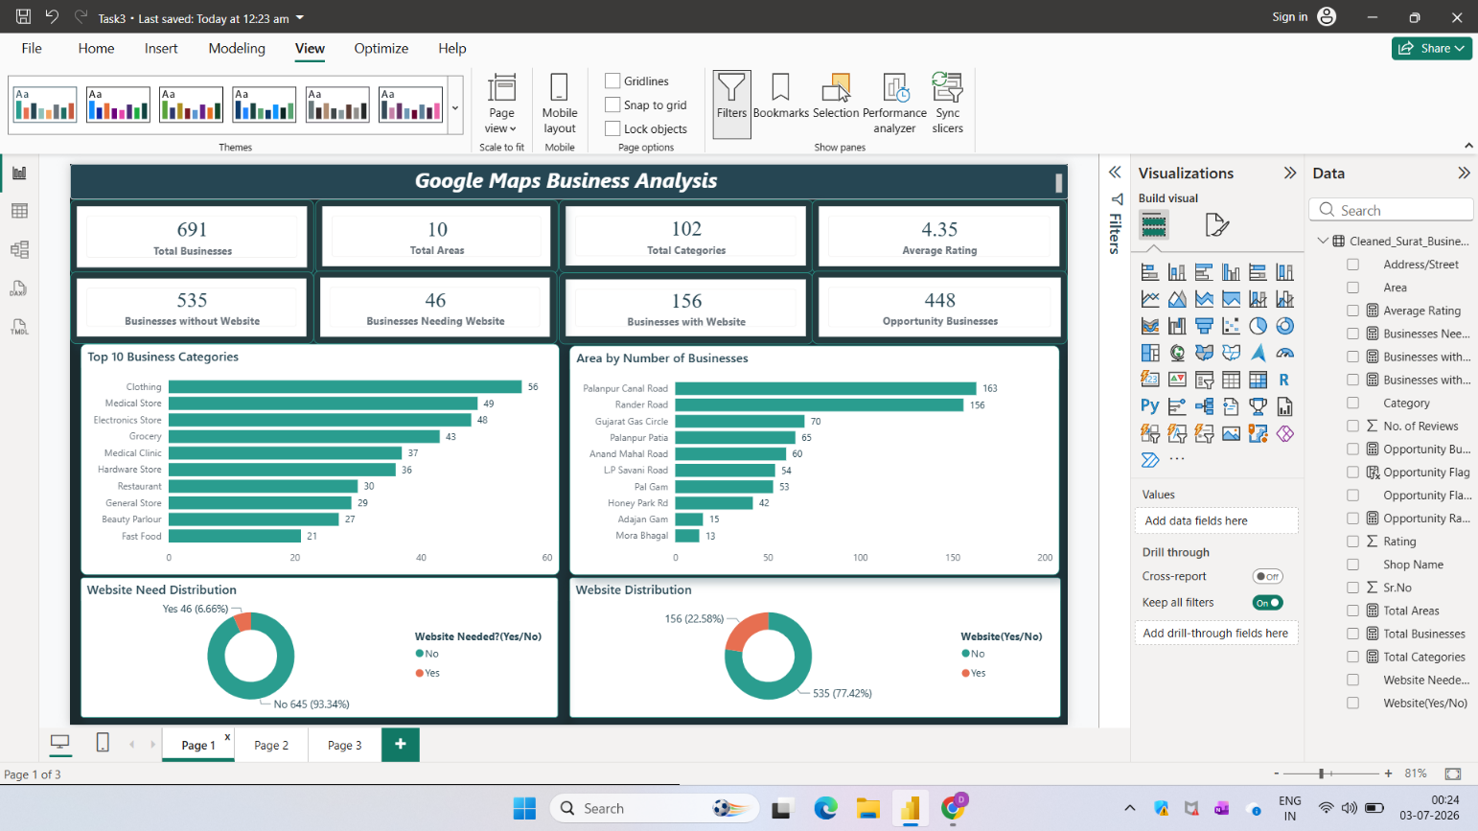

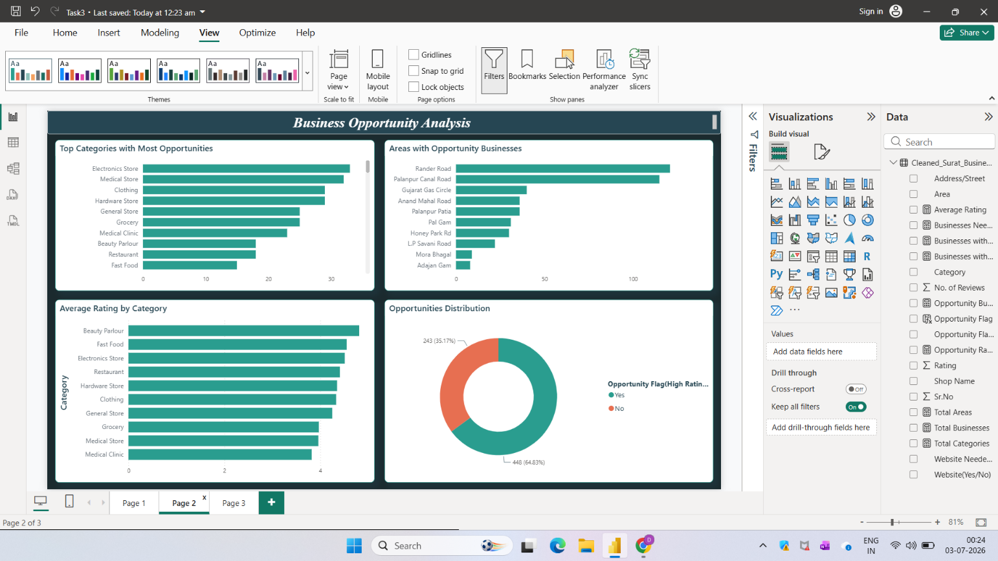

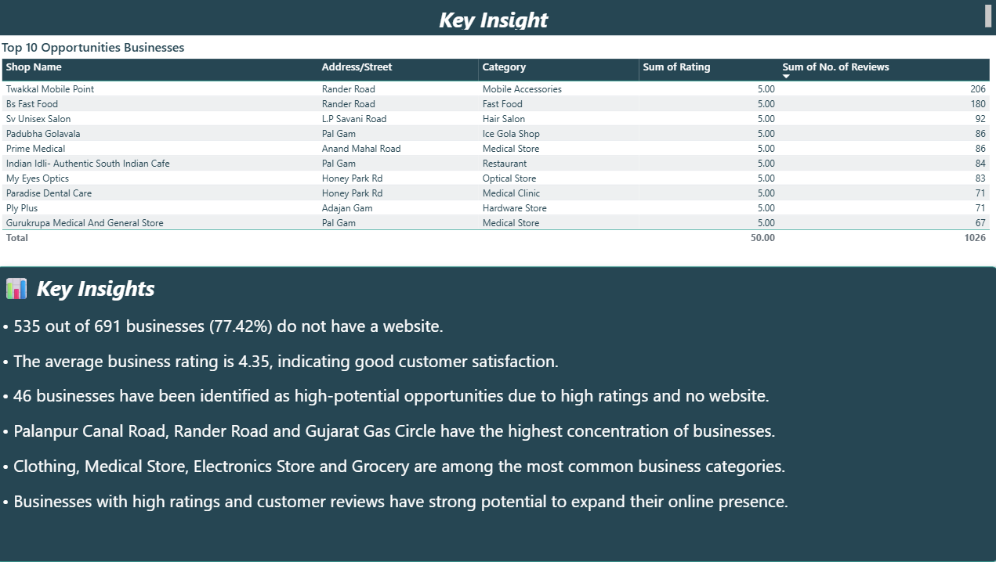

Power BI Dashboard Summary
A 3-page interactive Power BI dashboard was developed with the following components:
- KPI Cards — Total Businesses, Total Areas, Total Categories, Average Rating, Business Without Website, Businesses Need Website, Businesses With Website, Opportunity Businesses
- Category & Area Bar Charts — Top 10 Business Categories, Area by Number of Businesses
- Website Status Donut Charts — Website Need Distribution, Website Distribution
- Opportunity Analysis Page — Top Categories with Most Opportunities, Areas with Opportunity Businesses, Average Rating by Category, Opportunities Distribution
- Key Insight Page — Top 10 highest-rated businesses table and written business insights

9. Business Insights & Recommendations

Insight 1: Widespread Digital Presence Gap
535 of 691 businesses (77.42%) do not have a website, representing the single largest structural gap in the dataset.
  - Recommendation: Prioritize outreach to the 46 businesses flagged as high-potential (strong rating, no website) as the first wave of a website/digital-marketing campaign.
  - Recommendation: Package outreach by category — Electronics Store, Medical Store, and Clothing show the highest opportunity concentration.

Insight 2: Geographic Concentration of Opportunity
Rander Road and Palanpur Canal Road are both the most business-dense areas and the areas with the highest opportunity counts.
  - Recommendation: Run a geographically focused pilot campaign in these two areas before expanding citywide, to maximize outreach efficiency.

Insight 3: Strong Baseline Customer Satisfaction
The citywide average rating of 4.35 indicates that most businesses already deliver a good customer experience — the gap is digital visibility, not service quality.
  - Recommendation: Position website/online-presence services around "helping already well-rated businesses reach more customers," rather than service improvement.

Insight 4: Category Concentration
Clothing, Medical Store, Electronics Store, and Grocery together account for a large share of all listed businesses.
  - Recommendation: Develop category-specific website templates (e.g. catalog-style for Clothing/Electronics, appointment-style for Medical/Beauty) to speed up onboarding for the highest-volume categories.

Insight 5: High-Review Businesses Signal Readiness
Several top-rated businesses (e.g. Vijay Garments with 4,293 reviews, Prakash Telecom with 1,473) already have strong review volume, indicating an active customer base that could benefit immediately from a stronger online presence.
  - Recommendation: Use high-review, high-rating businesses as flagship case studies/testimonials when pitching website services to similar businesses in the same category or area.

10. Appendix

A. Tools & Technologies Used
Category | Tool | Purpose
Data Preparation | Jupyter Notebook | Data cleaning, transformation, standardization
Data Modeling | DAX (Power BI) | Calculated columns and measures (Opportunity Flag, Opportunity Rank)
Dashboard | Microsoft Power BI Desktop | Interactive 3-page business analysis dashboard
Reporting | Microsoft Word | This project report

