- ONLINE RETAIL SALES ANALYSIS REPORT

Dataset Analysis & Reporting

Prepared Using Python and Power BI

Prepared By
Devyansi Chapadia

Data Analytics Internship

June 2026

Table of Contents

1. Executive Summary
2. Dataset Overview
3. Data Quality Assessment
4. Data Cleaning Report
5. Descriptive Statistics
6. Univariate Analysis
7. Bivariate Analysis
8. Power BI DashBoard
9. Business Insights
10. Appendix

1. Executive Summary

This report presents a comprehensive analysis of the online retail dataset covering transactions from December 2010 to December 2011. The dataset comprises 524,878 transaction records across 38 countries, providing a rich foundation for understanding sales performance, customer behavior, and product trends.

The analysis was conducted using Python (Pandas, NumPy, Matplotlib, Seaborn) for data loading, cleaning, exploratory data analysis, and visualization. An interactive Power BI dashboard was developed to visualize revenue trends, customer insights, product performance, and geographic sales distribution.

Key Highlights

Metric | Value
Total Transactions | 524,878
Total Revenue | £10,642,110.80
Unique Customers | 4,339
Unique Products | 3,922
Unique Invoices | 19,960
Countries Covered | 38
Period | Dec 2010 – Dec 2011

Key Findings
- The United Kingdom dominates sales, accounting for approximately 91.4% of all transactions.
- November 2011 recorded the highest monthly revenue of £1,503,866 — a strong pre-holiday peak.
- DOTCOM POSTAGE was the highest revenue-generating product at £206,248.77.
- Customer 14646 was the top spender with £280,206.02 in purchases.
- 132,186 transactions (25.18%) had missing CustomerID values — these rows were retained as-is to preserve complete transaction data.
- Strong positive correlation (0.91) exists between Quantity sold and Revenue generated.

2. Dataset Overview

The online retail dataset is a transactional dataset sourced from a UK-based and registered non-store online retail company. The company primarily sells unique all-occasion gifts, and many of its customers are wholesalers.

Dataset Source & Context
- Source: Kaggle database
- Type: Online Retail
- Period Covered: 1st December 2010 to 9th December 2011 (approximately 12 months)
- Geographic Scope: 38 countries worldwide
- Primary Market: United Kingdom

Dataset Dimensions
Attribute | Value
Total Rows | 524,878
Total Columns | 10
File Format | CSV
Time Span | 12 months

Column Descriptions
Column | Data Type | Description
InvoiceNo | String | Unique invoice number for each transaction
StockCode | String | Unique product/item code
Description | String | Product name and description
Quantity | Integer | Number of units purchased per transaction
InvoiceDate | DateTime | Date and time of the transaction
UnitPrice | Float | Price per unit in GBP (£)
CustomerID | Float | Unique customer identifier. Contains missing values (nullable).
Country | String | Country where the customer resides
Revenue | Float | Total revenue = Quantity x UnitPrice
Month | String | Year-Month extracted from InvoiceDate

3. Data Quality Assessment

Before performing any analysis, a thorough data quality assessment was conducted to identify issues that could affect the reliability of insights. The assessment covered completeness, consistency, accuracy, and validity of the dataset.

Missing Values Analysis
Column | Missing Count | Missing % | Action Taken
InvoiceNo | 0 | 0.00% | No action needed
StockCode | 0 | 0.00% | No action needed
Description | 0 | 0.00% | No action needed
Quantity | 0 | 0.00% | No action needed
InvoiceDate | 0 | 0.00% | No action needed
UnitPrice | 0 | 0.00% | No action needed
CustomerID | 132,186 | 25.18% | Retained as-is (no replacement)
Country | 0 | 0.00% | No action needed
Revenue | 0 | 0.00% | No action needed
Month | 0 | 0.00% | No action needed

Data Quality Summary
- Overall dataset completeness: 97.48% (only CustomerID had missing values)
- No duplicate invoice rows were found after cleaning
- All date fields were valid and parseable
- Unit prices and quantities were within expected business ranges post-cleaning
- Revenue column was validated against Quantity x UnitPrice calculations

4. Data Cleaning Report

The raw dataset underwent a structured cleaning pipeline in Python using the Pandas library. The following steps were applied systematically to ensure data integrity and analysis readiness.

Cleaning Steps Applied

Step | Issue | Action | Records Affected
1 | Missing CustomerID | Retained as-is — missing rows kept to preserve all transaction data | 132,186 rows
2 | Negative Quantities | Removed cancelled/return transactions (negative Quantity) | Cleaned
3 | Zero Unit Prices | Removed rows with UnitPrice = 0 (free/test items) | Cleaned
4 | Date Formatting | Converted InvoiceDate to datetime format | All rows
5 | Revenue Column | Calculated Revenue = Quantity x UnitPrice | 524,878 rows
6 | Month Column | Extracted Year-Month from InvoiceDate for trend analysis | 524,878 rows
7 | Data Types | Standardized dtypes (int, float, str, datetime) | All columns

CustomerID Treatment Decision

CustomerID contained 132,186 missing values (25.18%). These records were retained to avoid losing valuable sales and transaction data.

Post-Cleaning Dataset
Metric | Before Cleaning | After Cleaning
Total Rows | 524,878 | 524,878
Missing Values | 132,186 | 132186
Duplicate Rows | Checked | Removed
Data Types | Mixed | Standardized
Revenue Column | Not present | Computed

5. Descriptive Statistics

Descriptive statistics provide a high-level numerical summary of the dataset's key variables. The following metrics were computed for the three primary numerical columns: Quantity, UnitPrice, and Revenue.

Summary Statistics Table
Statistic | Quantity | UnitPrice (£) | Revenue (£)
Count | 524,878 | 524,878 | 524,878
Mean | 10.62 | 3.92 | 20.28
Std Dev | 156.28 | 36.09 | 271.69
Min | 1 | £0.001 | £0.001
25th Percentile | 1 | £1.25 | £3.90
Median (50th) | 4 | £2.08 | £9.92
75th Percentile | 11 | £4.13 | £17.70
Max | 80,995 | £13,541.33 | £168,469.60

Key Observations
- The mean quantity per transaction is 10.62 units, but the median is only 4 — indicating most orders are small but some bulk orders significantly skew the average.
- UnitPrice ranges from £0.001 to £13,541.33, suggesting the product catalog spans from low-cost accessories to high-value items.
- Revenue per transaction has a mean of £20.28 and a median of £9.92 — a right-skewed distribution driven by a few very high-value transactions.
- The maximum single-transaction revenue is £168,469.60, which represents a significant bulk order.
- Standard deviations are large for all variables, confirming high variability typical of B2B/wholesale retail patterns.

6. Univariate Analysis

Univariate analysis examines each variable individually to understand its distribution, frequency, and range. Four charts were created in Python using Seaborn and Matplotlib to visualize the distribution of the key numerical variables.

Chart 1: Revenue Distribution (Histogram)

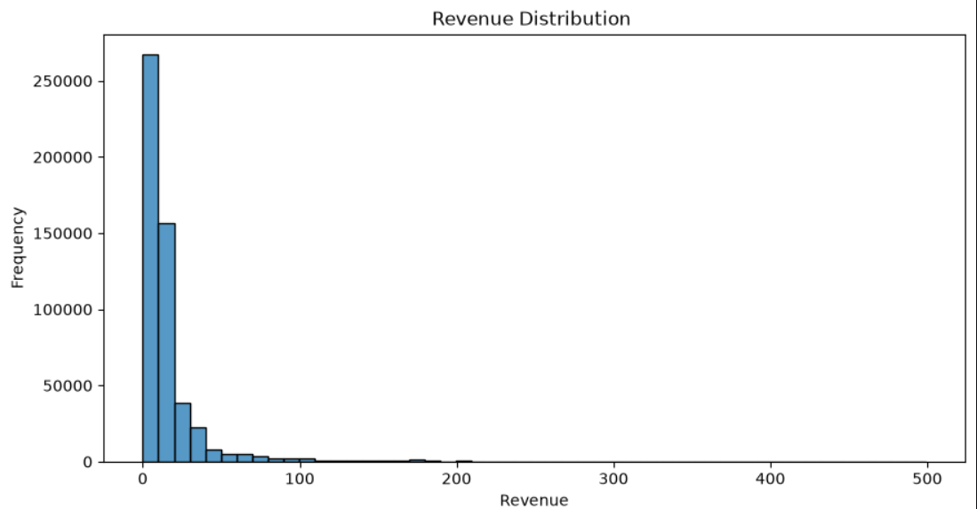

- Revenue values were filtered below £500 to focus on the majority of transactions and remove extreme outliers from the visualization.
- The histogram shows a very strong right-skewed distribution — the vast majority of transactions (over 260,000) fall in the £0–£20 range.
- The frequency drops sharply after £50, confirming that high-revenue transactions are rare but exist.
- This skew is typical of wholesale/retail datasets where most orders are small but occasional bulk orders generate large revenue.

Chart 2: Revenue Boxplot

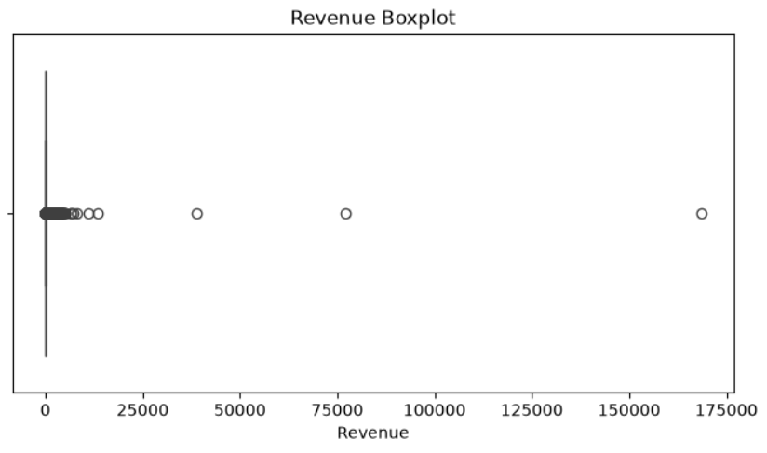

- The boxplot of Revenue reveals extreme outliers — data points spread from £0 all the way to £168,469.60 (the maximum single transaction).
- The box (IQR) is compressed near zero on the left side, confirming the median is very low (£9.92) relative to the range.
- Several visible outlier points appear at £25,000, £50,000, £100,000 and £168,000+ — these represent major bulk wholesale orders.
- This visualization confirms that Revenue is heavily influenced by a small number of very high-value transactions.

Chart 3: Quantity Distribution (Histogram)

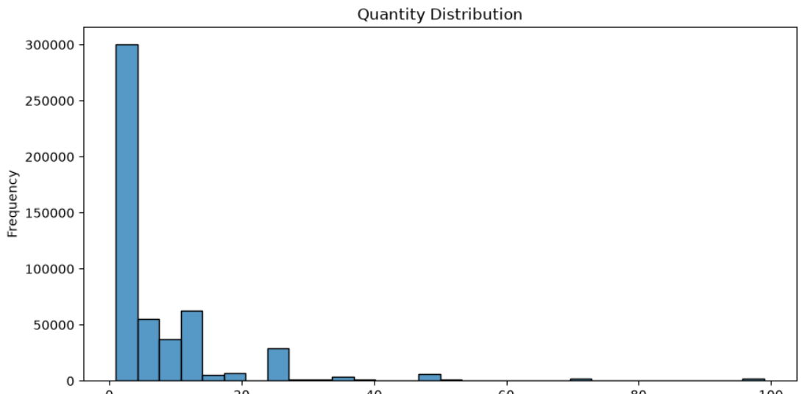

- Quantity was filtered to values below 100 units to focus on typical transaction sizes and exclude extreme bulk orders.
- The histogram shows that the majority of transactions (nearly 300,000) involve very small quantities (1–5 units).
- A secondary cluster appears around 12–24 units, likely representing standard pack/box sizes common in wholesale retail.
- Quantities above 50 units per transaction are rare, appearing as a thin tail on the right side of the chart.

Chart 4: Unit Price Distribution (Histogram)

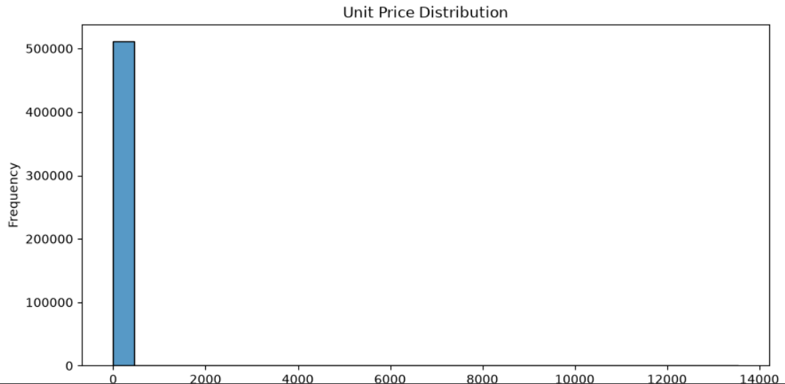

- The Unit Price histogram (filtered for Quantity < 50) shows an extremely right-skewed distribution with over 500,000 transactions priced at very low values (£0–£500).
- The x-axis extends to £14,000, confirming a few very high-priced items exist in the catalog — but they are extremely rare.
- Most products are low-cost items (below £10), consistent with the nature of a gift/novelty retail business.
- The extreme right tail represents premium or specialty items that are infrequently purchased.

7. Bivariate Analysis

Bivariate analysis explores relationships between pairs of variables. Two charts were created in Python — a scatter plot and a correlation heatmap — to understand how the numerical variables interact with each other.

Chart 1: Quantity vs Revenue (Scatter Plot)

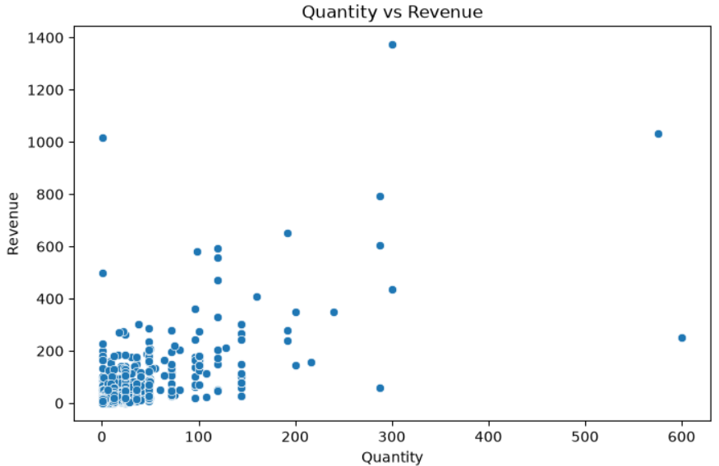

- A sample of the dataset was used for the scatter plot to improve visualization clarity and rendering performance.
- The scatter plot shows a clear positive relationship between Quantity and Revenue — as quantity increases, revenue tends to increase proportionally.
- Most data points are clustered in the lower-left (small quantity, low revenue), with a few high-quantity outliers generating revenues above £800–£1,400.
- One notable point shows a transaction of ~600 units generating around £1,000 in revenue, suggesting a lower unit price bulk order.
- The pattern confirms that Quantity is the primary driver of Revenue in this dataset.

Chart 2: Correlation Matrix (Heatmap)

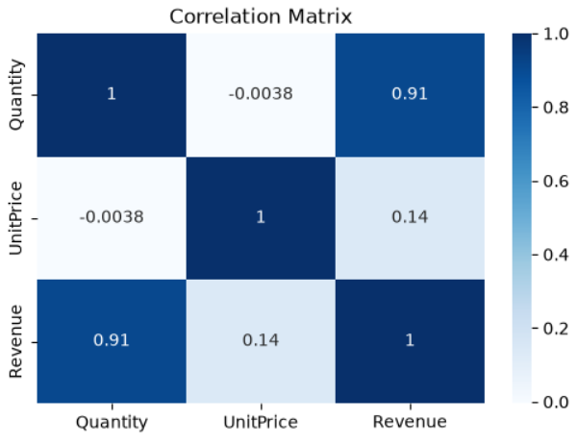

Variable | Quantity | UnitPrice | Revenue
Quantity | 1.00 | -0.0038 | 0.91
UnitPrice | -0.0038 | 1.00 | 0.14
Revenue | 0.91 | 0.14 | 1.00

- Quantity vs Revenue (r = 0.91): Very strong positive correlation — the strongest relationship in the dataset. Higher quantity directly drives higher revenue.
- UnitPrice vs Revenue (r = 0.14): Weak positive correlation — unit price has only a minor effect on total revenue, meaning volume matters far more than price.
- UnitPrice vs Quantity (r = -0.0038): Near-zero correlation — product price has virtually no effect on how many units are ordered, indicating price-inelastic purchasing behavior.
- The heatmap used the 'Blues' colormap, making it easy to visually identify the strong Quantity-Revenue relationship (dark blue) vs weak relationships (light blue/white).

8. Power BI Dashboard

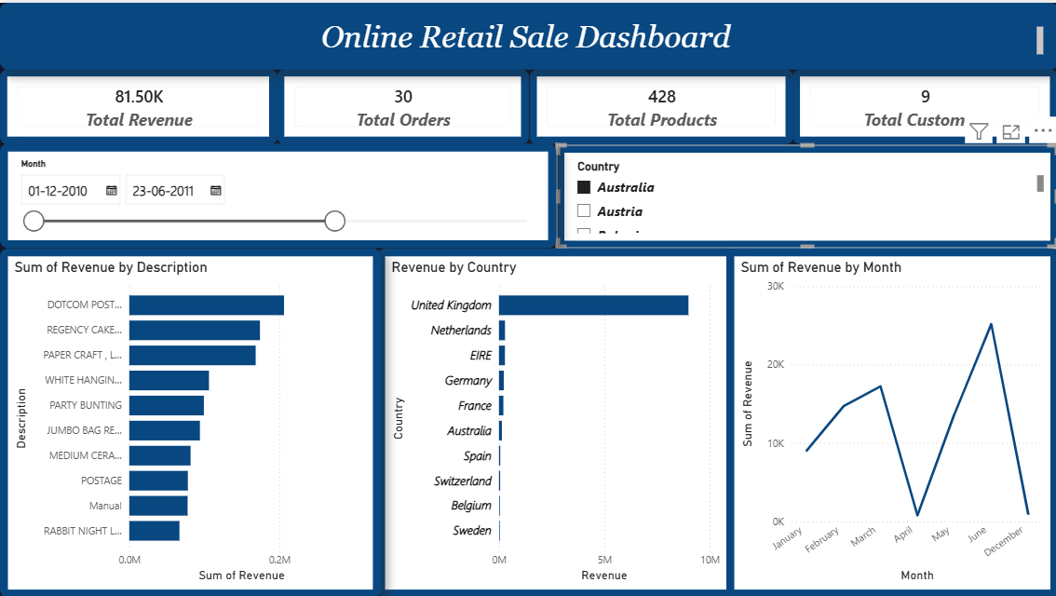

Power BI Dashboard Summary
An interactive Power BI dashboard was developed with the following components:
- Revenue Trend Line Chart — Monthly revenue from Dec 2010 to Dec 2011
- Top 10 Products Bar Chart — Ranked by total revenue
- Revenue by Country Map — Geographic revenue distribution
- Top Customers Table — Ranked customer spend analysis
- KPI Cards — Total Revenue, Total Orders, Unique Customers, Total Products
- Slicers — Filter by Country, Month, and Customer ID

9. Business Insights

Insight 1: UK Market Dominance
The United Kingdom accounts for 91.45% of all transactions and 84.59% of total revenue. While this demonstrates a strong home market, it also represents a significant concentration risk.
- Recommendation: Develop targeted international expansion strategies, particularly in Germany, France, and Netherlands — markets already showing organic growth.
- Recommendation: Invest in localized marketing campaigns for top 5 non-UK countries.

Insight 2: Strong Q4 Seasonality
Revenue spikes sharply in September–November 2011, with November being the peak month at £1,503,866.78. This is consistent with holiday gifting patterns.
- Recommendation: Build inventory and staffing plans well ahead of Q4 to capitalize on seasonal demand.
- Recommendation: Launch early Q4 promotions (October) to capture early holiday shoppers.

Insight 3: High-Value Customer Concentration
The top 5 customers alone generated over £1,046,000 in revenue. This suggests a B2B wholesale model where a few large buyers drive significant revenue.
- Recommendation: Implement a VIP/Key Account Management program for top 20 customers.
- Recommendation: Offer loyalty incentives and dedicated account managers to retain high-value customers.

Insight 4: Product Portfolio Opportunities
With 3,922 unique products, the catalog is broad. However, the top 5 products account for a disproportionate share of revenue.
- Recommendation: Apply the 80/20 (Pareto) principle — identify the top 20% of products generating 80% of revenue and ensure their availability and promotion.
- Recommendation: Review low-performing products for potential discontinuation or bundling.

Insight 5: Anonymous Customer Transactions
25.18% of transactions came from customers without registered IDs. These rows were retained as-is and represent a significant untapped customer acquisition opportunity.
- Recommendation: Implement account registration incentives (discounts, faster checkout) to convert guest buyers into registered customers.
- Recommendation: Analyze guest transaction patterns for product preferences and geographic distribution.

10. Appendix

A. Tools & Technologies Used
Category | Tool / Library | Purpose
Programming | Python 3.x | Core analysis language
Data Manipulation | Pandas, NumPy | Dataloading,cleaning, transformation
Visualization | Matplotlib, Seaborn | Static charts and plots
Dashboard | Microsoft Power BI | Interactive executive dashboard
Environment | Jupyter Notebook | Analysis and documentation
Version Control | GitHub | Code and script management
Reporting | Microsoft Word | This executive report

11. Conclusion
Conclusion
This project involved analyzing the Online Retail dataset using Python and Power BI. Data cleaning, exploratory data analysis (EDA), and visualization techniques were applied to understand sales trends, customer behavior, and product performance.
Key insights included identifying top-performing products, revenue trends across countries, and monthly sales patterns. An interactive Power BI dashboard was created to present the findings effectively.
Overall, this project helped strengthen skills in data cleaning, data visualization, dashboard development, and business insight generation.
――― End of Report ―――
Online Retail Dataset Analysis | Prepared using Python & Power BI | June 2026

