PREDICTIVE ANALYTICS SYSTEM FOR
WEATHER DATA ANALYSIS & RAIN PREDICTION
Internship Project Report — Week 5

Table of Contents
Table of Contents 1
1. Introduction 1
2. Objectives 1
3. Technology Stack 1
4. Dataset Overview 1
5. Data Cleaning and Preprocessing 1
6. Exploratory Data Analysis (EDA) 1
7. Dashboard 1
8. Machine Learning Implementation 1
9. Machine Learning Models 1
10. Model Evaluation (Model Comparison) 1
11. Feature Importance Analysis 1
12. Business Insights 1
13. Business Recommendations 1
14. Conclusion 1

1. Introduction
Weather has a direct influence on daily life, agriculture, transportation, and business planning. Being able to understand historical weather patterns and predict short-term conditions such as rainfall gives individuals and organizations the ability to plan more effectively and reduce weather-related risk.
This project focuses on building a complete, end-to-end data analytics pipeline using an hourly weather dataset. The pipeline covers data collection, cleaning and feature engineering, exploratory data analysis, predictive modelling, and dashboard-based reporting, following the standard data analytics lifecycle used in real-world business intelligence projects.
The analysis is based on hourly weather observations covering the period from January 2025 to July 2026. After cleaning and enriching the dataset with time-based and categorical features, exploratory visualizations and machine learning models were developed to identify weather patterns and to predict whether rainfall will occur in a given hour. The project demonstrates how data engineering and machine learning can be combined to convert raw sensor-style data into actionable, business-ready insights.

2. Objectives
The primary objectives of this project are:
- To collect and load hourly weather data for analysis.
- To clean, standardize, and enrich the dataset through an ETL (Extract, Transform, Load) pipeline.
- To perform Exploratory Data Analysis (EDA) and identify weather trends and patterns.
- To develop an interactive dashboard for visualizing weather metrics and model results.
- To build and compare multiple machine learning models for rain prediction.
- To identify the best-performing predictive model based on evaluation metrics.
- To generate meaningful, actionable business insights and recommendations.

3. Technology Stack
Technology | Purpose
Python | Data preprocessing, analysis, and machine learning
Jupyter Notebook | Data cleaning, EDA, and model development
Pandas & NumPy | Data manipulation, cleaning, and numerical computation
Matplotlib & Seaborn | Statistical data visualization
Plotly | Interactive chart generation and image export
Scikit-learn | Machine learning model development and evaluation
Power BI / Streamlit | Interactive dashboard creation

4. Dataset Overview

Dataset Description
The dataset used in this project contains hourly weather observations, including temperature, apparent temperature, humidity, precipitation, wind speed, surface pressure, cloud cover, and weather code. The purpose of collecting this dataset was to analyze weather behaviour over time and build a model capable of predicting rainfall occurrence.

Dataset Summary
Attribute | Value
Dataset Type | Hourly weather observations
Date Range | January 2025 – July 2026
Total Records | 13,368
Original Columns | 9
Columns After Feature Engineering | 18
File Format | CSV

Dataset Attributes
Column Name | Description
DateTime | Timestamp of the hourly observation
Temperature | Recorded air temperature (°C)
Apparent_Temperature | Perceived ("feels-like") temperature (°C)
Humidity | Relative humidity (%)
Precipitation | Rainfall recorded in the hour (mm)
Weather_Code | Coded weather condition (WMO code)
Surface_Pressure | Atmospheric surface pressure (hPa)
Wind_Speed | Wind speed (km/h)
Cloud_Cover | Cloud cover (%)
Rain (Yes/No) | Target variable used for prediction
The Rain (Yes/No) column, derived from the Precipitation field, was used as the target variable for the machine learning models, while the remaining numerical weather attributes served as input features for prediction.

5. Data Cleaning and Preprocessing

Data Loading
The dataset was imported into Jupyter Notebook using Pandas, skipping metadata rows present at the top of the raw file. After loading, the first few records, column data types, and dataset dimensions were examined to understand the structure of the data.

Missing Value and Duplicate Analysis
The dataset was checked for missing values using the isnull() function and for duplicate rows using the duplicated() function.
- No missing values were found across any of the nine original columns.
- No duplicate records were present in the dataset.
This confirmed that the dataset was already clean at the record level and reliable for direct use in analysis and modelling.

Column Standardization
Column headers from the raw source were renamed to clear, consistent names (for example, "temperature_2m (°C)" was renamed to "Temperature"), and the DateTime column was converted from text to a proper datetime data type to enable time-based analysis.

Feature Engineering
Several new columns were derived from the DateTime field and existing weather attributes to support deeper analysis and modelling:
- Year, Month, Month_Name, Day, Day_Name, and Hour — extracted from DateTime for time-based grouping.
- Weekend — a boolean flag identifying Saturday and Sunday observations.
- Season — Winter, Summer, Monsoon, or Post-Monsoon, derived from the month.
- Rain (Yes/No) — derived from Precipitation, used as the target variable for prediction.
These engineered features expanded the dataset from 9 to 18 columns and significantly improved both the exploratory analysis and the machine learning process.

Train-Test Split
The prepared dataset was divided into training and testing subsets using an 80:20 ratio, with stratification on the target variable to preserve the Rain/No-Rain class balance in both sets.
Dataset | Records
Training Records | 10,694
Testing Records | 2,674

The training dataset was used to build the prediction models, while the testing dataset was used to evaluate their performance on unseen data.

6. Exploratory Data Analysis (EDA)
Exploratory Data Analysis was performed to understand weather behaviour over time and identify meaningful patterns before developing predictive models. Visualizations were created using Matplotlib, Seaborn, and Plotly.

Overall Weather Summary
Metric | Value
Average Temperature | 27.95 °C
Average Humidity | 62.49 %
Total Rainfall | 1,928.6 mm
Average Wind Speed | 10.21 km/h
Average Surface Pressure | 1,006.72 hPa

Rain Distribution
Out of 13,368 hourly observations, 11,122 hours (83.2%) recorded no rain, while 2,246 hours (16.8%) recorded rainfall.

Temperature Trends
The temperature trend chart shows a clear seasonal cycle, with temperatures rising through the summer months and dipping during the monsoon and winter periods, consistent with expected regional seasonal patterns.

Monthly and Seasonal Patterns
May, April, and June recorded the highest average temperatures, while rainfall was heavily concentrated in July, June, and August — the core monsoon months.

Correlation Analysis
A correlation heatmap was generated across all numerical weather variables to understand relationships between temperature, humidity, pressure, wind speed, and cloud cover.

7. Dashboard

Dashboard 1 — Weather Analytics Overview
The overview page presents KPI cards for average temperature, humidity, wind speed, precipitation, cloud cover, and pressure, alongside a temperature trend line, monthly average temperature, rain distribution, and monthly rainfall charts.
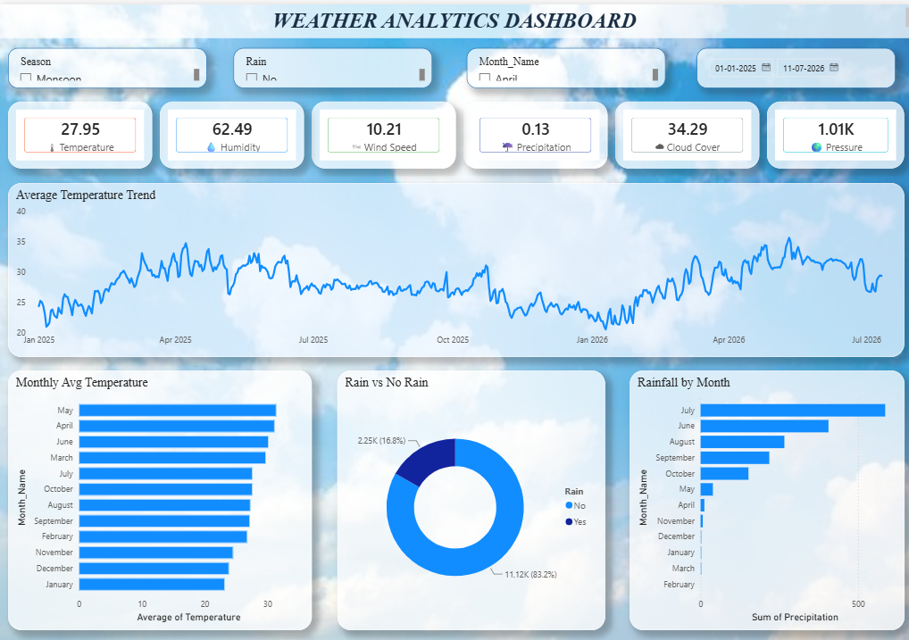

Dashboard 2 — Predictive Model Results
The second page focuses on the machine learning models developed during the project, presenting accuracy comparisons, feature importance, detailed model metrics, and key insights.
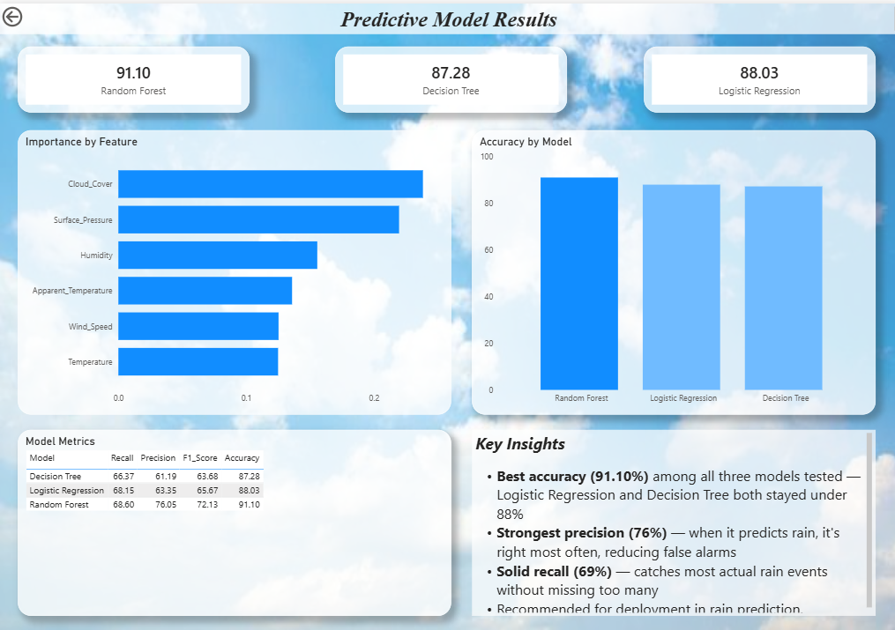

8. Machine Learning Implementation
Machine learning was applied to predict whether rain is likely to occur in a given hour, based on the surrounding weather conditions. Predictive modelling of this kind supports proactive planning for agriculture, logistics, events, and daily activities.

Target Variable
The prediction target for this project is: Rain (Yes/No).
This binary variable indicates whether precipitation was recorded during a given hourly observation.

Input Features
The following numerical weather features were selected for model training:
- Temperature
- Apparent Temperature
- Humidity
- Surface Pressure
- Wind Speed
- Cloud Cover

Data Preparation
Before training the machine learning models, the following preprocessing steps were performed:
- Label Encoding of the target variable (Rain: Yes/No → 1/0).
- Feature selection of relevant numerical weather attributes.
- Stratified Train-Test Split (80:20) to preserve class balance.
Dataset | Records
Training Data | 10,694
Testing Data | 2,674

9. Machine Learning Models
Three supervised machine learning algorithms were implemented and evaluated for the rain prediction.

Logistic Regression
Result: Accuracy — 88.03%
Logistic Regression achieved strong overall accuracy, though its ability to correctly identify rain events specifically (the minority class) was moderate compared to the tree-based ensemble model.

Decision Tree
Result: Accuracy — 87.28%
The Decision Tree model performed comparably to Logistic Regression but showed a slightly higher tendency to overfit to specific patterns in the training data, which is reflected in its evaluation metrics.

Random Forest
Result: Accuracy — 91.10%
Among all evaluated models, the Random Forest achieved the highest accuracy and the best balance of precision and recall for detecting rain events. Therefore, the Random Forest model was selected as the final predictive model for this project.

10. Model Evaluation (Model Comparison)
The performance of all three machine learning models was compared using accuracy, precision, recall, and F1-score, since accuracy alone can be misleading on an imbalanced dataset such as this one, where non-rain hours substantially outnumber rain hours.
Model | Accuracy (%) | Recall (%) | Precision (%) | F1-Score (%)
Logistic Regression | 88.03 | 68.15 | 63.35 | 65.67
Decision Tree | 87.28 | 66.37 | 61.19 | 63.68
Random Forest | 91.10 | 68.60 | 76.05 | 72.13

Analysis
The comparison shows that the Random Forest model outperformed the other two models across every evaluation metric, achieving the highest accuracy (91.10%), the highest precision (76.05%), and the highest F1-score (72.13%). Its higher precision means that when the model predicts rain, it is correct more often, reducing false alarms. For this reason, Random Forest was selected as the final recommended model for rain prediction.

11. Feature Importance Analysis
Feature Importance helps identify which variables have the greatest influence on the Random Forest model's predictions.
According to the Random Forest model, the most important features, ranked from highest to lowest influence, are:
- Cloud Cover
- Surface Pressure
- Humidity
- Apparent Temperature
- Wind Speed
- Temperature

Explanation
Cloud Cover was identified as the most influential feature, which aligns with meteorological expectations — heavier cloud cover is directly associated with precipitation formation. Surface Pressure and Humidity also ranked highly, as low-pressure, high-humidity conditions are classic precursors to rainfall. Apparent Temperature, Wind Speed, and Temperature contributed comparatively less individually but still provided useful supporting context for the model.
This feature importance analysis helps explain why the model makes certain predictions and confirms that the model has learned patterns consistent with real-world weather behaviour rather than arbitrary correlations.

12. Business Insights

Insight 1: Rainfall Is Concentrated in a Short Monsoon Window
Out of 13,368 hourly observations, only 2,246 hours (16.8%) recorded rainfall, and the majority of this rainfall was concentrated in July, June, and August. This shows that rain-sensitive operations — such as outdoor events, construction, and agriculture — face a narrow but high-impact window of weather risk each year.

Insight 2: Random Forest Delivers the Most Reliable Predictions
Three machine learning models were developed and compared. The Random Forest model achieved the highest accuracy of 91.10%, making it the best-performing model, followed by Logistic Regression (88.03%) and Decision Tree (87.28%). Random Forest also achieved the highest precision (76.05%), meaning its rain predictions can be trusted with fewer false alarms.

Insight 3: Cloud Cover and Atmospheric Pressure Are the Strongest Rain Signals
Feature Importance analysis showed that Cloud Cover and Surface Pressure had the greatest impact on rain prediction results, ahead of temperature-related features. This confirms that monitoring cloud cover and pressure trends provides the earliest and most reliable signal of upcoming rainfall.

Insight 4: Humidity Is a Strong Early Indicator
The average humidity across the dataset was 62.49%, and humidity ranked among the top three predictive features. Sustained periods of high humidity, particularly when combined with falling surface pressure, are strong early indicators that rainfall is likely within the following hours.

Insight 5: Seasonal Planning Should Be Prioritized Around Monsoon Months
Rainfall totals by month confirm that June, July, and August together account for the large majority of the year's precipitation, while temperatures peak earlier, in April and May. This split between the hottest months and the wettest months should inform separate planning strategies for heat-related and rain-related operational risks.

13. Business Recommendations
- Deploy the Random Forest model for operational rain prediction, as it achieved the highest accuracy (91.10%) and precision (76.05%), making it the most reliable model in this project.
- Prioritize monitoring of cloud cover and surface pressure as early-warning indicators, since these were identified as the strongest predictors of rainfall.
- Concentrate weather-risk planning and contingency measures in the June–August monsoon window, where the large majority of annual rainfall occurs.
- Use humidity trends as a secondary early-warning signal, particularly when combined with falling pressure readings, to anticipate rainfall a few hours in advance.
- Separate heat-risk planning (peaking in April–May) from rain-risk planning (peaking in June–August), since the two risk periods do not overlap.
- Regularly retrain the model with new hourly weather data to maintain prediction accuracy and adapt to seasonal or climate-driven shifts in weather patterns.

14. Conclusion
This project successfully developed an end-to-end data pipeline and predictive analytics system for hourly weather data, covering data collection, cleaning, feature engineering, exploratory analysis, dashboard reporting, and machine learning.
The project involved collecting and preprocessing 13,368 hourly weather records, performing exploratory data analysis, developing an interactive dashboard, and implementing and comparing three machine learning models for rain prediction. Among the evaluated models, Random Forest achieved the highest accuracy of 91.10% and the best precision-recall balance, making it the most suitable model for this dataset.
The analysis demonstrated that rainfall is concentrated in a well-defined monsoon window and is most strongly signalled by cloud cover, surface pressure, and humidity. These findings support proactive, data-driven weather planning and illustrate how data analytics and machine learning can be combined to convert raw sensor data into actionable business insights.

