# GS Native Mobile Share

This utility is compatible with Unity 5.3 or above.

# Overview

Sharing is an important part of every game. Now you can easily integrate native share system in your own iOS or Android game. You can customize share message, can include URLs, can show custom object on screenshot and can hide things that you don’t want in your screenshot. It’s all simple and pretty easy, just drag drop prefab in your scene under a canvas object and edit properties. Simply add a line of code when you want to take screenshot. Also you can hide or show the share interface anywhere in your game with a simple line of code.

# Features List:

This asset includes following features.

1. Complete source code
2. Editor support to configure share message, url and more
3. Include custom objects to be part of your screenshot
4. Exclude specific objects from the screenshot
5. 1 click drag and drop prefab in your scene
6. Works with Android and iOS
7. 24/7 hours Support from author

# Getting Started:

To test the package, open demo scene present in “NativeMobileShare” Directory and hit play. You can’t test sharing in editor so just build on android or iOS, however screen shot can be taken and preview can be seen on editor.

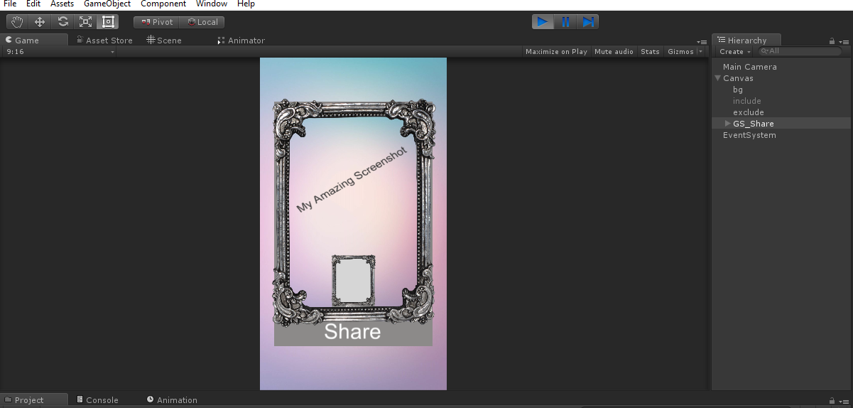

# Script Reference

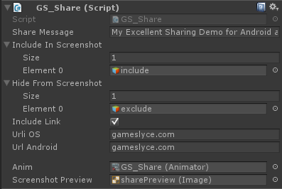The namespace of the Project is GameSlyce. The Main script is GS_Share. This class handles everything related sharing. This includes taking care of what items to include and what to exclude in the screenshot. You can edit your share message and iOS or Android Urls if you wish to include. It is a singleton class so you can just drag drop it in the scene and can call from any script in your code. The UI that let’s user share animate back to its place after share.

TakeScreenshot(): This method is the only thing that you need to know. This handles taking care of screenshot grabbing and setting it as preview on the Share UI.

ShareScreensot (): This method is a click handler. It further calls shareRoutine(), to just check if screenshot is available and then calls the respective native android or iOS code or no code at all on editor.

Show (bool): This method is for showing or hiding the share Button. It’s needed for places in your code where you want to hide it and can be unhide when needed like on main menu. You need to pass false for hiding and true to show the share button UI.

# Help and Support

The code is minimal and self-explanatory with comments so you can easily understand it and further customize it if. Contact if you need additional help:

**More Assets from GameSlyce Design:**<https://goo.gl/0xSQ9L>

**More Assets from GameSlyce:** <https://goo.gl/D6XvPE>

**Email**: info.gameslyce@gmail.com

**Facebook**: <https://www.facebook.com/gameslyce>