Effective Supply of Science and Technology Talent: A Pipeline Perspective
Jane Doe, John Smith — Institute for Policy Studies

Abstract
Conventional workforce projections count degree holders as if every graduate enters the domestic research labor market. We argue that this overstates supply. Using a porous-pipeline framework, we estimate the effective supply of doctoral-level researchers by subtracting leakage at four transition points: field switching, emigration, career exit, and underemployment. Applying the framework to administrative data from 2018 to 2022, we find that effective supply is 27% lower than headcount-based estimates, with the gap widening over time.

1. Introduction
Governments routinely justify expansion of graduate programs by pointing to projected shortages of researchers. However, the link between the number of degrees awarded and the number of researchers actually available to employers is weaker than these projections assume. This paper addresses that gap by distinguishing nominal supply from effective supply.
The remainder of the paper is organized as follows. Section 2 reviews prior work on pipeline leakage. Section 3 describes the data and estimation strategy. Section 4 presents results, and Section 5 discusses policy implications.

2. Related Work
The 'leaky pipeline' metaphor originated in studies of gender attrition in academic careers (Berryman, 1983) and was later generalized to describe any systematic loss of talent between training and employment. Critics note that the metaphor implies a single linear path, whereas real careers involve re-entry and lateral moves (Cannady et al., 2014). We adopt the term 'porous pipeline' to acknowledge bidirectional flows.

3. Data and Methods
We link three administrative sources: the national graduate survey, employment insurance records, and the researcher registry. The linked panel covers 48,213 doctoral recipients. Figure 1 shows the growth in annual doctoral graduates over the study period.
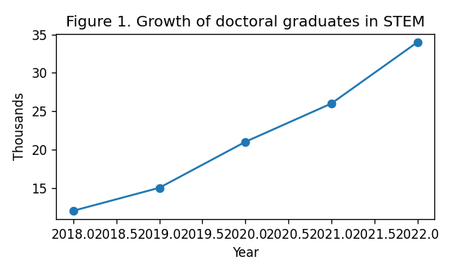
Figure 1. Growth of doctoral graduates in STEM fields, 2018–2022.
Effective supply S_eff is defined as S_eff = N × (1 − l_1)(1 − l_2)(1 − l_3)(1 − l_4), where N is the number of new degree holders and l_k is the leakage rate at transition k. Leakage rates are estimated with a discrete-time hazard model controlling for field, institution tier, and cohort.

4. Results
Table 1 reports estimated leakage rates. Emigration is the largest single source of loss, followed by career exit. Figure 2 shows first-job destinations of PhD holders.
Transition | Leakage rate | 95% CI
Field switching | 6.1% | 5.4–6.8
Emigration | 11.3% | 10.5–12.1
Career exit | 8.7% | 8.0–9.4
Underemployment | 4.2% | 3.7–4.7
Table 1. Estimated leakage rates by transition point.
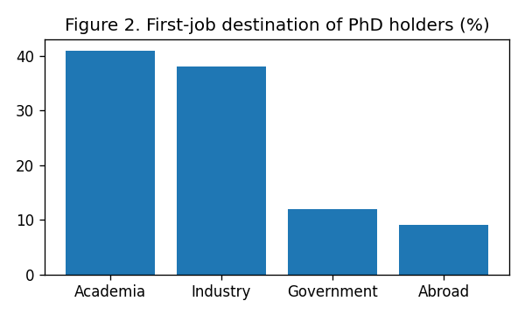
Figure 2. First-job destination of PhD holders (%).

5. Discussion and Policy Implications
Our findings suggest that policies aimed solely at increasing enrollment will have a muted effect on the research workforce unless leakage is addressed simultaneously. Retention measures—competitive early-career salaries, stable positions, and return incentives for researchers abroad—may yield higher marginal returns than further expansion of doctoral programs.

References
Berryman, S. (1983). Who Will Do Science? Rockefeller Foundation.
Cannady, M., Greenwald, E., & Harris, K. (2014). Problematizing the STEM pipeline metaphor. Science Education, 98(3), 443–460.

