DBMS Lab Assignment 3

Abhishek Arya (19BCS004)

1. Add, Modify and Delete Column using Alter Command

CREATE TABLE Doctor

(DID INT NOT NULL

CONSTRAINT AK_DID UNIQUE(DID),

Doctor_Name VARCHAR(45) NOT NULL,

Current_Case VARCHAR(45),

DPhone_Number VARCHAR(10) NOT NULL

CONSTRAINT AK_DPhone_Number UNIQUE(DPhone_Number),

Qualification VARCHAR(45) NOT NULL,

Salary INT NOT NULL,);

ALTER TABLE Doctor

ADD testcol INT;

ALTER TABLE Doctor

ALTER COLUMN testcol VARCHAR(5);

ALTER TABLE Doctor

DROP COLUMN testcol;

2. Insert 20 Employees Data into all the tables. Use all the 3 methods that have been showcased

INSERT INTO Doctor(DID, Doctor_Name, Current_Case, Dphone_Number, Qualification, Salary)

VALUES(1,'Abhishek Kumar','Covid','1111111111','Flu Expert',58000);

INSERT INTO Doctor(DID, Doctor_Name, Current_Case, Dphone_Number, Qualification, Salary)

VALUES(2,'Gabru','Covid','1111111112','Flu Expert',58000);

INSERT INTO Doctor(DID, Doctor_Name, Current_Case, Dphone_Number, Qualification, Salary)

VALUES(3,'Mehndi','Bird flu','1111111113','Flu Expert',38000);

INSERT INTO Doctor(DID, Doctor_Name, Current_Case, Dphone_Number, Qualification, Salary)

VALUES(4,'Bassi','Bird flu','1111111114','Bird Watcher',38000),

(5,'Brar','Fever','1111111115','Cook',48000),

(6,'Shaan','Cold','1111111116','Singer',48000),

(7,'Dawood','','1111111117','Drug Lord',88000),

(8,'Mahes','Stomach Ache','1111111118','Flu Expert',18000),

(9,'Bhangar','','1111111119','Hacker',28000),

(10,'Bhau','','1111111110','Brother',28000),

(11,'Shankar','Gas','1111111121','Tribal',38000),

(12,'Lakshman','Nuclear Radiation','1111111130','Medical',18000),

(13,'Sweta','Burns','1111111122','Call Center',48000),

(14,'Pewds','Amnesia','1111111123','Gamer',98000),

(15,'Kevin','Amnosea','1111111124','Chaotic',68000),

(16,'Ken','','1111111125','Stramer',28000);

INSERT INTO Doctor(DID, Doctor_Name, Current_Case, Dphone_Number, Qualification, Salary)

SELECT 17,'Buff','','1111111126','Flu Expert',38000;

INSERT INTO Doctor(DID, Doctor_Name, Current_Case, Dphone_Number, Qualification, Salary)

SELECT 18,'Kalki','','1111111127','Neurologist',38000;

INSERT INTO Doctor(DID, Doctor_Name, Current_Case, Dphone_Number, Qualification, Salary)

SELECT 19,'Reva','Stress','1111111128','Psychologist',38000;

INSERT INTO Doctor(DID, Doctor_Name, Current_Case, Dphone_Number, Qualification, Salary)

SELECT 20,'Mercedes','','1111111129','Enterprenaur',38000;

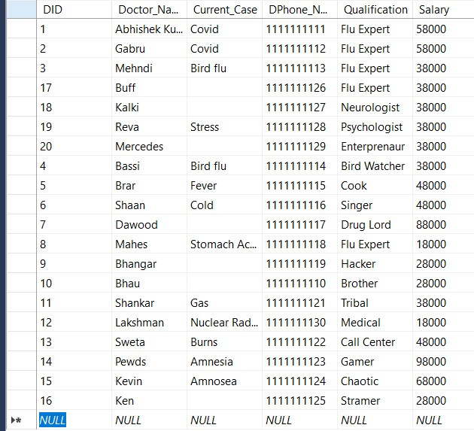

3. Show Violation of Primary Key, Unique Not Null and default key constraints through insertion.

Violation of UNIQUE KEY constraint 'AK_DPhone_Number'. Cannot insert duplicate key in object 'dbo.Doctor'. The duplicate key value is (1111111111).

4. Insert tuples into the table and see how foreign key constraint works if you try to insert into dependent table first.

5. Show Violation of Foreign Key Constraint when you try to delete from a base table. If you get an error explain why deletion gives an error

6. Try to update a non-existing entity data and check for error.

7. Add a column which has default value.

8. 5 Simple Select queries to retrieve data from your database.

9. Show how foreign key constraint effects updating a dependent table when value is not existing and in Base table where the value is referred and you want to update it.