Weak Prompt:
Explain regression
Strong Prompt:
Explain regression as if I am a 10-year-old in under 5 sentences
Screenshot:
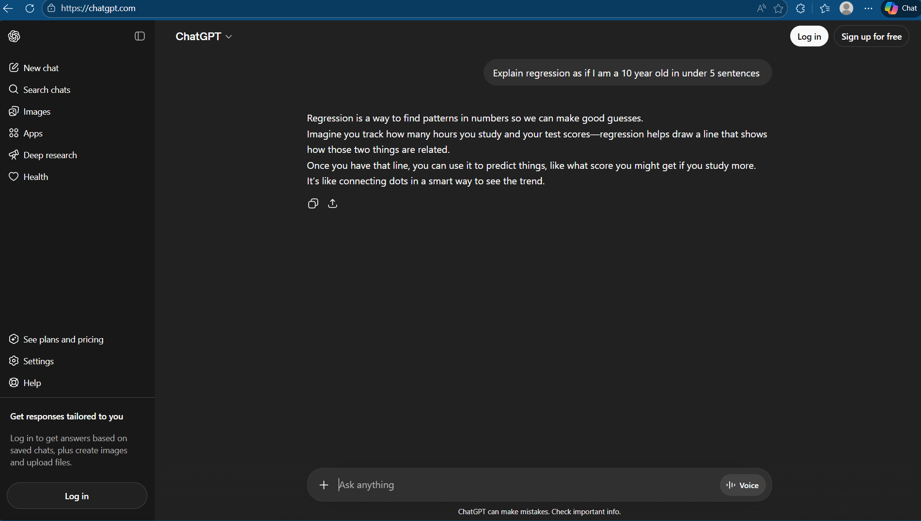
Explanation:
I took the weak prompt and added some constraints like who the audience is and how long the explanation needs to be. I wanted to create a prompt that explains regression and does it in a simplified way.

Weak Prompt:
Help me understand SQL
Strong Prompt:
I am a data analytics trainee, explain SQL to me in under 6 sentences
Screenshot:
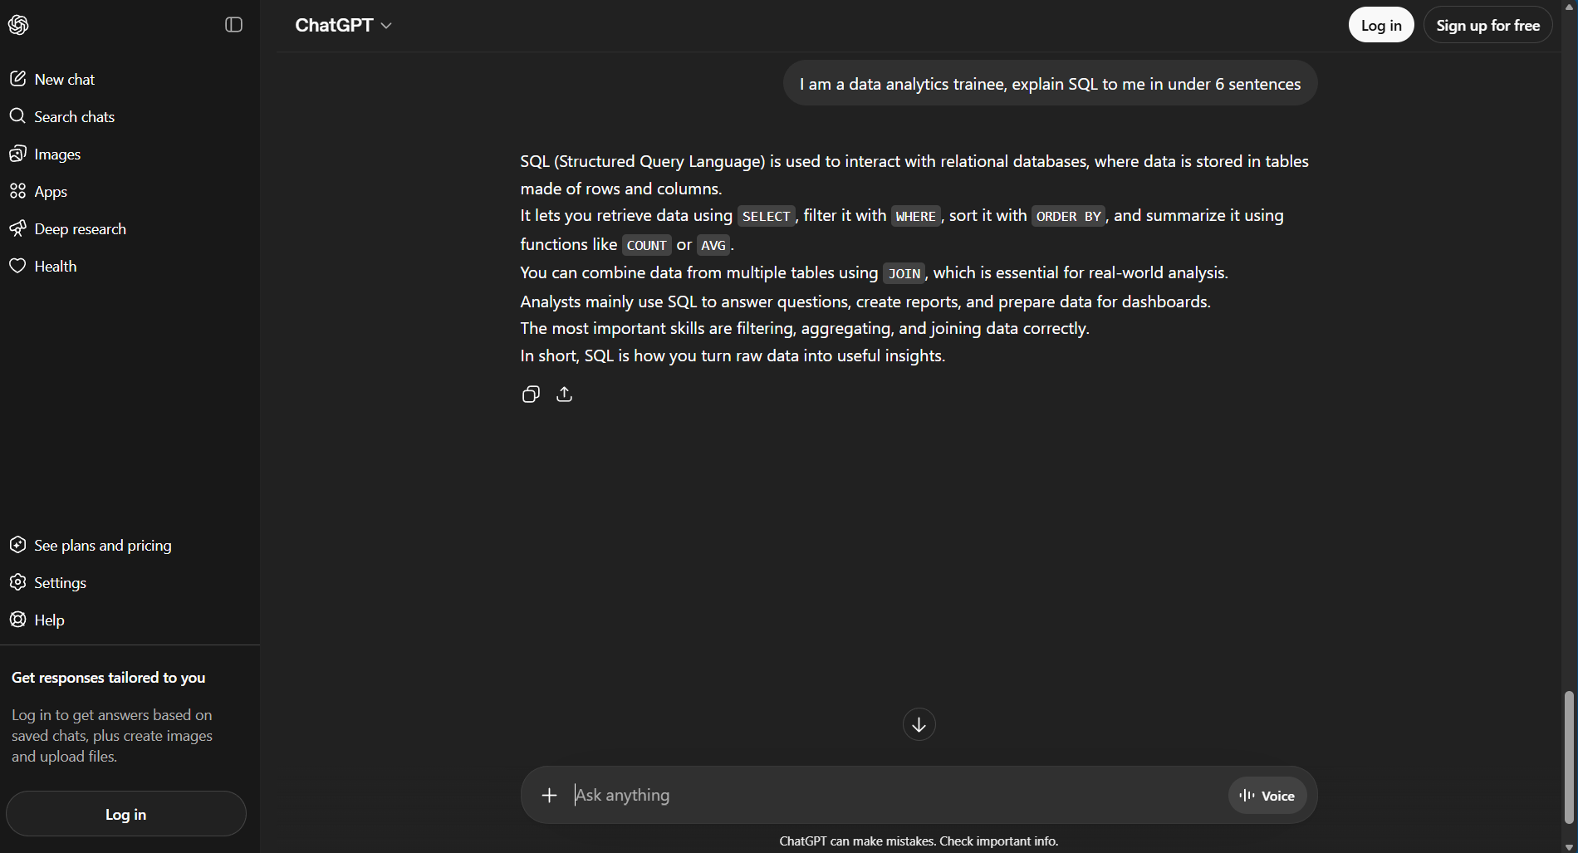
Explanation:
I created the prompt “I am a data analytics trainee, explain SQL to me in under 6 sentences” in order to have ChatGPT explain SQL to a data analytics trainee and in under 6 sentences. I gave it some constraints.

Weak Prompt:
Create a dataset
Strong Prompt:
Create a table showing how many data analytics jobs there are and the salary of each job
Screenshot:
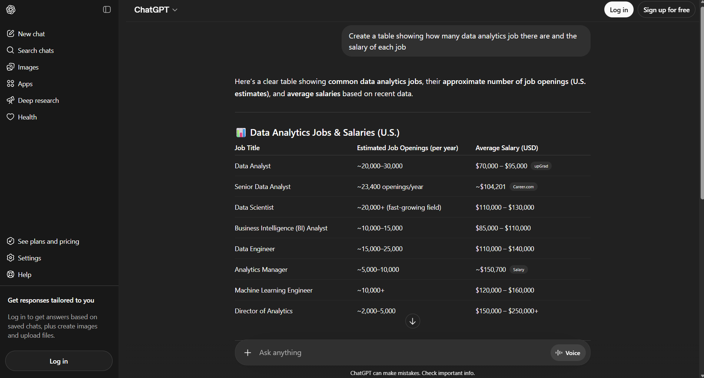
Explanation:
I created a dataset with more specific information. You need to clarify to ChatGPT what kind of dataset you are looking for and how you want the data presented.

