# 飞机大战游戏设计

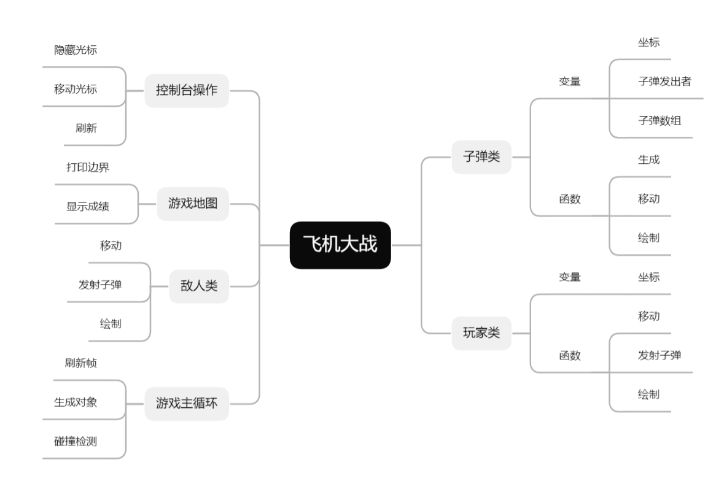

**（飞机大战相关设计思维导图）**

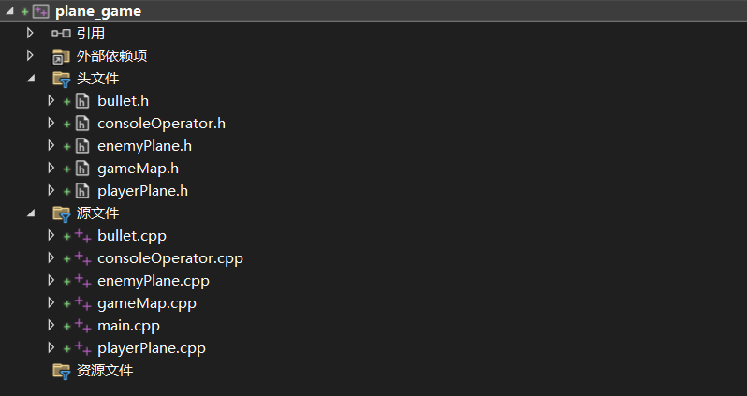

**（项目文件结构）**

游戏为每秒10帧，敌机和子弹生成通过对随机数进行取余的方式实现，每次刷新游戏帧时对子弹和敌机的位置进行更新，并对子弹与敌机、敌机与玩家和子弹与玩家进行碰撞检测，最后将画面绘制出来。画面绘制使用windows.h头文库，对光标进行隐藏和移动并输出相应形状。

//子弹和玩家碰撞检测

for (auto it = Bullet::bullets.begin(); it != Bullet::bullets.end();) {

if (!it->isPlayer) {

if (it->x >= player.x - 2 && it->x <= player.x + 2 &&

it->y >= player.y - 1 && it->y <= player.y + 1) {

gameMap::score -= 1;

if (gameMap::score < 0) {

gameMap::gameOver = true;

}

it = Bullet::bullets.erase(it);

}

else {

++it;

}

}

else {

++it;

}

}

//子弹和敌机碰撞检测

for (auto bIt = Bullet::bullets.begin(); bIt != Bullet::bullets.end();) {

if (bIt->isPlayer) {

bool hit = false;

for (auto eIt = enemyPlane::enemies.begin(); eIt != enemyPlane::enemies.end(); ++eIt) {

if (bIt->x >= eIt->x - 2 && bIt->x <= eIt->x + 2 &&

bIt->y >= eIt->y - 1 && bIt->y <= eIt->y + 1) {

gameMap::score += 1;

eIt = enemyPlane::enemies.erase(eIt);

hit = true;

break;

}

}

if (hit) {

bIt = Bullet::bullets.erase(bIt);

}

else {

++bIt;

}

}

else {

++bIt;

}

}

//敌机和玩家碰撞检测

for (auto it = enemyPlane::enemies.begin(); it != enemyPlane::enemies.end(); ++it) {

if (it->x - 2 <= player.x + 2 && it->x >= player.x - 2 &&

it->y - 1 <= player.y + 1 && it->y >= player.y - 1) {

gameMap::score -= 1;

if (gameMap::score < 0) {

gameMap::gameOver = true;

}

it = enemyPlane::enemies.erase(it);

if (it == enemyPlane::enemies.end()) break;

}

}

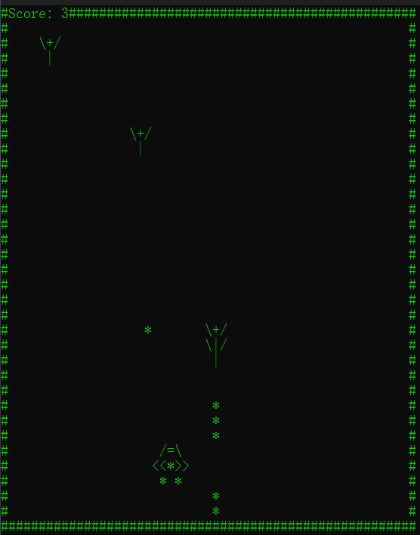

**（游戏运行界面）**

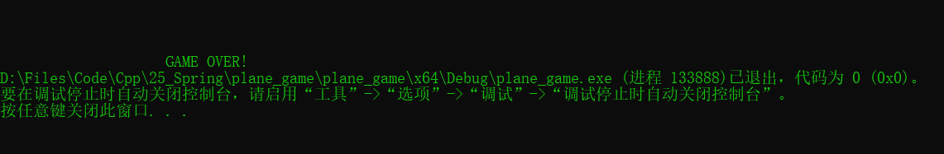

**（游戏结束界面）**