Charlize May S. Sarte  
AC192

**FLOWCHART**

“A flowchart is a diagram that depicts a process, system or computer algorithm. They are widely used in multiple fields to document, study, plan, improve and communicate often complex processes in clear, easy-to-understand diagrams.” (lucidchart.com)

Flowchart is graphical presentation of steps or a guide for us to understand what are the process done in order to come up to a product or a decision.

Flowchart is used in presenting the flow of algorithms, workflow or processes. Flowchart is important to all especially in programming in order for the team to understand how the program was made or what are the steps in processing the program.

FLOW-CHARTING SYMBOLS

The terminator symbol represents the starting and ending of the system. The symbol usually has an “Start” or ”End” inside.

Terminator

Process

A box represents a single step or entire sub-process.

A diamond which represents the decision or branching point.

Decision

Document

It represents the printed document or report.

It represents the entering or leaving of materials or information in the system.

Data

It represents that multiple documents are in the process.

Multiple Documents

Manual Input

A step in which represents that the user should manually enter the information.

List of information that is used in sorting and searching.

Database

Represents a set-up to another step in the process.

Preparation

Shows that the flow continues where a matching symbol has been placed.

Connector

There is a delay in the process.

Delay

The data gets stored.

Data Storage/ Stored Data

Display

Displays an information.

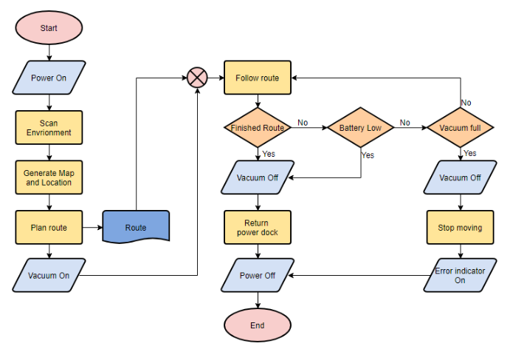  
Here is an example of flowchart:

PSEUDO CODES

According to geekforgeeks.org, Pseudo codes is used in programming and algorithm to represent the implementation of algorithm. It is in the form of annotations and informative text written in plain English. It consists of short, English phrases used to explain specific tasks within a program. It has no syntax like any of the programming language and thus can’t be compiled or interpreted by the computer.

In general, the syntax used for pseudo code is arbitrary and user dependent and typically reflects the programming language the user is most familiar with. The key to using pseudo code is to convey the process clearly and accurately in a way that real code using some programming language can not necessarily do as well, otherwise, one might as well write out the code directly.

Writing pseudocode saves time later during the coding and testing stage of a program's development and also helps communication between designers, coders, and project managers. Some projects may use pseudocode for design, others may use flow charts, and some a combination of both.

Here is the example of Pseudo codes (from sciencedirect.com):

**Example 1** Pseudo-code to read in a number from the keyboard, square it and write out the result to the VDU.

Output(“Input number”)

 input (number)

number=number*number

 output(“Number squared is”, number)

Here, the data I/O is assumed to be controlled by the functions output and input.

**Example 2** Pseudo-code to compute the square-root of an array containing 10 elements.

for i=1,2, … ,10; do:

 array(i)=sqrt(array(i))

enddo

**Example 3** Pseudo-code to read a number (assumed to be non-zero), check whether it is positive or negative and output the result.

output(“Input positive or negative numbers”)

 input (number)

 Begin:

 if number > 0

 then

 output(“Number is positive”)

 endif

 if number < 0

 then

 output(“Number is negative”)

 endif

 end

**References:**

Unknown. (n.d). *What is Flowchart*. Retrieved from <https://www.lucidchart.com/pages/what-is-a-flowchart-tutorial#section_2>

Flowchart Tutorial (with Symbols, Guide and Examples). (n.d). Retrieved from <https://www.visual-paradigm.com/tutorials/flowchart-tutorial/>

How to write a Pseudo Code? (n.d). Retrieved from <https://www.geeksforgeeks.org/how-to-write-a-pseudo-code/>

Pseudocode. (n.d). Retrieved from <https://www.sciencedirect.com/topics/engineering/pseudocode>