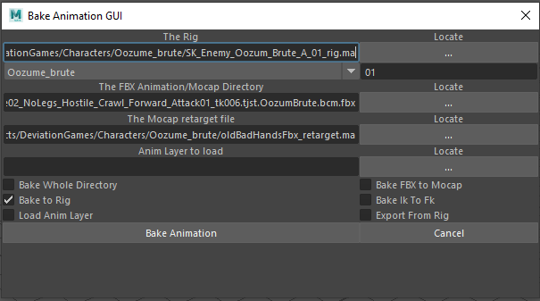

First field is the rig to have animation baked onto

Next is the namespace options. If using a mocap skelton with meta data this info is bypassed, otherwise more namespaces can be added in the python code line 43 by updating self.__nameSpaces. The value to its side adds digits in case more than one is in the scene.

Next is the directory for the file/files to be baked. The first checkbox below determines what you can select when clicking the locate button. If “Bake Whole Directory” is checked, the file prompt will only allow you to select a directory, if its unchecked you can only select a file.

The Mocap retarget file is a file for retargeting from other rigs to the mocap skeleton for this specific rig. For instance, if you have an old version of the character with different joints you can make a file in maya that retargets from one to the other, this file must have the appropriate meta data to work ( I will be adding code to this to allow you to add the meta data)  
“Anim Layer to load” Will load an exported anim layer to your baked rig scene for bulk animation fixes if “Load Anim Layer” is checked  
“Bake to Rig” takes the file from “The FBX Animation/Mocap Directory” field and bakes it to the rig. This bake is done in IK to cancel out any unwanted side to side rotations that can be in mocap in knees and elbows.

“Bake Ik To Fk” will then bake all Ik animation to the Fk controls also if needed. This is an option since it adds time to the bake and if you are baking hundreds of animations its not needed.  
“Export from Rig” will then export the animation joints only from the rig for import to UE.

File naming conventions are in place adding the standard “A_” to the beginning of animation files.