**HOMEWORK 3**

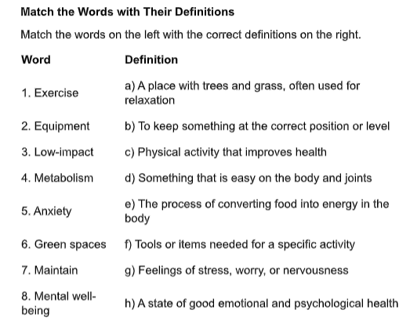 



**1—c**

**2—f**

**3—d**

**4—e**

**5—g**

**6—a**

**7—b**

**8—h**

1. Many people go for a walk **outdoors** to enjoy fresh air and nature.
2. Walking helps burn **calories**, which can help with weight management.
3. To avoid injury while walking, you should have good **posture** and wear comfortable shoes.
4. Regular **exercise** is important for staying healthy and active.
5. Walking is a low-impact activity, which means it is easy on the **joints**.
6. Eating healthy and staying active helps the body’s **metabolism** work properly.
7. Simple (synonym) -- Easy
8. Reduce (synonym) -- Lower
9. Essential (synonym) -- Necessary