*Image Processing Assignment*

***Part A***

**A1:** Bilateral filter is an advanced version of the Gaussian filter and is a technique used to smooth images while preserving edges. While, Gaussian filter is linear bilateral filter is not. Gaussian smoothing is good at noise removal, but it also removes image detail. It makes edges less sharp or even disappear. To solve this problem, Bilateral filter is used. The influence of one pixel over the others is determined by two factors, the spatial proximity and the measure of the similarity between two pixels. The similarity of the two pixels is the difference of their intensity values. When there is a large difference in intensities it means that the two pixels are not very similar and thus, they have small influence in the filtering process and vice versa. In Gaussian filter, the influence of one pixel over another is determined by spatial proximity only. Bilateral filter smooths an image but respects sharp features. The idea is that a pixel is replaced by a weighted average of its neighbours. The equation of the bilateral filter is:

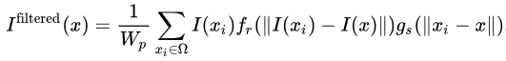

Wp is the normalization term and it is given by the equation:

  
 The first part of the formula is the range kernel for smoothing differences in intensities. The further away a pixel is from p (central pixel) and the more different its intensity from that of p is, the less its influence over the new value of p. The second part comes from the Gaussian blur and it defines the spatial kernel for smoothing differences in coordinates.

Bilateral filter can be used to denoise an image. This is the primary goal of the filter and it uses a square box function usually consisting of 9 pixels as a spatial kernel. When we denoise an image we should use a small spatial sigma, for example use the 2% of the image diagonal, so that the spatial sigma depends on the size of the image. Then the range kernel is the “minimum” amplitude of an edge, in this case we adapt it to the noise level.

Moreover, bilateral filter can be used to smooth the image. In order to do that, the spatial kernel needs to be increased because, as the spatial kernel increases it smooths larger features. Spatial kernel makes sure only nearby pixels are used for smoothing, so as the spatial kernel increases, the neighbourhood will be larger, and more distant pixels will influence the central pixel. Also, the spatial kernel and the range kernel must have approximately the same value. In that way only, nearby pixels with the same intensity have influence on the central pixel. If the pixels are far away or have different intensities no smoothing will occur.

Furthermore, bilateral filter can be iterated. By applying the filter multiple times, it will result in the image being piecewise constant and it will appear cartoonish. Moreover, bilateral filter can be used to blur an image. To do that, the range kernel needs to be set to a high value. This is because the range kernel uses a Gaussian function and as it increases, the filter becomes closer to the Gaussian blur because the Gaussian range is flatter.

**A2:**Bilateral filter, from OpenCV, was applied to the test images. Larger images with higher resolution can be found in the appendix.

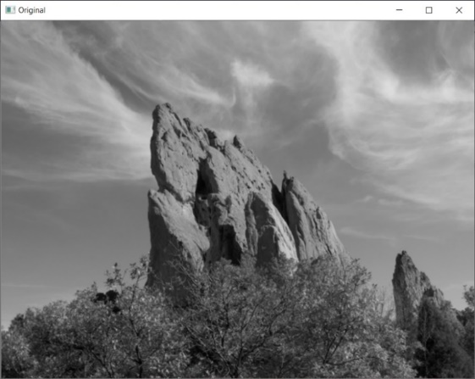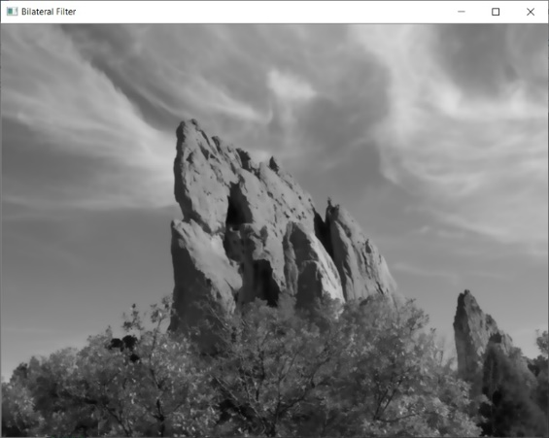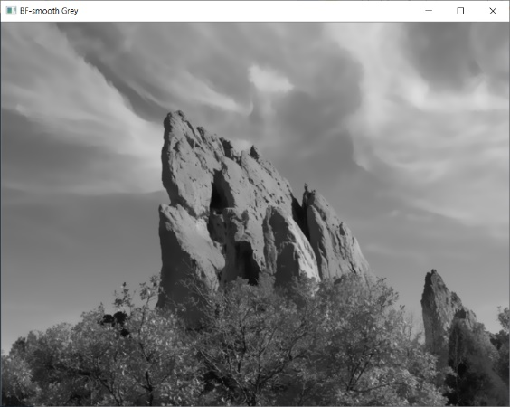**A3:**

org

1

2

In this test (see the three images above) the bilateral filter was applied to the greyscale image (test1.png) to smooth it. Larger pictures can be found in the appendix and it is named test 1. The parameters that were used for image 1 were d=9 where d is the diameter of each pixel neighbourhood, sigmaColor= 50 and sigmaSpace= 50. The parameters that were used for image 2 were d=20, sigmaColor= 30 and sigmaSpace= 20. These parameters were set this way because the two values (sigmaColor and sigmaSpace) are multiplied together and smoothing only occurs when the pixels are as close and similar to each other as they can be. If one value is close to 0 then no smoothing occurs because this means that the pixels are very similar but far away with each other or vice versa. Image 2 had lower values as parameters because a larger neighbourhood was used, so more distant pixels affected the central pixel. As we can see image 2 smooths the image more and preserves the edges. This is because of the larger neighbourhood that was used. This application is useful since it produces more simplified pictures without any loss of overall shape. This is useful in image transmission, picture editing and picture manipulation.

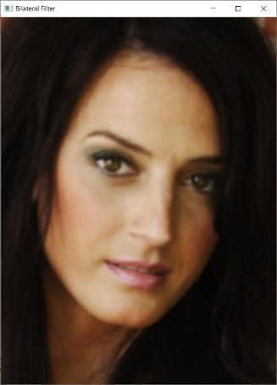

2

1

In this test (see images org and 1 above) the bilateral filter was applied to the coloured image (test2.png) and was used to smooth the image. Large pictures can be found in the appendix and it is named test 2, figure a. The parameters that were used were d=9, sigmaColor= 75 and sigmaSpace= 75. These parameters were set this way because the two values are multiplied together and smoothing only occurs when the pixels are as close and similar to each other as they can be. In smooth regions, pixel values in a small neighbourhood are similar to each other. However, if the pixel values were different, due to the parameter sigmaColor which was set to 75 we get edge preservation as the two different pixels do not influence each other.

org

In this test (see images org and 2 above) the bilateral filter was applied to the coloured image (test2.png) and was used to blur the image. Larger picture can be found in the appendix and it is named test 2, figure b. The parameters that were used were d=9, sigmaColor= 500 and sigmaSpace= 10. SgimaColor was set to 500 because the larger the range kernel the more blurry the image will appear to be since more pixels will be grouped together in a larger area. Also, the bilateral filter becomes closer to Gaussian blur because the range Gaussian is flatter. Sigma Space, the spatial kernel, was set to 10 because we need to select pixels close to each other and with similar intensities, in order for the pixels to have influence on each other and to blur the image.

***Part B*B1:** The joint bilateral filter is similar to the bilateral filter with the only difference being, that the range kernel is calculated using another secondary image. The range kernel of the joint bilateral filter is a combination of the similarity of the weights of the distance and intensity; so, it will only smooth pixels with similar distance and intensity and keep the rest unaffected. This is the role of the second image. The comparisons of intensity and distances are made in one image and the filter weights are applied to the other. As a result, the filtered image will gain the edge information from the secondary image and this is how the filter preserves the edges. Simplifying this, this filter smooths the first photo which is heavily noised, while relying on the secondary photo to locate the edges to preserve. As the value of the spatial kernel increases it blurs the image more since it combines values from more distant pixels. On the other hand, bilateral filter uses only one image, so smoothing and edge 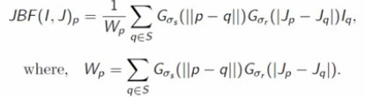preservation are done on the same image. The following is an equation of the joint bilateral filter.

The p in the equation is the central pixel and S denotes the neighbourhood of the pixel p while q is any pixel in that neighbourhood. Parameters s and r specify the amount of filtering of the image I. Image I is the first photo which it is heavily noised. The difference to bilateral filter is, instead of using image I to calculate the range kernel, a secondary image called J is used. The second equation (Wp) is the bilateral filter where Gσs is the spatial kernel and Gsr is the range kernel which is applied on the secondary image J instead of the first image.

One application of the joint bilateral filter is flash / no flash photography. The idea is to take a photo with flash where the colours will look bad and a photo without flash where there will be a lot of noise and use the edges of the flash photo to help smooth the noised image. Then add, the edges back to the flash photo, since it will have a higher resolution as it captures the high-frequency texture. In practice, this is done by smoothing the image with no flash while relying on the flash photo to locate the edges to preserve. The reason that we use joint bilateral filter and not smooth the image directly is because the image has a high noise level.

Another application of the joint bilateral filter is tone mapping. This is especially useful for displaying high dynamic range (HDR) images on ordinary devices with lower resolution. It can be observed that in the original HDR image the noise is linearly proportional to the light in the scene. Firstly, the HDR image is tone mapped using some tone mapping operator. Then this tone mapped image is used in combination with the low-resolution HDR image to apply joint bilateral filter and produce an image that is visually closer to the ground truth.

Another application is red eye correction. The idea is to remove the red eyes from an image of a person by computing the red differences in the two images and to keep the extreme points. However, the colour space that is used is not the RGB one because RGB is correlated with luminosity. The one that is used is the YCrCb. The filter relies on the flash image as an estimator of the ambient image. This works by firstly finding the red difference using a low threshold and this will result in a few spots where there is a possible red eye. After that the spots that pass the high threshold are selected and cross bilateral filter is used.

**B2:**

Joint bilateral filter was implemented in python and tested with images test3a and test3b. Larger images with higher resolution can be found in the appendix.

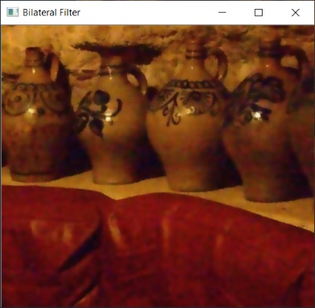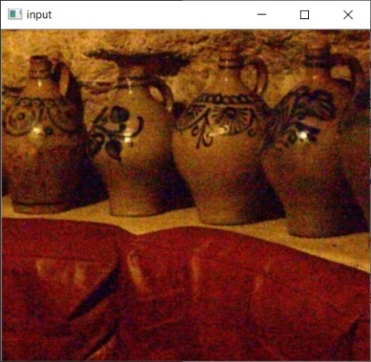**B3:**

JBF

BF

Org

Joint Bilateral filter is used in flash and no flash photography. As we can see from the results above (shown larger in the appendix, named test 3), bilateral filter has managed to remove some noise from the image however the image is blurry. Especially the top of the vases cannot be separated from the wall in the back. As a result, we use joint bilateral filter and the idea is, to use the good features of each photo to create a better image. In practice, the range kernel is computed using the picture with flash instead of the original noisy picture which was taken without flash. This is done by applying a spatial filter to the photo without flash where the resolution is low. At the same time a similar range filter is applied on the photo which was taken with flash. The photo taken with the flash will have a higher resolution as it captures the high-frequency texture. The joint bilateral filter smooths the first image while preserving the edges of a second image.

In my implementation of the joint bilateral filter the parameters that were used were σς=30 (spatial kernel) and σr=20 (range kernel). They were set this way because σς specifies the amount of low-pass filtering and also as it increases it blurs the image more since more distant pixels affect the central pixel. Moreover, σr was set to 20 because the value of σr depends on the amount of edges to be preserved. It was not set to a very high value because it would preserve all edges even the fake ones that were created from taking the picture with a flash. The image would then seem unrealistic and a bit distorted.

Moreover, in my implementation bilateral filter is applied on the flash image or image J as the equation from B1 implies. Then the image with no flash which is heavily noised is filtered using the joint bilateral filter and uses the flash image as a guide. This is done because the flash image is smooth with no noise. Then, the details of the flash image are applied to the no flash image by multiplying the previous result of the filter with the ratio of the flash image.

This shows that the joint bilateral filter is better in preserving detail while reducing noise at the same time. In our case the photo which was taken with flash had very little noise, so we used that photo as a secondary image. The joint bilateral filter relies on the flash image as an estimator of the ambient image, however it can fail in shadows. What this means is that shadows might appear in the flash image because of the flash, but they do not exist in the image without flash. As a result, at the edges of these shadows the filter will over blur them. So, this filter darkens the areas where those shadows appear to be.

Furthermore, it is possible to see small halos around the edges of the bottles. However, my approach is able to smooth the image and remove the noise while preserving the edges and details, like the carvings on the vases. Lastly, one limitation of both the bilateral and joint bilateral filter is that they are nonlinear and therefore their implementation requires performing the convolution in the spatial domain.

**References:**   
En.wikipedia.org. (2018). *Bilateral filter*. [online] Available at: https://en.wikipedia.org/wiki/Bilateral_filter [Accessed 3 Dec. 2018].

Paris, S., Kornprobst, P., Tumblin, J. and Durand, F. (2018). *A Gentle Introduction to Bilateral Filtering and its Applications*. [ebook] pp.4-6. Available at: https://people.csail.mit.edu/sparis/bf_course/course_notes.pdf [Accessed 2 Dec. 2018].

Saplin.blogspot.com. (2018). *Bilateral image filter: Edge preserving blur and noise reduction*. [online] Available at: http://saplin.blogspot.com/2012/01/bilateral-image-filter-edge-preserving.html [Accessed 4 Dec. 2018].

Xiao, C. and Gan, J. (2012). *Fast image dehazing using guided joint bilateral filter*. [ebook] pp.715-716. Available at: https://link.springer.com/content/pdf/10.1007%2Fs00371-012-0679-y.pdf [Accessed 4 Dec. 2018].

Image fusion based on pixel significance using cross bilateral filter. (2013). [ebook] pp.1195-1196. Available at: https://link.springer.com/content/pdf/10.1007%2Fs11760-013-0556-9.pdf [Accessed 3 Dec. 2018].

Paris, S. and Durand, F. (2007). *A Fast Approximation of the Bilateral Filter Using a Signal Processing Approach*. [ebook] pp.26-27. Available at: https://link.springer.com/content/pdf/10.1007%2Fs11263-007-0110-8.pdf [Accessed 3 Dec. 2018].

Kopf, J., Cohen, M., Lischinski, D. and Uyttendaele, M. (2018). [online] pp.2-3 Johanneskopf.de. Available at: https://johanneskopf.de/publications/jbu/paper/FinalPaper_0185.pdf [Accessed 3 Dec. 2018].

G. Petschnigg, R. Szeliski, M. Agrawala,M. Cohen, H. Hoppeand K. Toyama. "Digital photography with flash and no-flash image pairs." In ACM Trans. on Graphics, vol. 23, no. 3, pp. 664-672, 2004

**Appendix:**

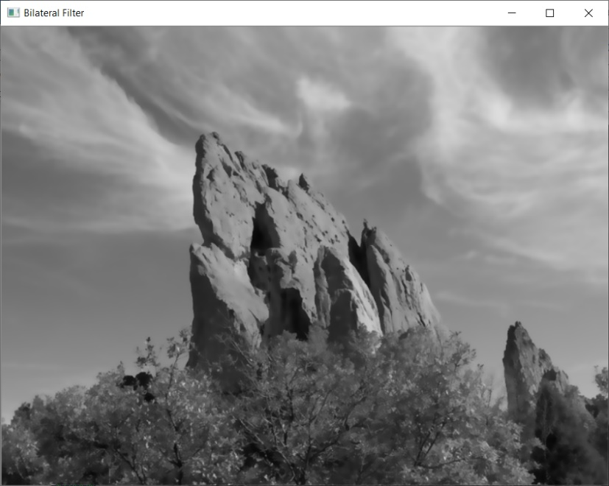*Test 1:*

Fig a

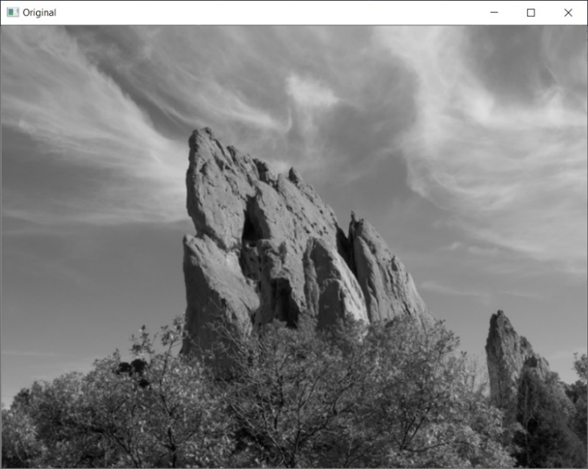

Original

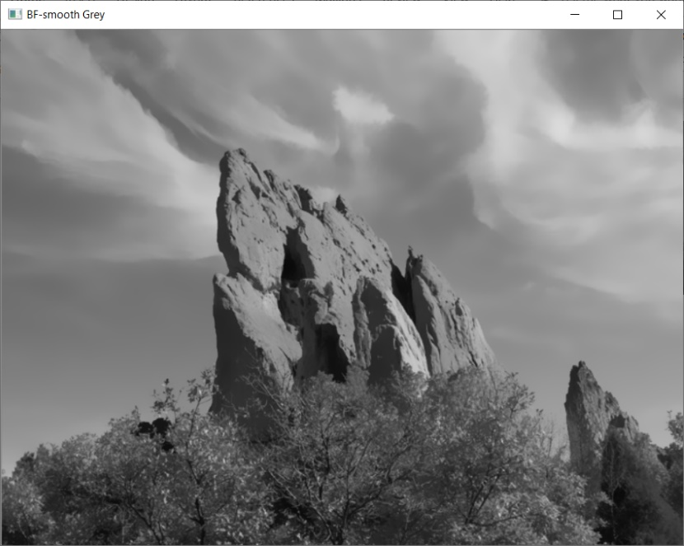

Fig b

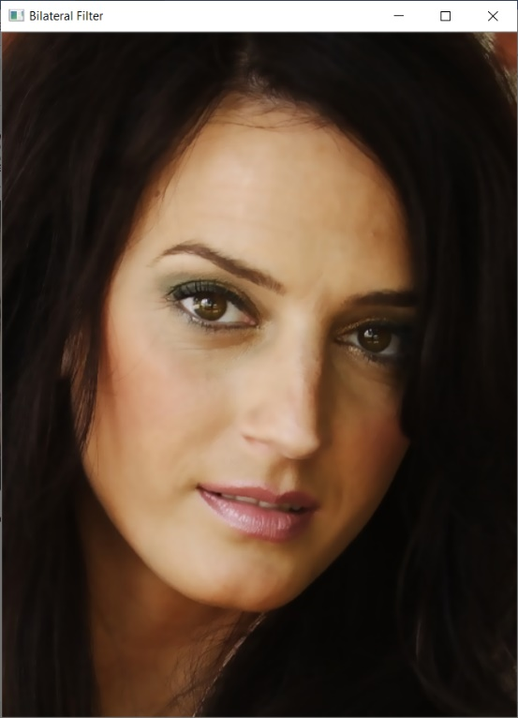*Test 2:*

Original

Fig b

Fig a

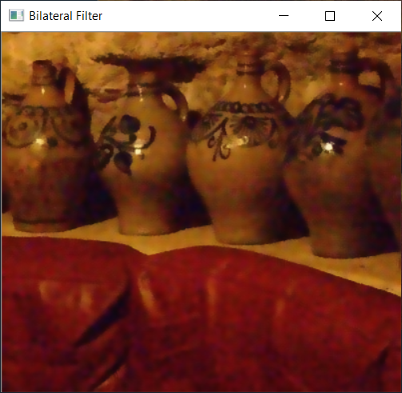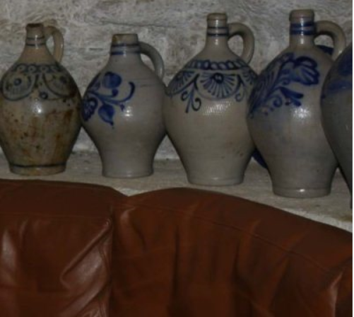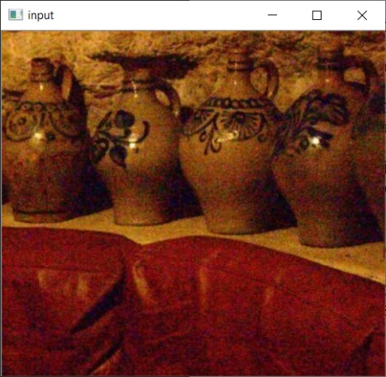*Test 3:*

Bilateral Filter

Joint Bilateral Filter

Flash

No Flash