The window size can be increased, but this will cause two losses. One is that the algorithm

processing time will increase for it should perform once character matching with prior

cache for each location of sliding window. The second is the field should be longer to

permit longer jump.

The running time of the compression algorithm is linear, that is by using a window and a lookahead buffer the data can be compressed in linear time. The size of the window is usually limited due to lack of memory and so the window stores only the newer part of the string. As we move from the start of the string to the end, the window and the buffer move as the current position in the string changes. In my implementation the function that takes the most time is the function to find the longest match in the string. This is because it consists of many if-else statements and a for loop as well. Different experiments were carried out as can be seen from the graphs below.

The peak at the beginning can be explained with measurement inaccuracy, that is the interpreter needs some time to interpret the program or there is possible interaction of the operating system with python causing an increase in the time at first.

Lastly when having large files, the index data structures used to perform compression grow linearly as the input size increases and thus on big files they can start to exceed the size of memory available.

The algorithm uses a limited window size to find a match in already read text. If there is a very long string, then many possible matches may be lost. To prevent this the window size can be increased however the compression time will increase as well since the algorithm will go back to the text further to find character matches and thus more time is needed to

do that.

**Lempel-Ziv coding (LZ77)**

1. ***Running time of the encoder (compression)***

***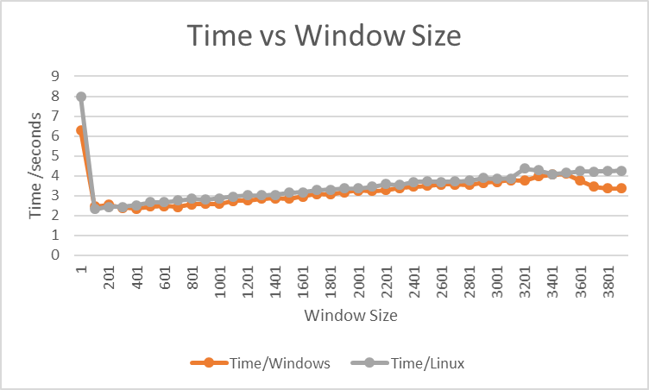****File name:* **22.txt** *File size:* ***38.1KB***

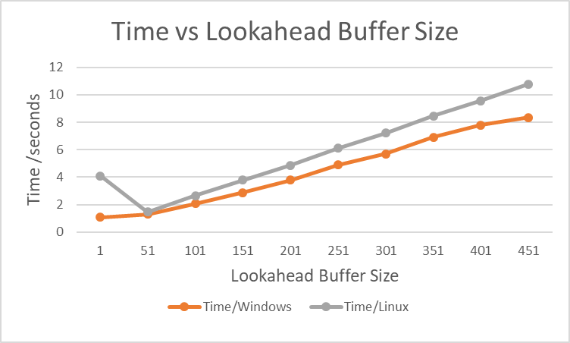

**Max** time Linux: 10.789 sec

**Min** time Linux: 1.467 sec

**Average:** 5.899 sec

**Max** time Windows: 8.360 sec

**Min** time Windows: 1.084 sec

**Average:** 4.475 sec

**Max** time Linux: 7.977 sec

**Min** time Linux: 2.323 sec

**Average:** 3.512 sec

**Max** time Windows: 6.281 sec

**Min** time Windows: 2.353 sec

**Average:** 3.227 sec

***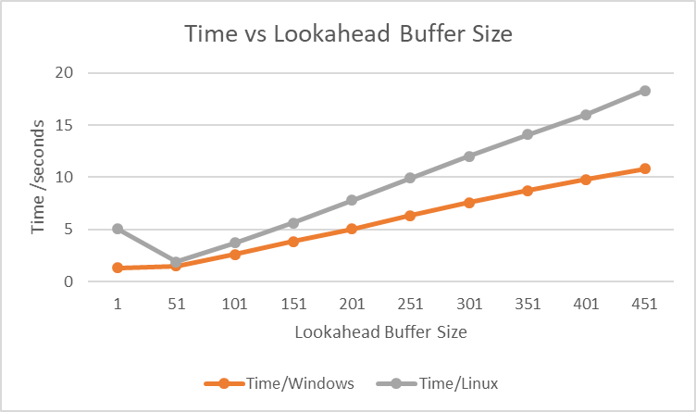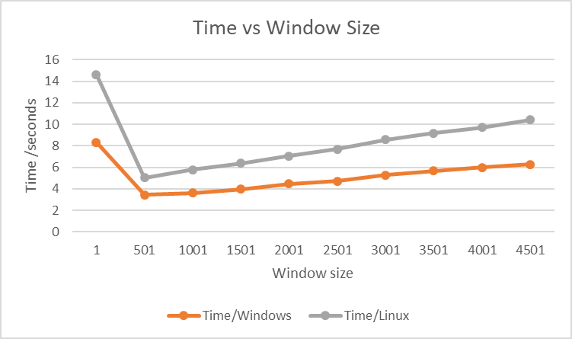****File name:* **memetics.txt** *File size:* ***46.5KB***

**Max** time Windows: 8.340 sec

**Min** time Windows: 3.425 sec

**Average:** 5.168 sec

**Max** time Linux: 14.621 sec

**Min** time Linux: 5.036 sec

**Average:** 8.447 sec

**Max** time Windows: 10.793 sec

**Min** time Windows: 1.350 sec

**Average:** 5.754 sec

**Max** time Linux: 18.287 sec

**Min** time Linux: 1.897 sec

**Average:** 9.438 sec

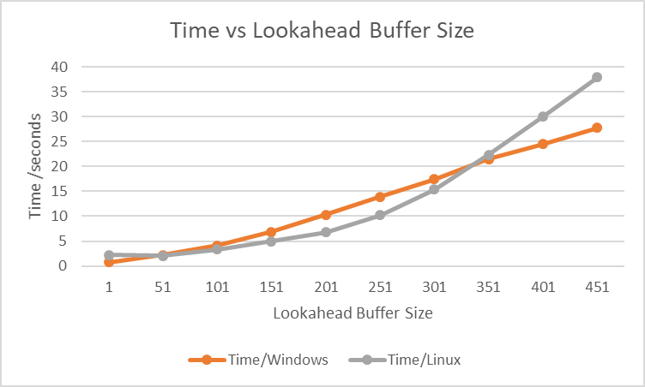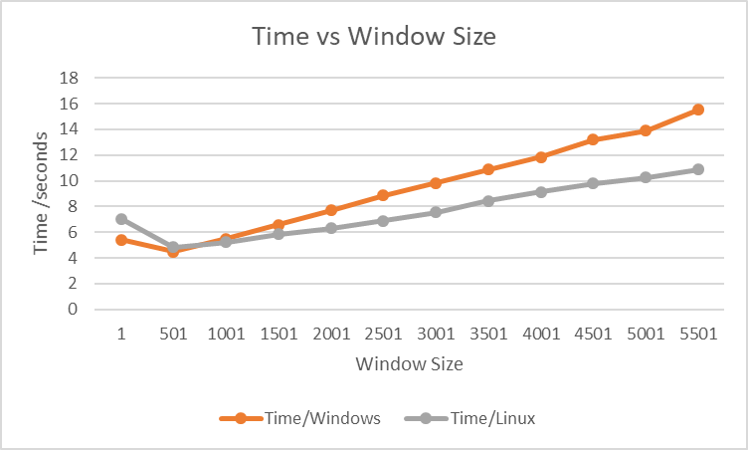*File name:* **dog1.jpg** *File size:* ***34.0KB***

**Max** time Linux: 10.883 sec

**Min** time Linux: 4.843 sec

**Average:** 7.681 sec

**Max** time Windows: 15.535 sec

**Min** time Windows: 4.485 sec

**Average:** 9.473 sec

**Max** time Linux: 37.880 sec

**Min** time Linux: 2.081 sec

**Average:** 13.532 sec

**Max** time Windows: 27.780 sec

**Min** time Windows: 0.782 sec

**Average:** 12.939 sec

The experiments that I carried out were done by having a constant window size and changed the buffer size at constant intervals and then vice versa.

***Results:***

To start off, the relationship between compression speed and file size for **text files** is almost linear. The peak at the beginning can be explained with measurement inaccuracy, that is the interpreter needs some time to interpret the program or there is possible interaction of the operating system with python causing an increase in the time at first. As the file size of a **text file** increases the compression time increases as well. This can be seen from the average values of time obtained from the two text files. The reason for that is a larger file will contain more information so the length of the text to be read is longer. For a text file the size of the lookahead buffer plays a more significant role in the compression time and as we can see from the graphs the rate of change of time against buffer size is greater than the rate of change of time against the window size. This happens because in my code there is a function which finds the longest match in a string. This function contains a for loop which iterates from the current position in the text up to the size of the lookahead buffer. So, by increasing the size of the buffer, the for loop will perform more iterations and thus increase the overall running time. By using a small buffer size, the loop does few iterations and thus producing faster results. Furthermore, the window size also plays a role in the compression time of the algorithm, but, as was said before the buffer size has a greater rate of change than the window size. As the window size increases the running time increases as well. This is because as the window size increases the algorithm has to look further back in the text to find any matches and thus needing more time to read the whole text and compress it. In addition, the algorithm runs better on Windows instead of Linux. One reason is that I used the university’s Linux timeshare service (Mira) which at that time might had a lot of users connected to it and thus increased the overall running time of my program. Moreover, the algorithm can also compress **images**. Conversely, images with smaller size than a text file take longer to compress. The reason is that each point (pixel) in an image consists of RGB values. So, for the algorithm to compresses the image it has to read and compress three values per point instead of a single character as it was the case with the text files. The same procedure occurs with image files as with text files. The lookahead buffer has a higher rate of change than the window size and as the buffer increases the compression time increases as well.

Furthermore, in order to find how many bits we need to use to encode an integer we take the log value of the window and the buffer size plus one. The larger the two sizes are the more bits are needed to encode each number, so the compression time increases.

***Conclusion*:**  
These results show that when using a small lookahead buffer size the compression can be done very fast however this does not mean that the file is compressed well. There is a trade of, between compression speed with the compression ratio. If the look ahead buffer size is small, then the longest match in the string will not be found resulting in creating more tuples and more memory will be needed to encode these tuples, so the compression ratio becomes worse. However, time wise the algorithm will run very fast since it does only a few iterations. Also, by having a smaller window the algorithm will not look far back in the text and thus compress the file faster but again the compression ratio will be reduced. Generally, the ideal sizes are to use a relatively big window size usually around a few thousands and a small lookahead buffer usually around one to three hundred characters.

1. ***Running time of the decoder (decompression)***

***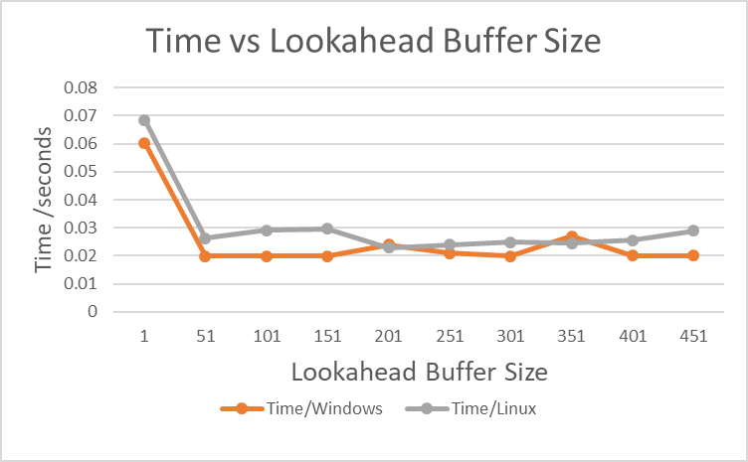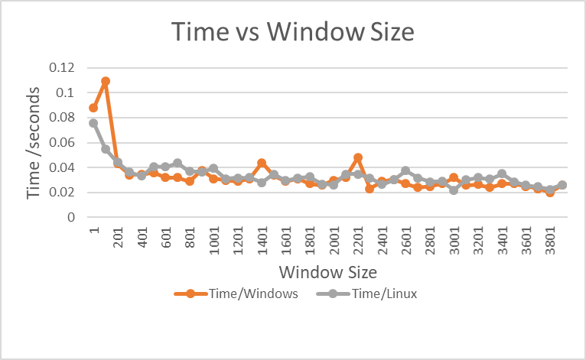****File name:* **22.txt** *File size:* ***38.1KB***

**Max** time Windows: 0.109 sec

**Min** time Windows: 0.020 sec

**Average:** 0.033

sec

**Max** time Linux: 0.069 sec

**Min** time Linux: 0.023 sec

**Average:** 0.030 sec

**Max** time Windows: 0.060 sec

**Min** time Windows: 0.020 sec

**Average:** 0.025 sec

**Max** time Linux: 0.076 sec

**Min** time Linux: 0.022 sec

**Average:** 0.034 sec

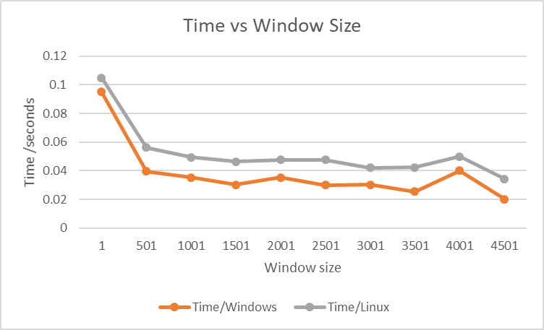*File name:* **memetics.txt** *File size:* ***46.5KB***

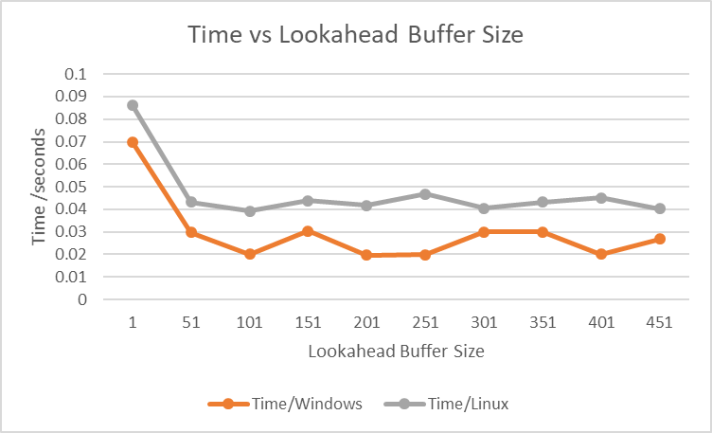

**Max** time Linux: 0.105 sec

**Min** time Linux: 0.034 sec

**Average:** 0.052 sec

**Max** time Linux: 0.086 sec

**Min** time Linux: 0.039 sec

**Average:** 0.047 sec

**Max** time Windows: 0.095 sec

**Min** time Windows: 0.020 sec

**Average:** 0.038 sec

**Max** time Windows: 0.070 sec

**Min** time Windows: 0.020 sec

**Average:** 0.030 sec

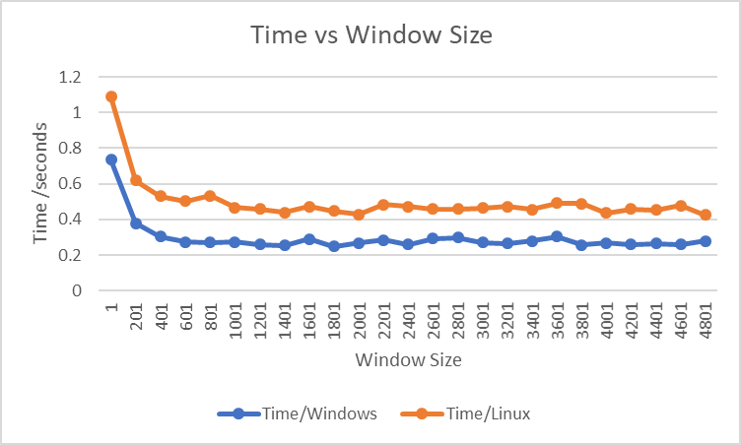 *File name:* **dog1.jpg** *File size:* ***34.0KB***

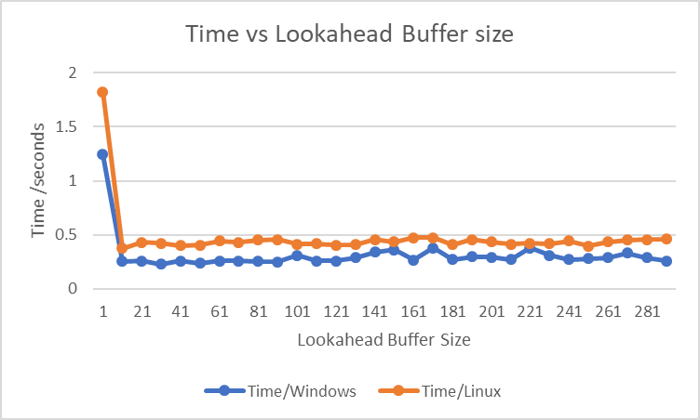

**Max** time Linux: 1.826 sec

**Min** time Linux: 0.375sec

**Average:** 0.478 sec

**Max** time Windows: 1.245 sec

**Min** time Windows: 0.230 sec

**Average:** 0.318 sec

**Max** time Linux: 1.088 sec

**Min** time Linux: 0.426 sec

**Average:** 0.500 sec

**Max** time Windows: 0.735 sec

**Min** time Windows: 0.250 sec

**Average:** 0.296 sec

The experiments that I carried out were done by having a constant window size and changed the buffer size at constant intervals and then vice versa.

**Results:**

The results from the graphs show that there is a correlation between decompression time and the size of the window or the buffer. As the window size or buffer size increases the decompression time decreases. Nonetheless there are some fluctuations on the graphs, they are not constant. This might be that there is some interaction between python and the operating system that causes a slight delay in the time. But generally, this does not affect the decompression time to a great amount because as we can see from the results the decompression time fluctuates between 0.02 and 0.105 for the window size and between 0.02 and 0.086 for the buffer size. So generally decompression occurs in less than 1 seconds which is very fast. So the decoding process is simpler than the encoding process since there is no comparisons involved in the decoding. As we can see from the results as the file size of the text files increases the decompression time increases as well. This is the case since a larger file will contain more information and thus more tuples will be used to compress the file. As a result of the increased number of tuples the time needed to decompress the file is greater since the algorithm will have to read more tuples and output the text. Also, a very large file was not used during testing since during decompression when copying characters from the already decompressed part of the file RAM is used to retrieve those characters. If the decompressed part of the file exceeds the RAM space, the computer will use the virtual memory from the hard drive and this slows down decompression to a large amount.

Furthermore, my results show that as the buffer size or the window size increase the time needed to decompress the file is lowered. This is because as the size of either the buffer or the window is increased the bits needed to encode each tuple are increased as well. Since more bits are used for each tuple the total number of tuples that the algorithm has to go through during decompression are less. As a result, the loop that iterates through each tuple will do fewer iterations and thus have a better decompression time. My results show that the algorithm performs better on windows rather than Linux. Also, the rate of change for both increasing the window size or the buffer size is about the same.

The decoding is much faster than the encoding in this process and it is one of the important features of this process. In LZ77, most of the compression time used in searching for the longest match, whereas the decompression is quick as each reference is simply replaced with the string, which it points to.

**Conclusion**

The algorithm is asymmetric. This means that compression is slower than decompression since in order to compress, the algorithm has to iterate through the text and find a longest possible match but with decompression the algorithm will read the tuples from a list and output the text. Generally as we can see the decompression time is less than one second so whichever values are used decompression will be executed faster. Even though decompression time is about the same for any size of the window or the buffer we can see that the algorithm will decompress faster on large values of window and buffer size so the best practise to do is to use a large window size around 3500 and a lookahead buffer of about 200. This will result in both **compressing** the file in relatively fast time and at the same time **decompress** the file faster.

1. ***Compression Ratio***

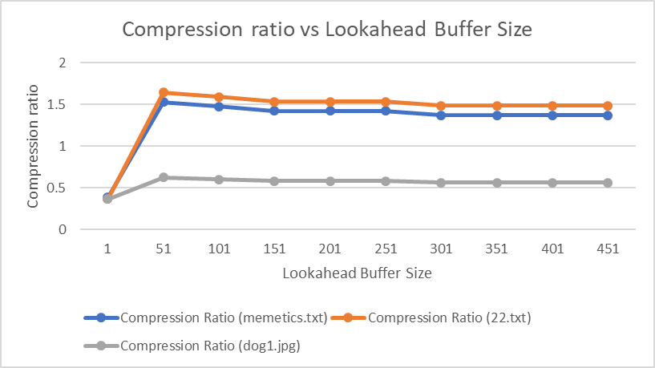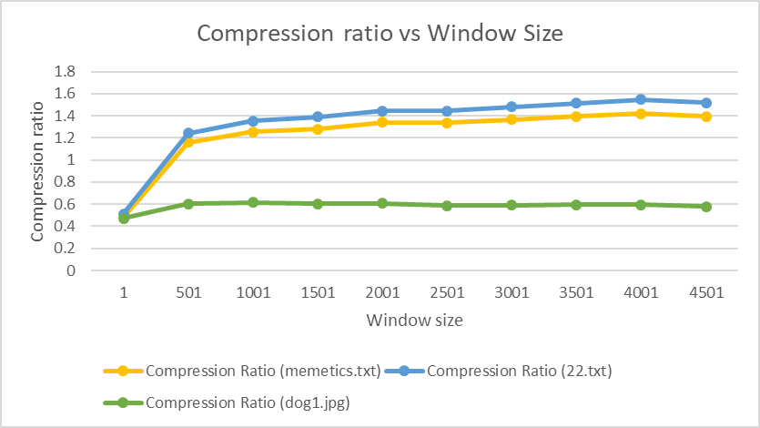*File name:* **memetics.txt** and **22.txt** and **dog1.jpg**

**Max** Ratio dog1.jpg: 0.618

**Min** Ratio dog1.jpg: 0.473

**Average:** 0.585

**Max** Ratio 22.txt: 1.546

**Min** Ratio 22.txt: 0.514

**Average:** 1.345

**Max** Ratio dog1.jpg: 0.623

**Min** Ratio dog1.jpg: 0.364

**Average:** 0.557

**Max** Ratio 22.txt: 1.642

**Min** Ratio 22.txt: 0.364

**Average:** 1.413

**Max** Ratio memetics.txt: 1.421

**Min** Ratio memetics.txt: 0.480

**Average:** 1.243

**Max** Ratio memetics.txt: 1.530

**Min** Ratio memetics.txt: 0.381

**Average:** 1.313

The experiments that I carried out were done by having a constant window size and changed the buffer size at constant intervals and then vice versa.

**Results**

Firstly, the compression ratio was tested on a Windows machine and on a Linux machine as well but only the compression ratio of the windows machine is shown in the graphs because the ratio is exactly the same on both machines.

The compression ratio increases with the size of the window or the buffer. But there is a point where increasing their sizes does not result in an increase of the compression ratio any more.

As we can see from the results both graphs show an increase in the ratio at the beginning as the window size or the buffer size increases. For a window size between 1 and 1001 and for a buffer size between 1 and 21, this algorithm seems not to be able to find enough matches in the data inside the window size. Therefore, it has to encode many short phrases which result in having more tuples, thus the size of the compressed file increases and so the compression ratio decreases. However, after a certain point, we can see on the graph that the line remains unchanged or changes slightly. This is the case because as the size of the window increases the algorithm looks further back in the string to find a match. At first where there is a sudden increase in the graph the algorithm finds a longer match in the text and this process continues resulting in even longer matches up to a point where the longest match has been found. This explains the increase in the ratio in the first part of the graph and then when the longest match is found the algorithm has a constant compression ratio from that point on since it cannot compress the text to a larger amount. This explains the second part of the graph where the ratio is almost unchanged. Furthermore, in order to calculate the compression ratio, the size of the original file is divided by the size of the compressed file. When the size of the window or the buffer increases more bits are used to encode each number and letter so less tuples (d,l,m) are generated. By generating less tuples, the size of the compressed file decreases and thus the compression ratio becomes better.

In addition, we can see that the algorithm compresses text files well with an average ratio of around 1.3 whereas for the image file the ratio is much lower, with an average of 0.585 for changing the window size and 0.557 for changing the buffer size. Images have a worse compression ratio because the algorithm has to encode 3 values per pixel (RGB) so the size of the compressed file of the images will be higher compared with the size of the compressed file of a text file. Also, since the images contain colours the values that are encoded are between 0 and 255 and each pixel will have a slightly different value so less matches will be found. A string can have values between 0 and 127 including all ASCII special characters. These different values that the string can have are half of the values an image can have. This will result in the compressed image having more tuples and thus the length of the compressed file is larger, so the ratio is lower.

**Conclusion:**

To compress a string well, we have to find the longest match in the string. It is also important to find the nearest one among the longest match strings because the nearest one is encoded in fewer bits. As a result, the best values to use are around 3500 for the window size and around 250 for the lookahead buffer size. These values will not only give a fast compression and decompression speed but will also give a high compression ratio.